Jaypee Institute of Information Technology

Database Systems & Web (15B11CI312)

**Tutorial –1 (HTML)**

1. Create a webpage to print a paragraph with 4 – 5 sentences. Each sentence should be in a different font and color.
2. Create a webpage as shown below.

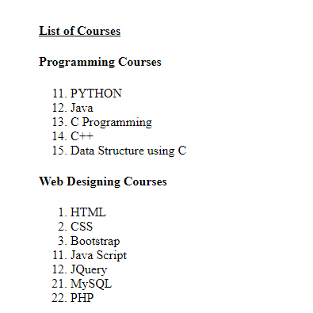

1. Create a webpage containing a table as shown below.

