Jaypee Institute of Information Technology

Database Systems & Web

15B11CI312

**Tutorial –2**

1. How can we hide an element in CSS?
2. Draw the following two column layout using CSS.

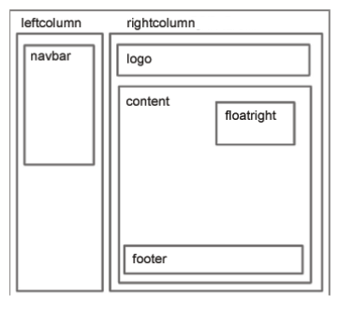

1. Write a JavaScript program to calculate multiplication and division of two numbers (input from user).

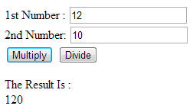

1. Write a JavaScript program to check whether a given string is palindrome or not (input from user).