WEEK – 4 Assignments
ASP. NET Core 8. 0 Web API
Mandatory hands-on :-
2. WebApi_Handson :
Objectives:
· Demonstrate Swagger installation to WebAPI and WebAPI listing on browser
o Nuget package to download Swashbuckle.AspNetCore, Usage of ProducesResponseType to Web API method, AddSwaggerGen, UseSwaggerUI
· Demonstrate the usage of Postman tool to hit WebAPI methods
o Structure in Postman tool, Headers with Authorization, Body as JSON, Option to choose the type of request, Request collection and how to add a new request in the collection, Tabs in the center pane that corresponds to the request
· Demonstrate the usage of Route and Explain Name attribute in Http requests
o Importance of user friendly name to action method, Explain the usage of ActionName to have more than 1 method with the same Action verbDemonstrate creation of a simple WebAPI - With Read, Write actions.

1. Web Api using .Net core with Swagger
Employee.cs :

public class Employee
{
public int Id { get; set; }
public string Name { get; set; }
}

Program.cs :

using Microsoft.OpenApi.Models;
var builder = WebApplication.CreateBuilder(args);
// Add services to the container.
builder.Services.AddControllers();
builder.Services.AddSwaggerGen(c =>
{
c.SwaggerDoc("v1", new OpenApiInfo
{
Title = "Swagger Demo",
Version = "v1",
Description = "TBD",
TermsOfService = new Uri("https://example.com/terms"),
Contact = new OpenApiContact
{
Name = "John Doe",
Email = "john@xyzmail.com",
Url = new Uri("https://www.example.com")
},
License = new OpenApiLicense
{
Name = "License Terms",
Url = new Uri("https://www.example.com")
}
});
});
var app = builder.Build();
// Configure the HTTP request pipeline.
app.UseSwagger();
app.UseSwaggerUI(c =>
{
c.SwaggerEndpoint("/swagger/v1/swagger.json", "Swagger Demo");
});
app.UseAuthorization();
app.MapControllers();
app.Run();

EmployeeController.cs :

using Microsoft.AspNetCore.Mvc;
using System.Collections.Generic;
using System.Linq;
[Route("api/Emp")]
[ApiController]
public class EmployeeController : ControllerBase
{
private static List<Employee> employees = new List<Employee>
{
new Employee { Id = 1, Name = "Divyanshu" },
new Employee { Id = 2, Name = "Prateek" }
};
[HttpGet]
[ProducesResponseType(typeof(IEnumerable<Employee>), 200)]
public ActionResult<IEnumerable<Employee>> Get()
{
return Ok(employees);
}
[HttpPost]
[ProducesResponseType(typeof(Employee), 201)]
public ActionResult<Employee> Post([FromBody] Employee emp)
{
emp.Id = employees.Count + 1;
employees.Add(emp);
return CreatedAtAction(nameof(Get), new { id = emp.Id }, emp);
}
}

OUTPUT (Swagger):
GET : api/Emp :
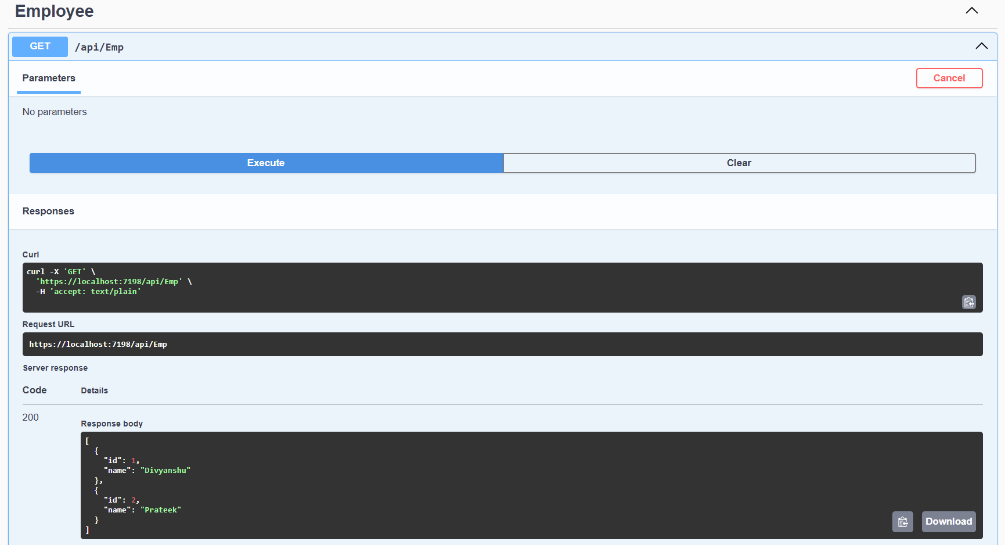
POST : api/Emp :
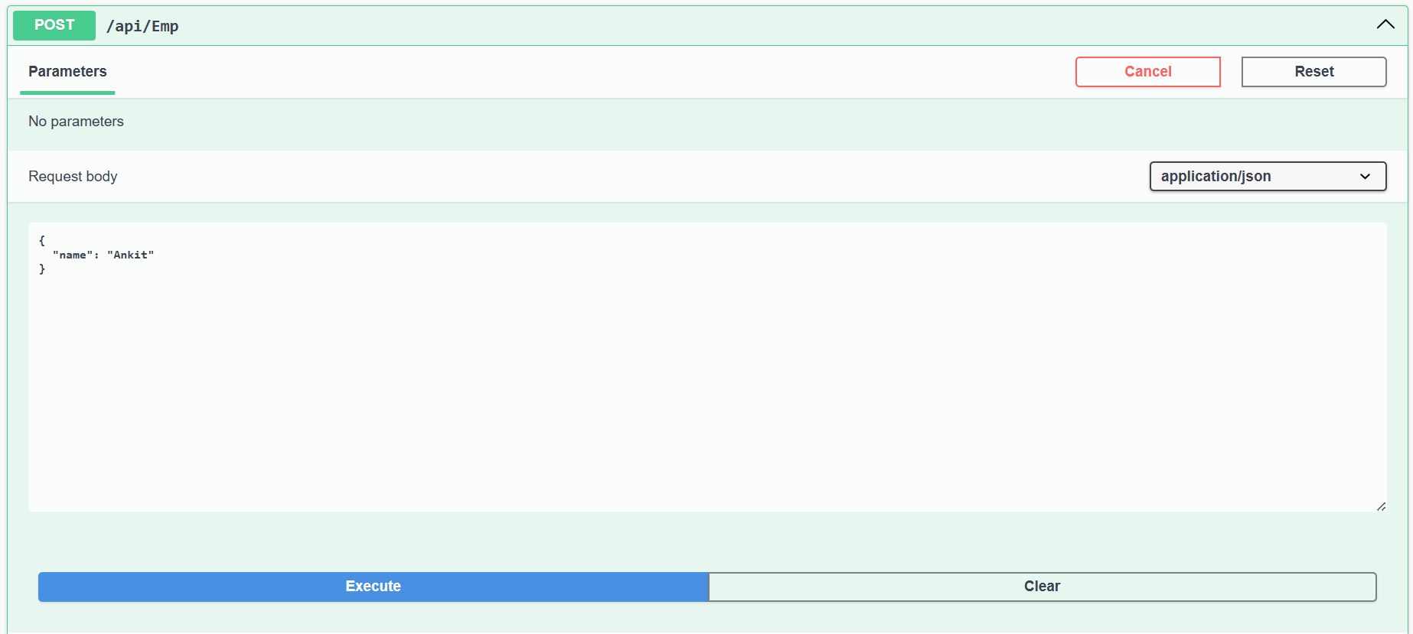

POST : api/Emp :
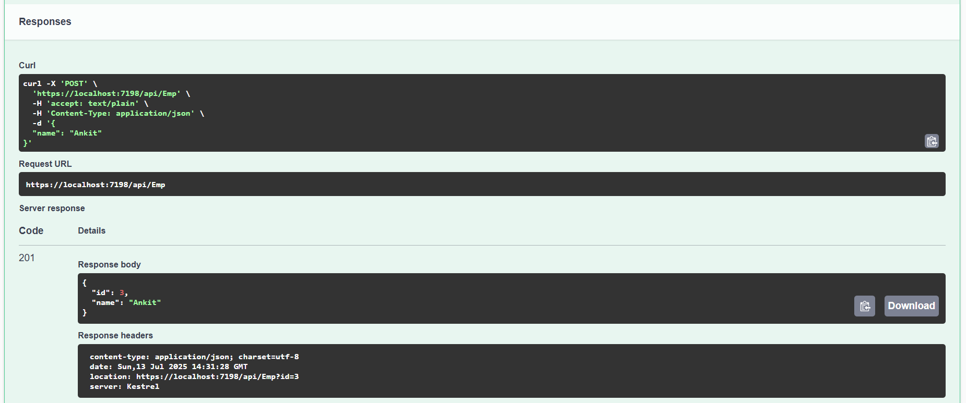

OUTPUT (POSTMAN) :
GET : api/Emp :
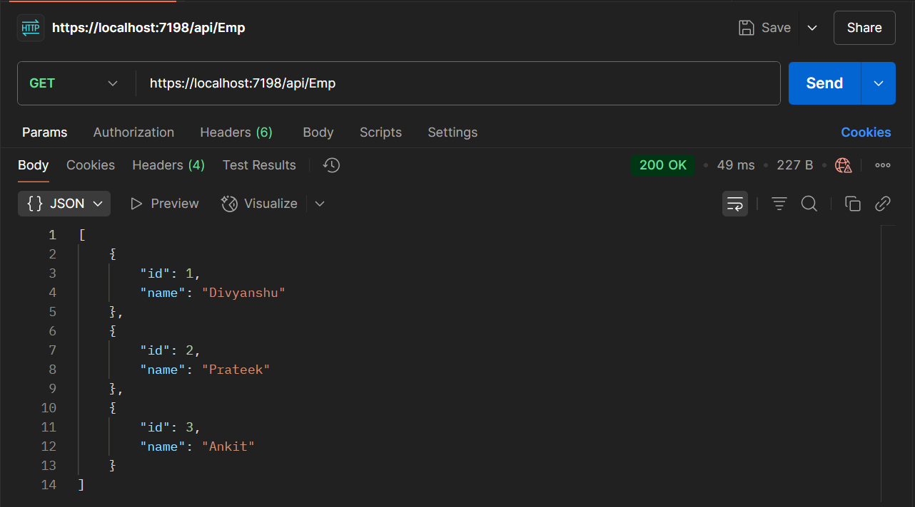

POST : api/Emp :
