WEEK – 4 Assignments
ASP. NET Core 8. 0 Web API
Mandatory hands-on :-
3. WebApi_Handson :
Objectives:
· Demonstrate creation of an Action method to return list of custom class entity
o Model class creation, Use AllowAnonymous attribute, Use HttpGet action method
· Explain the usage of FromBody attribute
o Read the model object from request, other than the query string parameter
· Demonstrate Custom filter
o Usage of ActionFilterAttribute, OnActionExecuting method to intercept the request, Create filter for Custom exception - Need to install Microsoft.AspNetCore.Mvc.WebApiCompatShim package

1. Web Api using custom model class :
Employee.cs :

public class Department
{
public int Id { get; set; }
public string Name { get; set; }
}
public class Skill
{
public int Id { get; set; }
public string Name { get; set; }
}
public class Employee
{
public int Id { get; set; }
public string Name { get; set; }
public int Salary { get; set; }
public bool Permanent { get; set; }
public Department Department { get; set; }
public List<Skill> Skills { get; set; }
public DateTime DateOfBirth { get; set; }
}

Program.cs :

var builder = WebApplication.CreateBuilder(args);
// Add services to the container.
builder.Services.AddControllers(options =>
{
options.Filters.Add<CustomExceptionFilter>();
});
// Learn more about configuring Swagger/OpenAPI at https://aka.ms/aspnetcore/swashbuckle
builder.Services.AddEndpointsApiExplorer();
builder.Services.AddSwaggerGen();
var app = builder.Build();
// Configure the HTTP request pipeline.
if (app.Environment.IsDevelopment())
{
app.UseSwagger();
app.UseSwaggerUI();
}
app.UseHttpsRedirection();
app.UseAuthorization();
app.MapControllers();
app.Run();

EmployeeController.cs :

using Microsoft.AspNetCore.Authorization;
using Microsoft.AspNetCore.Mvc;
using System;
using System.Collections.Generic;
[ApiController]
[Route("api/[controller]")]
[AllowAnonymous]
[CustomAuthFilter]
public class EmployeeController : ControllerBase
{
private static List<Employee> _employees = GetStandardEmployeeList();
private static List<Employee> GetStandardEmployeeList()
{
return new List<Employee>
{
new Employee
{
Id = 1,
Name = "Ankit Sahu",
Salary = 50000,
Permanent = true,
Department = new Department { Id = 1, Name = "HR" },
Skills = new List<Skill>
{
new Skill { Id = 1, Name = "C#" },
new Skill { Id = 2, Name = "SQL" }
},
DateOfBirth = new DateTime(1990, 1, 1)
},
new Employee
{
Id = 2,
Name = "Divyanshu Kumar",
Salary = 60000,
Permanent = false,
Department = new Department { Id = 2, Name = "IT" },
Skills = new List<Skill>
{
new Skill { Id = 3, Name = "JavaScript" }
},
DateOfBirth = new DateTime(1992, 2, 2)
}
};
}
[HttpGet]
[ProducesResponseType(StatusCodes.Status200OK)]
public ActionResult<List<Employee>> GetStandard()
{
return Ok(_employees);
}
[HttpPost]
public IActionResult CreateEmployee([FromBody] Employee employee)
{
_employees.Add(employee);
return CreatedAtAction(nameof(GetStandard), new { id = employee.Id }, employee);
}
[HttpPut("{id}")]
public IActionResult UpdateEmployee(int id, [FromBody] Employee employee)
{
var existing = _employees.Find(e => e.Id == id);
if (existing == null) return NotFound();
existing.Name = employee.Name;
existing.Salary = employee.Salary;
existing.Permanent = employee.Permanent;
existing.Department = employee.Department;
existing.Skills = employee.Skills;
existing.DateOfBirth = employee.DateOfBirth;
return NoContent();
}
[HttpGet("throw")]
[ProducesResponseType(StatusCodes.Status500InternalServerError)]
public ActionResult ThrowException()
{
throw new Exception("Demo exception");
}
}

2. Create a Custom action filter for Authorization :
CustomAuthFilter.cs :
using Microsoft.AspNetCore.Mvc;
using Microsoft.AspNetCore.Mvc.Filters;
public class CustomAuthFilter : ActionFilterAttribute
{
public override void OnActionExecuting(ActionExecutingContext context)
{
var hasAuth = context.HttpContext.Request.Headers.TryGetValue("Authorization", out var token);
if (!hasAuth)
{
context.Result = new BadRequestObjectResult("Invalid request - No Auth token");
return;
}
if (!token.ToString().Contains("Bearer"))
{
context.Result = new BadRequestObjectResult("Invalid request - Token present but Bearer unavailable");
return;
}
base.OnActionExecuting(context);
}
}

3. Custom Exception filter :
CustomExceptionFilter.cs :
using Microsoft.AspNetCore.Mvc;
using Microsoft.AspNetCore.Mvc.Filters;
using System.IO;
public class CustomExceptionFilter : IExceptionFilter
{
public void OnException(ExceptionContext context)
{
var exception = context.Exception;
File.AppendAllText("exceptions.txt", $"{DateTime.Now}: {exception.Message}{Environment.NewLine}");
context.Result = new ObjectResult("An error occurred. Please contact support.")
{
StatusCode = 500
};
context.ExceptionHandled = true;
}
}

OUTPUT (POSTMAN):
GET : api/employee :
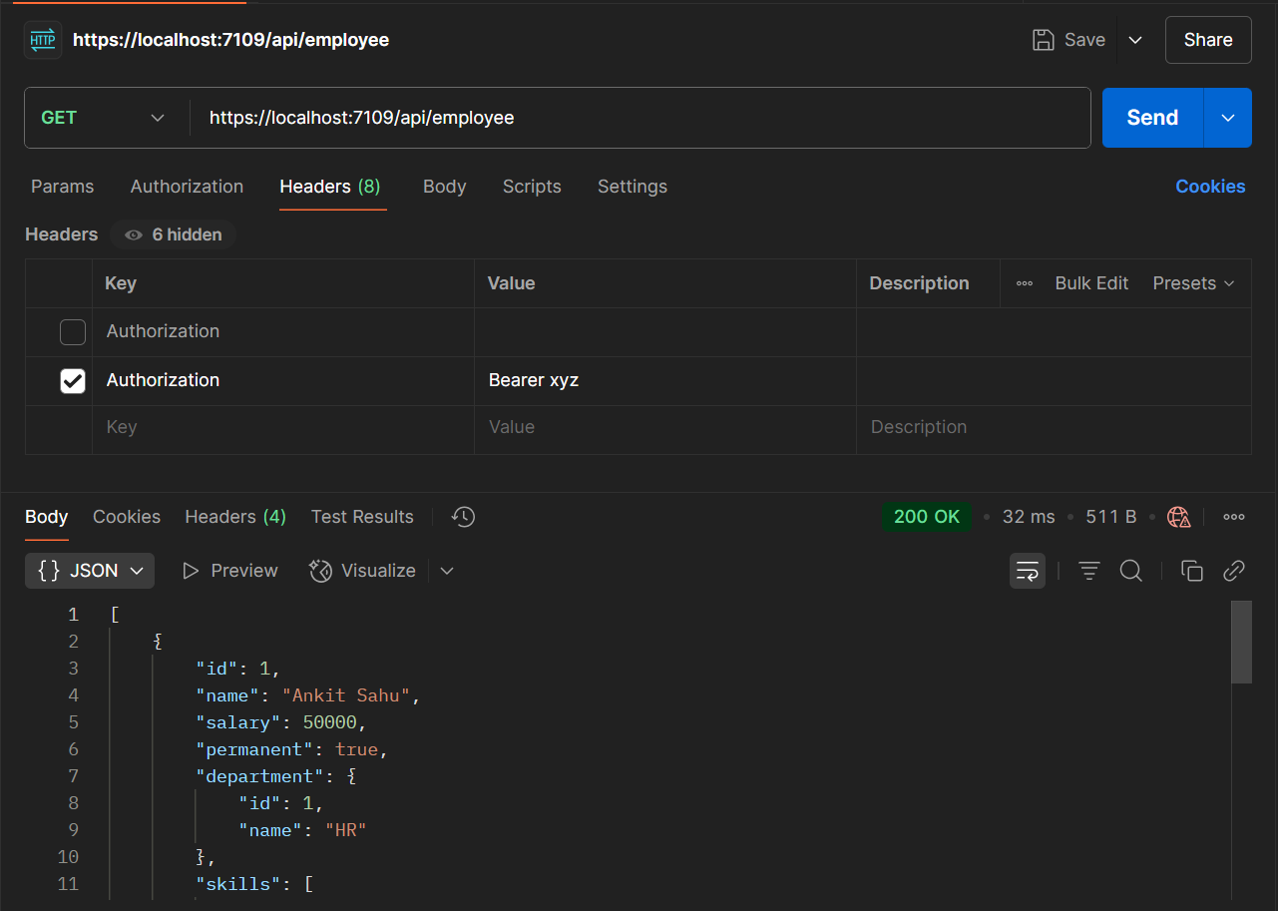
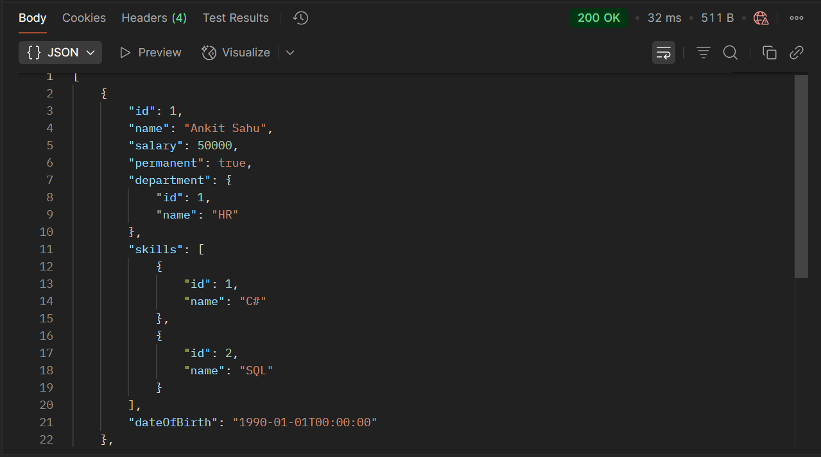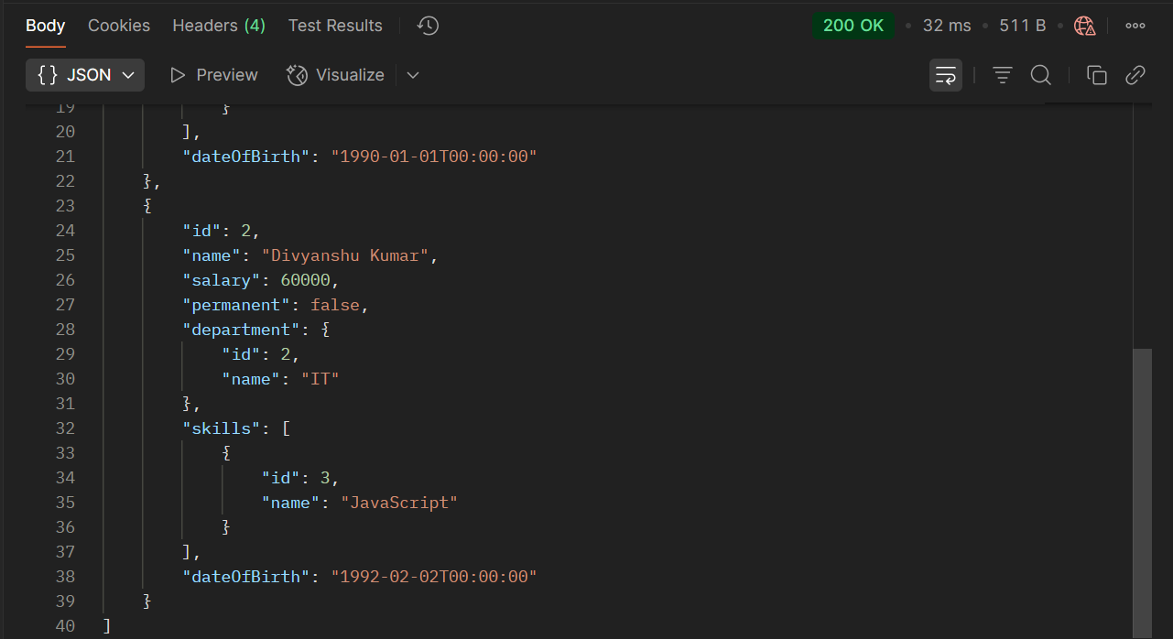

POST : api/employee :
