WEEK – 4 Assignments
ASP. NET Core 8. 0 Web API
Mandatory hands-on :-
4. WebApi_Handson :
Objectives:
· Demonstrate creation of an Action method to perform data create, update & delete operation
o Use FromBody attribute, extract data to custom model class using FromBody attribute, use hardcoded data to update & delete data, Use Swagger and POSTMAN to test.

1. Web Api CRUD operation :
Employee.cs :

namespace EmployeeApiDemo.Models
{
public class Employee
{
public int Id { get; set; }
public string Name { get; set; }
public int Age { get; set; }
public string Position { get; set; }
}
}

Program.cs :

var builder = WebApplication.CreateBuilder(args);
// Add services to the container.
builder.Services.AddControllers();
// Learn more about configuring Swagger/OpenAPI at https://aka.ms/aspnetcore/swashbuckle
builder.Services.AddEndpointsApiExplorer();
builder.Services.AddSwaggerGen();
var app = builder.Build();
// Configure the HTTP request pipeline.
if (app.Environment.IsDevelopment())
{
app.UseSwagger();
app.UseSwaggerUI();
}
app.UseHttpsRedirection();
app.UseAuthorization();
app.MapControllers();
app.Run();

EmployeeController.cs :

using Microsoft.AspNetCore.Mvc;
using EmployeeApiDemo.Models;
using System.Collections.Generic;
using System.Linq;
namespace EmployeeApiDemo.Controllers
{
[ApiController]
[Route("api/[controller]")]
public class EmployeesController : ControllerBase
{
private static List<Employee> employees = new List<Employee>
{
new Employee { Id = 1, Name = "Ankit Sahu", Age = 30, Position = "Developer" },
new Employee { Id = 2, Name = "Divyanshu Kumar", Age = 25, Position = "Designer" },
new Employee { Id = 3, Name = "Prateek Singh", Age = 40, Position = "Manager" }
};
// GET: api/Employees
[HttpGet]
public ActionResult<IEnumerable<Employee>> GetAllEmployees()
{
return Ok(employees);
}
// GET: api/Employees/{id}
[HttpGet("{id}")]
public ActionResult<Employee> GetEmployeeById(int id)
{
var employee = employees.FirstOrDefault(e => e.Id == id);
if (employee == null)
{
return NotFound("Employee not found");
}
return Ok(employee);
}
// PUT: api/Employees/{id}
[HttpPut("{id}")]
public ActionResult<Employee> UpdateEmployee(int id, [FromBody] Employee updatedEmployee)
{
if (id <= 0)
{
return BadRequest("Invalid employee id");
}
var employee = employees.FirstOrDefault(e => e.Id == id);
if (employee == null)
{
return BadRequest("Invalid employee id");
}
employee.Name = updatedEmployee.Name;
employee.Age = updatedEmployee.Age;
employee.Position = updatedEmployee.Position;
return Ok(employee);
}
}
}

OUTPUT (POSTMAN) :
GET : api/Employees :
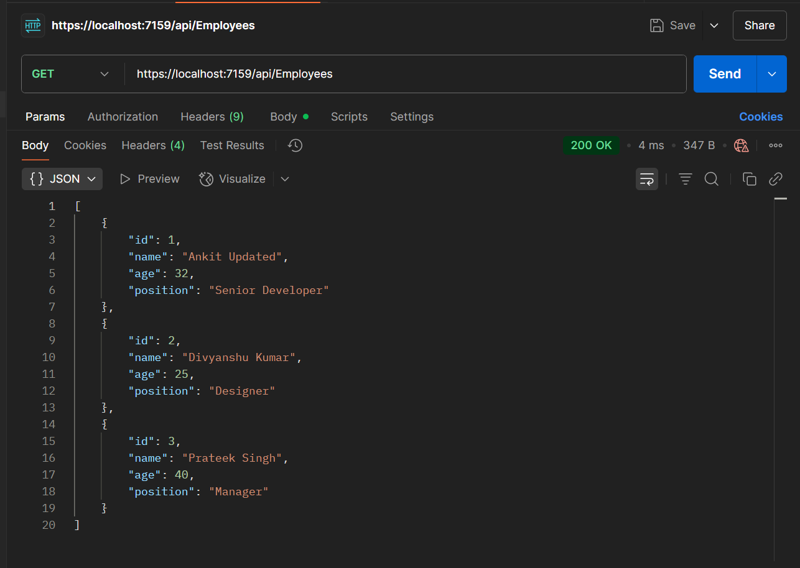

PUT : api/Employees/1 :
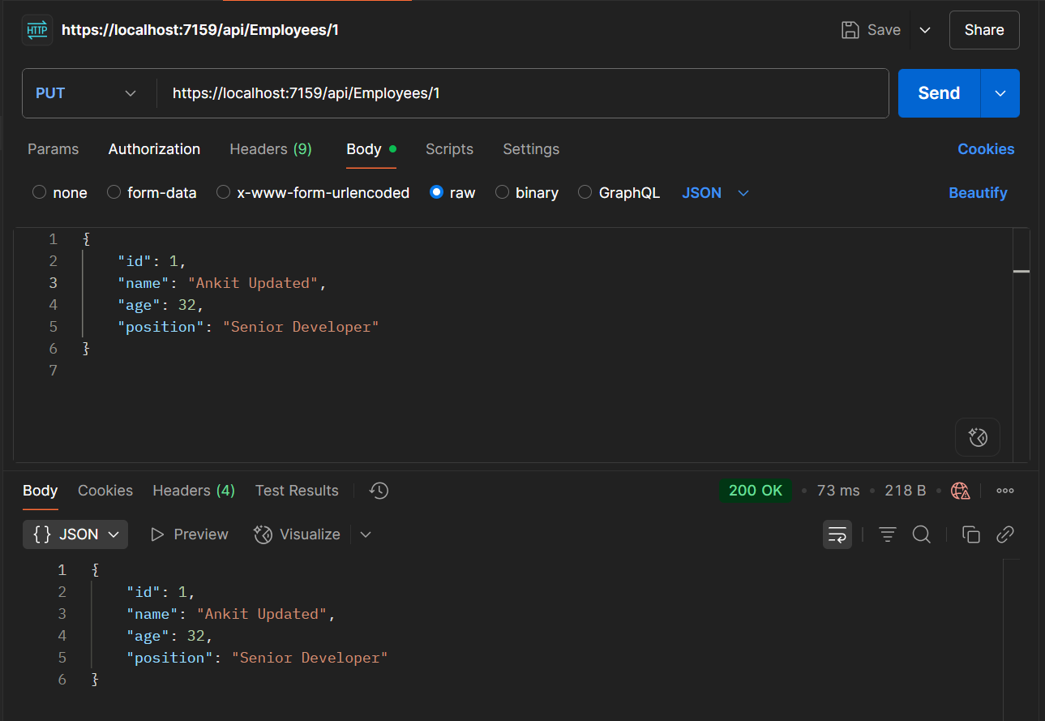

BadRequest :
