WEEK – 4 Assignments
ASP. NET Core 8. 0 Web API
Mandatory hands-on :-
5. WebApi_Handson :
Objectives :
· Explain CORS enablement for Web API access for local application
o What is CORS?, How to enable CORS thru Startup.cs, Install Cors nuget package to Web API application
· Demonstrate security in WebAPI
o Bearer and Jwt token authentication, Use Authorize attribute & send roles in Jwt token, Setting in Startup.cs for AddAuthentication and AddJwtBearer with validation attributes, UseAuthentication, AllowAnonymous to AuthController to generate token, Claims.

1. JsonWebToken :
2. Use the JWT generated thru the AuthController to be used in POSTMAN request :
Program.cs :

using Microsoft.AspNetCore.Authentication.JwtBearer;
using Microsoft.IdentityModel.Tokens;
using System.Text;
var builder = WebApplication.CreateBuilder(args);
// Add services to the container.
builder.Services.AddControllers();
// CORS policy
builder.Services.AddCors(options =>
{
options.AddPolicy("AllowAll",
policy => policy.AllowAnyOrigin()
.AllowAnyHeader()
.AllowAnyMethod());
});
// JWT Authentication
string securityKey = "mysuperdupersecretkeythatismorethan32chars!";
var symmetricSecurityKey = new SymmetricSecurityKey(Encoding.UTF8.GetBytes(securityKey));
builder.Services.AddAuthentication(options =>
{
options.DefaultAuthenticateScheme = JwtBearerDefaults.AuthenticationScheme;
options.DefaultChallengeScheme = JwtBearerDefaults.AuthenticationScheme;
options.DefaultSignInScheme = JwtBearerDefaults.AuthenticationScheme;
})
.AddJwtBearer(JwtBearerDefaults.AuthenticationScheme, options =>
{
options.TokenValidationParameters = new TokenValidationParameters
{
ValidateIssuer = true,
ValidateAudience = true,
ValidateLifetime = true,
ValidateIssuerSigningKey = true,
ValidIssuer = "mySystem",
ValidAudience = "myUsers",
IssuerSigningKey = symmetricSecurityKey
};
});
var app = builder.Build();
app.UseCors("AllowAll");
app.UseAuthentication();
app.UseAuthorization();
app.MapControllers();
app.Run();

EmployeeController.cs :

using Microsoft.AspNetCore.Authorization;
using Microsoft.AspNetCore.Mvc;
namespace JwtCorsDemo.Controllers
{
[ApiController]
[Route("[controller]")]
[Authorize(Roles = "Admin,POC")] // Only users with Admin or POC roles can access
public class EmployeeController : ControllerBase
{
[HttpGet]
public IActionResult Get()
{
return Ok("You are authorized!");
}
}
}

AuthController.cs :
using Microsoft.AspNetCore.Authorization;
using Microsoft.AspNetCore.Mvc;
using Microsoft.IdentityModel.Tokens;
using System.IdentityModel.Tokens.Jwt;
using System.Security.Claims;
using System.Text;
namespace JwtCorsDemo.Controllers
{
[ApiController]
[Route("[controller]")]
[AllowAnonymous]
public class AuthController : ControllerBase
{
[HttpGet("token")]
public IActionResult GetToken()
{
var token = GenerateJSONWebToken(1, "Admin");
return Ok(new { token });
}
private string GenerateJSONWebToken(int userId, string userRole)
{
var securityKey = new SymmetricSecurityKey(Encoding.UTF8.GetBytes("mysuperdupersecretkeythatismorethan32chars!"));
var credentials = new SigningCredentials(securityKey, SecurityAlgorithms.HmacSha256);
var claims = new List<Claim>
{
new Claim(ClaimTypes.Role, userRole),
new Claim("UserId", userId.ToString())
};
var token = new JwtSecurityToken(
issuer: "mySystem",
audience: "myUsers",
claims: claims,
expires: DateTime.Now.AddMinutes(10), // Change to 2 for testing expiration
signingCredentials: credentials);
return new JwtSecurityTokenHandler().WriteToken(token);
}
}
}

OUTPUT (POSTMAN) :
GET : auth/token :
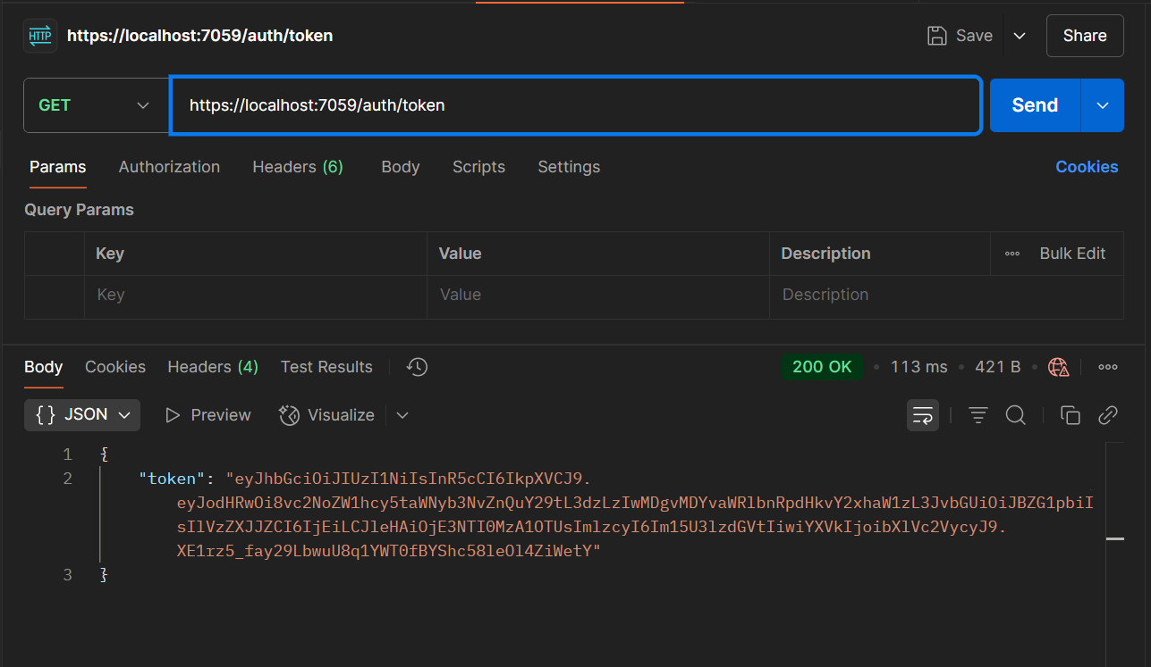

GET : employees :
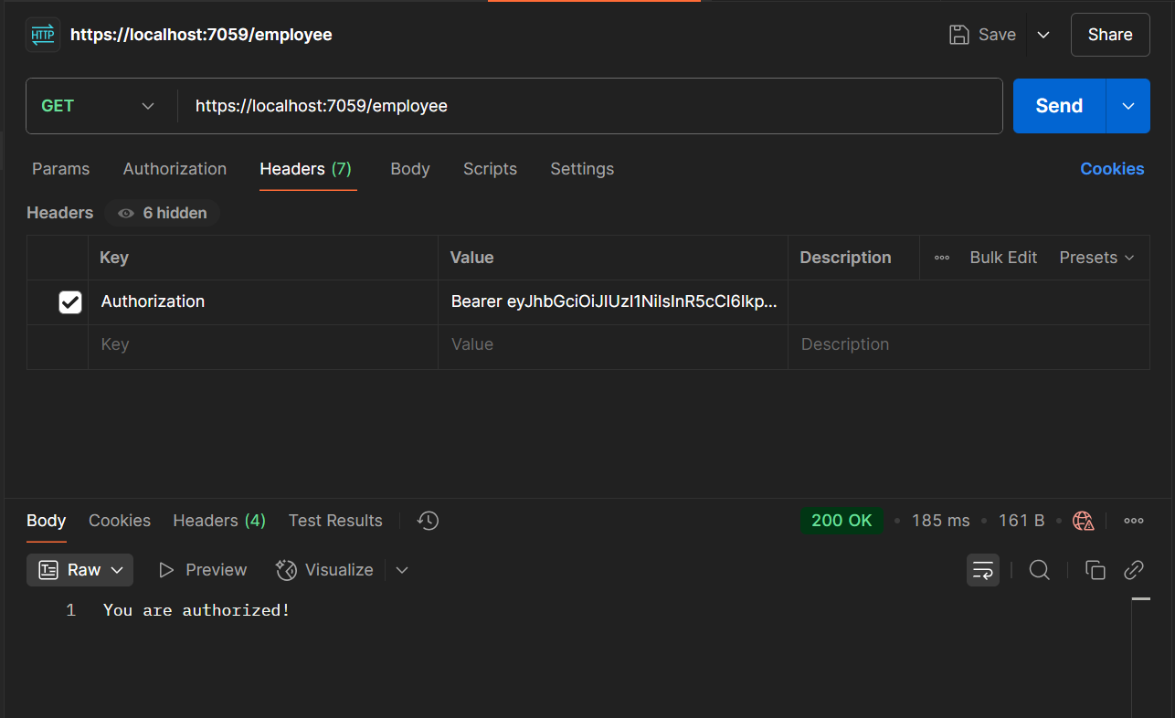

3. Check for JWT expiration :
AuthController.cs (Updated):
using Microsoft.AspNetCore.Authorization;
using Microsoft.AspNetCore.Mvc;
using Microsoft.IdentityModel.Tokens;
using System.IdentityModel.Tokens.Jwt;
using System.Security.Claims;
using System.Text;
namespace JwtCorsDemo.Controllers
{
[ApiController]
[Route("[controller]")]
[AllowAnonymous]
public class AuthController : ControllerBase
{
[HttpGet("token")]
public IActionResult GetToken()
{
var token = GenerateJSONWebToken(1, "Admin");
return Ok(new { token });
}
private string GenerateJSONWebToken(int userId, string userRole)
{
var securityKey = new SymmetricSecurityKey(Encoding.UTF8.GetBytes("mysuperdupersecretkeythatismorethan32chars!"));
var credentials = new SigningCredentials(securityKey, SecurityAlgorithms.HmacSha256);
var claims = new List<Claim>
{
new Claim(ClaimTypes.Role, userRole),
new Claim("UserId", userId.ToString())
};
var token = new JwtSecurityToken(
issuer: "mySystem",
audience: "myUsers",
claims: claims,
expires: DateTime.Now.AddMinutes(2), // Change to 2 for testing expiration
signingCredentials: credentials);
return new JwtSecurityTokenHandler().WriteToken(token);
}
}
}

OUTPUT (POSTMAN) :
GET : auth/token
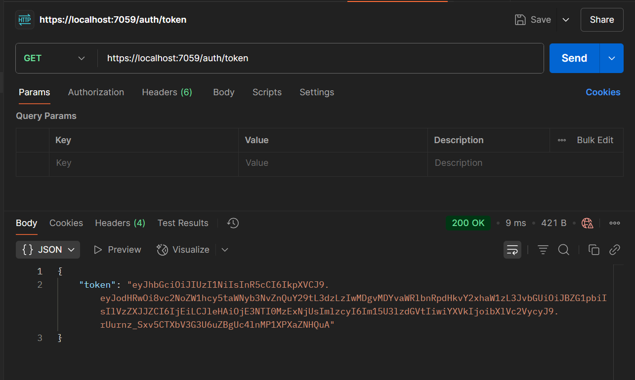
GET : employee :
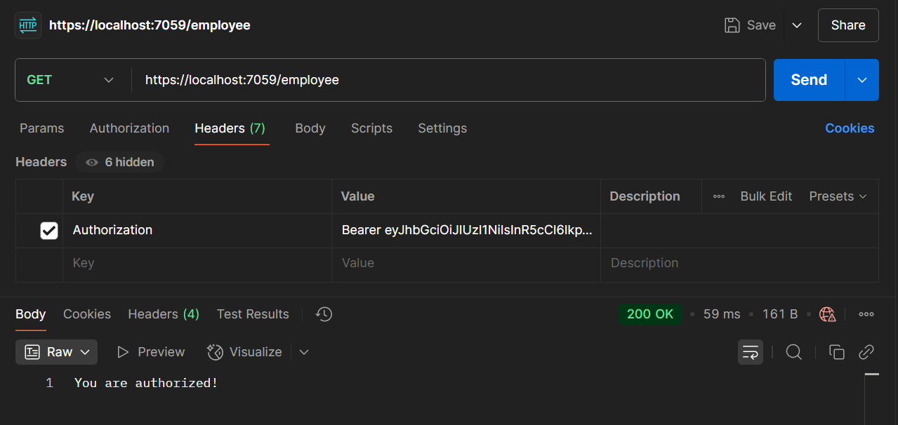

After 2 minutes :
GET : employee :
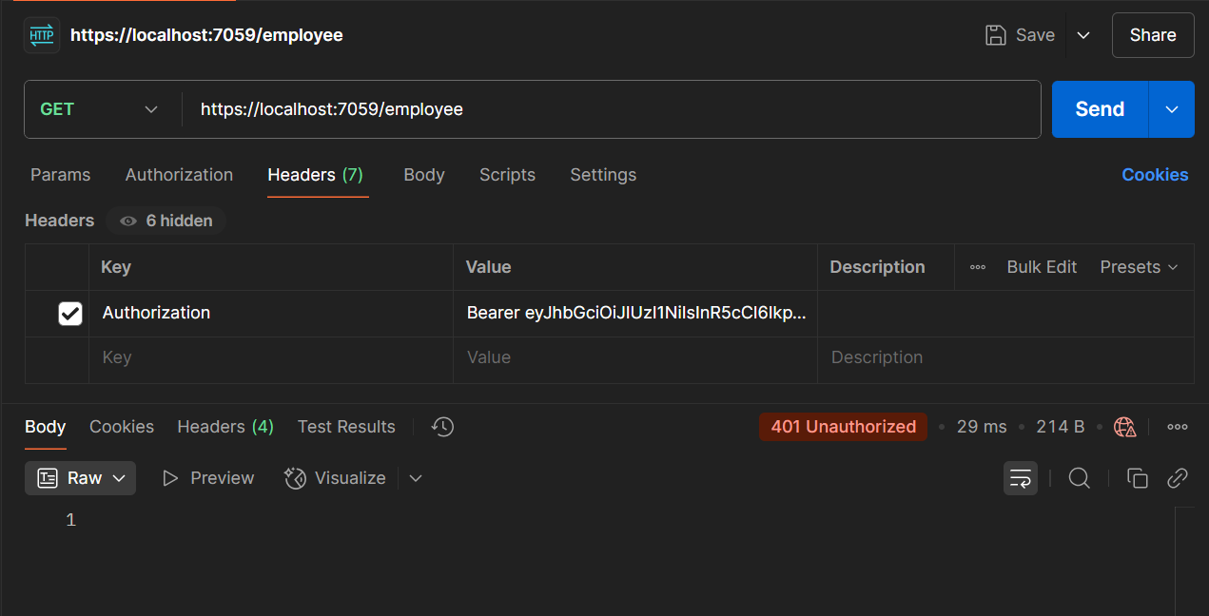
4. Add the roles to be authorized in the Authorize attribute.
EmployeeControIler.cs (updated):
using Microsoft.AspNetCore.Authorization;
using Microsoft.AspNetCore.Mvc;
namespace JwtCorsDemo.Controllers
{
[ApiController]
[Route("[controller]")]
[Authorize(Roles = "POC")] // Only users with Admin or POC roles can access
public class EmployeeController : ControllerBase
{
[HttpGet]
public IActionResult Get()
{
return Ok("You are authorized!");
}
}
}
OUTPUT (POSTMAN) :
GET : auth/token :
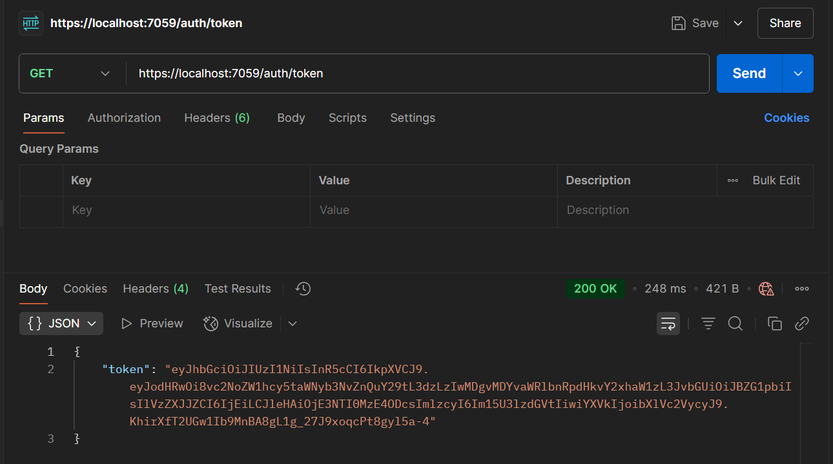
GET : employee :
