Game Design Document

Fill up the following document

1. Write the title of your project.

Make your own game-1

1. What is the goal of the game?

Pinocchio has to reach his house.

1. Write a brief story of your game.

Pinocchio is the main character in the game and he has to reach his

House. There are many obstacles on his way to home. He has only 2

Lives so, if he is eaten up by goblins so he is going to die. In order to

increase his strength to fight against the goblins, he has to catch rubies and if he catches 10 rubies out of 15 he will be promoted to the next level but the first level still continues untill you are eaten up by the goblin. There is also a speed booster in between of the game to increase its speed. But if the Pinocchio is eaten 1 time by the goblin then he would die and loose all the rubies and he has to start from where he died. And if again the Pinocchio is eaten up by the goblin then he would loose his lives, rubies and will have to start his game again from the very beginning. If he earns more than 15 rubies in his game then he’s going to get one extra life in the next level.

1. Which are the playing characters of this game?

* Playing characters are the ones who respond to the user based on the input from the user.
* Cars, monkeys, dinos, wizards, etc., are the playing characters in the game.

|  |  |  |
| --- | --- | --- |
| Number | Character Name | What can this character do? |
| 1 | Pinocchio | Walk, run, jump, slide |
| 2 | Goblins in level 1 | Eat Pinocchio, walk, throw knives |
| 3 | Goblins in level 2 | Eat Pinocchio,walk, run, throw knives |
| 4 | Goblins in level 3 | Eat Pinocchio,walk, run, throw knives, throw nets to stop Pinocchio |
| 5 | Goblins in level 4 | Eat Pinocchio,walk, run, throw knives, throw nets to stop Pinocchio, throw orbs to kill pinocchio and would send him directly to the starting of the game. |
| 6 |  |  |
| 7 |  |  |
| 8 |  |  |

1. Which are the Non-Playing Characters of this game?

* Non-Playing characters are the ones that don't have an action or behavior when the user interacts with the game.
* Hurdles, stones, bananas, coins, etc., are non-playing characters in the game.

|  |  |  |
| --- | --- | --- |
| Number | Character Name | What can this character do? |
| 1 | rubies | Give life to Pinocchio |
| 2 | Speed booster | Increse the speed of Pinocchio |
| 3 | trees | To give food to pinocchio |
| 4 | rocks | Can decrease the size of the Pinocchio |
| 5 |  |  |
| 6 |  |  |
| 7 |  |  |
| 8 |  |  |

Draw your imagination of this game. What does this game look like?

* Draw the game either on your computer or on paper.
* Add images of the game scenes to show each of the playing and non-playing characters at least once.

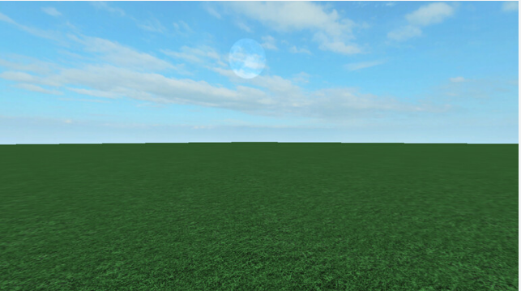

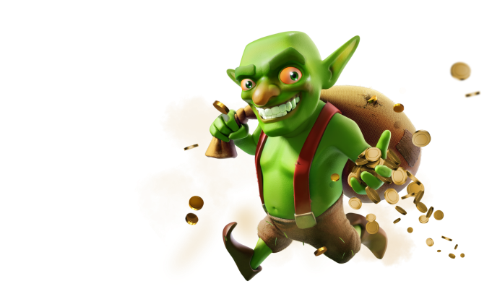

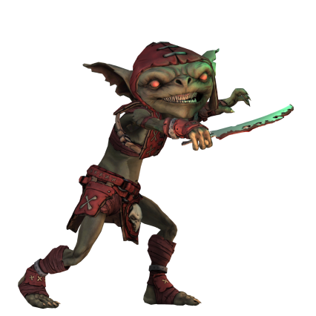

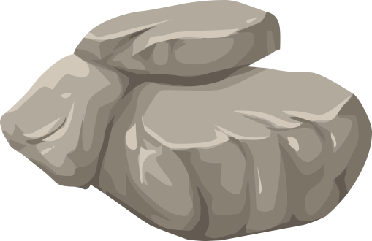  
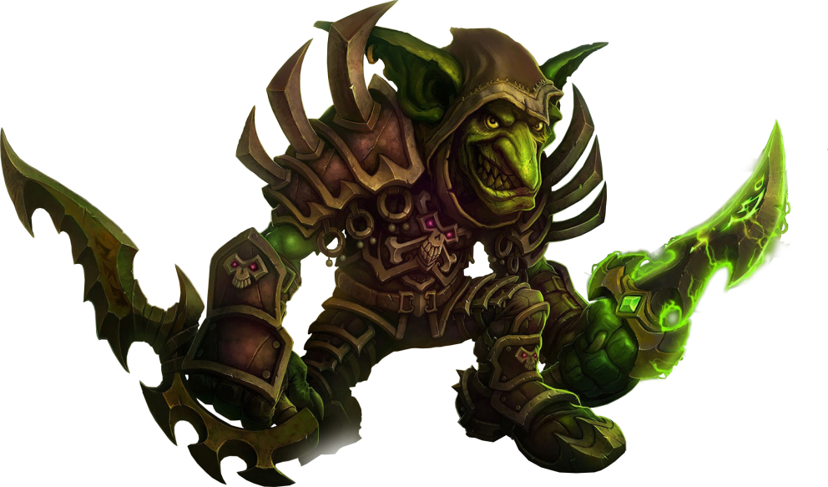

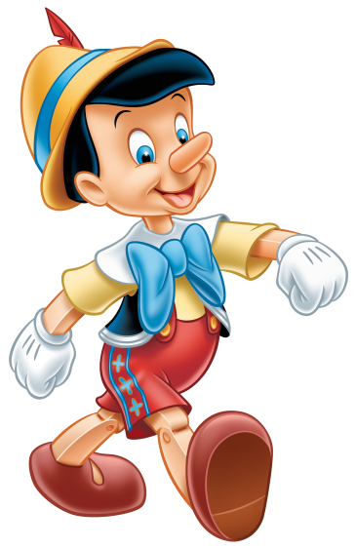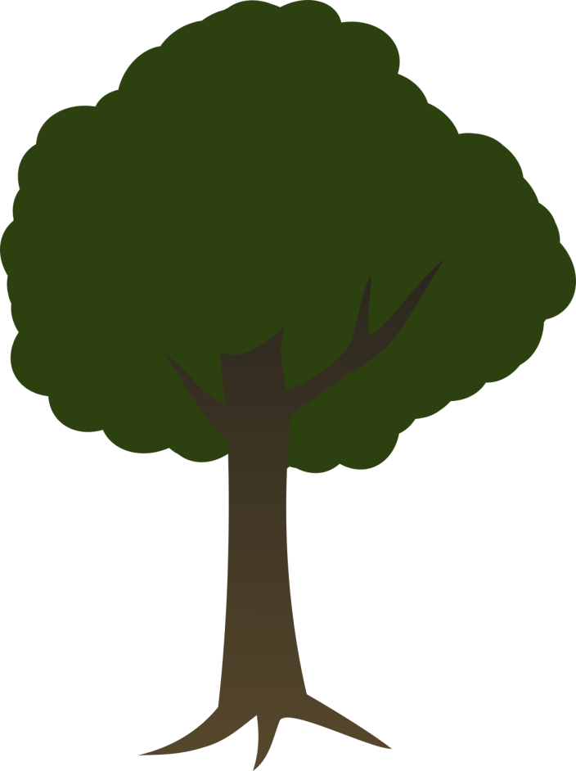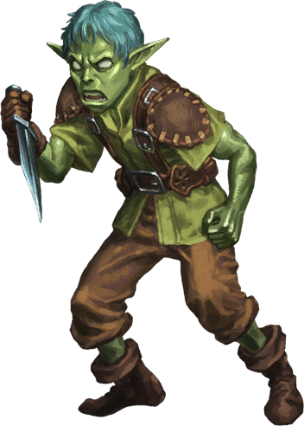

How do you plan to make your game engaging?

* + - 1. We’ll give them rubies to collect and a life.
      2. Provide different scenarios.
      3. Each scenario will have 4 levels.
      4. They’ll have a speed booster in each level.
      5. Different situations in each scenarios.
      6. Dofferent locations for each scenario.
      7. The goblin’s size will increase after each level so as to increase the difficulty of the game.