Operations Management - Retail Inventory Stockout

Report
1. PROBLEM STATEMENT :
Retail stores often struggle to balance inventory — sometimes they run out of stock, and sometimes they store too much.
Both problems cause losses:
- Stockouts → customers don’t get what they want → lost sales
- Overstocking → too much inventory → high carrying cost
- Poor forecasting → wrong purchase decisions
- Pricing & promotions affect demand but retailers don’t track it properly
So the main problem is:
Retailers do not have a clear and easy way to monitor inventory, demand, stockouts, or product performance.
This project aims to solve that problem by creating a Tableau dashboard that shows:
- How much inventory is available
- When stockouts happen
- How demand changes over time
- Which SKUs perform well
- How pricing, discounts, and competition affect sales
- Important KPIs like lost sales, stockout cost, turnover, DIOH, fill rate
This helps the retailer:
- Reduce stockouts
- Reduce extra stock
- Improve forecasting
- Understand customer demand
- Make better inventory decisions every day
2. INTRODUCTION
Retail inventory management is a critical component that impacts product availability, customer satisfaction, and business profitability. High-demand products going out of stock lead to lost sales, while excess inventory increases holding costs.
This project focuses on building a comprehensive Tableau dashboard using the “Retail Store Inventory Forecasting Dataset” from Kaggle. The dashboard provides powerful insights related to:
• Inventory trends
• Demand forecasting
• Stockout patterns
• SKU performance
• Pricing & promotion impact
• Lost sales and stockout cost analysis
The objective is to create a decision-support system that helps retailers optimize their daily operations and reduce financial loss.

3. DATASET OVERVIEW
Dataset: Retail Store Inventory Forecasting Dataset
Source: Kaggle
Link: https://www.kaggle.com/datasets/anirudhchauhan/retail-store-inventory-forecasting-dataset
The dataset contains 180,000+ rows and includes multi-store, multi-SKU daily records. Key fields include:
• Date
• Store
• SKU
• Inventory Level
• Demand
• Units Sold
• Units Ordered
• Replenishment Quantity
• Discount Applied
• Holiday/Promotion Indicator
• Competitor Pricing
• Price

This dataset is suitable for:
• Time-series forecasting
• Stockout detection
• Retail sales analytics
• Category/SKU-level performance analysis
• Pricing strategy evaluation

4. PROJECT OBJECTIVES
The goals of this project include:
  - Identify stockouts and their impact
  - Measure lost sales and calculate stockout cost
  - Analyze demand vs available inventory
  - Evaluate replenishment efficiency
  - Forecast demand using the dataset
  - Compare pricing with competitors
  - Analyze the effect of promotions and discounts
  - Evaluate SKU performance across stores
  - Track operational KPIs such as fill rate, turnover, DIOH, carrying cost, etc.

5. METHODOLOGY
5.1 Data Import
• The CSV dataset was loaded directly into Tableau.
• Data types were corrected (Dates → Date, Inventory → Integer).
• Null values were identified and handled where required.

5.2 Data Cleaning
• Renamed ambiguous column names
• Removed invalid entries
• Standardized SKU/store identifiers

5.3 Creation of Calculated Fields
We created custom metrics inside Tableau to enable deeper insights:
    - Stockout Flag
    - Stockout Count
    - Stockout Cost
    - Lost Sales
    - Fill Rate
    - Inventory Turnover
    - Inventory Carrying Cost
    - SKU Value
    - DIOH (Days Inventory on Hand)
    - Units Sold – Units Ordered difference
    - Demand Forecast
    - Competitor Pricing Impact
    - Holiday/Promotion Sales Boost
    - COF (Cost of Failure)
    - Discount Impact
5.4 Worksheets

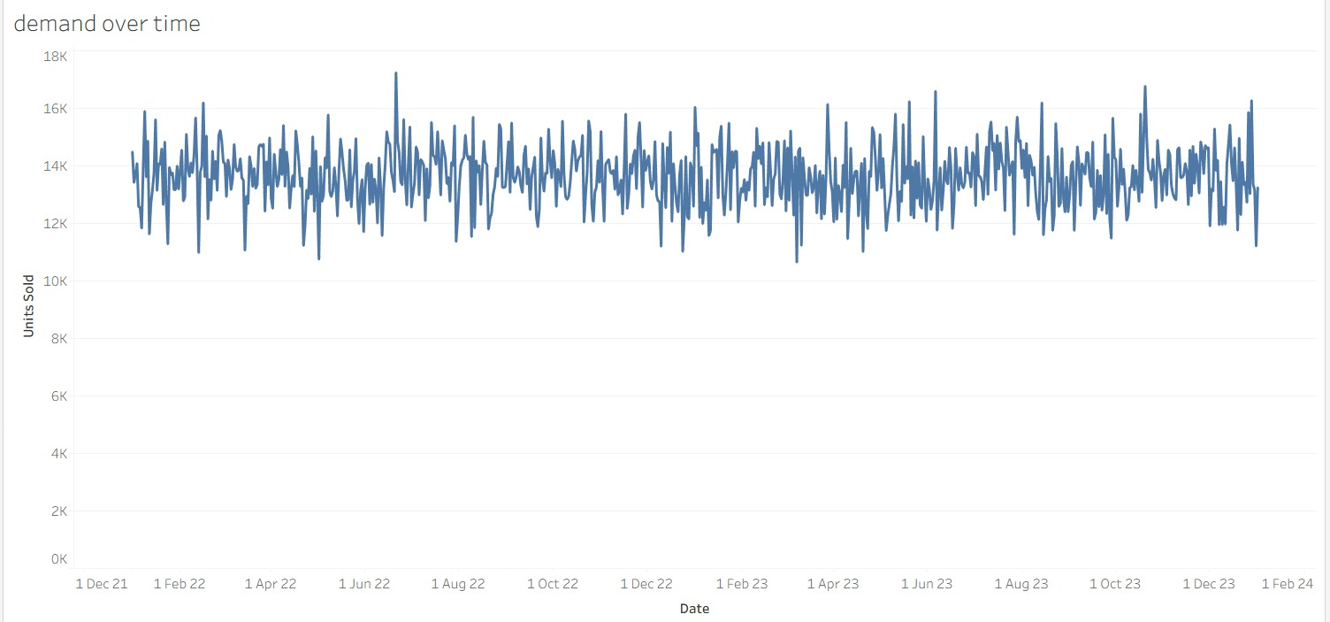
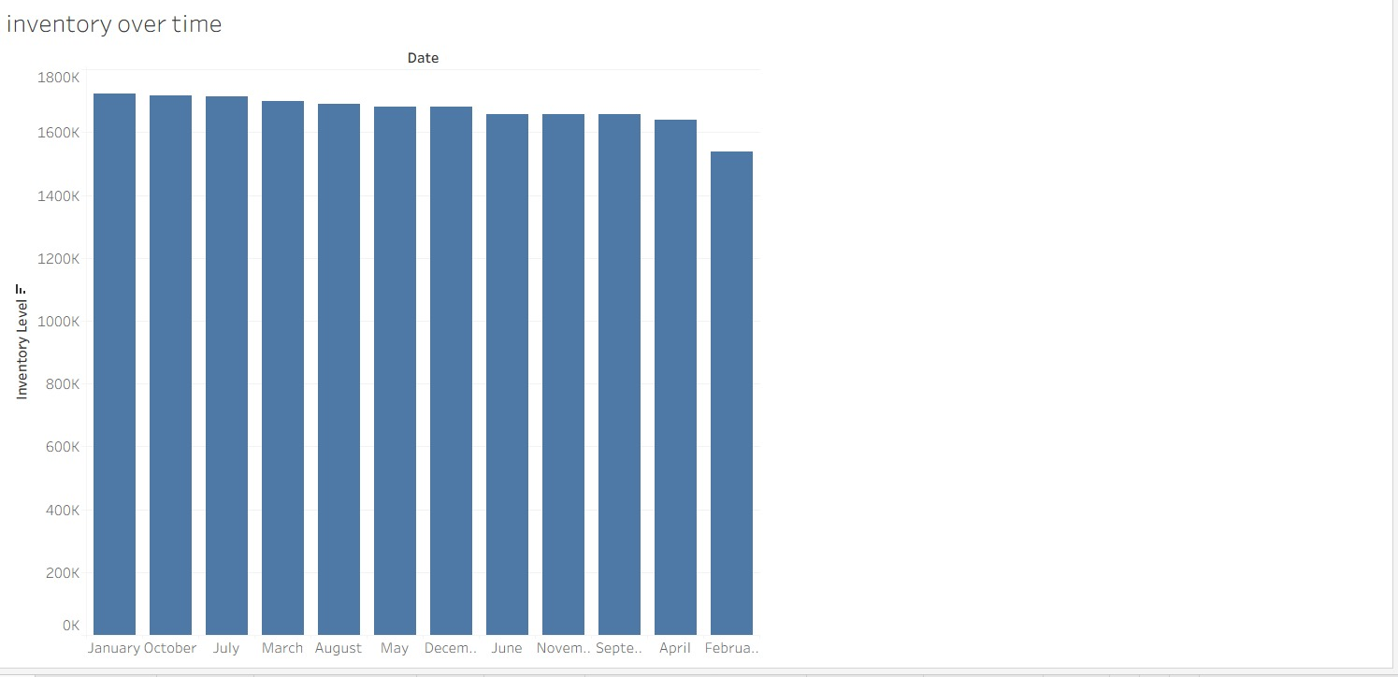

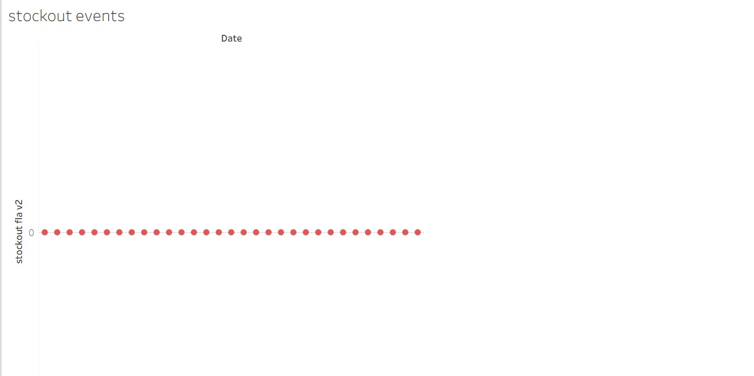

5.5 Dashboard Development
Using Tableau, we built dashboard, each with filters, highlights, parameters, and tooltips for interactive analysis.

6. DASHBOARD

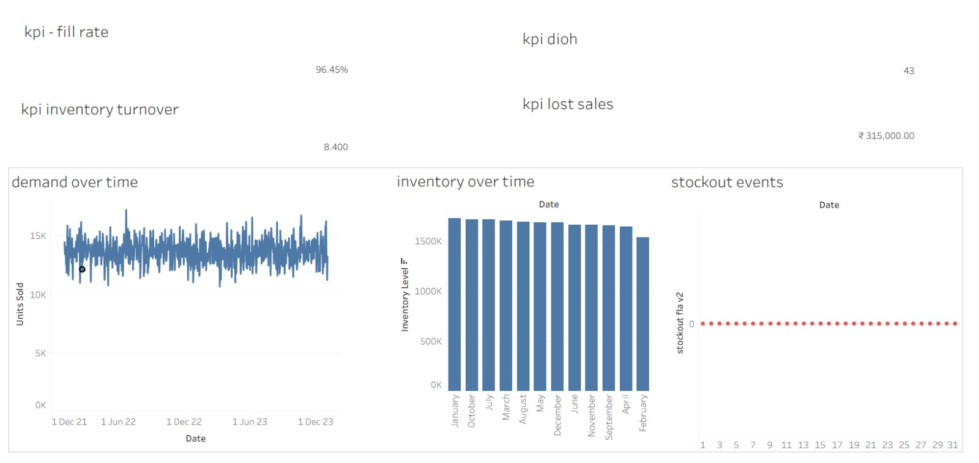

At the top, our KPI summary shows a 96.45% fill rate, which means almost all customer demand is being fulfilled.
Our inventory turnover is 8.4, indicating good efficiency in stock movement.
Days Inventory on Hand is 43 days, meaning our current stock levels are sufficient for around six weeks of demand.
We also estimate ₹3.15 lakhs in lost sales this year due to stockouts, which highlights opportunities to optimize reorder points and safety stock.

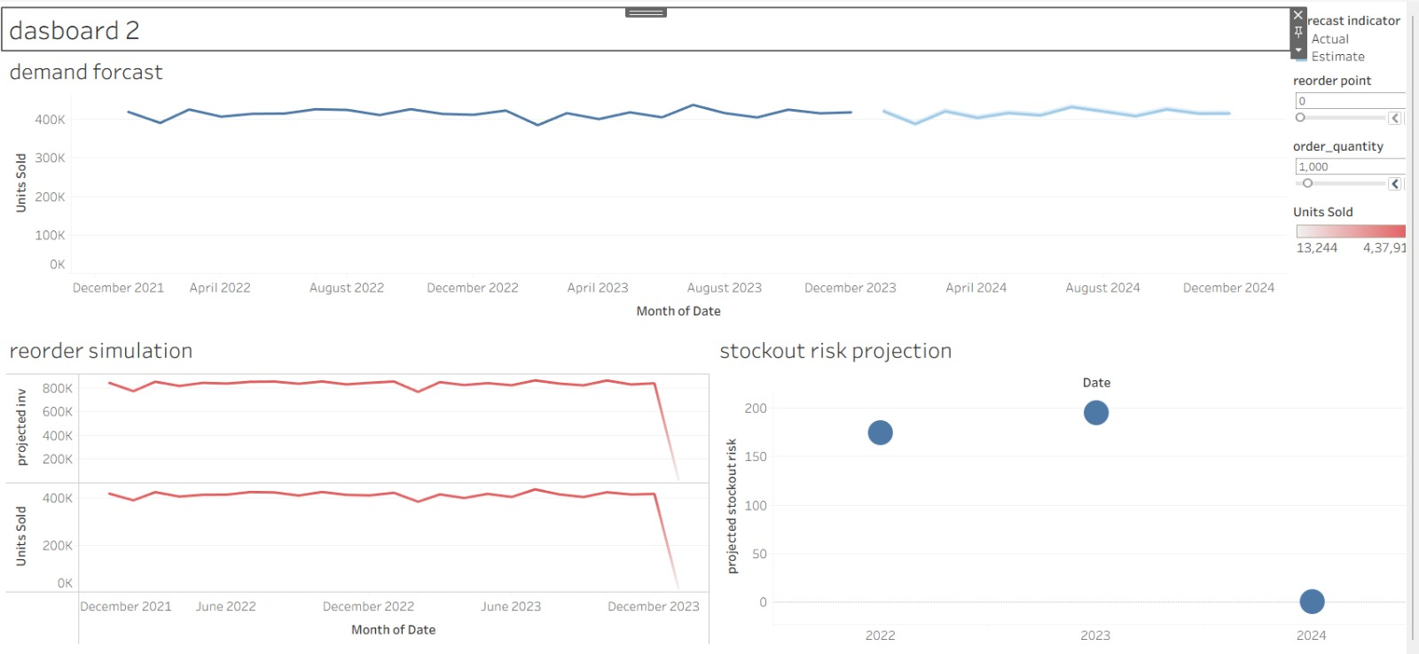

This dashboard helps forecast future demand and optimize inventory decisions.
The top chart shows the demand forecast generated from historical sales data.
On the right, the user can adjust the Reorder Point and Order Quantity using interactive sliders.
When these values change, the Reorder Simulation below dynamically updates to show how inventory will behave in the future.
Finally, the Stockout Risk Projection identifies periods where stockouts may occur based on the selected reorder strategy.
This helps managers choose the best inventory policy and avoid lost sales.

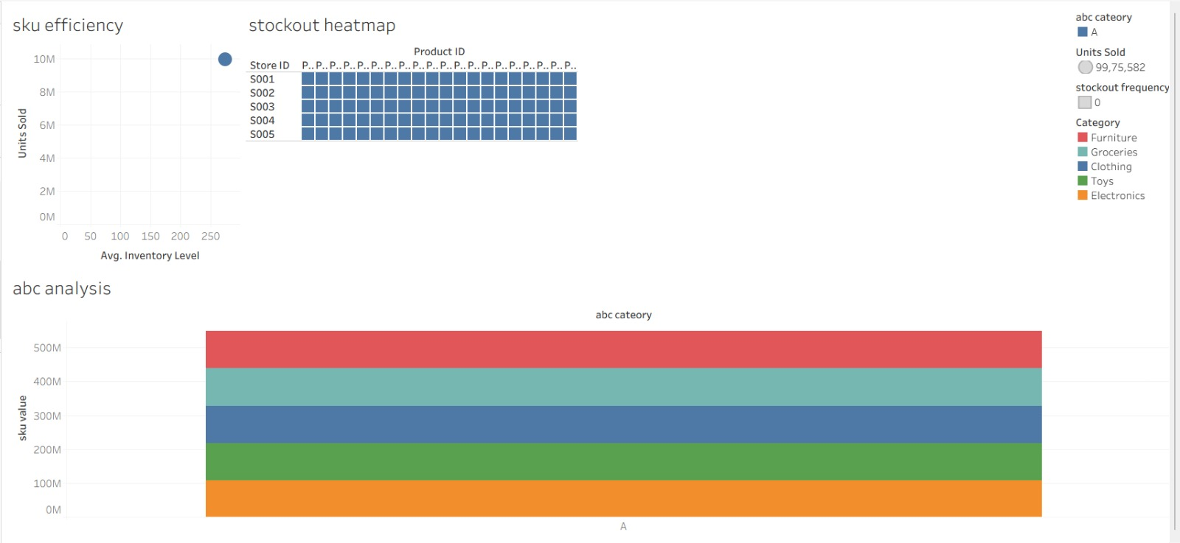

Dashboard 3 focuses on SKU-level inventory optimization.
The scatter plot shows SKU efficiency by comparing units sold with average inventory.
The stockout heatmap highlights which SKUs experience stockouts across stores.
The ABC analysis helps categorize SKUs based on their value contribution, enabling better prioritization for replenishment decisions.
Together, these visuals allow managers to identify which products are overstocked, which ones are at risk of stockouts, and which items drive the most value.

7. CONCLUSION
This Tableau project successfully visualizes and analyzes retail inventory performance using real-world data. The insights generated from the dashboards can help retailers:
• Reduce stockouts & minimize lost sales
• Improve replenishment planning
• Forecast demand more effectively
• Optimize pricing & promotions
• Identify high-value SKUs to prioritize
• Improve overall supply chain efficiency
This system can be integrated into retail operations for everyday decision-making.

8. TEAM DETAILS
Team-Z
1. Smruthi Chandrashekar ENG23AM0281
2. Shreya S Rao ENG23AM0278
3. Maanya G V ENG23AM0041
4. Vandana Kumari Meena ENG23AM0291

9. REFERENCES
• Kaggle Retail Inventory Forecasting Dataset
• Tableau Documentation (Official)

