1. Getting the artist with the highest renumeration for every band



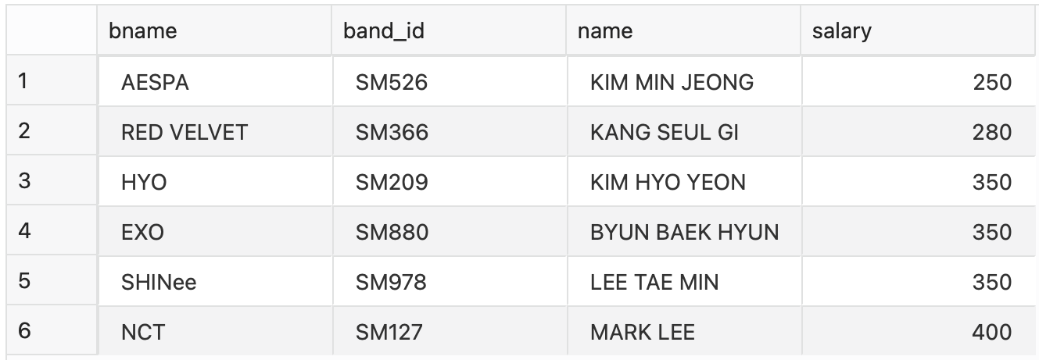

1. a. Top 3 bands by no. of records sold

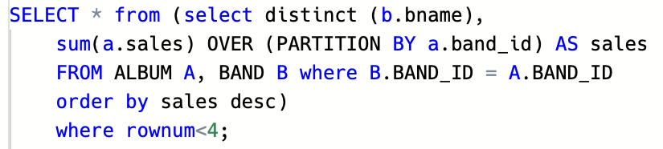

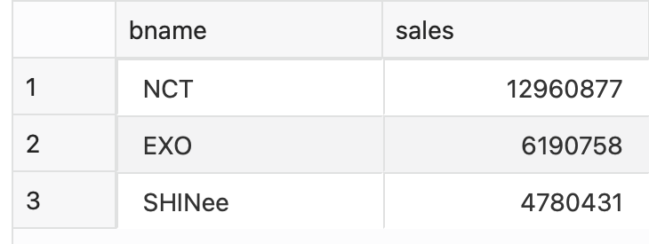

b. Top 3 bands by value of records sold

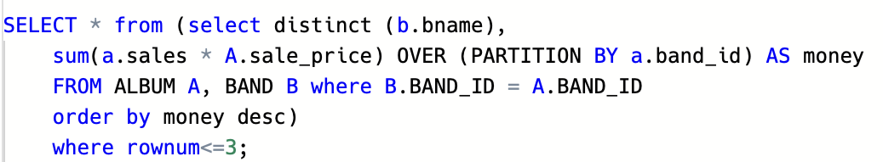

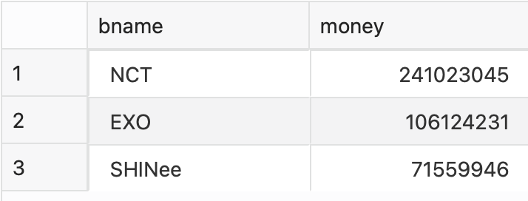

1. Getting the total duration for every album, for every band.

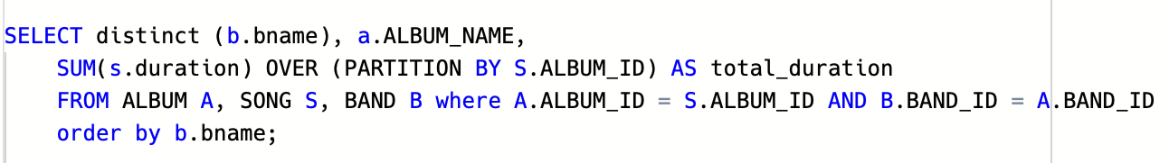

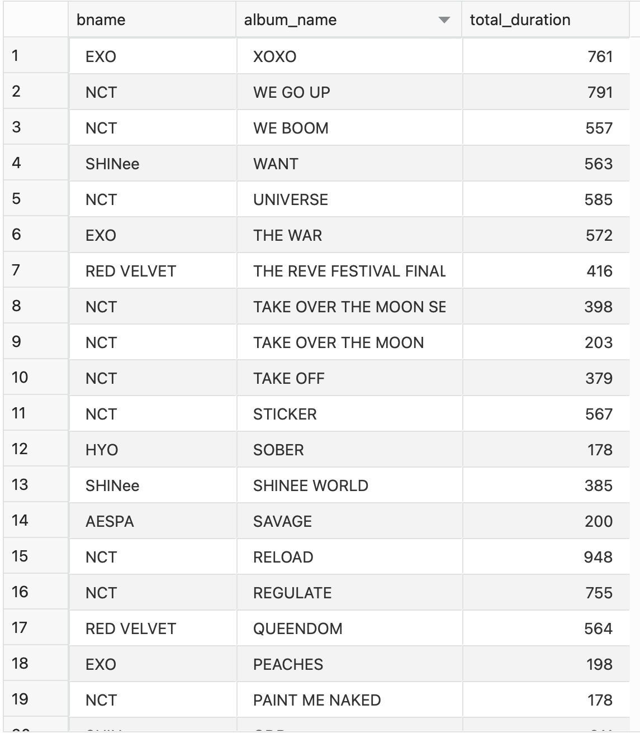

1. Getting the band if any debuted in the past 1 year

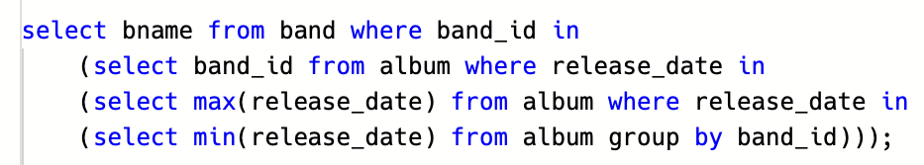

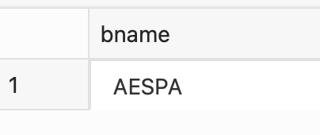

1. Getting the latest album released, no. of records sold and the value of records sold so far, for every group.

