PSG COLLEGE OF TECHNOLOGY, COIMBATORE – 641 004
Department of Applied Mathematics and Computational Sciences
M Sc SOFTWARE SYSTEMS – Semester IV
20XW48 – Web Designing Lab
PROBLEM SHEET 1 – HTML Basic Tags

Start Date: 23.12.2021 Complete Date: 30.12.2021

- Write HTML code to develop a web page having the background in red and title as “My First Page”.

<html>
<head>
<title> My First Page </title>
</head>
<body bgcolor = red>
<h1>My First Page</h1>
</body>
</html>
- Print the numbers 1 - 10, each number being a different color.
<html>
<head>
<title> q2 </title>
</head>
<body>
<p>
<font color = blue> 1 </font><br>
<font color = green> 2 </font><br>
<font color = orange> 3 </font><br>
<font color = cyan> 4 </font><br>
<font color = pink> 5 </font><br>
<font color = gray> 6 </font><br>
<font color = magenta> 7 </font><br>
<font color = purple> 8 </font><br>
9 <br>
<font color = red> 10 </font>
</p>
</body>
</html>
- Create a HTML document giving details of your name, age, mobile no, address & enrollment no. aligned in proper order?
<html>
<head>
<title> q3 </title>
</head>
<body>
<p align = "right"> Name: Maanasa S <br> Age: 19 </p>
<p align = "center">Mobile No: 98409 26975<br>Address: Peelamedu</p>
<p>Roll no: 20PW19</p>
</body>
</html>

- Write a HTML code to print your name with different heading style.
<html>
<head>
<title> q4 </title>
</head>
<body>
<h1> <font color = "blue"> MAC </font></h1>
<h2> <font color = "blue"> MAC </font></h2>
<h3> <font color = "blue"> MAC </font></h3>
<h4> <font color = "blue"> MAC </font></h4>
<h5> <font color = "blue"> MAC </font></h5>
<h6> <font color = "blue"> MAC </font></h6>
</body>
</html>
- Print a paragraph that is a description of a book, include the title of the book as well as its author. Names and titles should be underlined, adjectives should be italicized and bolded.
<html>
<head>
<title> q5 </title>
</head>
<body>
<h1><u> Percy Jackson </u></h1>
<h2> By: <u>Rick Riordan </u></h2>
<p>
A book about a boy named <u>Percy Jackson</u> who is a <i><b>demi-god, hald god and half human</b></i>.<br>The series is of 5 books describing the adventures he goes through to save the world from the <i><b>wrath</b></i> of gods' enemies. </p>
</body>
</html>
- Print a paragraph with 4 - 5 sentences. Each sentence should be in a different font.
<html>
<head>
<title> q6 </title>
</head>
<body>
<p> <font face = 'calibri'>Quantum physics underlies how atoms work, and so why chemistry and biology work as they do. You, me and the gatepost – at</font> <br> <font face = 'times new roman'> some level at least, we’re all dancing to the quantum tune. If you want to explain how electrons move through a computer chip, </font><br> <font face = 'arial'> how photons of light get turned to electrical current in a solar panel or amplify themselves in a laser, </font> <br> <font face = 'copperplate'>or even just how the sun keeps burning, you’ll need to use quantum physics. </font><br> </p>
</body>
</html>
- Design a page having background color, given text color red and use all the attributes of font tag.
<html>
<head>
<title> q7 </title>
</head>
<body bgcolor = 'black'>
<p> <font color = 'red' size = '72' face = 'arial'> HI </font></p>
</body>
</html>
- Print the squares of the numbers 1 - 20. Each number should be on a separate line, next to it the number 2 superscripted, an equal sign and the result. (Example: 10² = 100)
<html>
<body>
<p>
1<sup>2</sup> = 1 <br>
2<sup>2</sup> = 4 <br>
3<sup>2</sup> = 9 <br>
4<sup>2</sup> = 16 <br>
5<sup>2</sup> = 25 <br>
6<sup>2</sup> = 36 <br>
7<sup>2</sup> = 49 <br>
8<sup>2</sup> = 64 <br>
9<sup>2</sup> = 81 <br>
10<sup>2</sup> = 100 <br>
11<sup>2</sup> = 121 <br>
12<sup>2</sup> = 144 <br>
13<sup>2</sup> = 169 <br>
14<sup>2</sup> = 196 <br>
15<sup>2</sup> = 225 <br>
16<sup>2</sup> = 256 <br>
17<sup>2</sup> = 289 <br>
18<sup>2</sup> = 324 <br>
19<sup>2</sup> = 361 <br>
20<sup>2</sup> = 400 <br>
</p>
</body>
</html>
- Prints 10 names with a line break between each name. The list should be alphabetized, and to do this place a subscripted number next to each name based on where it will go in the alphabetized list. (Example: Alan₁). Print first, the unalphabetized list with a subscript number next to each name, then the alphabetized list. Both lists should have an <h1> level heading.
<html>
<body>
<ul>
<h1>Unalphabetised List</h1>
<li>Chan<sub>1</sub></li>
<li>Lee Know<sub>9</sub></li>
<li>Changbin<sub>2</sub></li>
<li>Hyunjin<sub>6</sub></li>
<li>Han Jisung<sub>5</sub></li>
<li>Felix<sub>4</sub></li>
<li>Seungmin<sub>10</sub></li>
<li>Jeongin<sub>7</sub></li>
<li>Kkami<sub>8</sub></li>
<li>Dori<sub>3</sub></li>
</ul>
<h1>Alphabetised List</h1>
<p>
Chan<br>Changbin<br>Dori<br>Felix<br>Han Jisung<br>Hyunjin<br>
Jeongin<br>Kkami<br>Lee Know<br>Seungmin
</p>
</body>
</html>
- Print two paragraphs that are both indented using the &nbsp; command.
<html>
<body>
<p> &nbsp &nbsp Lemurs are primates found exclusively in the isolated island of
Madagascar.<br> Lemurs are primates just like apes and monkeys, but they
evolved independently and are unique. </p>
<p> &nbspThe numbers of lemurs are dwindling due to poaching and other destructive human activities. Lemurs
are worth more than $2 Trillion.<br> In fact, no amount of money can ever buy one.
So, protect lemurs! </p>
</body> </html>
- Print two lists with any information you want. One list should be an ordered list, the other list should be an unordered list.
<html>
<body>
<ol>
<h3> Percy Jackson Books: </h3>
<li> The Sword Thief </li>
<li> Sea of Monsters </li>
<li> Titan's Curse </li>
<li> Battle of Labyrinth </li>
<li> The Last Olympian </li>
</ol>

<ul>
<h3> John Green Books: </h3>
<li> Looking for Alaska </li>
<li> Turtles All the Way Down </li>
<li> Let it Snow </li>
<li> Paper Towns </li>
<li> Fault in our stars </li>
</ul>
</body>
</html>
- Create a HTML document containing three ordered lists: ice cream, soft serve and frozen yogurt. Each ordered list should contain a nested, unordered list of your favorite flavors. Provide a minimum of three flavors in each unordered list.
<html>
<body>
<ol>
<li> Ice cream: <ul>
<li> Vanilla </li>
<li> Butterscotch </li>
<li> Chocolate </li>
<li> Strawberry </li>
</ul> </li>
<li> Soft serve: <ul>
<li> Vanilla </li>
<li> Dark Chocolate Dip</li>
<li> Chocolate </li>
<li> Strawberry </li>
</ul> </li>
<li> Frozen Yogurt: <ul>
<li> Mango </li>
<li> Lychee </li>
<li> Orange </li>
<li> Strawberry </li>
</ul> </li>
</ol>
</body>
</html>
- Prints an h1 level heading followed by a horizontal line whose width is 100%. Below the horizontal line print a paragraph relating to the text in the heading.
<html>
<body>
<h1 align = center> Harry Potter </h1>
<hr width = 100%>
<p align = center> Harry Potter, a series of stories of a guy named Harry Potter who turns out to be a wizard and goes for adventures handling all the <br> muggles or the humnas who don't know magic.
His friends Hermoine Granger and Ron Weasley accompany him for the various adventures.</p>
</body>
</html>

- Print some preformatted text of your choosing. (hint: use the <pre> tag)
<html>
<body>
<pre>
*****
***
*
</pre>
</body>
</html>
- Print a long quote and a short quote. Cite the author of each quote.
<html>
<body>
<p><q>Love all, trust a few, do wrong to none</q> - Shakespeare, All's well that ends well. </p>
<p><blockquote>Be not afraid of greatness. Some are born great, some achieve greatness, and others have greatness thrust upon them.</blockquote> - Shakespeare, Twelfth Night</p>
</body>
</html>
- Print some deleted and inserted text of your choosing.
<html>
<body>
<p> My favourite band in Day6 </p>
<p>My favourite band is <del>Day6</del> <ins>Xtraordinary Heroes</ins></p>
</body>
</html>
- Print a definition list with 5 items.
<html>
<body>
<dl>
<dt>Percy Jackson and the Lightning Thief </dt>
<dd>Zeus's sword is missing and accused Percy Jackson to having stolen it. Percy Jackson goes on a mission to find at return it to Zeus.</dd>
<dt>Percy Jackson and the Sea of Monsters </dt>
<dd>Percy Jackson helps his dad Poseidon to fight the monsters invading the sea and to protect his father's powers.</dd>
<dt>Percy Jackson and the Titan's Curse </dt>
<dd>Percy Jackson faces the curse of Titan in order to the protect the Olympus.</dd>
<dt>Percy Jackson and the Battle of Labyrinth </dt>
<dd>Percy Jackson finds himself a lot of enemies who want to destroy him, him beingthe son of the big three.</dd>
<dt>Percy Jackson and the Last Olympian </dt>
<dd>Percy Jackson being the son who would either destroy Olympus or destroy it, he finds himself on various adventures.</dd>
</dl>
</body>
</html>
- Print two addresses in the same format used on the front of envelopes (senders address in top left corner, receivers address in the center).

<html>
<body>
<address> From: Maanasa <br> Duraisamy Layout <br> Peelamedu <br> Coimbatore - 641004 </address><br><br>
<center><address>To: Sherlin <br> Balaji Nagar <br> Kalapatti <br> Coimbatore - 641048 </center></adress>
</body>
</html>

- Print ten acronyms and abbreviations of your choosing, each separated by two lines. Specify the data that the abbreviations and acronyms represent.
<html>
<body>
<abbr title = "Literature">Lit.</abbr><br><br>
<abbr title = "Example">Ex.</abbr><br><br>
<abbr title = "Miss">Ms.</abbr><br><br>
<acronym title = "WHO">World Health Organisation</acronym><br><br>
<acronym title = "BTS">BangTan Sonyeondan</acronym><br><br>
<acronym title = "NCT">Neo Culture Technology</acronym><br><br>
<acronym title = "MOA">Moments Of Alwaysness</acronym><br><br>
<acronym title = "LAN">Local Area Network</acronym><br><br>
<abbr title = "Stray Kids">SKZ</abbr><br><br>
<abbr title = "Enhypen">EN-</abbr><br><br>
</body>
</html>
- Write a HTML code to create a web page of blue color and display links in red color.
<html>
<body bgcolor="Blue">
<p>Want to Learn Something Today? Try these:</p>
<li><a href = "https://www.w3schools.com/python/"><font color = 'Red'>Python Programming</font></a></li>
<li><a href = "https://www.programiz.com/c-programming"><font color = 'Red'>C Programming</font></a></li>
<li><a href = "https://www.w3schools.com/CPP/default.asp"><font color = 'Red'>C++ Programming</font></a></li>
</body>
</html>

- Create some links to various search engines (google, yahoo, altavista, lycos, etc).
<html>
<body>
<li><a href = "https://www.google.com"><font color = 'Cyan'>Google</font></a></li>
<li><a href = "https://www.yahoo.com"><font color = 'Cyan'>Yahoo!</font></a></li>
<li><a href = "https://www.bing.com"><font color = 'Cyan'>Bing!</font></a></li>
<li><a href = "https://www.altavista.com"><font color = 'Cyan'>Altavista!</font></a></li>
<li><a href = "https://www.lycos.com"><font color = 'Cyan'>Lycos!</font></a></li>
</body>
</html>

- Create links to five different pages on five different websites that should all open in a new window.

<html>
<body>
<li><a href = "https://www.instagram.com" target = "_blank">Instagram</a></li>
<li><a href = "https://www.facebook.com" target = "_blank">Facebook</a></li>
<li><a href = "https://www.tumblr.com" target = "_blank">Tumblr</a></li>
<li><a href = "https://www.pinterest.com" target = "_blank">Pinterest</a></li>
<li><a href = "https://www.twitter.com" target = "_blank">Twitter</a></li>
</body>
</html>

- Create a page with a link at the top of it that when clicked will jump all the way to the bottom of the page. At the bottom of the page there should be a link to jump back to the top of the page.

<html>
<body>
<a name = "top">Top of the page</a>
<a href="#bottom">Jump to the bottom of the page</a>
<p>Hi</p>
<p>Hola</p>
<p>Bonjour</p>
<p>नमस्ते</p>
<p>வணக்கம்</p>
<p>こんにちは</p>
<p>안녕</p>
<p>Ciao</p>
<p>你好</p>
<br><br><br><br><br><br><br><br><br><br><br><br><br>
<br><br><br><br><br><br><br><br><br><br><br><br><br>
<br><br><br><br><br><br><br><br><br><br><br><br><br>
<br><br><br><br><br><br><br><br><br><br><br><br><br>
<a href = "#top">Jump to the top of the page</a>
<a name = "bottom">Bottom of the page</a>
</body>
</html>

- Design a web page to display five different images. Skip two lines between each image. Each image should have a title. Also, display each image that has a border of size 2, a width of 200, and a height of 200.

<html>
<body>
<img src = 'santa.jpg' width = '200' height = '200' alt = 'Santa' border = '2'><br>
<img src = 'ctree.jpg' width = '200' height = '200' alt = 'Christmas Tree' border = '2'><br>
<img src = 'gifts.jpg' width = '200' height = '200' alt = 'Gifts' border = '2'><br>
<img src = 'snow.jpg' width = '200' height = '200' alt = 'Snow' border = '2'><br>
<img src = 'cookies.jpg' width = '200' height = '200' alt = 'Cookies' border = '2'>
</body>
</html>

- Design a web page with two images, when the first image clicked will link to a search engine of your choice (should be opened in a new window) and when the second image clicked will link to itself and will display the image in the browser by itself.

<html>
<body>
<h3>Image 1:</h3>
<a href = "https://www.google.com" target = "_blank"><img src = "gifts.jpg"></a>
<br><br>
<h3>Image 2:</h3>
<a href = "ps1.html" target = "_blank"><img src = "snow.jpg"></a>
</body>
</html>
- Design a web page as shown below using text formatting elements and lists:
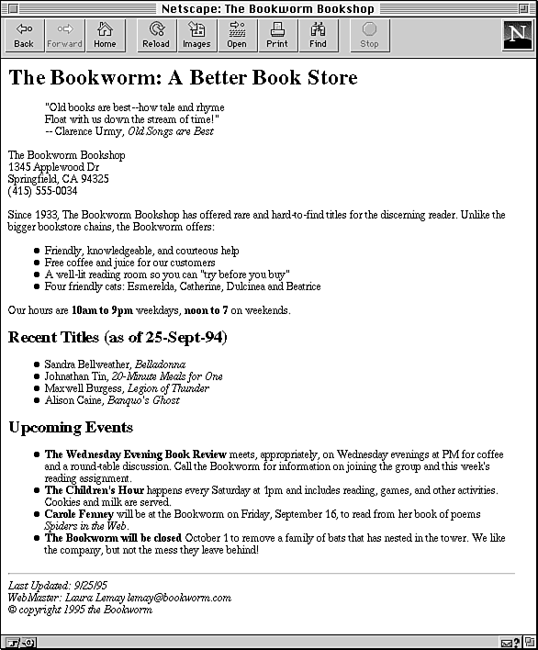

<html>
<body>
<h1>The Bookworm: A Better Book Store</h1>
<p align = "center"><blockquote>"Old books are best - how tale and rhyme
<br>Float with us down the stream if time!</blockquote>
</blockquote> --Clarence Urmy, Old Songs are Best</p>

<p>The Bookwrm Bookshop<br>1345, Applewood Dr<br>Springfield, CA 94325<br>
(415) 555-0034</p>

<p>Since 1933, The Bookworm.... </p>
<ul>
<li>Friendly, knowlegable and courteous help</li>
<li>Free coffee and juice for our customers</li>
<li>A well-lit reading room so you can "try before you buy"</li>
<li>Four friendly cats:</li>
</ul>
<p>Our hours are <b>10am to 9pm</b> weekdays, <b>noon to 7</b> on weekends</p>

<h1>Recent Titles (as of 25-Sept-94)</h1>
<ul>
<li>Sandra</li>
<li>Johnathan</li>
<li>Maxwell Burgress</li>
<li>Aluison Caine</li>
</ul>

<h1>Upcoming Events</h1>
<ul>
<li><b>The Wednesday Evening Book Review </b> meets</li>
<li><b>The Children's Hour</b> happens</li>
<li><b>Carole Fenny</b> will be at the Bookworkm on Friday</li>
<li><b>The Bookworm will be closed</b> October 1 to remove a family of bats</li>
</ul>
<hr>
<address>Last updated<br>Web Master: Laura Lemary lermay@bookworm.com<br>
Copyright 1995 the Bookworm</address>

</body>
</html>
- Design a web page as shown below using text formatting elements:
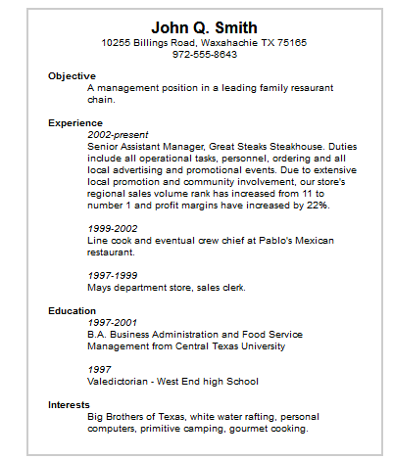

<html>
<body>
<center><h1>John Q. Smith</h1>
<p>10255 Billings Road, Waxahachie TX 75165<br>
972-555-8643</p></center>
<dl>
<dt><b>Objective</b></dt> <dd>A management position in a leading family restaurant chain</dd>
</dl>
<dl>
<dt><b>Experience</b></dt> <dd><i>2002-present</i><br>Senior Assisstabnt Manager
<br><br> <i>1999-2002</i><br>Line cook and eventual crew chief
<br><br><i>1997-1999</i><br>Mays departement store, sales clerk
</dd>
</dl>
<dl>
<dt><b>Education</b></dt> <dd>
<i>1997-2001<br></i>Business Administration..<br><br>
<i>1997</i><br> Valedictorian - West End high school
</dd>
</dl>
<dl>
<dt><b>Interest</b></dt> <dd>Big brothers od Texas</dd>
</dl>
</body>
</html>

- Design the below table using HTML with background image and also with real time data (atleast five records).
Train No. | Name of the Train | Place | Destination | Time |  | Fare
 |  |  |  | Arrival | Departure | Fare
….
….

<html>
<body>
<table border = '1' style = "table-layout:fixed; width:930px">
<colgroup>
<col style = "width: 79px">
<col style = "width: 141px">
<col style = "width: 124px">
<col style = "width: 94px">
<col style = "width: 99px">
<col style = "width: 190px">
<col style = "width: 203px">
</colgroup>

<thead>
<tr>
<th>Train</th>
<th>Name of the train</th>
<th>Place</th>
<th>Destination</th>
<th colspan="2">Time</th>
<th colspan="2">Fare</th>
</tr>
<tr>
<th colspan="4"></th>
<th>Arrival</th>
<th>Departure</th>
</tr>
</thead>
<tbody>
<tr>
<td>33742</td>
<td>Exp A</td>
<td>Chennai</td>
<td>Kanyakumnari</td>
<td>9:00</td>
<td>14:30</td>
<td>500</td>
</tr>

<tr>
<td>33284</td>
<td>Exp B</td>
<td>Chennai</td>
<td>Coimabtore</td>
<td>6:00</td>
<td>15:00</td>
<td>600</td>
</tr>

<tr>
<td>33287</td>
<td>Exp C</td>
<td>Chennai</td>
<td>Delhi</td>
<td>7:00</td>
<td>23:00</td>
<td>800</td>
</tr>

<tr>
<td>33874</td>
<td>Exp D</td>
<td>Chennai</td>
<td>Mumbai</td>
<td>7:00</td>
<td>17:00</td>
<td>980</td>
</tr>
<tr>
<td>33187</td>
<td>Exp E</td>
<td>Chennai</td>
<td>Bengaluru</td>
<td>9:00</td>
<td>20:00</td>
<td>750</td>
</tr>
</tbody>
</table>
</body>
</html>

- Write a HTML code to design a table filled with images in each cell.
1 | 2 | 3 | 4
5 | Image |  | 6
7 |  |  | 8
9 | 10 | 11 | 12

<html>
<head>
<meta charset="UTF-8">
<meta http-equiv="X-UA-Compatible" content="IE=edge">
<meta name="viewport" , initial-scale="4.0">
<title>Q29</title>;
</head>
<style>
img{
height: 100px;
width: 100%;
}

.center{
height: 200px;
}
</style>>
<body>

<table>
<tr>
<td><img src = 'img1.png' alt = 1></td>
<td><img src = 'img2.png' alt = 2></td>
<td><img src = 'img3.png' alt = 3></td>
<td><img src = 'img4.png' alt = 4></td>
</tr>
<tr>
<td><img src = 'img5.png' alt = 5></td>
<td rowspan = "2" colspan = "2"><img class = "center" src = 'img13.png' alt = 13></td>
<td><img src = 'img6.png' alt = 6></td>
</tr>
<tr>
<td><img src = 'img7.png' alt = 7></td>
<td><img src = 'img8.png' alt = 8></td>
</tr>
<tr>
<td><img src = 'img9.png' alt = 9></td>
<td><img src = 'img10.png' alt = 10></td>
<td><img src = 'img11.png' alt = 11></td>
<td><img src = 'img12.png' alt = 12></td>
</tr>
</table>

</body>
</html>

- Design the below table shows the seminar schedule
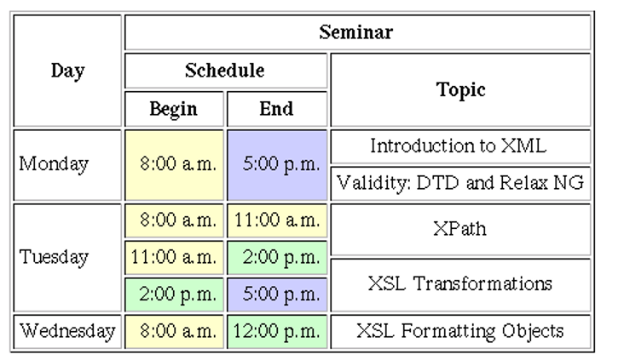
<html>
<body>
<table border = "1" cellpadding = "5" align = "center" height = "400" width = "700">
<tr>
<th rowspan="3"><font size "50px">Day</font></th>
<th colspan="3">Seminar</th>
<tr>
<th colspan="2">Schedule</th>
<th rowspan="2">Topic</th>
<tr>
<th>Begin</th>
<th>End</th>
</tr>
<tr>
<td rowspan = "2">Monday</td>
<td rowspan = "2" bgcolor="yellow">8:00am</td>
<td rowspan = "2" bgcolor="lavender">5:00pm</td>
<td>Introduction to XML</td>
<tr><td>Validity: DTD and Relax NG</td></tr>
</tr>
<tr>
<td rowspan = "3">Tuesday</td>
<td bgcolor="yellow">8:00am</td>
<td bgcolor="yellow">11:00am</td>
<td>XPath</td>
</tr>
<td bgcolor="yellow">11:00am</td>
<td bgcolor="lightgreen">2:00pm</td>
<td rowspan = "2">XSL Transformation</td>
<tr>
<td bgcolor="lightgreen">2:00pm</td>
<td bgcolor="lavender">5:00pm</td>
</tr>
<tr>
<td rowspan = "3">Wednesday</td>
<td bgcolor="yellow">8:00am</td>
<td bgcolor="lightgreen">12:00pm</td>
<td>XSL Formatting Objetcs</td>
</tr>
</table>
</body>
</html>

- Design a home with the contents shown below using Nested tables
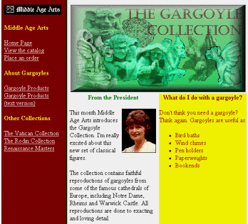

Web Resources:
- https://www.quackit.com/html/tutorial/introduction.cfm
- https://www.w3schools.com/html/
- https://www.tutorialspoint.com/html/
- http://htmldog.com/guides/html/

<html>
<body>
<table>
<tr>
<td rowspan="2" bgcolor="brown">
<img src="logo.jpg" alt="logo">
<h4><font color = "Yellow">Middle Age Arts</font></h4>
<a href="#"><font color = "White">HomePage</font></a><br>
<a href="#"><font color = "white">View the Catlog</font></a><br>
<a href="#"><font color = "white">Place an order</font></a><br>
<h4> <font color="yellow">About Gargoyles</font></h4>
<a href="#"><font color = "White">Gargoyle Products</font></a><br>
<a href="#"><font color = "White">Gargoyle Products</font></a><br>
<a href="#"><font color = "White">(text version)</font></a><br>
<h4> <font color="yellow">Other Collections</font></h4>
<a href="#"><font color = "White">The Vatican Collection</font></a><br>
<a href="#"><font color = "White">The Rodin Collection</font></a><br>
<a href="#"><font color = "White">Renaissance Masters</font></a><br>
</td>
<td colspan="2" style="height: 233px;">
<img height="100px" width="600px" src="coverr.jpg" alt="cover" />
</td> </tr> <tr>
<td width="200px">
<h4 align = 'center'><font color="green">From the President</font></h4>
<img src="p1" alt="photo" align = "right">
<p>This month Middle Age Arts introduces the Gargoyle Collection. I'm really excited about this new set of classical figures.</p>
<p>The collection contains faithful reproductions of gargoyles from some of the famous cathedrals of Europe, including Notre Dame, Rheims and Warwick Castle. All reproductions are done to exacting and loving detail.</p></td>
<td bgcolor="yellow" width="200px" align="top">
<h4 align="center"> <font color="brown" >What can you do with a gargoyle?</h4>
<p bgcolor="brown">
Don't think you need a gargoyle? Think again. Gargoyles are useful as:</p>
<ul bgcolor="brown">
<li>Bird baths</li>
<li>Wind chimes</li>
<li>Pen holders</li>
<li>Paperweights</li>
<li>Bookends</li>
</ul>
</td>
</tr>
</table>
</body>
</html>

