Modul Pendaftaran Siswa Baru Kelase (Kelase’s New Student Registration Module)

1. Alur Proses (Process Flow)
   1. Klik menu Daftar di menu Utama halaman depan Lembaga. Selanjutnya tampil halaman Informasi pendaftaran dengan tombol Daftar di dalamnya.

(Click the list menu, on the main menu which appears on the front page of the institution. After that, The Regsitration Information where there is “Daftar” Button in it)

* 1. Kemudian Isi formulir pendaftaran (then fill the registration form)
  2. Cetak/Kirimke Email kartupendaftaran yang telah di-generate (Print/send to Email a registration card that has been generated)
  3. Pendaftar menyerahkan persyaratan-persyaratan secara offline dengan menyertakan kartu pendaftaran kepada petugas di sekolah (Registrants submit requirements offline by including a registration card to officers at the school) (Applicants then submit the offline registration card included with the officer at the school)
  4. Pendaftar akan menerima informasi hasil penerimaan via Email atau dapat melihat di halaman Lembaga (Registrants will receive the results information by Email or can see on the Institute page) (Applicants will receive the acceptance of the results information via Email or can be viewed on the Intitution page)

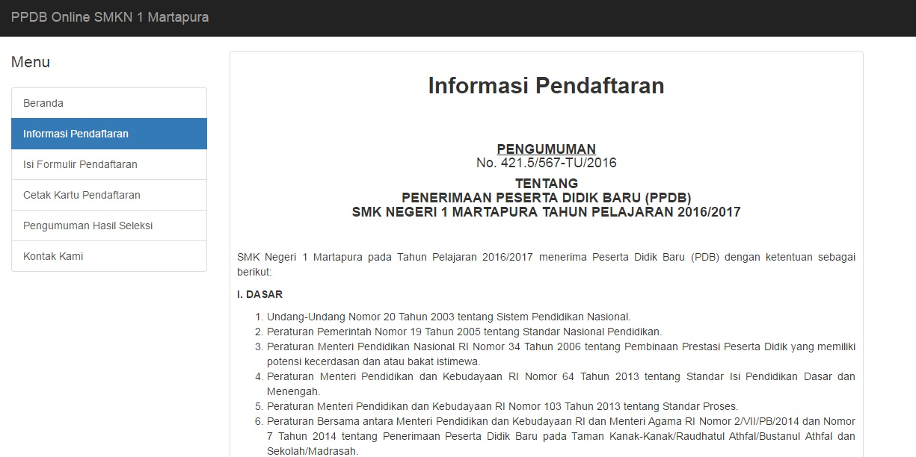

1. FormulirPendaftaran (registration form)

Berikut adalah isi dari formulir pendaftaran peserta didik baru. (This is the content of the registration form for new students)

**I. Data Pribadi Siswa (Student’s personal data)**

* 1. Nomor Induk Siswa Nasional (NISN)**(Mandatory)**
  2. Nomor Ujian/SKHUN**(Mandatory) (Exam Number/ SKHUN)**
  3. Nama Lengkap**(Mandatory) (Full Name)**
  4. Tempat Lahir**(Mandatory) (place of birth)**
  5. Tanggal Lahir**(Mandatory) (date of birth)**
  6. Jenis Kelamin**(Mandatory) (gender)**
  7. Golongan Darah (A/AB/B/O/TidakTahu) (blood type)
  8. Tinggi Badan (Height)
  9. Berat Badan (Weight)
  10. Agama **(Mandatory) (religion)**
  11. Alamat Rumah/Tempat Tinggal**(Mandatory) (Address)**
  12. Kode Pos (ZIP code)
  13. Kabupaten/Kota**(Mandatory) (district)**
  14. Provinsi**(Mandatory) (Province)**
  15. NomorTelp/HP**(Mandatory) (phone (mobile, etc))**
  16. Alamat Email (TidakWajib) (email address)
  17. Foto**(Mandatory) (photo)**

**II. Data SekolahAsal**

1. Nama Sekolah Asal **(Mandatory) (School Name)**
2. Alamat Sekolah**(Mandatory) (School Address)**
3. Nomor Telepon Sekolah (Phone’s school) (phone of school)
4. Tahun Lulus**(Mandatory) (Graduation Year)**

**III. Pilihan Program Pendidikan (Dapat Diaktifkan/ Di-nonaktifkan - Optional) – Daftar dan Jumlah Pilihan dapat diatur (The choice of educational Program (can be enabled/disabled-Optional)-list and number of options can be set)**

1. Pilihan 1 (option 1)
2. Pilihan 2 (option 2)

**IV. Data Orang Tua**

1. Nama Ayah**(Mandatory) (father name)**
2. Nama Ibu**(Mandatory) (mother name)**
3. Alamat Tempat Tinggal**(Mandatory) (address)**
4. No Telp/HP**(Mandatory) (phone)**
5. Penghasilan Rata-Rata Per-Bulan (Rp) (mounthly income)

**V. Data Wali**

1. Nama Wali (Guardian’s Name)

2. Alamat Wali (Address)

3. Penghasilan Rata-Rata per Bulan (Rp) (mounthly income)

4. NomorTelp/HP (phone)

**VI. Data Nilai (Jumlah Mata PelajarandapatDiatur)**

1. Nama Mata Pelajaran 1 (Subject 1)
2. Nama Mata Pelajaran 2 (Subject 2)
3. Nama Mata Pelajaran 3 (Subject 3)
4. Nama Mata Pelajaran 4 (Subject 4)

**VII. Pernyataan Kebenaran Data (The Truth Of Data Statement)**

1. Checklist (Radio Button) dan keterangan “Saya setuju dan menyatakan bahwa data yang saya masukkan adalah benar dan dapat dipertanggungjawabkan.” (Mark (Radio Buttons) on and statement "I agree and declare that data I have entered is true and can be accountable”)(Checklist (Radio buttons) and statement "I agree and declare that data I have entered is true and can be accountable)
2. Kartu Pendaftaran (registration card)

Ketika formulir pendaftaran telah dikirim maka akan tampil informasi sebagai berikut :

(When the registration form has been sent, it will appear the following information)

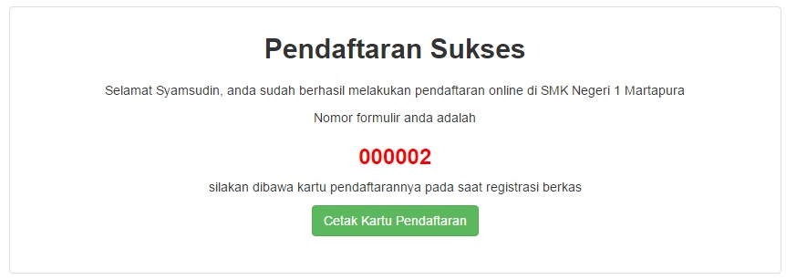

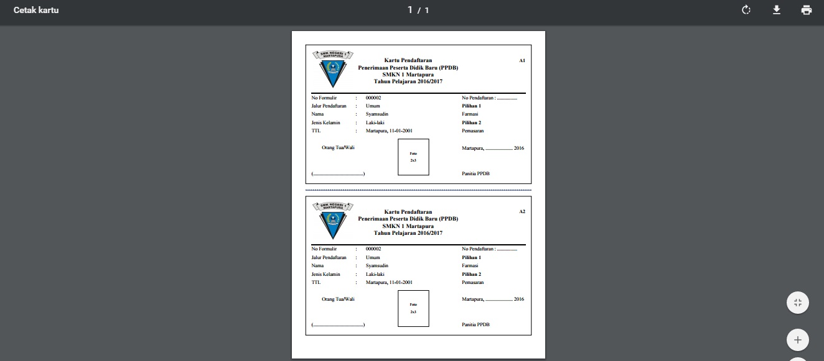

Selanjutnya calon peserta didik menyerahkan kartu pendaftaran dengan dilengkapi berkas-berkas pendaftaran kepada panitia PPDB di sekolah. (Then,

prospective students submit a registration card accompanied by a registration file to the PPDB committee at the school) (The next prospective students submit a registration card with the registration files to the PPDB Committee at the school)

1. **Halaman Pengumuman Penerimaan (Admission Announcement Page)**

Halaman pengumuman akan berisi daftar peserta didik yang diterima (ditampilkan pada saat opsi ditampilkan diaktifkan) (The announcement page will list the accepted students (It’ll show when display option is activated) (Announcement page will contain a list of students who have accepted (the page will be shown at the time the option shown has been enabled))

