**Finance Tracker - Requirements**

**Introduction**

The Finance Tracker application is designed to help individuals efficiently manage their personal finances. The app provides essential tools such as expense tracking, budgeting, financial insights, and custom categories to monitor income and spending. By offering a user-friendly and secure platform, the application aims to simplify financial management, enabling users to make informed financial decisions and maintain financial stability.

**Purpose**

The purpose of the Finance Tracker application is to provide users with a convenient and efficient tool to track their expenses, set budgets, and gain insights into their financial habits. It will enable users to:

* Monitor their income and expenses in an organised manner.
* Set and track monthly budgets to control their spending.
* Receive insights and visual reports on spending patterns and savings.
* Synchronise financial data across multiple devices.
* Convert currencies to facilitate financial management while travelling or making international transactions.

**Scope**

The Finance Tracker application will include:

* Expense logging with predefined and custom categories.
* Budget tracking with real-time monitoring and alerts.
* Financial analytics through graphs, charts, and reports.
* Multi-device synchronisation to ensure seamless access to financial data.
* Multi-language support to accommodate a global audience.
* Advanced security measures to protect sensitive financial information.

**Key Features**

**Must-Have Features**

* The application will allow users to log, categorise, and manage their expenses. They will be able to add, edit, and delete expenses, view expenses categorised by date and type, and filter and sort transactions based on user preferences.
* Users will have the ability to set and adjust monthly budgets. They will also be able to track their spending in real-time and receive alerts when they approach or exceed their budget limits.
* The app will provide users with detailed financial reports and visual breakdowns of their spending habits. It will offer graphical representations of spending patterns and a comparison of monthly expenses to monitor financial trends.
* To assist users who engage in international transactions or travel abroad, the app will include a real-time currency converter.
* All financial data will be securely stored in the cloud, allowing users to access their information from multiple devices.
* To protect sensitive financial information, the app will include multi-factor authentication for login and AES-256 encryption for securing stored financial data.

**Should-Have Features**

* The application will allow users to set up and manage recurring payments, such as monthly rent payments and subscription-based services.
* Users will have the option to export financial reports in CSV or PDF format for offline use or sharing with financial advisors.
* The application will offer support for multiple languages, including English, Arabic, and French, to ensure accessibility for a diverse user base.

**Could-Have Features**

* Users will be able to define personal savings goals and monitor their progress over time.
* The app may include features to help users track their investments, such as stocks, bonds, and real estate.
* Artificial Intelligence could be integrated to provide trend analysis, predictive financial planning, and personalised recommendations.

**Target Audience**

The Finance Tracker app is designed to cater to a broad audience, including individuals who want to track their personal expenses and budgets, families who need to manage shared household expenses, small business owners who want to monitor both business and personal finances, and financial advisors who require financial insights to assist clients with financial planning.

**User Research**

User research has indicated that users prefer a simple and clear interface for financial management. Real-time insights are essential for tracking finances effectively. Budget tracking and alerts should be customisable to suit individual needs.

**Personas**

The following user personas represent the key users of the application:

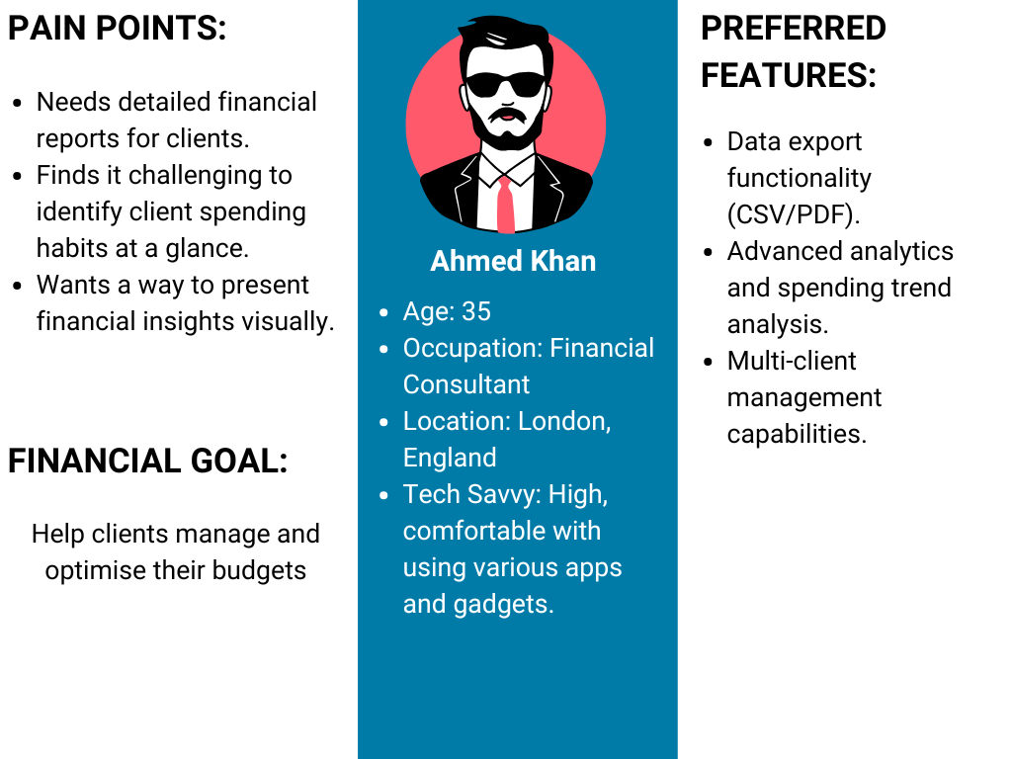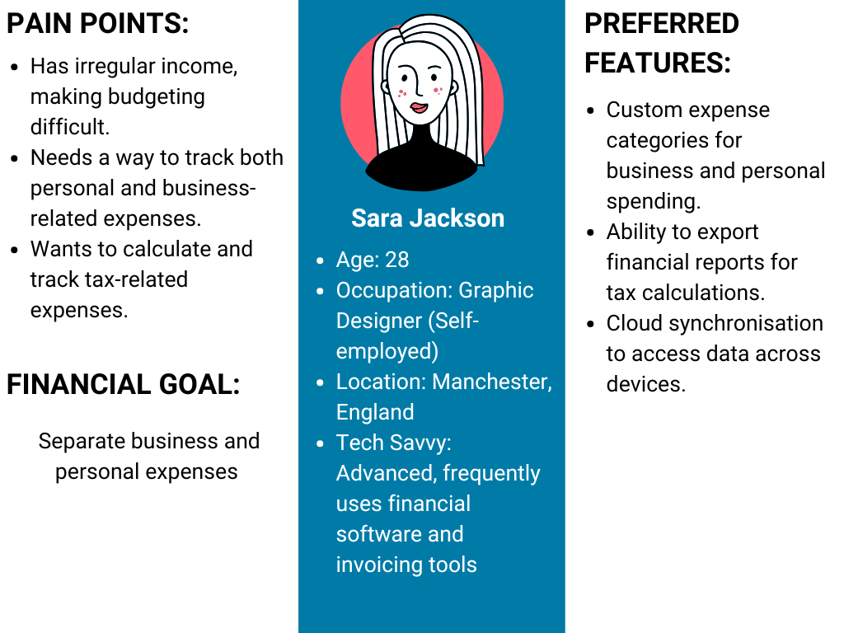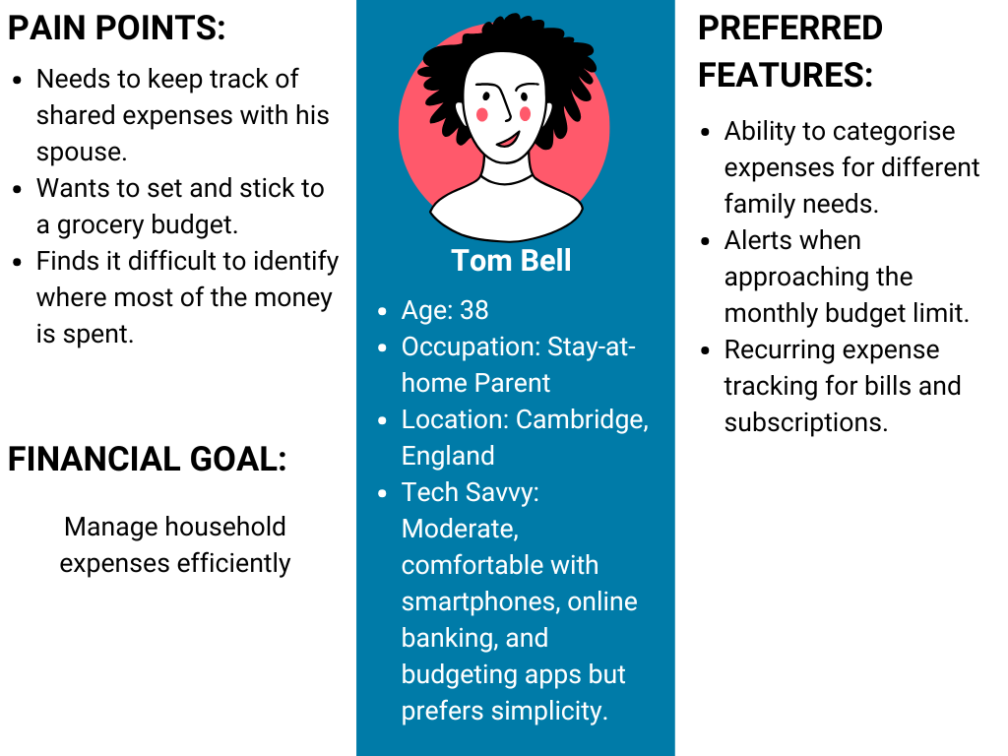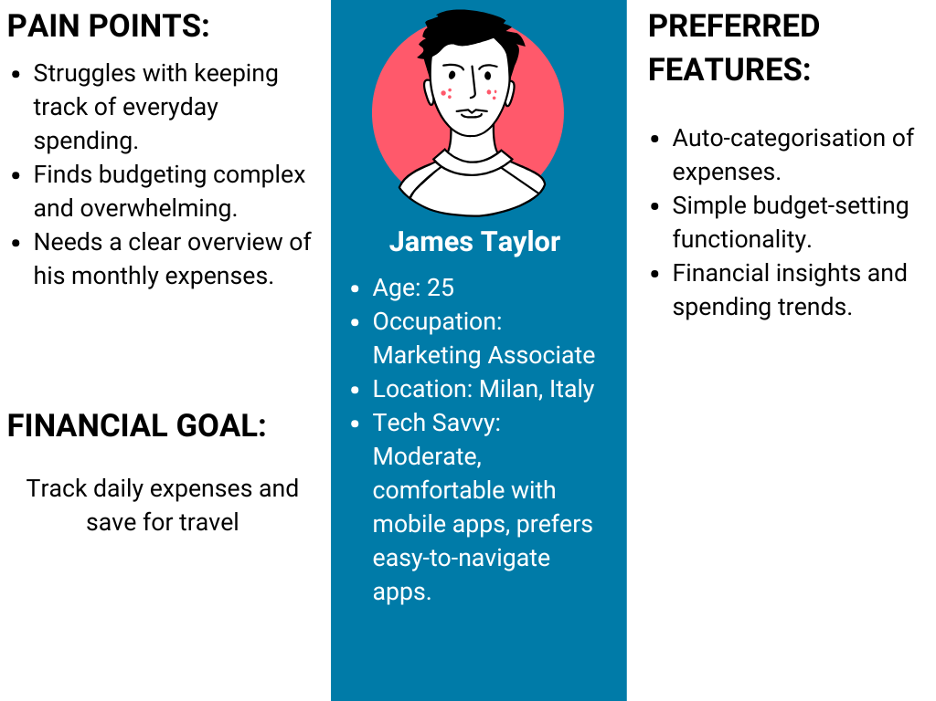

**Functional Requirements**

**Core Functionalities**

* Users will be able to add, edit, and delete expenses. The application will allow expenses to be filtered by category and date.
* Users will be able to set and track monthly budgets. Alerts will notify users if they exceed their allocated budget.
* The app will generate detailed expense breakdowns. Insights will be provided using graphs and charts.
* All financial data will be securely backed up and accessible across multiple devices.
* Multi-factor authentication will be used to enhance login security. Financial data will be encrypted to prevent unauthorised access.
* Users will receive reminder alerts for upcoming bills. Budget threshold notifications will be sent to help users manage their spending.

**Non-Functional Requirements**

* **System Performance:** Key actions, such as logging expenses, should complete within one second. The system should be capable of supporting up to one million concurrent users.
* **Security:** The system will use AES-256 encryption to protect financial data. Multi-factor authentication will enhance security during login.
* **Availability:** The system should ensure 99.9% uptime to guarantee uninterrupted access.
* **Reliability:** Automated backups will prevent data loss. An offline mode will be available for limited use when an internet connection is unavailable.
* **Accessibility:** The application will comply with WCAG accessibility standards. Multi-language support will be included for international users.

