# MVP Journey – LinkedIn Post Draft

Over the past weeks, I have taken the Legal PDF Summarizer from concept to a fully deployed MVP on Streamlit Cloud, with extensive local and cloud performance testing.  
  
Key takeaways:  
• Local performance with large (5MB+) PDFs initially suggested the need for chunking logic, but real-world cloud performance proved fast even without chunking.  
• The slowdown was a local-environment glitch, likely tied to API rate limits, local Python runtime performance, or transient connectivity 'blips'.  
• The multi-file mode now supports a table-based side-by-side comparison, a key feature for law firms.  
• Ready for targeted outreach to managing partners, lawyers, and legal tech decision-makers.  
  
#LegalTech #LawFirm #AI #LegalInnovation #ManagingPartner

## Visual MVP Pipeline (Simple)

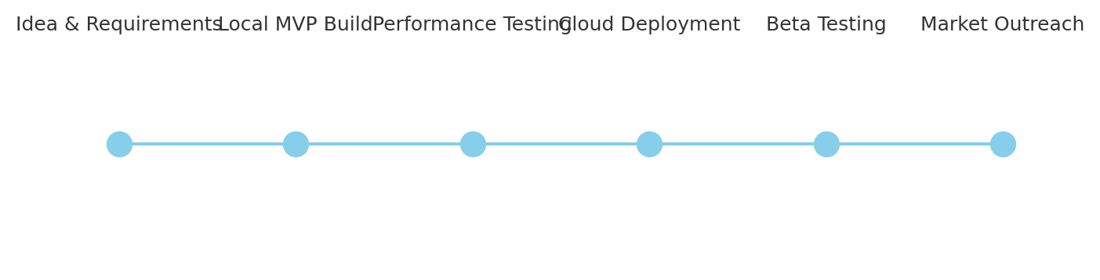

## Visual MVP Pipeline (Detailed)

