# REAL ESTATE EVALUATOR – Wireframe Design

Prepared for: Masoud Arouni  
Date: 2025-09-09

This wireframe shows the MVP layout for the Real Estate Evaluator app. It includes core input fields, a calculation trigger, and output panels including downloadable PDF and AI insights.

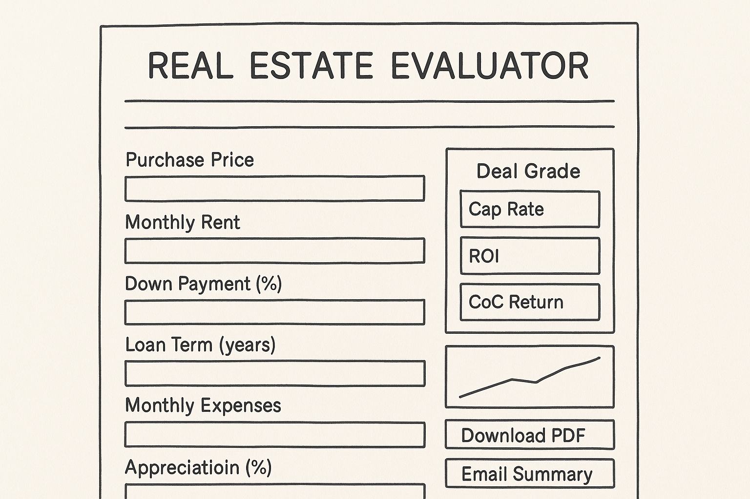

This layout is optimized for clarity and mobile-friendliness, while maintaining a clean UX for first-time investors and agents.