Exploratory Data Analysis Documentation: Drug Consumption Dataset.

Daniel Marquino Pérez, 819028
13.04.2026

Dataset Description and Origin
https://archive.ics.uci.edu/dataset/373/drug+consumption+quantified
https://www.kaggle.com/datasets/obeykhadija/drug-consumptions-uci?resource=download&select=Drug_Consumption.csv
The Drug Consumption comprises 1,884 respondents and 31 features, which fall into three conceptually distinct groups.
The first group consists of five demographic features: Age, Gender, Education, Country, and Ethnicity. Among these, Gender, Country, and Ethnicity are measured on a nominal scale. Age and Education are ordinal, as their values carry a meaningful rank ordering.
The second group contains seven personality scores derived from the validated NEO-PI-R psychometric instrument: Neuroticism (Nscore), Extraversion (Escore), Openness to Experience (Oscore), Agreeableness (AScore), Conscientiousness (Cscore), Impulsiveness, and Sensation Seeking (SS). These scores are quantitative continuous variables, expressed as standardised z-scores with a theoretical mean of zero and standard deviation of one.
The third and largest group comprises nineteen drug consumption columns, one for each of the substances surveyed (Alcohol, Cannabis, Heroin, Caffeine…). Each is measured on an ordinal scale with seven levels: CL0 (never used), CL1 (over a decade ago), CL2 (last decade), CL3 (last year), CL4 (last month), CL5 (last week), and CL6 (last day). The ordered nature of these labels allows ranking, but arithmetic operations such as computing a mean are not meaningful.

Research Questions and Points of Interest
The structure of the dataset suggests several analytically relevant questions. First, are personality traits associated with drug consumption. Specifically, do respondents scoring higher on Sensation Seeking or Neuroticism report more recent use of substances such as cannabis or cocaine? Second, do demographic groups differ in their consumption patterns? Third, how clearly do legal substances (Alcohol, Caffeine, Nicotine) differ from illegal ones in their frequency distributions? These questions motivate both the graphical representations and the grouped statistical analyses presented below.
The dataset additionally includes a fictitious substance, Semer, as a validity check. Only 8 respondents (0.4% of the total) claimed to have used it, which strongly supports the general reliability of self-reported answers.

Missing Values
Inspection of the dataset using pandas confirmed zero missing values across all 31 features and all 1,884 rows. As a consequence, no imputation strategy is required, and no bias is introduced into subsequent analyses.

Graphical Representation
4.1 Demographic Distribution
Bar charts were chosen to visualise the demographic features because Age, Gender, and Education are nominal or ordinal variables. The bar chart of Age reveals that the sample is strongly skewed toward younger respondents: the 18–24 group accounts for 643 individuals, while the 65+ group contains only 18.
Gender is nearly balanced at 943 male and 941 female respondents. In terms of education, a large proportion of participants hold a university or postgraduate degree, suggesting the sample overrepresents highly educated individuals relative to the general population.
A pie chart was applied to the Country variable, where the relatively small number of categories (seven) makes the proportional representation intuitive: the UK alone accounts for 55.4% of respondents, followed by the USA at 29.6%.
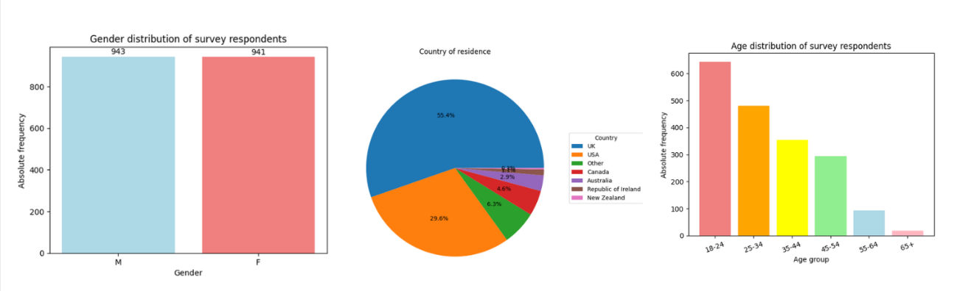
Figure 1: Gender, Country & Age Tables.
4.2 Drug Consumption Frequency
Bar charts were also used for the drug consumption variables, as their values (CL0–CL6) are ordinal categories rather than continuous measurements. Figure 2 illustrates the stark contrast between legal and illegal substances. Caffeine shows the most concentrated recent use, with 73.5% of respondents at CL6 (last day). In contrast, Heroin and Cocaine have modes at CL0 (never used), at 85.1% and 55.0% respectively. Cannabis occupies a middle position, with its mode also at CL6 (24.6%).
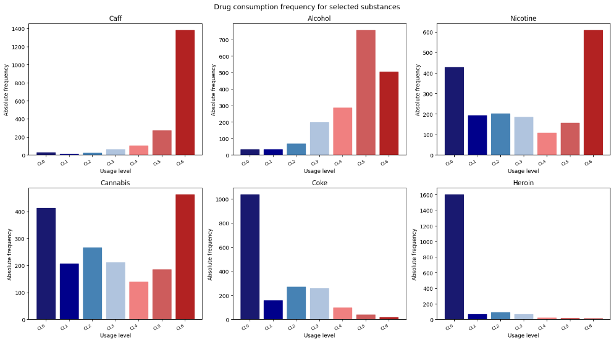
Figure 2: Drug frequency consumption for Caffeine, Alcohol, Nicotine, Cannabis, Coke and Heroine respectively.
4.3 Personality Score Distributions
Histograms were applied to the seven personality scores. This uniform binning enables direct visual comparison across scores. All seven distributions are approximately bell-shaped and centered near zero, which is expected given the z-score standardization.
A grouped boxplot of Sensation Seeking by Age group reinforces the histogram findings while enabling comparison across demographic strata.
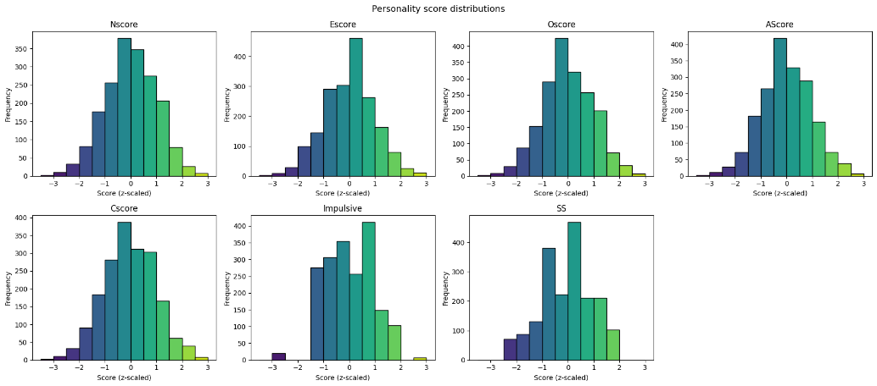
Figure 3: Distribution of all personality scores.

Measures of Location and Dispersion
For the quantitative personality scores, mean, median, standard deviation, and interquartile range were computed. The results are summarized in Table 1.
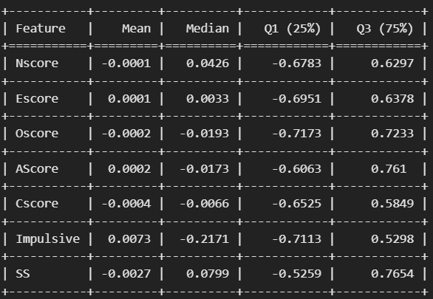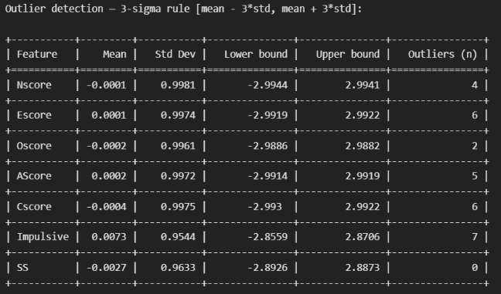
Table 1: Location and dispersion measures for personality scores (z-scaled).
All seven means are negligibly close to zero (the largest deviation is 0.0073 for Impulsiveness). For all features except Impulsiveness, the mean and median are nearly identical. In the case of Impulsiveness, the median (−0.217) is noticeably lower than the mean (0.007), suggesting a mild right skew: a small subset of highly impulsive respondents pulls the mean upward.
Standard deviations are close to 1.0 for all scores, consistent with z-score standardization.

Conclusions
The exploratory data analysis of the Drug Consumption dataset proposes the following conclusions. The dataset is complete, with no missing values, and the low Semer response rate (0.4%) confirms that respondents answered consciously.
Personality scores are well-distributed statistically: approximately normally distributed, centered near zero, and with standard deviations close to one.
The drug consumption distributions reveal a clear separation between legal and illegal substances. Legal substances such as Caffeine and Alcohol show high recent use while hard illegal substances show the opposite pattern. Cannabis occupies an intermediate position.
Finally, the age-based decline in Sensation Seeking provides evidence of a meaningful association between demographic characteristics and personality.

