1. <http://www.thomson.co.uk/blog/wp-content/uploads/infographic/interactive-music-map/index.html>

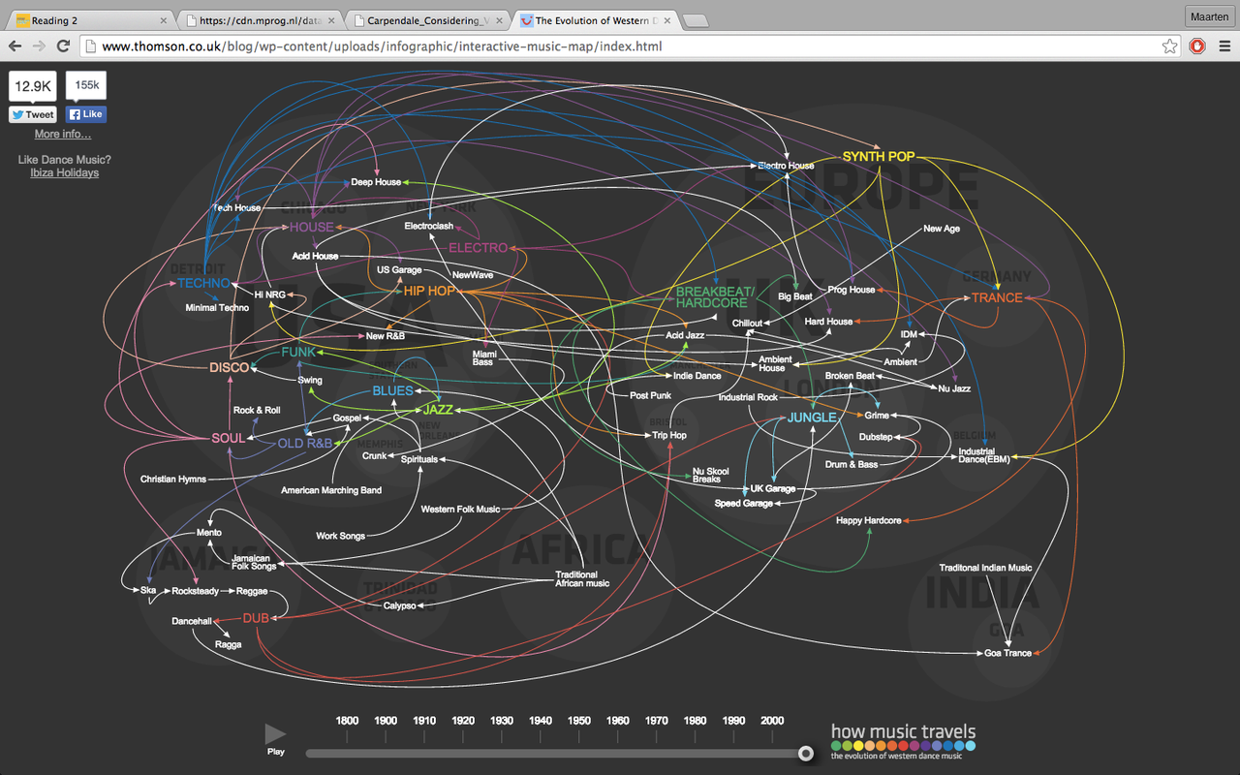

1. Position: The positions on the map are locations in the world. A name of a music genre is on the position where it originated. Pointers point to music genres that are influenced by the genre where the pointer came from.

Color: Every music genre has a different color. The name on the position where it originated is in that color. And the pointers that point to other music genres are also in that color.

1. Domain problem characterization: The visualization aims to introduce the user to the history of western dance music. Because of the appearing music genres and pointers to other music genres through time, the visualization succeeds in introducing the viewer to the history of western dance music.

Data/operation abstraction: The visualization uses music genres, influence, location and time as data types. Where are music genres originated? Which music genre influences other music genres? At what time does a music genre originate?

1. The visualization does embody good practices so users will be introduced to the history of western dance music. The pointers moving through time gives you a nice overview of the history of dance music.
2. I certainly do not agree that visualization is an art form. Visualization is a functional tool to explain something. It can be nice and visually appealing. But defining it as art is in my opinion too much.
3. 1) Introduce the user to music genres in western dance music

2) Introduce the user to the links between different genres

3) Introduce the user to the history of western dance music