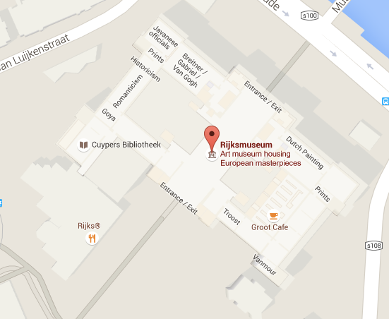Google Maps Bing Maps

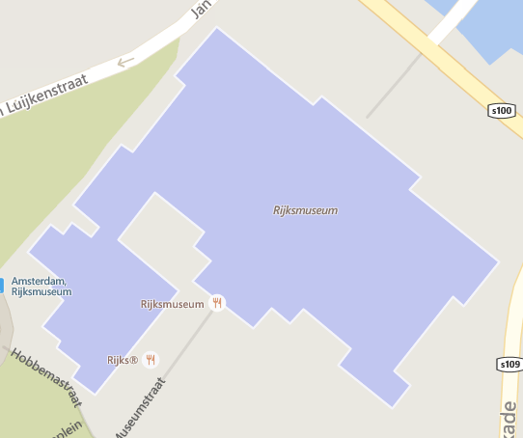

* 1. In the screenshots above you see the Rijksmuseum on Google Maps and Bing Maps. As you can see on Google Maps the texture of the building is highlighted. With the use of lighter and darker colours you get a more 3d feeling because some parts look like shadows. On the Bing Maps there the building is completely blue, and there is no texture.

Google Maps Bing Maps

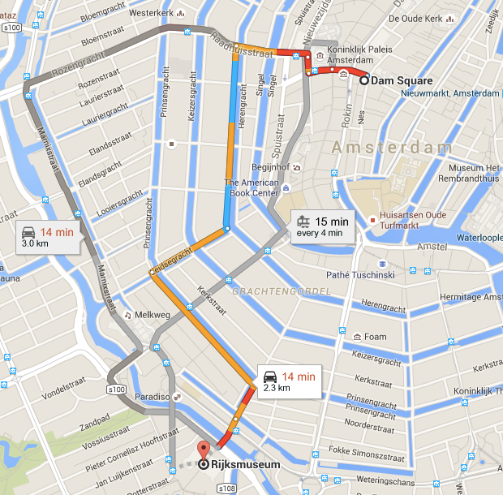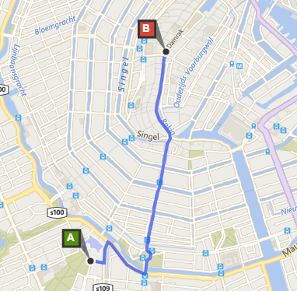

* 1. In the visualization of Google Maps they use different colours to highlight differnet aspects of route. Next to that there are also alternative routes in gray. In the Bing Maps visualization there are clear a and b points in red and green. There is only one route and it is in a clear blue colour.

1.3. In mine opinion the Google Maps visualization is better. Because of the textures in buildings it gives you a feeling that it is 3-d instead of a 2-d canvas. Next to that the route from the Rijksmuseum to Dam square is bettter because it gives you multiple options. It provides you with a more rounded answer to the question “how do I get from a to b?”.

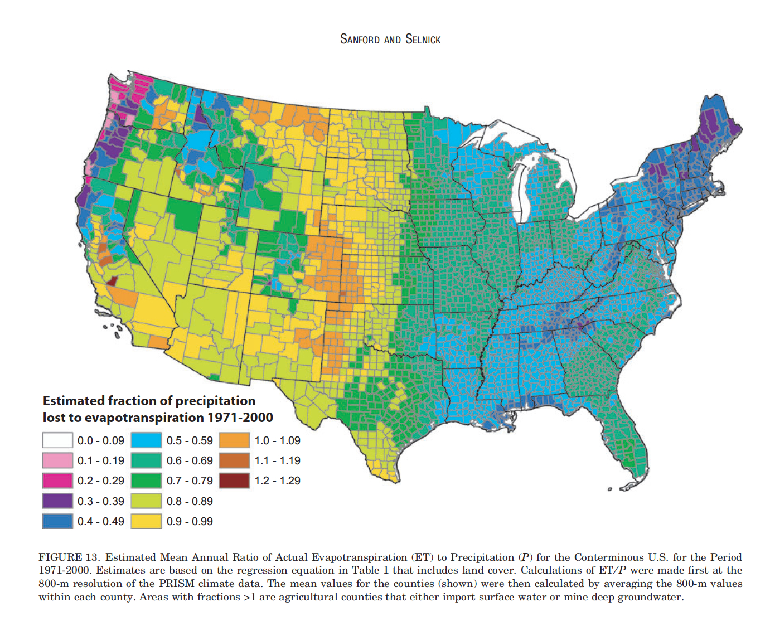

2.1. In this visualization the estimated fraction of precipitation lost to evapotranspiration in the period 1971 – 2000 is shown. The designer aimed to explain where in the united states the land is dry and where in the united states the land is wet. There are 13 different colours which represents the dryness of the land. Dark brown is the driest and white is the wettest. In this situation the colours in the visualization don’t explain the map in the best way. Blue which is normally associated with wet is in de middle of the schale of colours. This gives the impression that blue regions are wet. When they are actually not wet and not dry but in

2.2between. In this case it was single hue colour schale.