1. Ware argues that human perception involves 2.5 dimensions. Given this assertion, when might a 3D visualization be useful and why?

According to ware, people experience visual space in 2,5 dimensions. 2 dimensions for the 2-d experiences and the other 0,5 dimension refers to the away dimension. So humans are close to a 3-d dimension but don’t fully experience it. Therefore a 3-d visualization is useful when it contributes something to the goal of the visualization.

1. In Chapter 6, Ware presents some implications of pattern recognition and visual working memory on design. Provide an example that harnesses some of these principles (perhaps an advertisement, visualization, or interface) and discuss how the design takes these principles into account. Please include a screenshot, photo, or website URL.

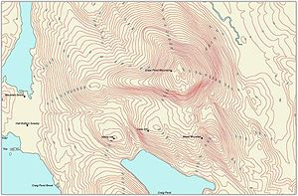

Above you see a contour map. The inner lines represent high areas and the outer lines represent low areas. I know this by convention; otherwise I only saw a lot of lines on a map without any meaning. Therefore these conventions or design rules are really useful for viewer to understand the image by pattern recognition. There is a pattern in the use of this design. It is stored in my visual working memory.

1. According to Bostock et. al., what are the primary advantages of D3? Based on your reading of the article, please provide an example of a type of visualization that would be easier and better implemented in D3 as opposed to HTML5, JSON, and Javascript. Please list the pros and cons of choosing D3 over pure HTML5, JSON and Javascript.

The primary advantages of D3 according to Bostock are better compatibility, better debugging and better performance. You should use D3 because it lets you build the data visualization in a better framework. Based on these primary advantages an example of visualization can be given where D3 is a more useful tool then html5, json or JavaScript. An example of a type of visualization that would be easier and better implemented in D3 as opposed to HTML5, JSON, and Javascript is a histogram.

1. Of the visualization figures presented in Heer et. al., which do you find the most difficult to comprehend? Does the complexity of the figure interfere with the goal of visualization as described in the article? Include a screenshot of the figure you have chosen in your response and use principles that you have learned so far (i.e., from design, perception, and cognition) to justify your choice.

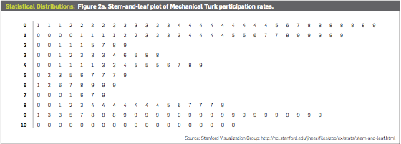

In the image above you see the visualization figure presented which I find the most difficult to comprehend? It took me more then 10 minutes to realize that the numbers in the visualization stand for percentages. Nowhere in the visualization is explained that we are talking about percentages. Next to that, I think it is chaotic to place all the numbers in the visualization. It would be better to make a histogram instead. D3 would be a useful program for that.

1. Play around with the interactive graphs included in the Heer article. You need to open this page in a browser that runs Java. Focus on Figure 1A. To what extent do interactivity and transitions, elements that D3 optimizes, add to the clarity and message of the visualization? With the element of interactivity in mind, redesign and sketch the contents of figure 1A with one of the other visualization types described in the Heer article. Include a picture of a sketch of your idea, and describe how it supports comprehension and data exploration.

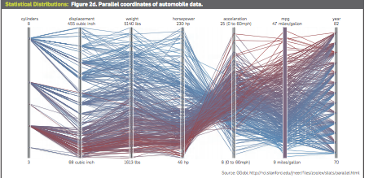

To answer this question, we make use of the above interactive visualization. You can move the slides on every axes to select the cars that fall into these regions of those specific axes. In this case interactivity and transitions, elements that D3 optimizes add to the clarity of the messages of the visualization. Because of the interactivity you can select the cars on better grounds, which gives you a better insight in the meaning of the data.