#### 4.4.1.1 Langmuir Isotherm

The Langmuir isotherm model describes adsorption onto a surface with a finite number of identical sites, assuming that all sites have equal energy and no interactions between adsorbed molecules. The model is represented by the following equation:

The data collected for Methylene Blue adsorption at different equilibrium concentrations are shown in table 4.3 and 4.4 and 4.5 parameters for analyzing the adsorption of Methylene Blue (MB) for Langmuir, freundlich and temkin isotherm model respectively.

**Table 4. 3:** parameters for analyzing the adsorption of Methylene Blue (MB) for Langmuir isotherm model

|  |  |  |  |
| --- | --- | --- | --- |
| $$Ce (mg/L)$$ | $$Qe (mg/g)$$ | $$1/Ce​ (L/mg)$$ | $$1/qe​ (g/mg)$$ |
| 7.26 | 1.37 | 0.137 | 0.729 |
| 10.24 | 2.38 | 0.098 | 0.420 |
| 9.38 | 5.31 | 0.107 | 0.188 |
| 16.22 | 4.39 | 0.061 | 0.228 |
| 14.63 | 7.69 | 0.068 | 0.130 |
| 19.11 | 7.95 | 0.052 | 0.126 |
| 20.72 | 9.64 | 0.048 | 0.104 |
| 21.24 | 14.38 | 0.047 | 0.069 |

The table 4.3 presents data on the adsorption process, illustrating the relationship between equilibrium concentration $(Ce​),$ adsorption capacity $(Qe​),$ and their reciprocal values. It lists $Ce​$ ranging from 7.26 mg/L to 21.24 mg/L and Qe​ values from 1.37 mg/g to 14.38 mg/g, indicating varying effectiveness of the adsorbent in capturing the target compound. The 1/Ce values, which decrease as Ce increases, provide insights into adsorption efficiency, while the 1/Qe​ values range from 0.069 g/mg to 0.729 g/mg, suggesting a correlation between lower adsorption capacities and higher equilibrium concentrations.

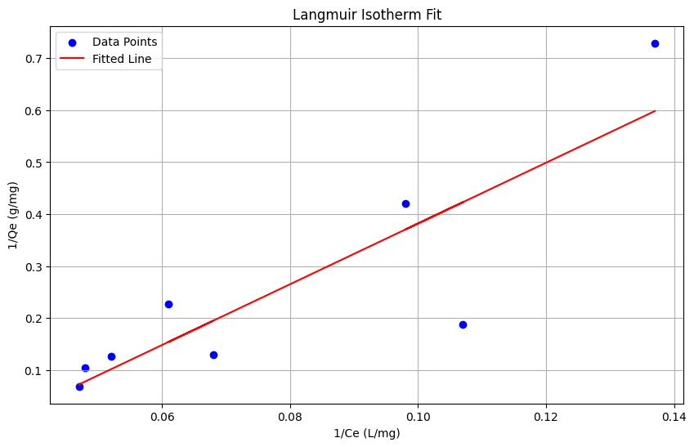

**Figure 4.7:** Langmuir isotherm model plot

Using the linearized Langmuir isotherm equation, the slope $(S)$ and intercept $(I)$ are utilized to determine the maximum adsorption capacity ($Qm$) and the Langmuir constant (b). From the data, the slope is 5.8412, which leads to a calculated $Qm$ of 0.1716 mg/g, indicating the material's maximum adsorption capacity for the adsorbate. The negative intercept (-0.2020) reflects the nature of adsorption interactions, and when multiplied by $Qm$, it results in a Langmuir constant (b) of -0.0347 L/mg. The constant "b" is related to the affinity of the binding sites for the adsorbate, and the negative value could suggest unfavorable adsorption interactions, possibly due to experimental conditions or material characteristics.

#### 4.4.1.2 Freundlich Isotherm

The **Freundlich Isotherm Model**: Represents adsorption on a heterogeneous surface with varying affinities for the adsorbate. This model indicates that the surface has multiple types of adsorption sites, each with different energies, and adsorption capacity increases with higher concentrations of the adsorbate.

**Table 4. 4** : presents the data used for fitting the Freundlich isotherm model, while Figure 4.6 illustrates the linear form of the Freundlich equation.

|  |  |  |  |
| --- | --- | --- | --- |
| $$Ce (mg/L)$$ | $$Qe (mg/g)$$ | $$log(Ce​)$$ | $$log(qe​)$$ |
| 7.26 | 1.37 | 0.360 | 0.137 |
| 10.24 | 2.38 | 0.010 | 0.377 |
| 9.38 | 5.31 | 0.172 | 0.727 |
| 16.22 | 4.39 | 0.210 | 0.643 |
| 14.63 | 7.69 | 0.167 | 0.886 |
| 19.11 | 7.95 | 0.280 | 0.952 |
| 20.72 | 9.64 | 0.317 | 0.984 |
| 21.24 | 14.38 | 0.328 | 1.156 |

The data presented includes concentration values $(Ce)$ in mg/L, adsorption capacities $(Qe)$ in mg/g, and their logarithmic transformations, $log(Ce)$ and $log(Qe).$ The table reveals a range of $Ce$ values from 7.26 mg/L to 21.24 mg/L, corresponding to $Qe$ values that increase from 1.37 mg/g to 14.38 mg/g. As the concentration increases, a positive trend is observed in the log-transformed values of both $Ce$ and $Qe$, suggesting a nonlinear relationship between the initial concentration of the adsorbate and the amount adsorbed. Specifically, the $log(Qe)$ values range from 0.137 to 1.156, indicating a significant increase in adsorption capacity with higher concentrations. This pattern reflects the potential adsorption efficiency of the material being studied and may assist in understanding the underlying mechanisms governing the adsorption process

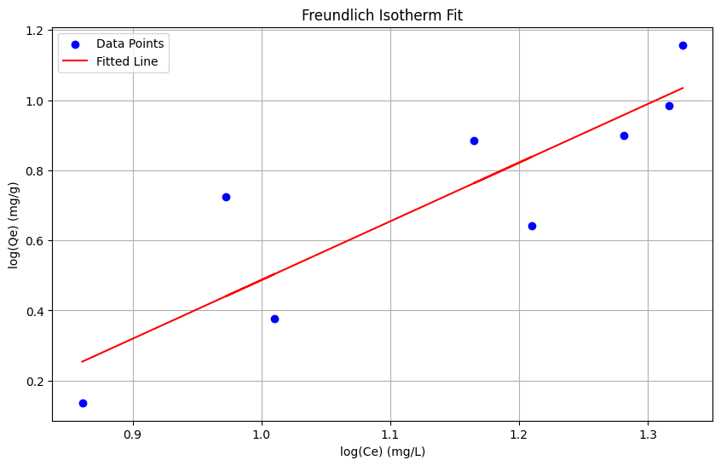

**Figure 4.8:** Freundlich isotherm model plot.

The Freundlich isotherm model provides insight into the adsorption process on heterogeneous surfaces. Based on the calculated parameters, the adsorption intensity n≈1.37 suggests moderate favorability of adsorption, as values of n between 1 and 10 indicate favorable adsorption. A lower n value closer to 1 means that the adsorption sites have similar energy, implying more homogeneity. The Freundlich constant KF≈3.66 represents the adsorption capacity of the material. This value indicates a moderate capacity for adsorption, with the material showing reasonable adsorption potential at low concentrations of the adsorbate. Overall, these parameters suggest that the material exhibits good but not exceptionally high adsorption, with a fairly uniform distribution of adsorption sites.

#### 4.4.1.3 The Temkin isotherm

The Temkin isotherm describes the adsorption behavior by assuming that the heat of adsorption decreases linearly with increasing coverage due to adsorbate-adsorbate interactions. In this study, the Temkin model was fitted to the adsorption data of Methylene Blue (MB) onto the synthesized material. The parameters obtained from the fitting, including constant A (related to the adsorption potential) and constant BBB (related to the adsorption heat), provide insights into the adsorption process. A moderate R2 value indicates a reasonably good fit, suggesting that the adsorption of MB follows the Temkin isotherm to some extent, with a significant interaction between the adsorbed molecules. The linear decrease in adsorption energy implies that as more MB molecules are adsorbed, the adsorptive forces weaken, which is typical for this model.

**Table 4. 5:** presents the data used for fitting the **Temkin Isotherm.**

|  |  |  |
| --- | --- | --- |
| $$Ce​ (mg/L)$$ | $$qe​ (mg/g)$$ | $$ln(Ce​)$$ |
| 2.74 | 1.37 | 1.008 |
| 4.76 | 2.38 | 1.557 |
| 10.62 | 5.31 | 2.363 |
| 8.78 | 4.39 | 2.166 |
| 15.37 | 7.69 | 2.743 |
| 15.89 | 7.95 | 2.759 |
| 19.28 | 9.64 | 2.959 |
| 28.76 | 14.38 | 3.360 |

Table 4.5 summarizes the data used for fitting the Temkin Isotherm, detailing the equilibrium concentrations $(Ce)$ of Methylene Blue (MB) in mg/L and the corresponding adsorption capacities $(qe)$ in mg/g, alongside their natural logarithmic transformations $(ln(Ce)).$ The data reveals a range of equilibrium concentrations from 2.74 mg/L to 28.76 mg/L, with corresponding adsorption capacities varying from 1.37 mg/g to 14.38 mg/g. As the concentration of MB increases, the adsorption capacity also tends to rise, indicating a positive relationship between $Ce$ and $qe.$ The natural logarithm of the equilibrium concentration $(ln(Ce))$ ranges from approximately 1.008 to 3.360, reflecting an exponential increase in the concentration values. This trend suggests that higher concentrations of MB lead to greater adsorption, consistent with the underlying principles of the Temkin isotherm, which accounts for interactions between adsorbate molecules on the adsorbent surface. Overall, the data indicates that the Temkin isotherm may effectively characterize the adsorption behavior of MB on the chosen adsorbent under the examined conditions.

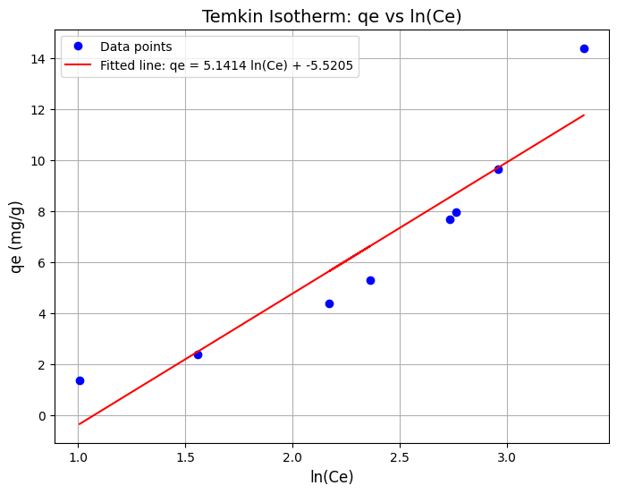

**Figure 4. 9:** Temkin isotherm model plot

The results based on the Temkin isotherm model indicate strong and favorable adsorption characteristics. The Temkin constant **(b)** of **14307.58 J/mol** reflects significant interaction energy between the adsorbent and adsorbate, suggesting that the adsorption process is energetically favorable. Additionally, the high equilibrium constant $(KT)$ of **1156.04 L/g** highlights the material’s excellent adsorption capacity, meaning it can effectively retain and adsorb molecules. Together, these values demonstrate that the material is highly efficient for adsorption-related applications, such as pollutant removal or catalytic processes.