**Hadi Abu-Maruf 301188504**

**Rawad Mansour 305506412**

**Exercise 1:**

1. Describe the decryption function for R = 3 and R=4.

R3 = (x2 * A + x1)%N =(x0 * (A2 + I)*A+ x0 *A )%N= x0(A3+2A) %N

R4=(x3*A+x2)%N=[x0(A3+2A)*A+x0*(A2+ I)]%N=[x0(A4+2A2)+x0*(A2+I)]%N= x0[(A4+3A2)+I)]%N

נסמן:

B=(A3+2A) -1

C=[(A4+3A2)+I)] -1

ולכן :

Decryption function for R3=(X0* B -1)%N

Decryption function for R4=(X0*C-1)%N

To find the inverse matrix and if the key is admissible we have to check this:[for m=2, the we have to find determinant be the minor algorithm then we check if:

there is A^-1 mod 26 <->

det(A)!= 0 mod 26 <->

det(A)!= 0 mod 13 and det(A) != 0 mod 2

1. How many different possible keys exist for m = 3 and R=3?

different possible for matrix 3X3 we have in every cell 26 possibilities. Then the whole possibilities is 926

1. Door_Encryption

Output:

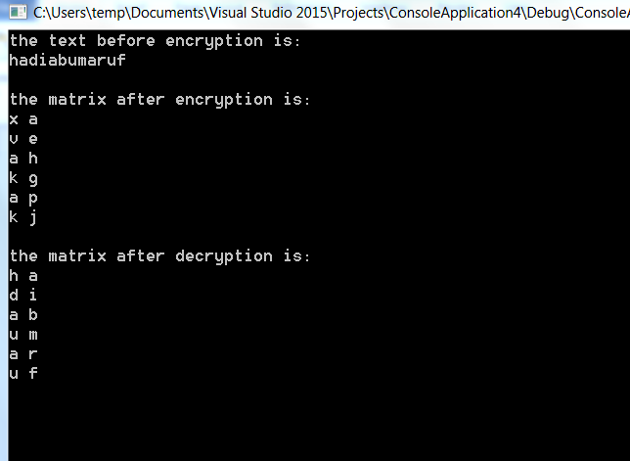

1. Door_decryption (the output above)

**Exercise 2:**

Output:

