**JSBootcamp Exam**

Hadi outputs:

Explanation:

I created folder with the name “MyFolder” with the contents:

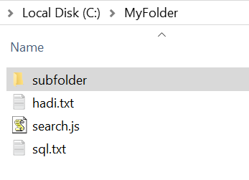

The subfolder includes 1 file:

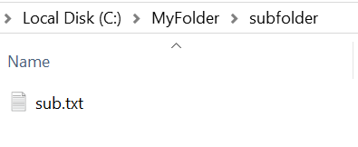

* You can find the file with its contents in the git repository

**My outputs**

Output 1: Running application without any parameter prints a simple help message

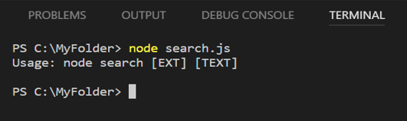

Output 2: Looking for all files with “txt” extension that contain the word “ori”

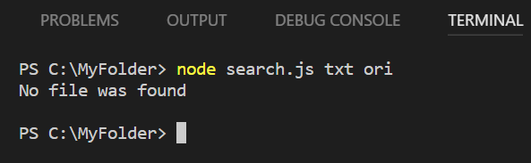

Output 3: Looking for all files with “js” extension that contain the word “file”

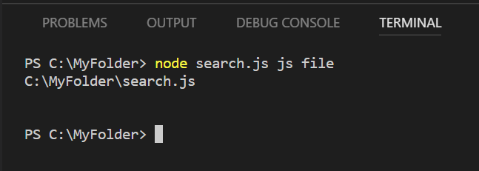

Output 4: Looking for all files with “txt” extension that contain the word “programming”, the output will be two files in the same folder

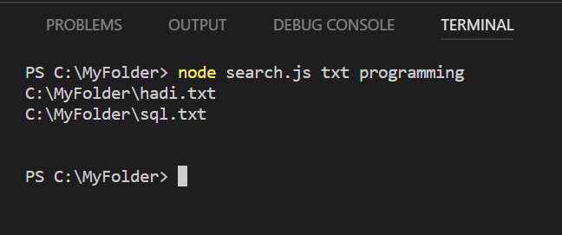

Output 5: Looking for all files with “txt” extension that contain the word “hello”, and we get 2 paths one of them form the subfolder

