Parsa Pourzargham

Neptune code: LUM2CE

Stereo 3D reconstruction Documentation

Contents

Dataset and data output 3

Screenshots from Aloe image pair: 4

Result comparison 4

Output comparison 5

Conclusion 8

# 

# Dataset and data output

The dataset used for this project is Middlebury dataset 2005 and 2006 available at <https://vision.middlebury.edu/stereo/data/> .

According to the webpage, the focal length for the dataset is 3740 pixels and the baseline is 160 centimeters.

The program takes the stereo image pairs as and input and calculates the disparity map using Naïve algorithm (image patch line searching), Dynamic programming approach and also SBM algorithms which is a built in disparity map algorithms in Opencv. In the next step, the obtained disparity maps are converted to a 3d point cloud using the formulas below:

The RGB values are extracted from the main image channels, hence the 3D point cloud obtained is a XYZRGB format with space separator. The output 3d file is stored as txt file, so that the format can be set in Meshlab at startup:

As the stereo setup calculates the coordinates up to and scale, the coordinates are multiplied by a scale value .

The disparity map image file obtained from all the above mentioned algorithms are included in data folder. Also, the 3D shape file obtained from all algorithms, as well as the 3D shape obtained from the ground truth disparity map provided by the dataset is also included in the data folder.

Here are some screenshots from the output of the disparity maps and 3D shapes from different image pairs:

## Screenshots from Aloe image pair:

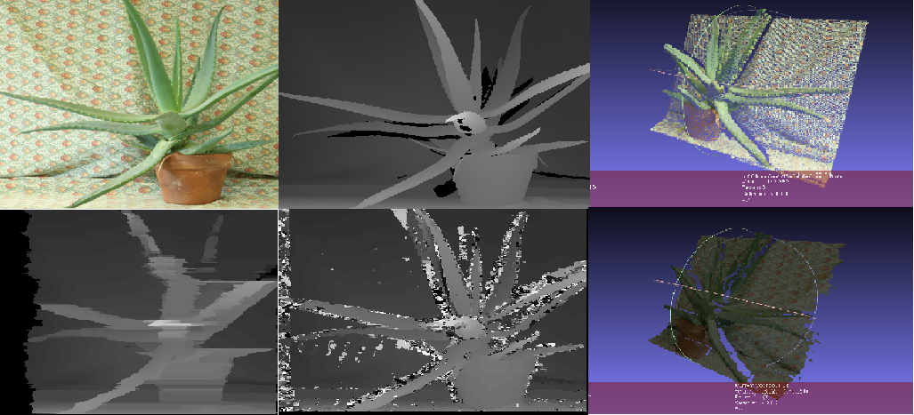

And here is the Moebius image pair results:

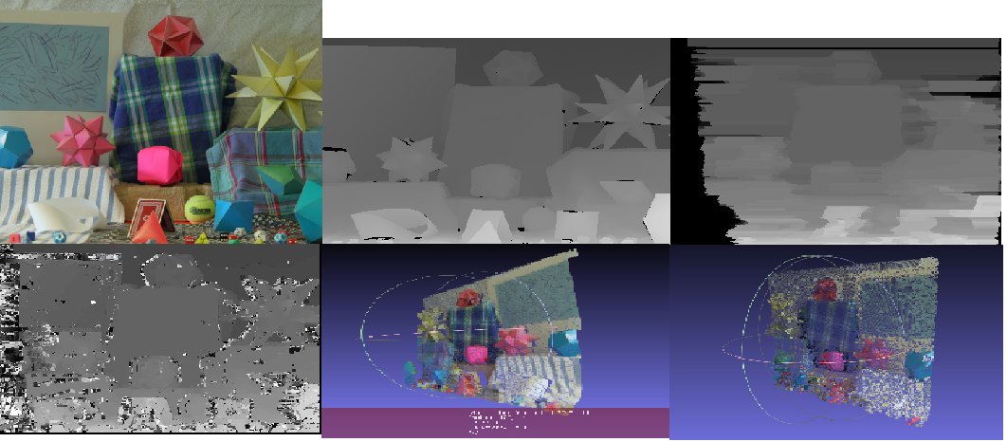

Result comparison

The runtime duration of all algorithms, SSD dissimilarity values are available in the performance.xlsx file for all 26 image pairs in the dataset.

For the sake of comparison, PSNR and SSIM metrics are computed for all the algorithms in comparison to the ground truth disparity image provided by the dataset. PSNR and SSIM metrics are computed using a python script (Simmilarity.py) and the results are available in the excel file.

Finally, the average, minimum and maximum values for runtime and dissimilarity metrics are calculated for all 3 algorithms.

According to the calculations, Naïve approach takes 4.85 seconds on average to run, 4.75 and 0.013 seconds for DP and SBM algorithms respectively. SBM is a much faster and more optimized algorithm which takes significantly less time to run.

Naïve approach has 3245 PSNR on average, 31.06 and 28.02 for DP and SBM respectively.

According to SSD dissimilarity, DP performs better than Naïve approach as it usually has a much less SSD value. Also SBM usually has a large SSD, due to a non-optimal parameterization.

# Output comparison

For the sake of comparison, the output for Aloe image pair are demonstrated:

The left image:

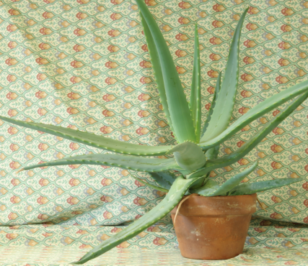

The ground truth disparity map:

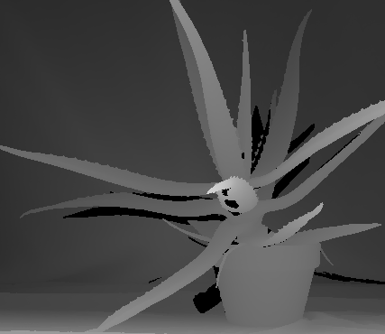

The output from Naïve approach with window size 7:

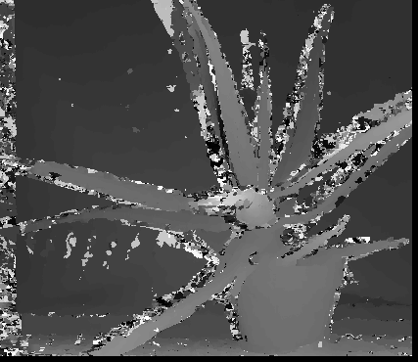

The output from DP algorithm with occlusion cost 50000 obtained from trial and error:

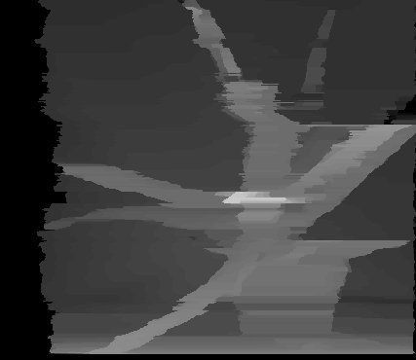

The output from the SBM algorithm:

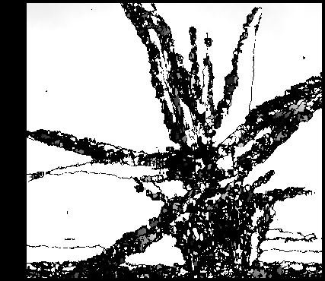

The 3D shape obtained from ground truth disparity map:

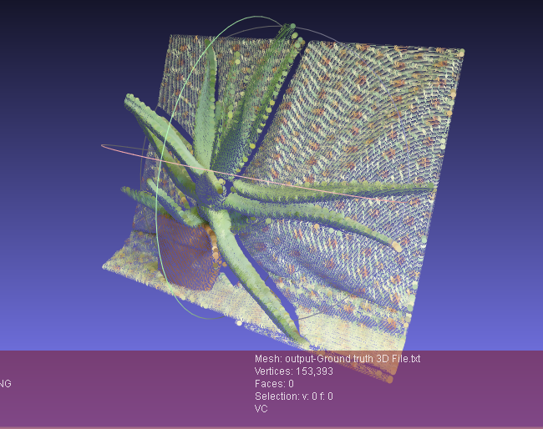

The output obtained from DP algorithm:

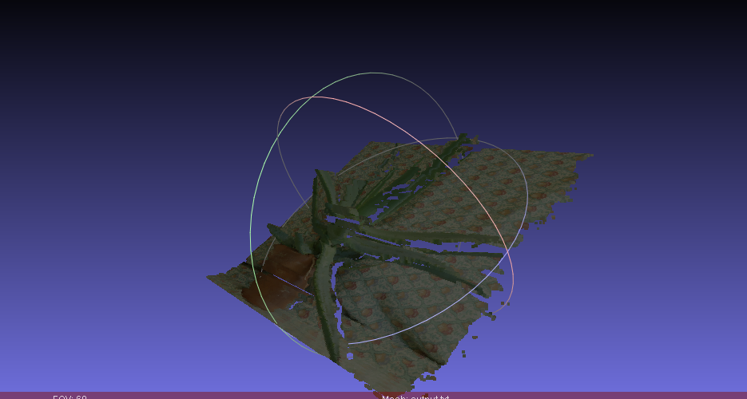

The output from Naïve approach:



# Conclusion

The Naïve approach does a moderate job; however, it is highly susceptible to noise in highly textured and homogenized areas in the picture as the matching window fails to find the best match.

The DP approach does a good job in general but because the DP algorithm takes the values from left or right neighboring pixel in case of occlusion, the line effect happens in this algorithm.