




DEVELOPMENT OF A TRAVEL RELATED SOFTWARE APP THAT CAN BE INSTALLED ON MOBILE PHONES THAT COULD CAPTURE TRIP RELATED INFORMATION

A MINI PROJECT REPORT

Submitted by

MAATHANGIDEVI N
REG.NO:922524106127

BACHELOR OF ENGINEERING

in

ELECTRONICS AND COMUNICATION ENGINEERING

V.S.B.ENGINEERING COLLEGE (AUTONOMOUS)

KARUR-639111.

JULY 2026

V.S.B.ENGINEERING COLLEGE (AUTONOMOUS)

KARUR-639111.

BONAFIDE CERTIFICATE

Certified that this project report “DEVELOPMENT OF A TRAVEL RELATED SOFTWARE APP THAT CAN BE INSTALLED ON MOBILE PHONES THAT COULD CAPTURE TRIP RELATED INFORMATION”is the bonafide work of “MAATHANGIDEVI N,922524106127 who carried out the project work under my supervison.

SIGNATURE OF THE FACULTY SIGNATURE OF THE HOD

Development of a travel related software app that can be installed on mobile phones that could capture trip related information

ABSTRACT
Travel planning is an important process that involves several activities such as selecting a suitable destination, preparing a travel itinerary, estimating trip expenses, managing travel details, finding local guidance, and accessing safety-related information. In most cases, travelers depend on different websites and applications to perform these activities. Using multiple platforms makes the travel planning process time-consuming and difficult, especially for users who are visiting unfamiliar destinations. To overcome these problems, the proposed project, IndiRoam: AI-Powered Smart Travel Companion, is developed as a centralized web-based application that provides multiple travel-related services through a single platform.
The main objective of IndiRoam is to simplify the complete travel planning process by integrating Artificial Intelligence, cloud-based services, and modern web technologies. The application provides secure user registration and login functionality, user profile management, an AI Itinerary Planner, a Discover module, My Travels, Local Travel Guides, a Smart Trip Safety and Emergency Assistant, and an AI Travel Budget Planner. These features are designed to help users plan, organize, and manage their trips in a simple and convenient manner.
The AI Itinerary Planner is one of the major features of the application. It allows users to provide their travel requirements and generates a suitable travel plan with the help of Artificial Intelligence. This reduces the manual effort and time required to search for different places and prepare a travel schedule. The Discover module helps users explore travel destinations and related information, while the My Travels module provides a centralized place for users to organize and manage their travel details.
The application also includes a Local Travel Guides feature to provide useful guidance and contact information for travelers visiting unfamiliar locations. The Smart Trip Safety and Emergency Assistant improves travel awareness by providing useful safety-related information and emergency assistance. In addition, the AI Travel Budget Planner helps users estimate and organize expected travel expenses, making financial planning easier during trip preparation.
Firebase Authentication is integrated into the system to provide secure user registration and login functionality, while Firebase and Firestore services are used for managing user profiles and application-related data. Gemini AI is integrated into the application to provide intelligent travel planning and assistance based on user requirements. GitHub is used for source code management and version control, and the completed web application is deployed using Vercel, allowing users to access the platform through the internet.
The developed IndiRoam system successfully combines important travel planning and assistance features into a single web application. The project reduces the need for users to depend on multiple travel platforms and provides a more organized, interactive, and user-friendly travel experience. The system demonstrates the practical application of Artificial Intelligence, cloud technologies, and modern web development techniques in creating an intelligent travel assistance platform. The developed application can be further enhanced in the future by integrating real-time weather information, transportation and hotel booking services, multilingual support, advanced personalized recommendations, and other smart travel services.

INTRODUCTION
Travel and tourism have become an important part of modern life. People travel for different purposes such as tourism, education, business, and personal needs. Planning a trip involves several activities, including selecting destinations, preparing travel itineraries, estimating expenses, managing travel details, finding local guidance, and accessing safety-related information. Usually, travelers depend on different websites and applications for these services, which makes the overall travel planning process time-consuming and difficult.
With the development of Artificial Intelligence and modern web technologies, travel planning can be made easier and more efficient. AI-based systems can understand user requirements and provide suitable travel suggestions and personalized assistance. The proposed project, IndiRoam: AI-Powered Smart Travel Companion, is developed as a centralized web application that combines multiple travel-related services into a single platform.
The application provides several useful features, including secure user Login and Signup, User Profile Management, AI Itinerary Planner, Discover, My Travels, Local Travel Guides, Smart Trip Safety and Emergency Assistant, and AI Travel Budget Planner. The AI Itinerary Planner helps users generate suitable travel plans based on their requirements, while the Discover and My Travels modules support destination exploration and travel management. The Local Travel Guides feature provides useful guidance and contact information for travelers visiting unfamiliar places.
The application also includes a Smart Trip Safety and Emergency Assistant to provide safety-related support and an AI Travel Budget Planner to help users estimate and organize their travel expenses. Gemini AI is integrated to provide intelligent travel assistance, while Firebase Authentication and Firestore are used for secure user authentication and data management. The completed web application is deployed using Vercel, allowing users to access the system online.
The main aim of IndiRoam is to reduce the difficulty of using multiple travel applications by providing important travel services through a single platform. The system demonstrates how Artificial Intelligence, cloud technologies, and modern web development techniques can be combined to create a simple, organized, and user-friendly travel planning experience.

CONTRIBUTION OF THE WORK
The major contributions of the proposed IndiRoam: AI-Powered Smart Travel Companion are as follows:
- Centralized Travel Assistance Platform
The proposed system combines multiple travel-related services into a single web application, reducing the need for users to depend on different platforms for various travel requirements.
- AI-Based Itinerary Planning
The system provides an AI Itinerary Planner that generates suitable travel plans based on user requirements, making the itinerary preparation process easier and less time-consuming.
- Destination Discovery
The Discover module helps users explore different travel destinations and access useful travel-related information through the application.
- Travel Management
The My Travels module provides a centralized platform for users to organize and manage their travel details conveniently.
- Local Travel Guidance
The Local Travel Guides feature provides useful local guidance and contact information, helping travelers receive assistance while visiting unfamiliar destinations.
- Smart Trip Safety Assistance
The Smart Trip Safety and Emergency Assistant provides useful safety-related information and emergency guidance to improve user awareness during travel.
- AI-Based Travel Budget Planning
The AI Travel Budget Planner helps users estimate and organize expected travel expenses such as transportation, accommodation, food, and other activities.
- Secure User Authentication
Firebase Authentication is integrated into the application to provide secure user registration and login functionality.
- Cloud-Based Data Management
Firebase and Firestore services are used to manage user profiles and application-related data efficiently.
- Artificial Intelligence Integration
Gemini AI is integrated into the application to provide intelligent travel planning and assistance based on user requirements.
- User-Friendly Web Application
The system provides a simple and interactive user interface that allows users to access different travel services conveniently.
- Online Deployment and Accessibility
The complete application is deployed using Vercel, allowing users to access the IndiRoam platform online through different devices.
Overall, the proposed work combines Artificial Intelligence, cloud services, travel planning, safety assistance, and budget management into a single platform to provide a simple, organized, and user-friendly travel experience.

LITERATURE SURVEY
Ref | Author (Year) | Methodology | Results Achieved | Limitations
[1] | C. Huda et al. (2024) | Developed a Smart Tourism Recommender System using deep learning and association rule techniques to provide personalized tourism recommendations based on user information and preferences. | The proposed system improved the recommendation process by providing personalized and relevant tourism suggestions to users. | The performance of the recommendation system depends on the availability and quality of user information and tourism datasets.
[2] | K. Al Fararni et al. (2021) | Proposed a hybrid recommender system for tourism by combining Big Data technologies, Artificial Intelligence, and operational research techniques. | The framework provided an intelligent approach for improving tourism recommendations and supporting personalized travel planning. | The proposed framework requires large amounts of reliable data and additional implementation for practical real-world deployment.
[3] | T. Alenezi and S. Al-Ahmadi (2022) | Proposed a normalized attraction travel personality representation approach to improve travel recommender systems and reduce travel-related information overload. | The approach improved the representation of tourist attractions and supported more effective personalized travel recommendations. | The recommendation performance depends on accurate attraction information and suitable representation of user travel preferences.
[4] | R. Sivarethinamohan et al. (2023) | Studied the transformation of digital tourism and analyzed recent technologies and trends that provide personalized and improved travel experiences. | The study identified the importance of digital technologies in providing personalized recommendations and seamless travel experiences. | The work mainly focuses on the analysis of digital tourism trends and requires further practical implementation and evaluation.
[5] | E. Masciari et al. (2024) | Conducted a systematic literature review on Artificial Intelligence-based recommender systems and analyzed different AI techniques used for personalized recommendations. | The study provided a detailed understanding of AI-based recommendation techniques, research developments, and their applications. | The study is mainly a literature review and does not provide a complete practical travel application implementation.

LITERATURE SURVEY DISCUSSION
From the literature survey, it is observed that Artificial Intelligence and recommender systems play an important role in the development of modern tourism applications.
C. Huda et al. developed a Smart Tourism Recommender System using deep learning and association rules to provide personalized tourism recommendations.
K. Al Fararni et al. proposed a hybrid tourism recommender framework by combining Big Data, Artificial Intelligence, and operational research techniques.
T. Alenezi and S. Al-Ahmadi focused on improving travel recommender systems through normalized attraction travel personality representation.
R. Sivarethinamohan et al. studied the development of digital tourism and the importance of modern technologies in providing personalized travel experiences.
E. Masciari et al. analyzed different Artificial Intelligence-based recommender systems through a systematic literature review.
From these existing works, it is understood that most systems mainly focus on tourism recommendations, destination suggestions, or individual travel services.
The proposed IndiRoam: AI-Powered Smart Travel Companion extends these concepts by integrating multiple travel-related features such as AI itinerary planning, destination discovery, travel management, local travel guidance, safety and emergency assistance, and AI-based travel budget planning into a single web application.

PROBLEM STATEMENT
Travel planning requires users to perform multiple activities such as searching for destinations, preparing travel schedules, estimating expenses, finding local guidance, and checking safety information.
Most existing travel platforms provide only specific services. Therefore, users need to depend on multiple websites and applications to complete their travel planning process.
The major problems identified in existing travel planning methods are:
- Travel information is distributed across different platforms.
- Creating a proper travel itinerary requires more time.
- Travelers may find it difficult to estimate their complete trip expenses.
- Users visiting unfamiliar places may require local travel guidance.
- Safety and emergency information may not be easily available.
- Managing different travel details using multiple applications can be difficult.
- Traditional travel applications provide limited personalized assistance.
The IndiRoam project is developed to solve these problems by creating a centralized AI-powered travel companion.

OBJECTIVES OF THE PROJECT
The main objective of the IndiRoam project is to develop an intelligent and user-friendly travel assistance platform.
The important objectives of the project are:
- To develop a centralized web application for travel planning.
- To provide secure user registration and login functionality.
- To provide profile management for registered users.
- To integrate Artificial Intelligence for generating travel itineraries.
- To help users discover different travel destinations.
- To provide a My Travels module for managing travel information.
- To provide Local Travel Guide information.
- To provide safety and emergency assistance for travelers.
- To develop an AI-based travel budget planning system.
- To store and manage user information using Firebase.
- To make the application available online through Vercel deployment.

EXISTING SYSTEM
The existing travel planning systems provide various services such as destination discovery, itinerary planning, hotel booking, transportation information, navigation, and budget estimation. However, most of these services are available through different websites and applications. Therefore, users often need to depend on multiple platforms to plan and manage a complete trip.
Some existing travel applications mainly focus on hotel and transportation booking, while others provide destination recommendations or navigation services. AI-based travel planning applications can generate travel suggestions and itineraries, but they may not provide additional features such as local travel guidance, safety and emergency assistance, travel management, and budget planning within the same platform.
Travelers visiting unfamiliar destinations may also face difficulties in finding reliable local guidance and accessing useful safety-related information. In addition, manually searching for destinations, preparing travel schedules, and estimating expenses requires considerable time and effort.
The major characteristics of existing travel systems are:
- Different applications are required for different travel services.
- Most platforms focus mainly on booking, navigation, or destination discovery.
- Complete travel planning and management features are not always available in a single application.
- Users need to spend more time searching and collecting travel information from multiple sources.
- Personalized AI-based travel assistance is limited in some traditional travel applications.
- Local travel guidance and contact information may not be easily available.
- Safety and emergency assistance features are not integrated into many travel planning applications.
- Travel budget planning is often provided separately from itinerary planning.
- Managing and organizing travel details across different platforms can be difficult for users.
- Users may experience difficulty while switching between multiple applications during the travel planning process.
Therefore, the existing travel systems have limitations in providing a complete, centralized, and intelligent travel planning experience, which creates the need for the proposed IndiRoam: AI-Powered Smart Travel Companion.

PROPOSED SYSTEM
The proposed system, IndiRoam: AI-Powered Smart Travel Companion, is a centralized web-based application developed to simplify travel planning and management. The system combines multiple travel-related services into a single platform, reducing the need for users to depend on different websites and applications.
The proposed system uses Artificial Intelligence and modern web technologies to provide intelligent and user-friendly travel assistance. Users can securely create an account, log in to the application, manage their profile, plan trips, explore destinations, manage travel details, access local travel guidance, receive safety-related assistance, and estimate their travel budget.
The major features of the proposed system are:
- Secure User Authentication
The system provides Login and Signup functionality using Firebase Authentication, allowing users to securely create and access their accounts.
- User Profile Management
Registered users can manage their personal information through the Profile Management feature.
- AI Itinerary Planner
The system uses Gemini AI to generate suitable travel itineraries based on user requirements, reducing the time and effort required for manual trip planning.
- Destination Discovery
The Discover module allows users to explore different travel destinations and access useful travel-related information.
- My Travels Management
The My Travels module helps users organize and manage their travel details through a centralized platform.
- Local Travel Guides
The system provides local travel guidance and contact information to assist users while visiting unfamiliar destinations.
- Smart Trip Safety and Emergency Assistant
This feature provides useful safety-related information and emergency assistance to improve user awareness and support during travel.
- AI Travel Budget Planner
The system helps users estimate and organize their expected travel expenses, including transportation, accommodation, food, and other activities.
- Artificial Intelligence Integration
Gemini AI is integrated into the application to provide intelligent and personalized travel planning assistance based on user requirements.
- Cloud-Based Data Management
Firebase and Firestore services are used to manage user profiles and application-related data efficiently.
- User-Friendly Interface
The application provides a simple and interactive interface that allows users to access different travel services conveniently.
- Online Accessibility
The complete application is deployed using Vercel, allowing users to access the IndiRoam platform online through different devices with an internet connection.
The proposed IndiRoam system provides a centralized, intelligent, and user-friendly travel assistance platform by combining AI-based itinerary planning, destination discovery, travel management, local guidance, safety assistance, and budget planning. The system aims to reduce travel planning complexity and provide users with a more organized and convenient travel experience.

SYSTEM ARCHITECTURE
The IndiRoam system consists of different components working together.
User Interface
The user interacts with the IndiRoam web application using a web browser.
Authentication Layer
Firebase Authentication manages user registration, login, and authentication.
Application Layer
The application processes user requests and manages the functionality of different travel modules.
Artificial Intelligence Layer
Gemini AI processes travel-related user requirements and generates intelligent responses.
Database Layer
Firebase and Firestore store user profile information and application-related data.
Deployment Layer
Vercel is used to host and deploy the web application.
System Architecture Flow:
User → Web Application → Authentication → Travel Modules → Gemini AI / Firebase → Results to User

SYSTEM WORKFLOW
┌───────────────────────────────┐
│ USER │
└───────────────────────────────┘
↓
┌───────────────────────────────┐
│ LOGIN / SIGN UP │
└───────────────────────────────┘
↓
┌───────────────────────────────┐
│ FIREBASE AUTHENTICATION │
└───────────────────────────────┘
↓
┌───────────────────────────────┐
│ USER DASHBOARD & PROFILE │
└───────────────────────────────┘
↓
┌───────────────────────────────┐
│ SELECT TRAVEL SERVICE │
└───────────────────────────────┘
↓
┌───────────────────────────────┐
│ AI ITINERARY PLANNER │
└───────────────────────────────┘
↓
┌───────────────────────────────┐
│ DISCOVER & MY TRAVELS │
└───────────────────────────────┘
↓
┌───────────────────────────────┐
│ LOCAL TRAVEL GUIDES │
└───────────────────────────────┘
↓
┌───────────────────────────────┐
│ SMART TRIP SAFETY & │
│ EMERGENCY ASSISTANT │
└───────────────────────────────┘
↓
┌───────────────────────────────┐
│ AI TRAVEL BUDGET PLANNER │
└───────────────────────────────┘
↓
┌───────────────────────────────┐
│ GEMINI AI & FIREBASE PROCESSING│
└───────────────────────────────┘
↓
┌───────────────────────────────┐
│ PERSONALIZED TRAVEL RESULTS │
└───────────────────────────────┘

TECHNOLOGY STACK
The IndiRoam project uses modern web development and cloud technologies.
Frontend
The frontend provides the graphical user interface of the application.
Next.js
Next.js is used for developing the web application and managing application functionality.
Firebase Authentication
Firebase Authentication is used for user login and registration.
Firebase / Firestore
Firebase services are used to manage user and application data.
Gemini AI
Gemini AI is integrated to provide intelligent travel planning and assistance.
GitHub
GitHub is used for source code storage and version control.
Vercel
Vercel is used for deployment and hosting of the web application.

USER AUTHENTICATION AND PROFILE MANAGEMENT
User authentication is an important module of the IndiRoam application.
New users can create an account using the Signup functionality.
Existing users can access their accounts using the Login functionality.
Firebase Authentication is used to verify user credentials and manage authentication.
After successful login, users can access the features of the application.
The Profile module allows users to manage their personal information.
Authentication improves application security by restricting user-related features to authorized users.
Firebase provides an efficient method for managing authentication without developing a complete authentication system manually.

REAL-TIME LOCATION ACCESS
The proposed IndiRoam Smart Travel Companion uses real-time location access to provide location-based travel assistance to users. With the user’s permission, the system accesses the current geographical location of the user through the device’s location services. Based on this location information, the application helps users explore nearby destinations and relevant travel information.
The real-time location feature improves the overall user experience by providing information based on the user’s current position instead of requiring the user to manually enter their location every time. It also supports location-based navigation and helps travelers identify nearby tourist places more easily.
The application requests location permission from the user before accessing the current location. Once permission is granted, the geographical coordinates of the user are obtained and used by the application to provide suitable location-based services. This feature makes IndiRoam more interactive, convenient, and useful for travelers exploring unfamiliar locations.
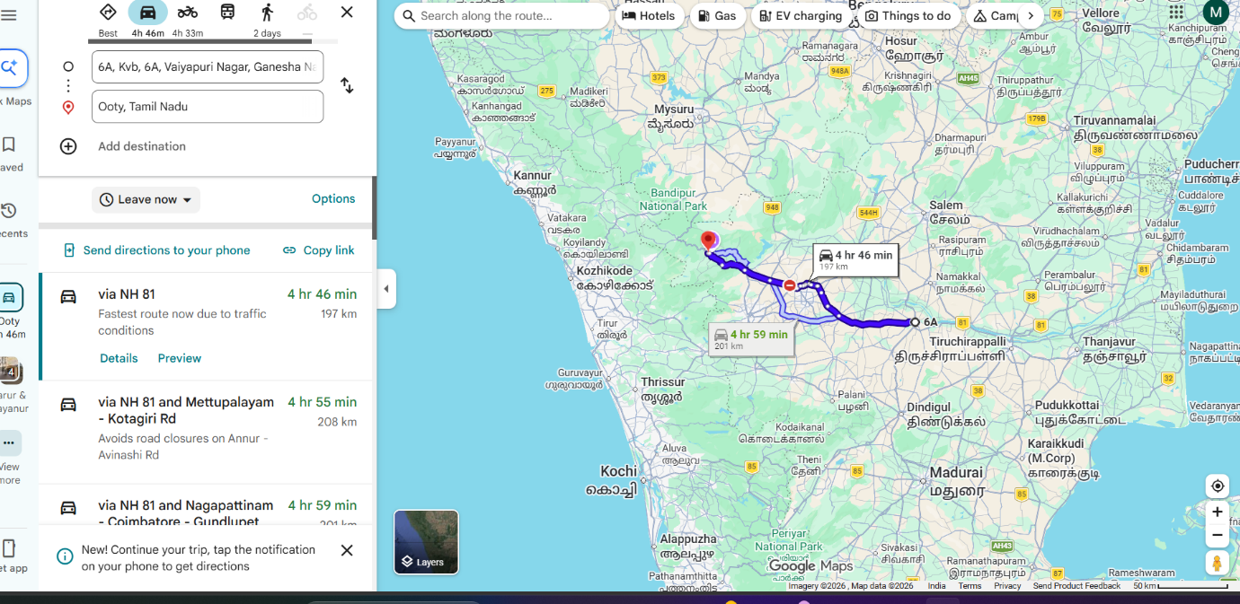

AI ITINERARY PLANNER
The AI Itinerary Planner is one of the main features of the IndiRoam application.
Planning a complete travel itinerary manually can require more time and effort.
The user provides travel requirements such as destination and trip information.
The application sends the user requirements to the AI system.
Gemini AI processes the information and generates a suitable travel itinerary.
The generated itinerary helps the user understand how the trip can be organized.
This feature reduces the manual effort required for searching and creating travel schedules.
The AI Itinerary Planner makes the travel planning process easier and more interactive.
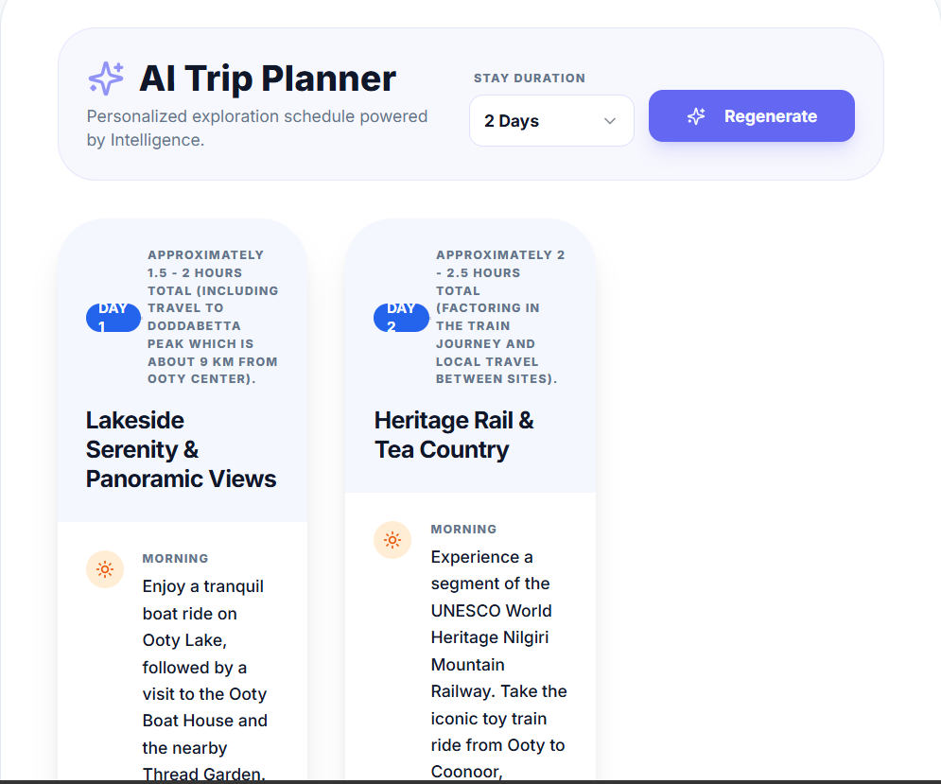

DISCOVER MODULE
The Discover Module is one of the main features of the IndiRoam Smart Travel Companion. It helps users explore various tourist destinations and interesting places available in the application. Instead of searching for travel information from multiple websites, users can easily discover suitable destinations through a single platform.
The module displays different destinations with useful information such as the place name, location, description, images, major attractions, and other travel-related details. Users can browse the available destinations and select a particular place to view detailed information.
After selecting a destination, the user can access additional features related to that place, including travel guides, safety information, budget planning, and AI-based trip planning. The Discover Module is designed with a simple and user-friendly interface, making it easier for travelers to explore and learn about different destinations.
By integrating destination discovery with other features of IndiRoam, this module provides a convenient starting point for users to plan their journey. It reduces the time and effort required to search for travel information and improves the overall travel planning experience.
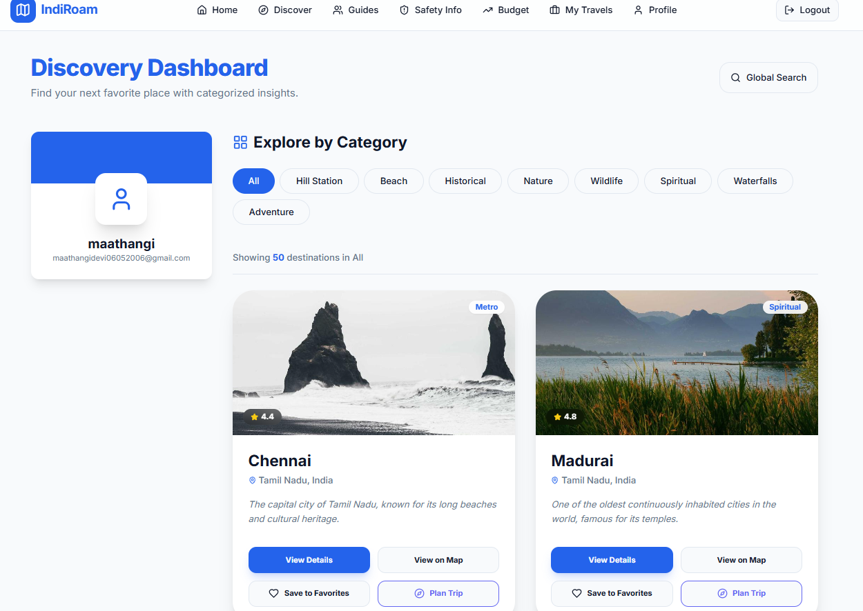

GUIDES MODULE
The Guides Module is an important feature of the IndiRoam Smart Travel Companion that helps users access useful travel guidance for different destinations. This module is designed to provide travelers with essential information about a place before and during their journey.
The module displays travel guides related to various destinations available in the application. Users can browse the list of guides and select a particular guide to view detailed information. Each guide provides useful details and suggestions that help travelers understand the destination and plan their visit more effectively.
The Guides Module helps users obtain important travel information in a simple and organized manner instead of searching across multiple websites. It is especially useful for users who are visiting an unfamiliar destination and require basic guidance about the place.
By integrating travel guidance with other modules such as Discover, Safety Information, Budget Planning, and AI Trip Planner, the Guides Module improves the overall functionality of the IndiRoam application. It provides users with a convenient and user-friendly way to access destination-related guidance and helps them make better travel decisions.
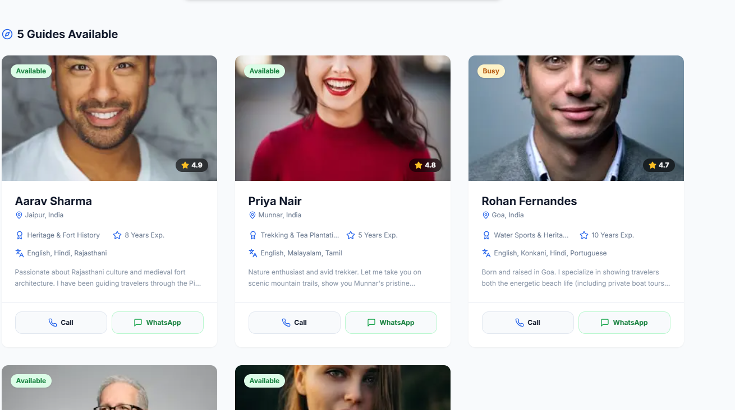

SAFETY INFO MODULE
The Safety Info Module is an important feature of the IndiRoam Smart Travel Companion designed to improve the safety and awareness of users during travel. Travelers visiting unfamiliar destinations may not be aware of possible risks, emergency situations, or important safety precautions related to that location.
This module provides useful safety-related information based on the selected travel destination. It helps users understand important precautions and provides guidance that can be useful before and during the journey. The module is designed to make safety information easily accessible within the same travel application.
The Safety Info Module also uses the user’s real-time location access to support location-based safety assistance. Based on the available location information, the application can provide relevant safety guidance and help users access useful emergency-related information during their trip.
By integrating the Safety Info Module with other features such as the Discover Module, Guides Module, AI Itinerary Planner, and Budget Planner, IndiRoam provides a more complete travel assistance experience. This module improves user awareness and makes the application useful not only for travel planning but also for supporting travelers during their journey.

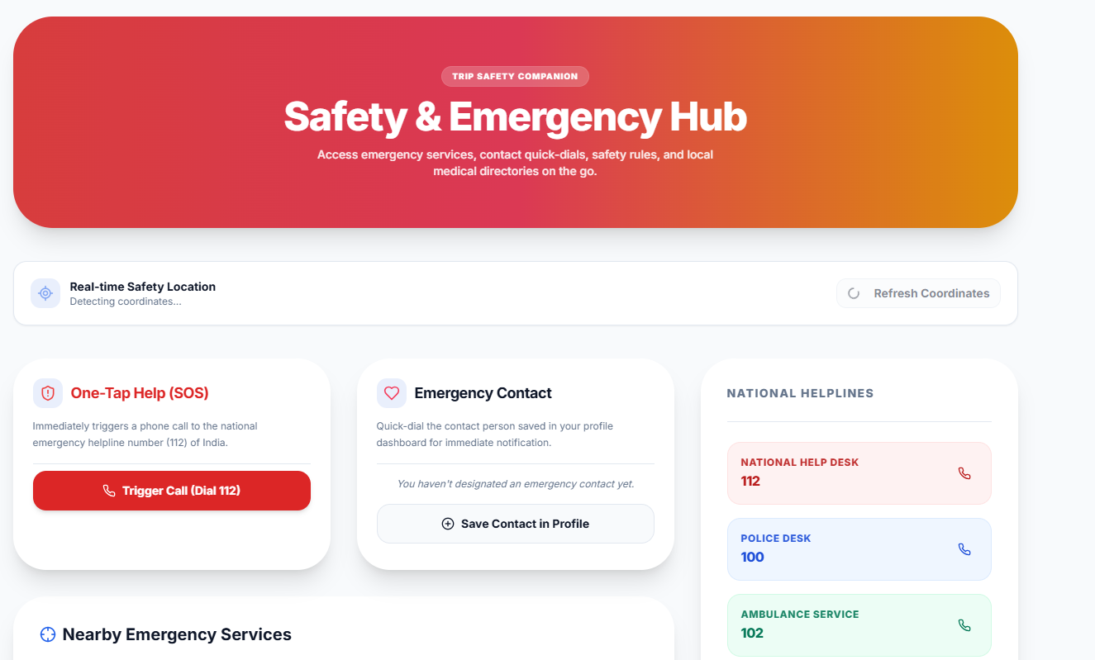

BUDGET MODULE
The Budget Module is an important feature of the IndiRoam Smart Travel Companion designed to help users plan and manage their travel expenses. Budget planning is an essential part of any journey because travelers need to consider various expenses such as transportation, accommodation, food, sightseeing, and other activities.
The module allows users to provide their trip-related requirements and helps them estimate the expected cost of the journey. Based on the available travel details, the system organizes the expenses into different categories, making it easier for users to understand how their travel budget may be spent.
The Budget Module helps users plan their trips according to their financial requirements and reduces the difficulty of manually calculating different travel expenses. It provides a simple and organized view of the estimated budget, allowing travelers to make better decisions before starting their journey.
By integrating the Budget Module with other features such as the AI Itinerary Planner, Discover Module, Guides Module, and Safety Info Module, IndiRoam provides a more complete travel planning experience. This module makes the application more useful by combining travel planning and expense estimation within a single platform.
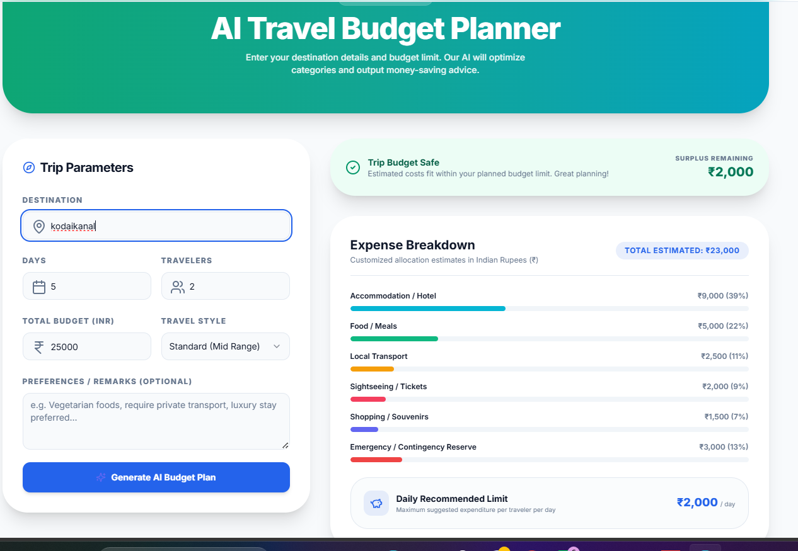

MY TRAVEL MODULE
The My Travels Module is an important feature of the IndiRoam Smart Travel Companion designed to help users store, organize, and manage their planned trips in a single place. Users may create different travel plans, and managing all these details separately can be difficult. This module provides a simple and organized way to access travel information.
When a user creates and saves a trip, the relevant travel details are displayed in the My Travels section. This allows users to view their saved trips and access important information related to their travel plans whenever required. Since the module is connected with the user account, each user can manage their own travel information separately.
The My Travels Module improves the overall travel management process by providing a centralized location for saved travel plans. Instead of searching for previously created trip details again, users can easily access them through this module.
By integrating the My Travels Module with other features such as the AI Itinerary Planner, Discover Module, Guides Module, Safety Info Module, and Budget Module, IndiRoam provides a more organized and user-friendly travel experience. This module helps users efficiently manage their travel plans and makes the overall trip planning process more convenient.
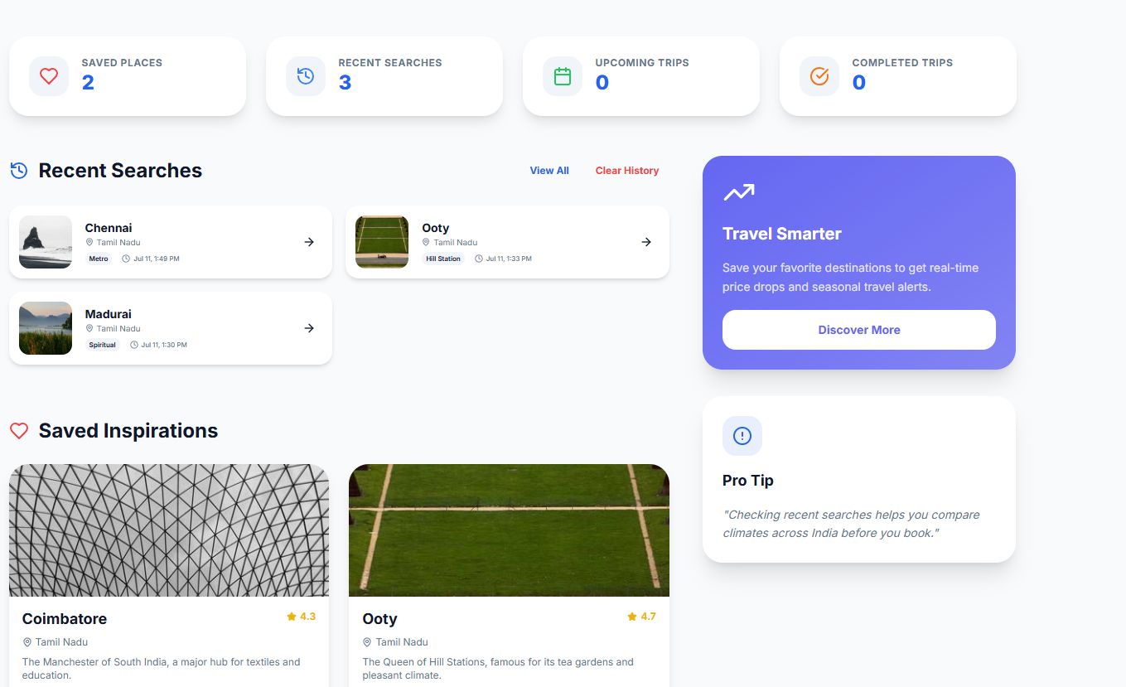

FIREBASE AUTHENTICATION AND DATABASE
Firebase is an important technology used in the IndiRoam application.
Firebase Authentication provides user registration and login functionality.
When users enter their credentials, Firebase processes the authentication request.
After successful authentication, the user can access the application.
Firestore is used for storing and managing application-related information.
Firebase provides cloud-based services, which reduces the requirement for developing and maintaining a separate authentication infrastructure.
The integration of Firebase improves the security, reliability, and data management capability of the IndiRoam application.

GEMINI AI INTEGRATION
Artificial Intelligence is one of the main technologies used in the IndiRoam project.
Gemini AI is integrated into the application to process user requirements and provide intelligent travel assistance.
When the user provides travel-related information, the application sends the request to the AI system.
Gemini AI analyzes the request and generates a suitable response.
AI integration is mainly useful for itinerary generation and intelligent travel assistance.
The quality of the generated response depends on the information provided by the user.
Gemini AI improves the application by providing dynamic responses instead of only displaying fixed travel information.

IMPLEMENTATION METHODOLOGY
The IndiRoam Smart Travel Companion was developed using a step-by-step implementation approach. The main aim of the methodology was to design, develop, integrate, test, and deploy all the travel-related features in an organized manner.
- Requirement Analysis
In the first stage, the major problems faced by travelers were identified. Based on these requirements, important features such as AI trip planning, destination discovery, local travel guidance, safety information, budget planning, and travel management were selected.
- User Interface Design
The application interface was designed to provide a simple and user-friendly experience. Separate modules were created for Login and Signup, Discover, Guides, Safety Info, Budget Planner, My Travels, Profile, and AI Trip Planner.
- User Authentication and Profile Development
Firebase Authentication was integrated to provide secure Login and Signup functionality. The Profile Management feature was developed to allow registered users to manage their personal information.
- Firebase and Database Integration
Firebase and Firestore services were integrated with the application for managing user profiles and application-related data. This helps the system store and retrieve required information.
- AI Integration
Gemini AI was integrated into the application to provide intelligent travel assistance. The AI Trip Planner processes user requirements and generates suitable travel itineraries.
- Travel Module Development
Different travel-related modules were developed and integrated into the application. The Discover Module helps users explore destinations, while the Guides Module provides useful local travel information.
- Real-Time Location Integration
Location access functionality was implemented to obtain the user’s current location with permission. This feature supports location-based services and improves the travel assistance provided by the application.
- Safety and Budget Module Development
The Safety Info Module was developed to provide useful safety-related information and assistance. The Budget Module was implemented to help users estimate and organize expected travel expenses.
- My Travels Module Development
The My Travels Module was implemented to help authenticated users access and manage their saved travel plans in a centralized location.
- Testing and Debugging
Each module was tested individually to identify and correct errors. The complete application was also tested after integrating all modules to verify that the features worked together properly.
- Version Control Using GitHub
Git and GitHub were used for source code management and version control. Project changes were committed and pushed to the GitHub repository during development.
- Application Deployment
Finally, the completed application was deployed using Vercel. The deployed website was tested to verify Login, Signup, AI features, and other application functionalities in the production environment.
Through this implementation methodology, the IndiRoam Smart Travel Companion was successfully developed by combining Artificial Intelligence, real-time location access, Firebase cloud services, and modern web technologies into a single travel assistance platform.

DEPLOYMENT PROCESS
The IndiRoam Smart Travel Companion was deployed using a systematic process to make the web application accessible online. After completing the development and local testing, the project was prepared for production deployment.
- Local Development and Testing
Initially, the application was developed and tested in the local development environment. All major modules, including Login, Signup, AI Trip Planner, Discover, Guides, Safety Info, Budget Planner, My Travels, and Profile, were checked before deployment.
- Source Code Management Using Git
Git was used as the version control system to manage changes made to the project. The updated project files were added and committed to maintain the development history.
- Uploading the Project to GitHub
After completing the required changes, the project source code was pushed to the GitHub repository. GitHub was used to securely store and manage the project code.
- Connecting GitHub with Vercel
The GitHub repository containing the IndiRoam project was connected to Vercel. This connection allows Vercel to access the latest version of the source code for deployment.
- Environment Variable Configuration
Required environment variables, such as the Gemini API key, were securely configured in Vercel. This method prevents sensitive API credentials from being directly exposed in the project source code.
- Production Build Process
Vercel automatically started the build process after receiving the project source code from GitHub. During this process, the required project files and dependencies were prepared for the production environment.
- Production Deployment
After the build process was successfully completed, the application was deployed to the production environment. Vercel generated a public web address through which the IndiRoam application could be accessed online.
- Post-Deployment Testing
After deployment, the application was tested again to verify the functionality of Login, Signup, Firebase integration, AI Trip Planner, and other travel-related modules in the production environment.
- Updating the Deployed Application
Whenever changes or new features are added to the project, the updated source code can be committed and pushed to GitHub. Vercel automatically receives the latest code and creates a new deployment.
Thus, the IndiRoam Smart Travel Companion was successfully deployed using Git, GitHub, and Vercel. The deployment process makes the application accessible online and provides an efficient method for managing and publishing future project updates.

TESTING AND VALIDATION
The IndiRoam Smart Travel Companion was tested and validated to ensure that all the developed modules work correctly and provide the expected results. Testing was carried out during different stages of development and also after the final deployment of the application.
- User Authentication Testing
The Login and Signup functionalities were tested using different user accounts. Firebase Authentication was verified to ensure that users could securely create accounts and log in to the application.
- Profile Module Testing
The Profile Module was tested to check whether users could enter, save, and manage their profile information correctly.
- AI Trip Planner Testing
The AI Trip Planner was tested using different destinations and travel requirements. The integration with Gemini AI was checked to verify whether suitable travel itineraries were generated based on user input.
- Discover Module Testing
The Discover Module was tested to ensure that users could explore destinations and access the available travel-related information properly.
- Real-Time Location Testing
The real-time location feature was tested by allowing location permission through the browser. The system was checked to ensure that it could access the user’s current location and provide location-based functionality.
- Guides Module Testing
The Guides Module was tested to verify whether users could access the available local travel guides and related information.
- Safety Info Module Testing
The Safety Info Module was tested to ensure that users could access useful safety-related information and emergency assistance features.
- Budget Module Testing
The Budget Module was tested using different travel requirements to verify whether the system could provide useful travel expense estimations and budget-related information.
- My Travels Module Testing
The My Travels Module was tested to check whether users could access and manage their saved travel plans correctly.
- Integration Testing
All the developed modules were tested together to verify the communication and functionality between different parts of the application. Firebase services, Gemini AI, real-time location access, and the user interface were checked after integration.
- Local Environment Testing
Before deployment, the complete application was tested in the local development environment. Errors identified during testing were corrected before the application was deployed.
- Production Testing
After deployment using Vercel, the application was tested again through the public website. The major features were checked to ensure that they worked correctly in the production environment.
- Validation of Results
The outputs produced by different modules were checked to verify whether they matched the expected functionality. The final testing results showed that the major modules of the IndiRoam application were successfully integrated and could provide the required travel assistance features.
Thus, the testing and validation process helped identify and correct errors during the development and deployment stages. The final IndiRoam Smart Travel Companion was successfully tested to ensure that its major features provide a functional, organized, and user-friendly travel experience.

RESULTS AND DISCUSSION
The IndiRoam Smart Travel Companion was successfully developed and deployed as a web-based travel assistance application. The final system combines multiple travel-related services into a single platform and provides a simple and user-friendly experience.
- Successful User Authentication
The Login and Signup functionalities were successfully implemented using Firebase Authentication. Users can create accounts, log in, and access the application features.
- AI-Based Trip Planning
The AI Trip Planner was integrated with Gemini AI to process user requirements and generate suitable travel itineraries. This reduces the time and manual effort required for trip planning.
- Destination Discovery
The Discover Module allows users to explore different travel destinations and access useful travel-related information in an organized manner.
- Real-Time Location Access
The application successfully uses real-time location access with user permission. This feature supports location-based travel services and improves the overall user experience.
- Local Travel Guidance
The Guides Module provides useful travel guidance and contact information, helping users obtain assistance while visiting unfamiliar destinations.
- Safety Information and Assistance
The Safety Info Module provides useful safety-related information and emergency assistance, making the application useful not only for trip planning but also during travel.
- Travel Budget Planning
The Budget Module helps users estimate and organize expected travel expenses. It supports better financial planning before starting a journey.
- Travel Management
The My Travels Module allows users to access and manage their saved travel plans in a centralized location.
- Firebase Integration
Firebase Authentication and Firestore were successfully integrated for user authentication, profile management, and application-related data storage.
- Successful Web Deployment
The complete application was successfully deployed using Vercel. The deployed website can be accessed online through different devices with an internet connection.
The final results show that the IndiRoam Smart Travel Companion successfully integrates Artificial Intelligence, real-time location access, cloud-based services, and modern web technologies into a single application. The developed system reduces the need to use multiple travel platforms and provides a more organized, convenient, and interactive travel planning experience.


CONCLUSION
The IndiRoam Smart Travel Companion was successfully developed as an AI-powered web application to simplify the travel planning and management process. The main objective of the project was to combine multiple travel-related services into a single platform and reduce the need for users to depend on different websites and applications.
The developed system provides several useful features, including secure user authentication, AI-based trip planning, destination discovery, real-time location access, local travel guidance, safety information, budget planning, and travel management. The integration of Gemini AI helps provide intelligent travel assistance, while Firebase Authentication and Firestore support secure user authentication and data management.
The real-time location feature improves the application by providing location-based travel assistance. The Discover, Guides, Safety Info, Budget, and My Travels modules work together to provide a more organized and convenient travel experience. The completed application was successfully tested and deployed using Vercel, making it accessible online.
Thus, the IndiRoam Smart Travel Companion demonstrates the practical use of Artificial Intelligence, cloud services, real-time location technology, and modern web development in the travel and tourism field. The developed system provides a simple, interactive, and user-friendly platform that makes travel planning easier, more organized, and convenient for users.

ADVANTAGES
- Centralized Travel Platform
IndiRoam combines multiple travel-related services into a single application, reducing the need to use different websites and platforms.
- AI-Based Trip Planning
The AI Trip Planner uses Gemini AI to generate suitable travel itineraries based on user requirements.
- Real-Time Location Access
The application accesses the user’s current location with permission and supports location-based travel assistance.
- Easy Destination Discovery
The Discover Module helps users explore different travel destinations and access useful travel-related information.
- Local Travel Guidance
The Guides Module provides useful guidance and contact information for travelers visiting unfamiliar locations.
- Safety and Emergency Assistance
The Safety Info Module provides useful safety-related information and emergency assistance during travel.
- Travel Budget Planning
The Budget Module helps users estimate and organize expected travel expenses.
- Easy Travel Management
The My Travels Module allows users to access and manage their saved travel plans in a centralized location.
- Secure User Authentication
Firebase Authentication provides secure Login and Signup functionality for users.
- Cloud-Based Data Management
Firebase and Firestore are used to manage user profiles and application-related information.
- User-Friendly Interface
The application provides a simple and interactive interface, making it easier for users to access different features.
- Online Accessibility
Since the application is deployed using Vercel, users can access the website online through different devices with an internet connection.

APPLICATIONS
• AI-Based Trip Planning
The application helps users generate suitable travel itineraries based on their travel requirements.
• Tourist Destination Discovery
Users can explore different tourist destinations and access useful travel-related information through the Discover Module.
• Real-Time Location-Based Assistance
The system uses the user’s current location, with permission, to provide useful location-based travel services.
• Travel Management
The My Travels Module helps users organize, save, and manage their travel plans in a centralized platform.
• Local Travel Guidance
The Guides Module provides useful travel guidance and contact information for users visiting unfamiliar destinations.
• Travel Safety Assistance
The Safety Info Module provides safety-related information and emergency assistance to improve user awareness during travel.
• Travel Budget Planning
The Budget Module helps users estimate and organize expected travel expenses such as transportation, accommodation, food, and other activities.
• Personalized Travel Assistance
Gemini AI provides intelligent travel assistance based on the requirements and information provided by the user.
• Individual and Family Trip Planning
The application can be used by individuals and families to plan and organize their trips more conveniently.
• Educational and Business Travel Planning
IndiRoam can also help students and professionals organize travel for educational visits, business trips, and other purposes.
• Assistance for Travelers Visiting Unfamiliar Places
The integrated Discover, Guides, Location, and Safety features help users obtain useful assistance while visiting new destinations.
• Centralized Travel Assistance
The system combines multiple travel-related services into a single platform, reducing the need for users to depend on different applications.

LIMITATIONS
Internet Connection Required
The application requires an active internet connection to access AI, Firebase, location-based, and other online services.
Dependence on External Services
The application depends on services such as Gemini AI, Firebase, and Vercel. Any service interruption may temporarily affect certain features.
AI Response Variation
The quality and accuracy of AI-generated travel plans may vary depending on the information provided by the user and the AI model response.
Location Permission Required
Real-time location-based features work only when the user provides location access permission.
Limited Real-Time Information
The current system may not provide complete real-time information about traffic, transportation schedules, and weather conditions.
No Direct Booking Facility
The application currently does not provide direct hotel, flight, train, or bus booking functionality.
Limited Offline Functionality
Most features of the application cannot be fully accessed without an internet connection.
Dependence on API Availability
AI-based features may be affected by API usage limits, configuration issues, or temporary service unavailability.

FUTURE ENHANCEMENT
• Real-Time Weather Information
Live weather data can be integrated to provide current weather conditions and forecasts for travel destinations.
• Live Traffic Updates
Real-time traffic information can be added to help users identify traffic conditions and plan better travel routes.
• Hotel and Transportation Booking
Direct booking facilities for hotels, flights, trains, and buses can be integrated into the application.
• Advanced Personalized AI Recommendations
The AI system can be improved to provide more personalized travel suggestions based on users’ previous trips, interests, and preferences.
• Multilingual Support
Multiple language support can be added to make the application easier to use for travelers from different regions.
• Mobile Application Development
A dedicated Android and iOS mobile application can be developed to improve accessibility and convenience.
• Offline Travel Assistance
Important travel details, itineraries, guides, and safety information can be made available offline for areas with limited internet connectivity.
• Real-Time Transportation Tracking
Live tracking of buses, trains, and other transportation services can be integrated into the application.
• Advanced Emergency Assistance
The Safety Info Module can be improved by providing faster access to nearby hospitals, police stations, and other emergency services based on the user’s current location.
• Voice-Based AI Assistant
Voice interaction can be added to allow users to communicate with the AI Travel Assistant using voice commands.
• Smart Notification System
Notifications and reminders can be provided for travel schedules, important activities, safety alerts, and other trip-related information.
• Improved Budget Management
The Budget Module can be enhanced to track actual travel expenses and compare them with the initially planned budget.
• User Reviews and Ratings
A review and rating system can be added to allow users to share their travel experiences and provide feedback about destinations.
• Group Travel Planning
The application can be enhanced to allow multiple users to collaboratively create and manage a common travel plan.
• Advanced AI-Based Travel Assistance
Future versions of IndiRoam can use more advanced AI models to provide improved itinerary generation, destination recommendations, budget optimization, and real-time travel assistance.

REFERENCES
[1] K. Al Fararni, F. Nafis, B. Aghoutane, A. Yahyaouy, J. Riffi, and A. Sabri, “Hybrid Recommender System for Tourism Based on Big Data and AI: A Conceptual Framework,” Big Data Mining and Analytics, vol. 4, no. 1, pp. 47–55, Mar. 2021, doi: 10.26599/BDMA.2020.9020015.
[2] T. Alenezi and S. Al-Ahmadi, “Normalized Attraction Travel Personality Representation for Improving Travel Recommender Systems,” IEEE Access, vol. 10, pp. 52747–52759, 2022, doi: 10.1109/ACCESS.2022.3178439.
Firebase Documentation — Login, Signup, Authentication, Firestore/database-related implementation.
Google Gemini / Genkit Documentation — AI Trip Planner and AI-based travel assistance integration.
Next.js Documentation — namma web application development and project structure.
GitHub Documentation — source code repository and version control process.
Vercel Documentation — application deployment and Environment Variables configuration.

