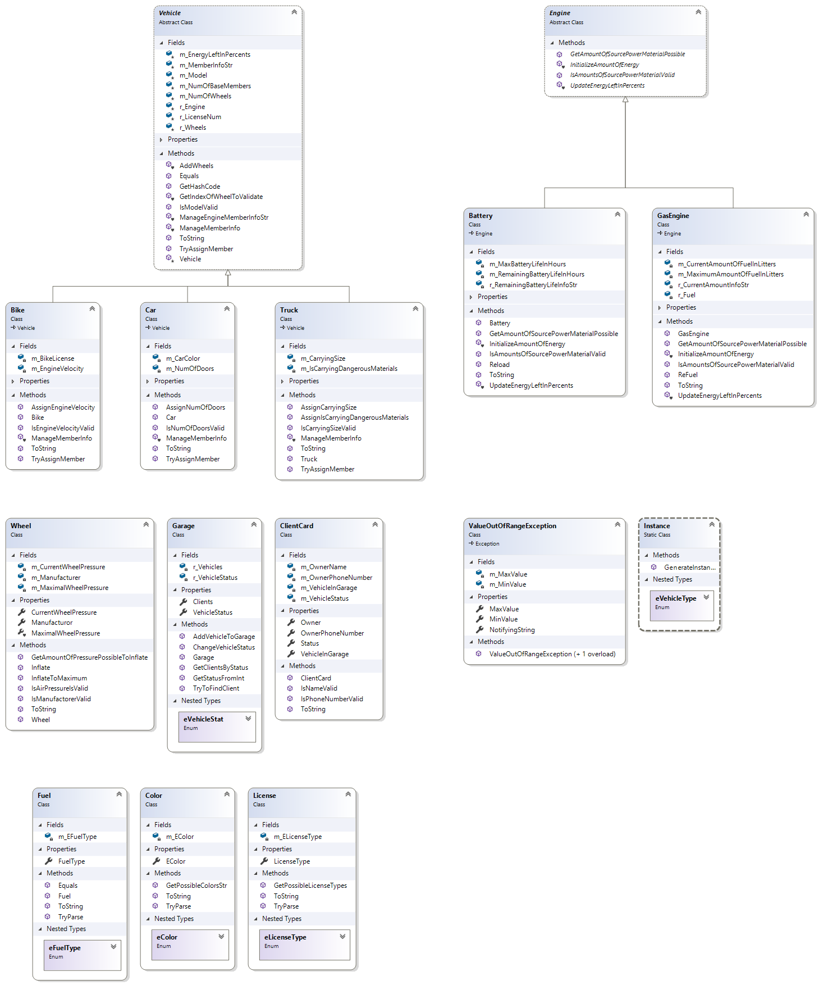

A short explanation about the classes:

Vehicle: Base class for all vehicles, contains an engine object, which determines whether it is a gasoline vehicle or an electric vehicle

Truck, Bike, Car each class is a derived class from Vehicle and has the unique features that mentioned in the task.

Engine: Base class for Battery(Used by electric vehicles) and GasEngine(Used by gasoline vehicles)

Wheel: Class for each wheel, able to inflate and validate its fields.

Garage: Contains all information about the vehicles currently in the garage and their owners

Client card: Class that contains the client information ( Name, Contact and his vehicle).

Instance: Creates the actual object of vehicle.

Fuel: class for Fuel objects (contained by GasEngine objects), contains the fuel types and auxiliary functions.

Color: class for Color object (contained by Car objects) , has the colors that supported by the garage and auxiliary functions.

License: class for License object ( contained by Bike objects), has all the types of License supported by the garage and auxiliary functions.