

Ben-Gurion University of the Negev

Faculty of Engineering Science

School of Electrical and Computer Engineering

Dept. of Communication Systems Engineering

Fourth Year Engineering Project

Preliminary report

Autonomous Driving using Swarms

**Project Number:** p-2023-003

**Students:** Noy Ella 312252257, Maayan Ben-Gal 311438733

**Supervisors:** Prof. Michael Segal

**Submitting Date:** 08/01/2023

**Table of Contents:**

Abstract 3

Abstract (English) 3

Abstract (Hebrew) 4

Project’s Goal 5

Research Proposal: Spec Sheet 5

Product Essence 5

Technologies and Methodologies that Will be Used in the Project 5

Work Plan 6

Application for our Project 6

System Performance Spec 7

General Scheme 7

Literature review 8

General background 8

Different Approaches for the Problem 9

Planning proposal 10

Schema of the system 10

Schema of our algotihm 11

Project Constraints 12

Project Assumptions 12

Initial Risks 12

Defining the Content of the Project  12

Final Testing Proposal 13

Budget Estimation 14

Schedule and Work Division 15

Gantt 15

Gantt chart 16

Bibliography 17

Appendix 18

PRE Evaluation 18

Copyright and Confidentiality Form 19

# Abstract

## Abstract (English):

**Autonomous Driving using Swarms**

Students Names: Ben-Gal Maayan, Ella Noy

*bengalm*[*@post.bgu.ac.il*](mailto:axalrod@post.bgu.ac.il)

The future of transportation depends on development of autonomous vehicles that are required to function in real-time and make decisions according to traffic conditions, when contacting an external factor may take valuable time and cause accidents in cases of a communication failure.

The goal of the project is to develop an algorithm that creates swarms of vehicles with peer-to-peer (P2P) communication in a decentralized manner. Each swarm is a group of vehicles moving together as one, according to their destination and the vehicle's location on the road in real-time. The algorithm must organize the vehicles with a minimal number of steps until the swarms are stabilized.

The concept of communication without an external server is innovative in the context of autonomous vehicles. Beyond the idea of ​​communication without a human factor, the idea of ​​swarms can improve the decision-making of a vehicle.

The method will include a fixed number of vehicles on a road with more than one lane, each vehicle having a color according to its destination. Each car can communicate with vehicles up to 100 meters, to identify its swarm mates. After dealing with this, edge cases will be considered to improve the algorithm and adapt it to reality. In the end, the expectation is to develop a single initial algorithm that could be installed on all autonomous vehicle systems and will organize the moving vehicles into swarms in a minimum time.

Keywords – Innovative transportation, Autonomic cars, Autonomous Driving, Distributed algorithms, P2P, Swarms, real-time, SUMO (vehicle simulation software).

## Abstract (Hebrew):

**נהיגה אוטונומית בעזרת להקות**

שמות הסטודנטים: בן-גל מעיין, אלה נוי

*bengalm*[*@post.bgu.ac.il*](mailto:axalrod@post.bgu.ac.il)

עתיד התחבורה תלוי בפיתוח רכבים אוטונומיים הנדרשים לתפקד ולקבל החלטות בזמן-אמת בהתאם לתנאי התנועה והשטח, כאשר יצירת קשר עם גורם חיצוני כגון חדר בקרה עלול לגזול זמן יקר ולגרום לתאונות במקרה של נפילת תקשורת.

מטרת הפרויקט לפתח אלגוריתם המייצר להקות רכבים הנעים בכביש בעזרת תקשורת עמית לעמית (P2P) באופן מבוזר. כל להקה היא קבוצת רכבים הנעה יחד כרכב אחד, על פי יעד הנסיעה בהתאם לרכבים הממוקמים על הכביש בזמן אמת. על האלגוריתם לארגן את הרכבים כך שכמות השלבים עד להתייצבות הלהקות בכביש תהיה מינימלית.

הרעיון של תקשורת ללא שרת חיצוני הוא חדשני בהקשר של רכבים אוטונומיים. מעבר לרעיון התקשורת ללא גורם אנושי, רעיון הלהקות יכול לשפר משמעותית את תהליך קבלת ההחלטות של הרכב.

שיטת העבודה תכלול מספר קבוע של רכבים על כביש בעל למעלה מנתיב אחד, כאשר לכל רכב יש צבע על פי יעדו הסופי. לכל מכונית ישנה יכולת לתקשר עם רכבים עד 100 מטר, על מנת לזהות את חבריו העתידיים ללהקה. לאחר התמודדות עם מצב זה נוסיף מקרי קצה במטרה לשפר את האלגוריתם ולהתאימו למציאות. בסיום הפרויקט הצפי הוא לפתח אלגוריתם ראשוני יחיד שיותקן על כל מערכות הרכבים האוטונומיים וייבצע את ארגון הרכבים הנעים ללהקות בזמן מינימלי.

מילות מפתח: תחבורה חדשנית, רכבים אוטונומיים, נהיגה אוטונומית, אלגוריתמים מבוזרים, P2P, להקות, זמן אמת, SUMO (תוכנת סימולציית רכבים).

# Project’s Goal

The goal of the project is to develop an algorithm that maps moving cars to swarms using peer-to-peer communication in real-time with minimum steps until the stabilization of the swarms. The idea is to sort the cars by their destination by marking every car with color and creating a swarm from all the cars with the same color on the road, this way every swarm can move and be referred to as a single car.

# Research Proposal: Spec Sheet

Autonomous Driving using Swarms

## Product Essence:

The idea is to create an algorithm that makes autonomous vehicles move as one in a swarm in real-time. If, and when this algorithm will be good enough and there is the technology for it, the algorithm can not only reduce the amount of message traffic on the network but also can be used to remove all the traffic jams on the roads as we know today.

## Technologies and Methodologies that Will be used in the Project:

* + - Communication protocols – The cars use peer-to-peer communication when there is a difference between inter-swarm and intra-swarm communication. The car communicates by broadcasting messages and unicast messages. Broadcast messages are required to find cars with the same color, and the unicast messages are required to talk with a specific car to become a swarm or with the swarm leader to get instructions. A possible existing communication protocol that we will use is (DSRC) protocol. Dedicated short-range communications are one-way or two-way short-range to medium-range wireless communication channels specifically designed for automotive use [11].
    - Physical conditions – Our algorithm must depend on a few physical conditions like the roadway, the number of lanes on the road, the different cars or traffic around each car, the communication ability of the cars, and even the speed limit. All these physical conditions are important and need to be considered in the protocols and the algorithm. The initial physical conditions are an infinite road with 2 lanes and no speed limit, the cars can send a message up to 100 meters radius.
    - Simulation of Urban Mobility (SUMO) – SUMO is an open-source, microscopic, multi-modal traffic simulation. [2] SUMO can simulate large traffic and network features; it can be used in Python. This package is the way the algorithm simulation tool will be used to simulate different states and edge cases. [3]
    - Driving Protocols – The cars are Autonomous, which means they need to know how to drive, the cars must know simple driving protocols – such as speeding up, slowing down, passing other cars by speeding in another lane, and stopping at a red light.[4]

## Work Plan:

* + - Create a basic algorithm that handles with only two swarms on 2 lanes infinite road.
    - Simulate the algorithm and check simple edge cases and check the algorithm performance.
    - Develop the algorithm for more than two swarms and more than two lanes, check if the way of decision-making is more efficient and if the traffic can be stabilized into swarms with minimal steps.
    - Simulate and check the efficiency in cases when a new car enters the road or leaves the road along with other simple edge cases.
    - Formulate the protocol that should be coded on every single car.
    - Try to formulate a protocol that can be used on autonomic cars and semi-autonomic cars as well, define protocols dealing with complicated human-dependent edge cases, and create a simulation with randomly generated traffic to test it.

## Applications for our Project:

The project's algorithm's purpose is to create a program based on the algorithm that will be compatible with all types of autonomous vehicles. The project will reduce the need for vehicles to communicate with an external server in real-time and even avoid problems arising from server crashes or communication fails. In the future, the goal is that it will even be possible to apply the algorithm to semi-autonomous cars and make the project more relevant to what exists on the markets today.

## System Performance Spec:

The algorithm can change the way autonomous cars are perceived, get a better way of monitoring autonomous traffic and lower the risks around real-time decisions of autonomic individual cars. The algorithm allows the cars to lower the dependence on navigating systems and lower the risks around other cars' decisions – when the cars drive as a swarm there is a lower risk of a car interrupting the traffic unexpectedly and making the other cars react and decide in real-time with higher risk for accidents.

## General Scheme:

Figure 1: General diagram of the algorithm's flow.

As described in Fig. 1, the algorithm input is random traffic of vehicles with different destinations as we mark by different colors. Each vehicle goes through the steps of the algorithm and each swarm is perceived as one vehicle instructed by the swarm's leader. Every round the algorithm will ask if all the cars are divided into swarms, if so it would get the wanted output of swarms of cars sorted by destination, else it would repeat the steps as shown.

# Literature review

## General background:

An Autonomous car, also known as a Self-driving Car, is a vehicle that can drive in its environment (in the case of a car - road) using auxiliary sensors such as distance and motion sensors, video cameras, radars, etc., and perform tasks according to navigation protocol without human intervention [8]. The autonomous car can be used to drive a human passenger (without taking control of the vehicle) or be used as an autonomous courier to deliver Shipments such as packages, food deliveries, and more. The main goal of the autonomous car is to go wherever a traditional car goes and do everything an experienced human driver does. Nowadays the Society of Automotive Engineers (SAE) [10] defines 6 levels of driving automation from Level 0 (No automation) to Level 5 (full automation). Those levels are divided into two parts: in levels 0-2 the human monitors the driving environment and in levels 3-5 the automated system monitors the driving environment [6]. As of 2022, autonomous cars are still in the planning, development, and testing stages and many companies such as Google, Mobileye, Tesla, General Motors, and more are in different stages of development and at different levels of automation. Today, fully autonomous cars are not yet available to the general public meaning there are only semi-autonomous cars today on the market [8].

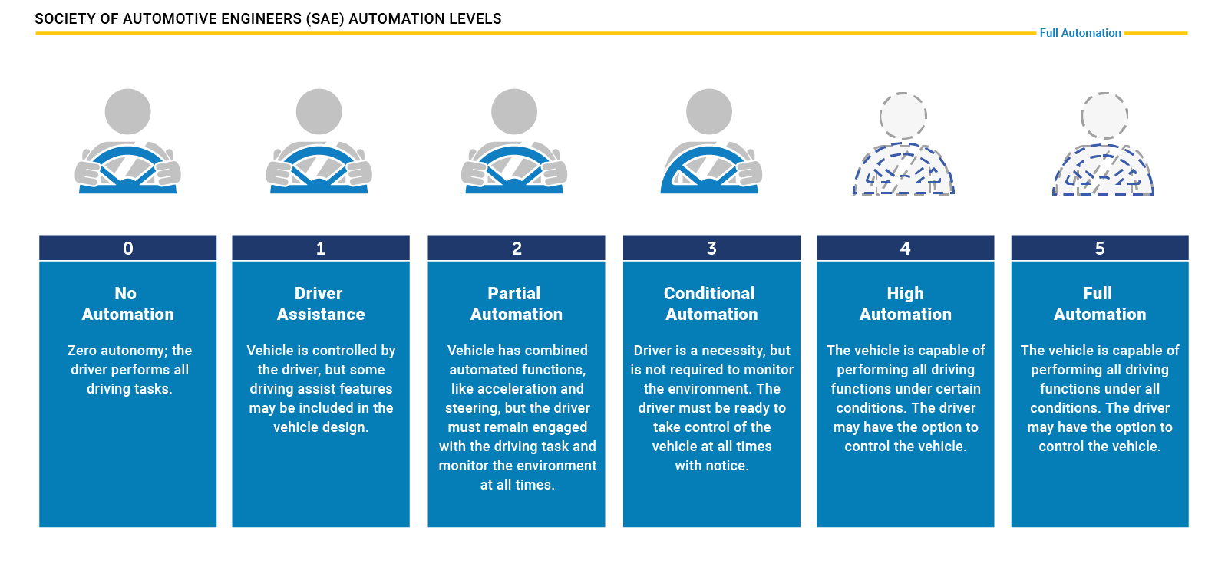

Figure 2: levels of driving automation [7]

Automated driving using swarm intelligence is a rising technology in recent years. It is based on swarm behavior among animals such as ants and birds that utilize the power of the swarm to improve the performance of each individual in the group and of the group. Incorporating swarm intelligence into autonomous cars helps in avoiding collisions with neighbors, optimizing each car in terms of energy consumption, improves performance, and enables cooperative driving between autonomous cars.

## Different Approaches for the Problem:

* One approach is developing an algorithm that creates swarms according to physical geographical proximity of the vehicles in real time**.** That is, the cars on the road will communicate and connect to a collective according to their position on the road at a minimum distance. In prof. Michael Segal article [1] a D-Cut algorithm is presented that generates clusters of vehicles according to their position on the road and chooses a temporary leader for the swarm each time. The advantage of this approach is that the swarm creation and stabilization time is fast. Another advantage is that there is a limit on the number of vehicles in each cluster, which gives a simple intra-swarm communication protocol. A disadvantage of this approach is the instability of the swarm in a situation where a vehicle leaves the group when it reaches its destination. Since the vehicles in the swarm do not necessarily reach the same destination, the group will not remain intact throughout the route.
* Another approach is to develop an algorithm to create swarms when the communication between the moving cars is not Peer-2-Peer but through the cloud. The information about each car (velocity, location on the road, etc.) is stored in the cloud, which is updated immediately and shared with all vehicles on the road [9]. The advantage of this approach is efficient use of memory, instead of each car containing all the information about all the cars and the road conditions, the information is saved once in the cloud with quick access to all the cars. The disadvantage of this approach is the reliance on an external factor (cloud) in real-time systems. The access to cloud memory, however fast, can sometimes be harmful in real-time systems. In case of server crash, all the cars on the road are immediate disabled and require a human intervention.

# Planning proposal

## Scheme of the system:

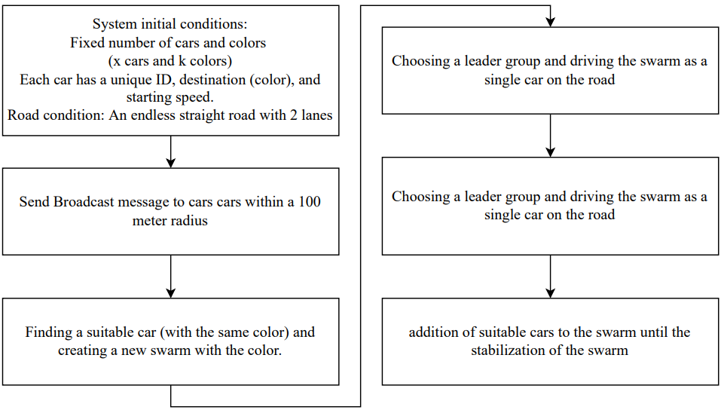

Figure 3: Rectangular scheme of the system

The algorithm developed in our project is an algorithm for creating swarms of autonomous cars organized according to their destination. The initial conditions given to the simulator are a fixed number of cars (at this stage in the project) where each car has a color, an initial position on the road and an initial speed. When the simulation runs, the algorithm is applied to each car: each car starts driving and sends broadcast messages to all the cars in its reception area. When a car with the same color receives the message, it returns a unicast message to the sending car in order to create a swarm with it in their common color. When there is an agreement, the cars can catch up with each other when the cars behind must advance to the car in front and not the other way around. When the two cars are at some threshold from each other, they create the swarm and choose a leader for the swarm arbitrarily. From this moment on, the cars move on the road as one when the swarm leader decides at what speed and whether it is necessary to switch lanes. The swarm continues to send and receive BC messages from cars in its area until the swarm contains all cars of the given color. The algorithm converges when all the autonomous cars on the road are arranged in swarms according to their color.

## Scheme of out algorithm:

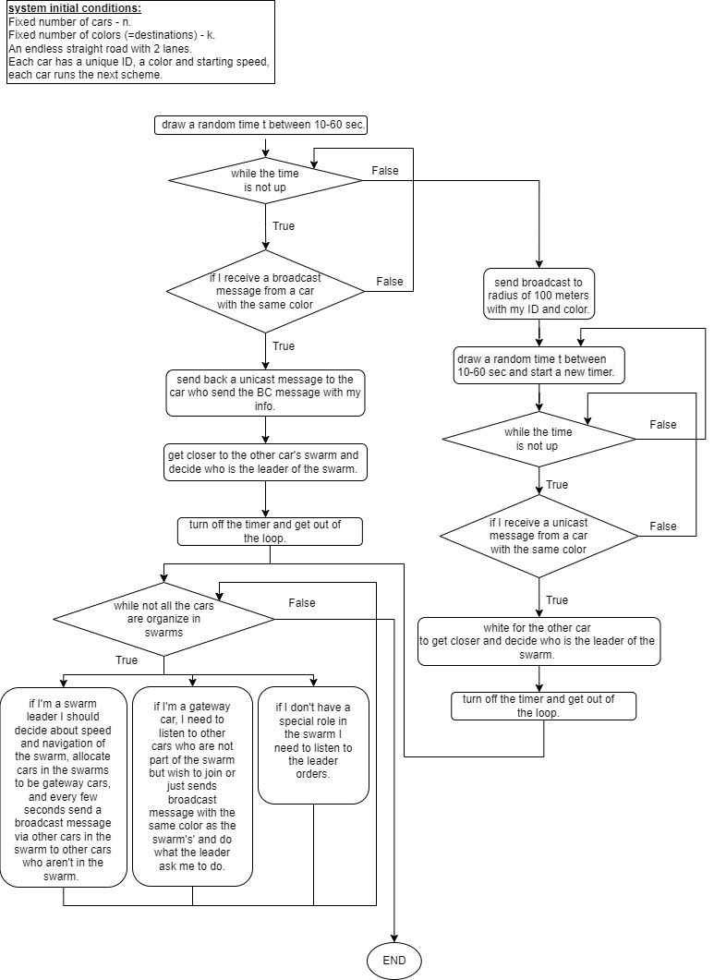

## Project Constraints:

### The project is limited to the conditions of the simulator and if we want to test a function that does not exist in it, we will not be able to test it reliably.

### There is not currently a way to examine our algorithm in real-life traffic conditions.

### There is not currently suitable technology to implement our algorithm in real-life. (There only Semi-autonomous cars nowadays)

## Project Assumptions:

### The assumptions regarding the road conditions are that the road is endlessly straight without interchanges or exits and without bumps in the road that could cause accidents.

### The number of cars on the road and their colors at any moment is fixed and cars do not leave or enter the road (As of today, changes may be added during the project, depending on its progress).

## Initial Risks:

### As explained in ‘Project Constraints’ above, SUMO has limitations, planning our future algorithm, we are taking a risk of the simulation system not performing close enough to the real real-life traffic conditions.

### The algorithm we are developing is innovative and requires complex functionality, so there is no guarantee that we will indeed be able to achieve all the required performance by the end of the project.

# Defining the Content of the Project

* The project main content is an algorithm for autonomous vehicles, which organize moving vehicles on the road in real-time to swarms by their destinations. The algorithm will be written in python but will also be presented in pseudo-code. The algorithm will be using P2P communication protocols and will work under basic assumptions such as the vehicles autonomous high level, finite number of destinations.
* To evaluate and demonstrate the algorithm the project will contain a simulation of the algorithm. The simulation will be performed by 'SUMO' simulator supported by python codes. The simulation will present different situations with different inputs and a few edge cases. The simulation will be limited according to the limits of the SUMO simulator.
* One of the main assumptions of the algorithm is the vehicles are completely autonomous (and not semiautonomous as we have in the market nowadays). When the technology will be available, a future step of this project is a software or electrical component that could be uploaded or installed on the autonomous vehicles. Another option is to create a continuation project that will create an adapter with software that implements the algorithm on semiautonomous vehicles. Unfortunately, the project (and the world) is limited by the existing technology and this step hopefully would be able to proceed in the future only.

# Final Testing Proposal

* The project simulation will be the main tool to test the project's algorithm. The simulation will test the project's performance with the following categories:
  + Swarm's congestion – the first way to check the correctness of the algorithm is to check whether all the vehicles devised into swarms, at first the organizing shouldn't be limited in time in order to check if there is a congestion. After knowing the swarms do congest, the next step is to optimize the congestion time by defining a threshold value that depends by the number of vehicles and the number of destinations (=swarms).
  + Environment conditions – the algorithm performance depends on the terms of the road due to the idea the algorithm needs to be able to work in real-time. To make it easier at first the simulation will check performance on a scenario of a finite number of cars that start their driving in the same initial time, the next scenario will be a finite number determent in advance and start driving at a random time. A progress scenario is the random number of cars that get onto the road in different places in the road and at different random times.
  + Edge cases – in real life the vehicles will need to deal with unexpected situations, progress testing will include situations with edge cases such as failure of communication between cars, or a car that needs to stop driving and moving according to an emergency, car who need to change its destination, dealing with an unexpected road obstacle, etc.

# Budget Estimation

### Working Hours

|  |  |  |  |
| --- | --- | --- | --- |
| Total Cost | Cost per Hour | Amount | Parameter |
|  |  | 12 months | Project Duration |
|  |  | 2 | Number of Students |
| 61,440 ₪ | 80 ₪ | 8 | Weekly Hours per Student |
| 4,800₪ | 100 ₪ | 1 | Weekly Consultant Hours with Prof. Michael Segal |
| 66,240₪ | **Total Salary** | | |

### Hardware and Software

|  |  |  |
| --- | --- | --- |
| Total Cost | Amount | Device/Software |
| 6,800₪ | 2 | Personal Computers |
| 400 ₪ | 2 | Microsoft Office |
| 0 ₪ | 1 | SUMO simulator |
| 7,200₪ | **Total Cost** | |

### Total Budget Estimation

|  |  |
| --- | --- |
| Total Cost | Parameter |
| 66,240₪ | Salary |
| 16,560₪ | Overheads 25% |
| 82,800₪ | Salary + Overheads |
| 7,200₪ | Hardware and Software |
| 90,000₪ | **Summary** |

# Schedule and Work Division

### Gantt:

|  |  |  |  |
| --- | --- | --- | --- |
| Task | Duration | Estimated Start Date | Estimated Finish Date |
| Learning the systems | 31 days | 01/08/2022 | 31/08/2022 |
| Studying theoretical material | 40 days | 01/09/2022 | 09/10/2022 |
| Writing PDR report | 20 days | 10/10/2022 | 29/10/2022 |
| PDR Submission | 15 days | 30/10/2022 | 12/11/2022 |
| Learning the SUMO simulator | 38 days | 13/11/2022 | 20/12/2022 |
| Writing Preliminary report | 15 days | 13/11/2022 | 26/11/2022 |
| Preliminary Submission | 15 days | 27/11/2022 | 11/12/2022 |
| Read Articles | 30 days | 30/11/2022 | 30/12/2022 |
| Develop Initial Algorithm | 20 days | 30/11/2022 | 20/12/2022 |
| Testing Initial Algorithm in SUMO | 10 days | 21/12/2022 | 31/12/2022 |
| Create video for Technology Ventures | 15 days | 01/01/2023 | 14/01/2023 |
| Technology Ventures Submission | 15 days | 15/01/2023 | 29/01/2023 |
| Exams period | 15 days | 22/01/2023 | 05/02/2023 |
| Writing Progress report | 15 days | 04/03/2023 | 18/03/2023 |
| Progress Submission | 15 days | 19/03/2023 | 02/04/2023 |
| Develop Algorithm - continued | 35 days | 05/02/2023 | 11/03/2023 |
| Testing Algorithm in SUMO | 15 days | 12/03/2023 | 25/03/2023 |
| Algorithm Correction and Retest | 30 days | 26/03/2023 | 24/04/2023 |
| Writing Poster | 10 days | 10/05/2023 | 20/05/2023 |
| Poster Submission | 15 days | 21/05/2023 | 04/06/2023 |
| Writing Presentation | 20 days | 01/05/2023 | 20/05/2023 |
| Presentation Submission | 15 days | 21/05/2023 | 04/06/2023 |
| Results evaluation and conclusions | 20 days | 25/05/2023 | 13/06/2023 |
| Writing Final report | 15 days | 10/06/2023 | 24/06/2023 |
| Final Submission | 15 days | 25/06/2023 | 09/07/2023 |

### Gantt chart:

# Bibliography

|  |  |
| --- | --- |
| [1] | Yair Allouche and Michael Segal. “A cluster-based beaconing approach in vanets: Near optimal topology via proximity information”. English. In: Mo- bile Networks and Applications 18.6 (Dec. 2013) |
| [2] | SUMO wikipidia. https://en.wikipedia.org/wiki/Simulation_of_Urban_MObility |
| [3] | SUMO Overview. https://www.eclipse.org/sumo/ |
| [4] | Yadhu Prakash et al. “Incorporation of Swarm Intelligence in Autonomous Cars”. In: 2014 |
| [5] | Y. Anand and R. Ajithkumar, "Autonomous Car With Swarm Intelligence," 2019 2nd International Conference on Intelligent Computing, Instrumentation and Control Technologies (ICICICT), 2019, pp. 1659-1662 |
| [6] | https://www.synopsys.com/automotive/what-is-autonomous-car.html |
| [7] | https://accoladetechnology.com/5-levels-of-autonomy-l1-and-l2/ |
| [8] | Self-driving Car wikipidia: https://en.wikipedia.org/wiki/Self-driving_car |
| [9] | https://carbiketech.com/swarm-intelligence-automated-driving/ |
| [10] | SAE Official Website :https://www.sae.org/ |
| [11] | DSVR wikipidia: https://en.wikipedia.org/wiki/Dedicated_short-range_communications |

# Appendix:

## PRE Evaluation

**המלצת ציון (ע"י מנחה אקדמי) לדו"ח מכין**

אם יש צורך, לכל סטודנט/ית בנפרד

מספר הפרויקט: p-2023-003

שם הפרויקט: נהיגה אוטונומית בעזרת להקות.

שם המנחים מהמחלקה: פרופסור מיכאל סגל.

שם הסטודנטית: נוי אלה ת.ז.: 312252257

שם הסטודנטית: מעיין בן גל ת.ז.: 311438733

|  |  |  |  |  |  |  |
| --- | --- | --- | --- | --- | --- | --- |
| % |  | חלש  55-64 | בינוני  65-74 | טוב  75-84 | ט"מ  85-94 | מצוין  95-100 |
| 15 | הבנת הנושא הצורך וסביבת היישום |  |  |  |  |  |
| 15 | חיפוש מקורות והבנת עבודות דומות |  |  |  |  |  |
| 15 | שלמות דף מפרט (הצעת מחקר) |  |  |  |  |  |
| 15 | הצעת תכנון ותכנון הבדיקות הסופיות |  |  |  |  |  |
| 10 | גילוי יוזמה וחריצות |  |  |  |  |  |
| 20 | פתרון בעיות, מקוריות ותרומה אישית  (מעבר למילוי ההנחיות) |  |  |  |  |  |
| 10 | הערכת תקציב, לו"ז וחלוקת עבודה,  ציון מקורות ושלמות כללית |  |  |  |  |  |

הערכת רמת הקושי של הפרויקט: קל מאוד / קל / בינוני / קשה / קשה מאוד.

הערות:

## Copyright and Confidentiality Form:

**טופס כיבוד זכויות יוצרים וסודיות:**

יש לצרף את הטופס הבא חתום לדוח מכין:

אני מצהירה שלא אעשה שימוש בפרויקט ההנדסי שלי בכל חומר בעל זכויות יוצרים כגון:

טקסט,

תמונה,

אודיו,

וידיאו ,

מוזיקה,

סרט,

אנימציה,

תוכנה

חומרה

תיכנון מעגל

ללא קבלת אישור מראש מבעל הזכויות

אני מצהירה שאשלב בפרויקט ההנדסי שלי בדוחות, סרטונים, והרצאות אינפורמציה שאינה נחלת הכלל רק בתנאי שאושרה מראש ע"י בעל הזכויות.

הרישום לפרויקט ההנדסי משמש ההתחייבות שלי לקיים ולכבד זכויות יוצרים וסודיות

חתימה: נוי אלה        תאריך: 27.11.2022

חתימה: מעיין בן גל         תאריך: 27.11.2022