09/02/2024

1)CREATE A TABLE CALLED CUSTOMER

SQL> CREATE TABLE EMPLOYEE(EMPNO NUMBER PRIMARY KEY,ENAME VARCHAR2(20),JOB VARCHAR2(20),MGRNO NUMBER,SAL NUMBER);

Table created.

SQL> DESC EMPLOYEE

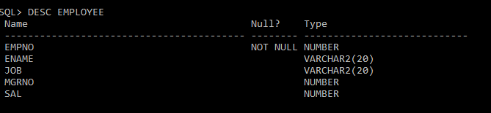

SQL> INSERT INTO EMPLOYEE VALUES(&EMPNO,'&ENAME','&JOB',&MGRNO,&SAL);

Enter value for empno: 101

Enter value for ename: AKSHARA

Enter value for job: PEON

Enter value for mgrno: 10

Enter value for sal: 1001

old 1: INSERT INTO EMPLOYEE VALUES(&EMPNO,'&ENAME','&JOB',&MGRNO,&SAL)

new 1: INSERT INTO EMPLOYEE VALUES(101,'AKSHARA','PEON',10,1001)

1 row created.

SQL> /

Enter value for empno: 102

Enter value for ename: AKSHAY

Enter value for job: OWNER

Enter value for mgrno: 00

Enter value for sal: 125000

old 1: INSERT INTO EMPLOYEE VALUES(&EMPNO,'&ENAME','&JOB',&MGRNO,&SAL)

new 1: INSERT INTO EMPLOYEE VALUES(102,'AKSHAY','OWNER',00,125000)

1 row created.

SQL> /

Enter value for empno: 103

Enter value for ename: ALEX

Enter value for job: MANAGER

Enter value for mgrno: 01

Enter value for sal: 100000

old 1: INSERT INTO EMPLOYEE VALUES(&EMPNO,'&ENAME','&JOB',&MGRNO,&SAL)

new 1: INSERT INTO EMPLOYEE VALUES(103,'ALEX','MANAGER',01,100000)

1 row created.

SQL> SELECT * FROM EMPLOYEE;

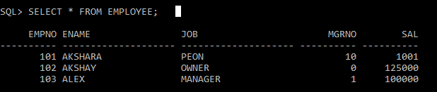

SQL> UPDATE EMPLOYEE SET JOB='CASHIER' WHERE EMPNO=101;

1 row updated.

SQL> SELECT * FROM EMPLOYEE;

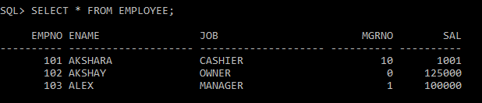

SQL> UPDATE EMPLOYEE SET SAL=60000 WHERE EMPNO=101;

1 row updated.

SQL> SELECT * FROM EMPLOYEE;

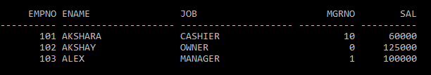SQL> ALTER TABLE EMPLOYEE RENAME COLUMN SAL TO SALARY;

Table altered.

SQL> SELECT * FROM EMPLOYEE;

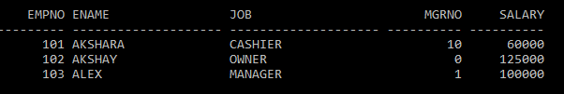

SQL> DELETE FROM EMPLOYEE WHERE EMPNO=103;

1 row deleted.

SQL> SELECT * FROM EMPLOYEE;

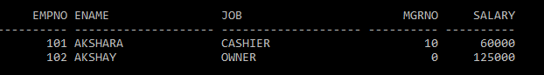

**2)CREATE A TABLE CALLED CUSTOMER TABLE**

|  |  |
| --- | --- |
| NAME | TYPE |
| CUST_NAME | VARCHAR2(20) |
| CUST_STREET | VARCHAR2(20) |
| CUST_CITY | VARCHAR2(20) |

SQL> CREATE TABLE CUSTOMER(CUST_NAME VARCHAR2(20),CUST_STREET VARCHAR2(20),CUST_CITY VARCHAR2(20));

Table created.

1. **INSERT RECORD INTO THE TABLE**

SQL> INSERT INTO CUSTOMER VALUES('&CUST_NAME','&CUST_STREET','&CUST_CITY');

Enter value for cust_name: AKSHARA

Enter value for cust_street: MALLAPPALLY

Enter value for cust_city: PATHANAMTHITTA

old 1: INSERT INTO CUSTOMER VALUES('&CUST_NAME','&CUST_STREET','&CUST_CITY')

new 1: INSERT INTO CUSTOMER VALUES('AKSHARA','MALLAPPALLY','PATHANAMTHITTA')

1 row created.

SQL> /

Enter value for cust_name: AKSHAY

Enter value for cust_street: ANCHAL

Enter value for cust_city: KOLLAM

old 1: INSERT INTO CUSTOMER VALUES('&CUST_NAME','&CUST_STREET','&CUST_CITY')

new 1: INSERT INTO CUSTOMER VALUES('AKSHAY','ANCHAL','KOLLAM')

1 row created.

SQL> /

Enter value for cust_name: AJAY

Enter value for cust_street: KURUKKANCHERY

Enter value for cust_city: THRISSUR

old 1: INSERT INTO CUSTOMER VALUES('&CUST_NAME','&CUST_STREET','&CUST_CITY')

new 1: INSERT INTO CUSTOMER VALUES('AJAY','KURUKKANCHERY','THRISSUR')

1 row created.

SQL> SELECT * FROM CUSTOMER;

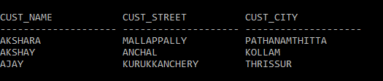

**B)ADD SALARY COLUMN TO THE TABLE**

SQL> ALTER TABLE CUSTOMER ADD (SALARY VARCHAR2(20));

Table altered.

SQL> SELECT * FROM CUSTOMER;

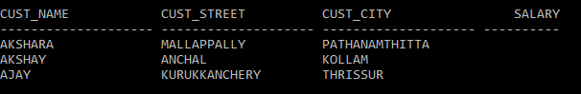

1. **ALTER THE TABLE COLUMN DOMAIN**

SQL> ALTER TABLE CUSTOMER MODIFY SALARY NUMBER;

Table altered.

SQL> SELECT * FROM CUSTOMER;



1. **DROP SALARY COULUMN OF THE TABLE CUSTOMER TABLE**

SQL> ALTER TABLE CUSTOMER DROP COLUMN SALARY;

Table altered.

SQL> SELECT * FROM CUSTOMER;

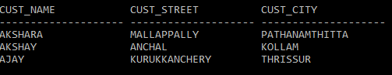

1. **DELETE THE ROWS OF THR CUSTOMER TABLE WHOSE CUST_CITY=”PATHANAMTHITTA”**

SQL> DELETE FROM CUSTOMER WHERE CUST_CITY='PATHANAMTHITTA';

1 row deleted.

SQL> SELECT * FROM CUSTOMER;

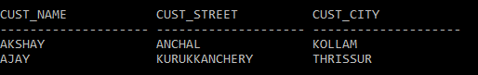

**3) CREATE AN EMPLOYEE TABLE EMP WITH FOLLOWING DATA**

|  |  |
| --- | --- |
| EMPNO | NUMBER(4) |
| ENAME | VARCHAR2(25) |
| JOB | VARCHAR(12) |
| SALARY | NUMBER(10,2) |
| COMMISSION | NUMBER(7,2) |
| DEPTNO | NUMBER(2) |

SQL> CREATE TABLE EMP(EMPNO NUMBER(4) PRIMARY KEY,ENAME VARCHAR2(20),JOB VARCHAR2(20),SALARY NUMBER(10,2),COMMISSION NUMBER(7,2),DEPTNO NUMBER(2));

Table created.

1. **DISPLAY THE STRUCTURE**

SQL> DESC EMP

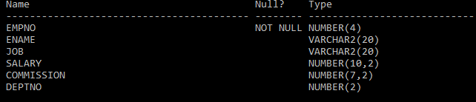

1. **INSERT VALUES**

SQL> INSERT INTO EMP VALUES(&EMPNO,'&ENAME','&JOB',&SALARY,&COMMISSION,&DEPTNO);

Enter value for empno: 101

Enter value for ename: AKSHAY

Enter value for job:NULL

Enter value for salary: 12000

Enter value for commission: 4000

Enter value for deptno: 12

old 1: INSERT INTO EMP VALUES(&EMPNO,'&ENAME','&JOB',&SALARY,&COMMISSION,&DEPTNO)

new 1: INSERT INTO EMP VALUES(101,'AKSHAY','',12000,4000,12)

1 row created.

SQL> /

Enter value for empno: 102

Enter value for ename: AJO

Enter value for job: ANALYST

Enter value for salary: 100000

Enter value for commission: 30000

Enter value for deptno: 13

old 1: INSERT INTO EMP VALUES(&EMPNO,'&ENAME','&JOB',&SALARY,&COMMISSION,&DEPTNO)

new 1: INSERT INTO EMP VALUES(102,'AJO','ANALYST',100000,30000,13)

1 row created.

SQL> /

Enter value for empno: 103

Enter value for ename: ALEX

Enter value for job: PROGRAMMER

Enter value for salary: 70000

Enter value for commission: 30000

Enter value for deptno: 10

old 1: INSERT INTO EMP VALUES(&EMPNO,'&ENAME','&JOB',&SALARY,&COMMISSION,&DEPTNO)

new 1: INSERT INTO EMP VALUES(103,'ALEX','PROGRAMMER',70000,30000,10)

1. row created.
2. **DISPLAY ALL THE RECORDS**

SQL> SET LINESIZE 200

SQL> SELECT * FROM EMP;

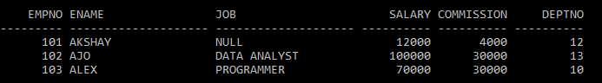

1. **CHANGE THE JOB TYPE NULL TO CLERK**

SQL> UPDATE EMP SET JOB='CLERK' WHERE JOB='NULL';

1 row updated.

SQL> SELECT * FROM EMP;

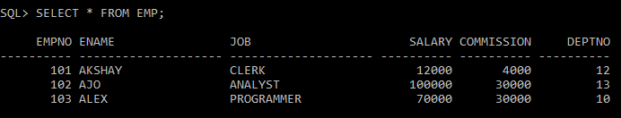

1. **CHANGE THE JOB TYPE ANALYST TO DATA ANALYST**

SQL> UPDATE EMP SET JOB='DATA ANALYST' WHERE JOB='ANALYST';

1 row updated.

SQL> SELECT * FROM EMP;

