**3) CREATE AN EMPLOYEE TABLE EMP WITH FOLLOWING DATA**

|  |  |
| --- | --- |
| EMPNO | NUMBER(4) |
| ENAME | VARCHAR2(25) |
| JOB | VARCHAR(12) |
| SALARY | NUMBER(10,2) |
| COMMISSION | NUMBER(7,2) |
| DEPTNO | NUMBER(2) |

SQL> CREATE TABLE EMP(EMPNO NUMBER(4) PRIMARY KEY,ENAME VARCHAR2(20),JOB VARCHAR2(20),SALARY NUMBER(10,2),COMMISSION NUMBER(7,2),DEPTNO NUMBER(2));

Table created.

1. **DISPLAY THE STRUCTURE**

SQL> DESC EMP

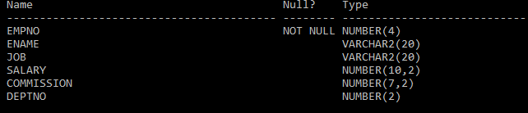

1. **INSERT VALUES**

SQL> INSERT INTO EMP VALUES(&EMPNO,'&ENAME','&JOB',&SALARY,&COMMISSION,&DEPTNO);

Enter value for empno: 101

Enter value for ename: AKSHAY

Enter value for job:NULL

Enter value for salary: 12000

Enter value for commission: 4000

Enter value for deptno: 12

old 1: INSERT INTO EMP VALUES(&EMPNO,'&ENAME','&JOB',&SALARY,&COMMISSION,&DEPTNO)

new 1: INSERT INTO EMP VALUES(101,'AKSHAY','',12000,4000,12)

1 row created.

SQL> /

Enter value for empno: 102

Enter value for ename: AJO

Enter value for job: ANALYST

Enter value for salary: 100000

Enter value for commission: 30000

Enter value for deptno: 13

old 1: INSERT INTO EMP VALUES(&EMPNO,'&ENAME','&JOB',&SALARY,&COMMISSION,&DEPTNO)

new 1: INSERT INTO EMP VALUES(102,'AJO','ANALYST',100000,30000,13)

1 row created.

SQL> /

Enter value for empno: 103

Enter value for ename: ALEX

Enter value for job: PROGRAMMER

Enter value for salary: 70000

Enter value for commission: 30000

Enter value for deptno: 10

old 1: INSERT INTO EMP VALUES(&EMPNO,'&ENAME','&JOB',&SALARY,&COMMISSION,&DEPTNO)

new 1: INSERT INTO EMP VALUES(103,'ALEX','PROGRAMMER',70000,30000,10)

1. row created.
2. **DISPLAY ALL THE RECORDS**

SQL> SET LINESIZE 200

SQL> SELECT * FROM EMP;

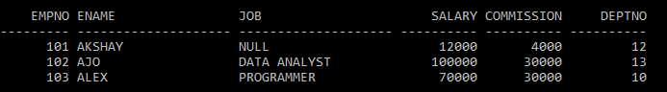

1. **CHANGE THE JOB TYPE NULL TO CLERK**

SQL> UPDATE EMP SET JOB='CLERK' WHERE JOB='NULL';

1 row updated.

SQL> SELECT * FROM EMP;

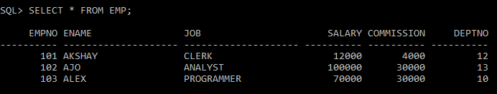

1. **CHANGE THE JOB TYPE ANALYST TO DATA ANALYST**

SQL> UPDATE EMP SET JOB='DATA ANALYST' WHERE JOB='ANALYST';

1 row updated.

SQL> SELECT * FROM EMP;

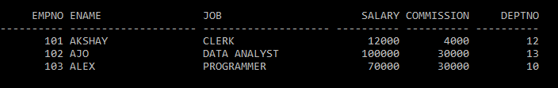

1. **ADD A NEW FIELD DOJ TO THE TABLE AND INSERT THE DATE 17-DEC-80 TO ALL RECORDS**

**ALTER**

SQL>ALTER TABLE EMP ADD(DOJ DATE);

1 row updated.

SQL> UPDATE EMP SET DOJ='17-DEC-2020';

3 rows updated.

SQL> SELECT * FROM EMP;

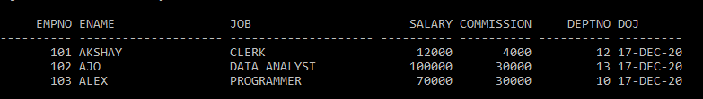

1. **DISPLAY ALL DISTINCT JOB TYPES IN EMP**

SQL> SELECT DISTINCT JOB FROM EMP;

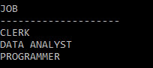

1. **DISPLAY EMPNO,ENAME,JOB FROM THE TABLE**

SQL> SELECT EMPNO,ENAME,JOB FROM EMP;

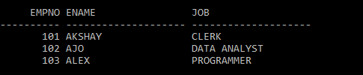

1. **DISPLAY NAME OF EMPLOYEEIN DEPT 10 AND DEPT 12**

SQL> SELECT ENAME FROM EMP WHERE DEPTNO IN(10,12);



1. **FIND THE SUM OF SALARY**

SQL> SELECT SUM(SALARY) FROM EMP;



1. **FIND THE SUM OF SALARY AND COMMISION OF ALL EMPLOYEES**

SQL> SELECT ENAME,SUM(SALARY+COMMISSION)FROM EMP GROUP BY ENAME;



SQL> SELECT JOB,SUM(SALARY+COMMISSION)FROM EMP GROUP BY JOB;



1. **REMOVE THE COLUMN COMMISSIONAND UPDATE SALARY AS SALARY +COMMISION**

SQL> UPDATE EMP SET SALARY=SALARY+COMMISSION;

3 rows updated.

SQL> ALTER TABLE EMP DROP(COMMISSION);

Table altered.

1. **DISPLAY THE EMPLOYEES WITH SALARY**

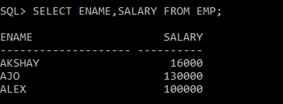

1. **CHANGE COLUMN ENAME TO EMPNAME AND EMPNO TO EMPID**

SQL> ALTER TABLE EMP RENAME COLUMN ENAME TO EMPNAME;

Table altered.

SQL> ALTER TABLE EMP RENAME COLUMN EMPNO TO EMPID;

Table altered.

1. **RENAME TABLE TO EMPLOYEE1**

SQL> ALTER TABLE EMP RENAME TO EMPLOYEE1;

Table altered.

SQL> SELECT * FROM EMPLOYEE1**;**

