QUESTION-2

Create the following tables and execute the queries given below

SAILORS

|  |  |  |  |
| --- | --- | --- | --- |
| sid | sname | rating | age |
| 22 | Dustin | 7 | 45 |
| 29 | Brutas | 1 | 33 |
| 31 | Lubber | 8 | 55 |
| 32 | Andy | 8 | 25 |
| 58 | Rusty | 10 | 35 |
| 64 | Horatio | 7 | 35 |
| 71 | Zorba | 10 | 16 |
| 74 | Horatio | 9 | 35 |
| 85 | Art | 3 | 26 |
| 95 | Bob | 3 | 64 |

BOATS

|  |  |  |
| --- | --- | --- |
| Bid | bname | color |
| 101 | Interlake | Blue |
| 102 | Interlake | Red |
| 103 | Clipper | Green |
| 104 | Marine | Red |

RESERVES

|  |  |  |
| --- | --- | --- |
| sid | bid | day |
| 22 | 101 | 10/10/98 |
| 22 | 102 | 10/10/98 |
| 22 | 103 | 10/8/98 |
| 22 | 104 | 10/7/98 |
| 31 | 102 | 11/10/98 |

|  |  |  |
| --- | --- | --- |
| 31 | 103 | 11/6/98 |
| 31 | 104 | 11/12/98 |
| 64 | 101 | 9/5/98 |
| 64 | 102 | 9/8/98 |
| 74 | 103 | 9/8/98 |

SQL> CREATE TABLE SAILORS(SID NUMBER PRIMARY KEY,SNAME VARCHAR2(20),RATING NUMBER,AGE NUMBER);

Table created.

SQL> INSERT INTO SAILORS VALUES(&SID,'&SNAME',&RATING,&AGE);

Enter value for sid: 22

Enter value for sname: DUSTIN

Enter value for rating: 7

Enter value for age: 45

old 1: INSERT INTO SAILORS VALUES(&SID,'&SNAME',&RATING,&AGE)

new 1: INSERT INTO SAILORS VALUES(22,'DUSTIN',7,45)

1 row created.

SQL> INSERT INTO SAILORS VALUES(&SID,'&SNAME',&RATING,&AGE);

Enter value for sid: 29

Enter value for sname: BRUTAS

Enter value for rating: 1

Enter value for age: 33

old 1: INSERT INTO SAILORS VALUES(&SID,'&SNAME',&RATING,&AGE)

new 1: INSERT INTO SAILORS VALUES(29,'BRUTAS',1,33)

1 row created.

SQL> INSERT INTO SAILORS VALUES(&SID,'&SNAME',&RATING,&AGE);

Enter value for sid: 31

Enter value for sname: LUBBER

Enter value for rating: 8

Enter value for age: 55

old 1: INSERT INTO SAILORS VALUES(&SID,'&SNAME',&RATING,&AGE)

new 1: INSERT INTO SAILORS VALUES(31,'LUBBER',8,55)

1 row created.

SQL> INSERT INTO SAILORS VALUES(&SID,'&SNAME',&RATING,&AGE);

Enter value for sid: 32

Enter value for sname: ANDY

Enter value for rating: 8

Enter value for age: 25

old 1: INSERT INTO SAILORS VALUES(&SID,'&SNAME',&RATING,&AGE)

new 1: INSERT INTO SAILORS VALUES(32,'ANDY',8,25)

1 row created.

SQL> INSERT INTO SAILORS VALUES(&SID,'&SNAME',&RATING,&AGE);

Enter value for sid: 58

Enter value for sname: RUSTY

Enter value for rating: 10

Enter value for age: 35

old 1: INSERT INTO SAILORS VALUES(&SID,'&SNAME',&RATING,&AGE)

new 1: INSERT INTO SAILORS VALUES(58,'RUSTY',10,35)

1 row created.

SQL> INSERT INTO SAILORS VALUES(&SID,'&SNAME',&RATING,&AGE);

Enter value for sid: 64

Enter value for sname: HORATIO

Enter value for rating: 7

Enter value for age: 35

old 1: INSERT INTO SAILORS VALUES(&SID,'&SNAME',&RATING,&AGE)

new 1: INSERT INTO SAILORS VALUES(64,'HORATIO',7,35)

1 row created.

SQL> INSERT INTO SAILORS VALUES(&SID,'&SNAME',&RATING,&AGE);

Enter value for sid: 71

Enter value for sname: ZORBA

Enter value for rating: 10

Enter value for age: 16

old 1: INSERT INTO SAILORS VALUES(&SID,'&SNAME',&RATING,&AGE)

new 1: INSERT INTO SAILORS VALUES(71,'ZORBA',10,16)

1 row created.

SQL> INSERT INTO SAILORS VALUES(&SID,'&SNAME',&RATING,&AGE);

Enter value for sid: 74

Enter value for sname: HORATIO

Enter value for rating: 9

Enter value for age: 35

old 1: INSERT INTO SAILORS VALUES(&SID,'&SNAME',&RATING,&AGE)

new 1: INSERT INTO SAILORS VALUES(74,'HORATIO',9,35)

1 row created.

SQL> INSERT INTO SAILORS VALUES(&SID,'&SNAME',&RATING,&AGE);

Enter value for sid: 85

Enter value for sname: ART

Enter value for rating: 3

Enter value for age: 26

old 1: INSERT INTO SAILORS VALUES(&SID,'&SNAME',&RATING,&AGE)

new 1: INSERT INTO SAILORS VALUES(85,'ART',3,26)

1 row created.

SQL> INSERT INTO SAILORS VALUES(&SID,'&SNAME',&RATING,&AGE);

Enter value for sid: 95

Enter value for sname: BOB

Enter value for rating: 3

Enter value for age: 64

old 1: INSERT INTO SAILORS VALUES(&SID,'&SNAME',&RATING,&AGE)

new 1: INSERT INTO SAILORS VALUES(95,'BOB',3,64)

1 row created.

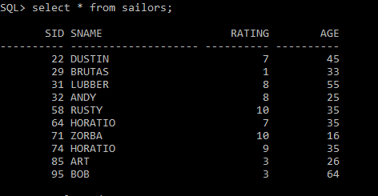

SQL> CREATE TABLE BOATS(BID NUMBER PRIMARY KEY,BNAME VARCHAR2(30),COLOR VARCHAR2(20));

Table created.

SQL> INSERT INTO BOATS VALUES(&BID,'&BNAME','&COLOR');

Enter value for bid: 101

Enter value for bname: INTERLAKE

Enter value for color: BLUE

old 1: INSERT INTO BOATS VALUES(&BID,'&BNAME','&COLOR')

new 1: INSERT INTO BOATS VALUES(101,'INTERLAKE','BLUE')

1 row created.

SQL> INSERT INTO BOATS VALUES(&BID,'&BNAME','&COLOR');

Enter value for bid: 102

Enter value for bname: INTERLAKE

Enter value for color: RED

old 1: INSERT INTO BOATS VALUES(&BID,'&BNAME','&COLOR')

new 1: INSERT INTO BOATS VALUES(102,'INTERLAKE','RED')

1 row created.

SQL> INSERT INTO BOATS VALUES(&BID,'&BNAME','&COLOR');

Enter value for bid: 103

Enter value for bname: CLIPPER

Enter value for color: GREEN

old 1: INSERT INTO BOATS VALUES(&BID,'&BNAME','&COLOR')

new 1: INSERT INTO BOATS VALUES(103,'CLIPPER','GREEN')

1 row created.

SQL> INSERT INTO BOATS VALUES(&BID,'&BNAME','&COLOR');

Enter value for bid: 104

Enter value for bname: MARINE

Enter value for color: RED

old 1: INSERT INTO BOATS VALUES(&BID,'&BNAME','&COLOR')

new 1: INSERT INTO BOATS VALUES(104,'MARINE','RED')

1 row created.

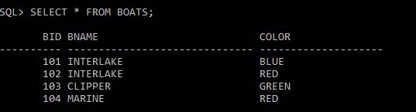

SQL> CREATE TABLE RESERVES(SID NUMBER REFERENCES SAILORS(SID),BID NUMBER REFERENCES BOATS(BID), DAY DATE);

Table created.

SQL> INSERT INTO RESERVES VALUES(&SID,&BID,'&DAY');

Enter value for sid: 22

Enter value for bid: 101

Enter value for day: 10/OCT/98

old 1: INSERT INTO RESERVES VALUES(&SID,&BID,'&DAY')

new 1: INSERT INTO RESERVES VALUES(22,101,'10/OCT/98')

1 row created.

SQL> INSERT INTO RESERVES VALUES(&SID,&BID,'&DAY');

Enter value for sid: 22

Enter value for bid: 102

Enter value for day: 10/OCT/98

old 1: INSERT INTO RESERVES VALUES(&SID,&BID,'&DAY')

new 1: INSERT INTO RESERVES VALUES(22,102,'10/OCT/98')

1 row created.

SQL> INSERT INTO RESERVES VALUES(&SID,&BID,'&DAY');

Enter value for sid: 22

Enter value for bid: 103

Enter value for day: 10/AUG/98

old 1: INSERT INTO RESERVES VALUES(&SID,&BID,'&DAY')

new 1: INSERT INTO RESERVES VALUES(22,103,'10/AUG/98')

1 row created.

SQL> INSERT INTO RESERVES VALUES(&SID,&BID,'&DAY');

Enter value for sid: 22

Enter value for bid: 104

Enter value for day: 10/JUL/98

old 1: INSERT INTO RESERVES VALUES(&SID,&BID,'&DAY')

new 1: INSERT INTO RESERVES VALUES(22,104,'10/JUL/98')

1 row created.

SQL> INSERT INTO RESERVES VALUES(&SID,&BID,'&DAY');

Enter value for sid: 31

Enter value for bid: 102

Enter value for day: 11/OCT/98

old 1: INSERT INTO RESERVES VALUES(&SID,&BID,'&DAY')

new 1: INSERT INTO RESERVES VALUES(31,102,'11/OCT/98')

1 row created.

SQL> INSERT INTO RESERVES VALUES(&SID,&BID,'&DAY');

Enter value for sid: 31

Enter value for bid: 103

Enter value for day: 11/JUN/98

old 1: INSERT INTO RESERVES VALUES(&SID,&BID,'&DAY')

new 1: INSERT INTO RESERVES VALUES(31,103,'11/JUN/98')

1 row created.

SQL> INSERT INTO RESERVES VALUES(&SID,&BID,'&DAY');

Enter value for sid: 31

Enter value for bid: 104

Enter value for day: 11/DEC/98

old 1: INSERT INTO RESERVES VALUES(&SID,&BID,'&DAY')

new 1: INSERT INTO RESERVES VALUES(31,104,'11/DEC/98')

1 row created.

SQL> INSERT INTO RESERVES VALUES(&SID,&BID,'&DAY');

Enter value for sid: 64

Enter value for bid: 101

Enter value for day: 9/MAY/98

old 1: INSERT INTO RESERVES VALUES(&SID,&BID,'&DAY')

new 1: INSERT INTO RESERVES VALUES(64,101,'9/MAY/98')

1 row created.

SQL> INSERT INTO RESERVES VALUES(&SID,&BID,'&DAY');

Enter value for sid: 64

Enter value for bid: 102

Enter value for day: 9/AUG/98

old 1: INSERT INTO RESERVES VALUES(&SID,&BID,'&DAY')

new 1: INSERT INTO RESERVES VALUES(64,102,'9/AUG/98')

1 row created.

SQL> INSERT INTO RESERVES VALUES(&SID,&BID,'&DAY');

Enter value for sid: 74

Enter value for bid: 103

Enter value for day: 9/AUG/98

old 1: INSERT INTO RESERVES VALUES(&SID,&BID,'&DAY')

new 1: INSERT INTO RESERVES VALUES(74,103,'9/AUG/98')

1 row created.

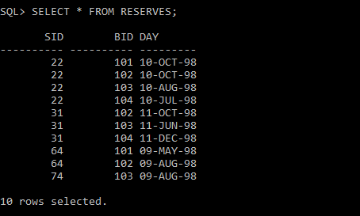

**1. Find the names and ages of all sailors**

SQL> SELECT SNAME,AGE FROM SAILORS;

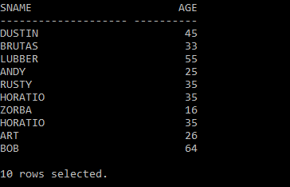

**2. Find all information of sailors who have reserved boat number 101.**

SQL>SELECT * FROM SAILORS S,RESERVES R WHERE S.SID=R.SID AND R.BID=101;

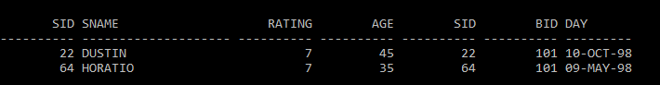

**3. Find all sailors with rating above 7**

SQL> SELECT * FROM SAILORS WHERE RATING>7;

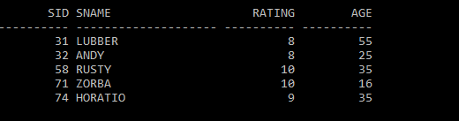

**4. Find the names of sailors who have reserved boat no 103**

SQL>SELECT SNAME FROM SAILORS S,RESERVES R WHERE S.SID=R.SID AND R.BID=103;

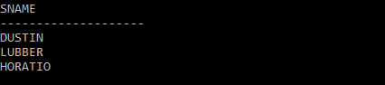

**5. Find the names of sailors who have reserved a red boat, and list in the order of age.**

SQL> SELECT SNAME FROM SAILORS WHERE SID IN(SELECT SID FROM RESERVES WHERE BID IN(SELECT BID FROM BOATS WHERE COLOR='RED'))ORDER BY AGE;

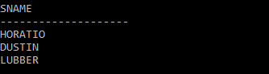

6. Find the names of sailors who have reserved either a red or green boat