**2)CREATE A TABLE CALLED CUSTOMER TABLE**

|  |  |
| --- | --- |
| NAME | TYPE |
| CUST_NAME | VARCHAR2(20) |
| CUST_STREET | VARCHAR2(20) |
| CUST_CITY | VARCHAR2(20) |

SQL> CREATE TABLE CUSTOMER(CUST_NAME VARCHAR2(20),CUST_STREET VARCHAR2(20),CUST_CITY VARCHAR2(20));

Table created.

1. **INSERT RECORD INTO THE TABLE**

SQL> INSERT INTO CUSTOMER VALUES('&CUST_NAME','&CUST_STREET','&CUST_CITY');

Enter value for cust_name: AKSHARA

Enter value for cust_street: MALLAPPALLY

Enter value for cust_city: PATHANAMTHITTA

old 1: INSERT INTO CUSTOMER VALUES('&CUST_NAME','&CUST_STREET','&CUST_CITY')

new 1: INSERT INTO CUSTOMER VALUES('AKSHARA','MALLAPPALLY','PATHANAMTHITTA')

1 row created.

SQL> /

Enter value for cust_name: AKSHAY

Enter value for cust_street: ANCHAL

Enter value for cust_city: KOLLAM

old 1: INSERT INTO CUSTOMER VALUES('&CUST_NAME','&CUST_STREET','&CUST_CITY')

new 1: INSERT INTO CUSTOMER VALUES('AKSHAY','ANCHAL','KOLLAM')

1 row created.

SQL> /

Enter value for cust_name: AJAY

Enter value for cust_street: KURUKKANCHERY

Enter value for cust_city: THRISSUR

old 1: INSERT INTO CUSTOMER VALUES('&CUST_NAME','&CUST_STREET','&CUST_CITY')

new 1: INSERT INTO CUSTOMER VALUES('AJAY','KURUKKANCHERY','THRISSUR')

1 row created.

SQL> SELECT * FROM CUSTOMER;

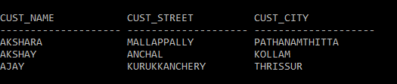

**B)ADD SALARY COLUMN TO THE TABLE**

SQL> ALTER TABLE CUSTOMER ADD (SALARY VARCHAR2(20));

Table altered.

SQL> SELECT * FROM CUSTOMER;

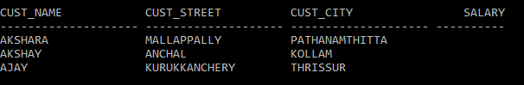

1. **ALTER THE TABLE COLUMN DOMAIN**

SQL> ALTER TABLE CUSTOMER MODIFY SALARY NUMBER;

Table altered.

SQL> SELECT * FROM CUSTOMER;



1. **DROP SALARY COULUMN OF THE TABLE CUSTOMER TABLE**

SQL> ALTER TABLE CUSTOMER DROP COLUMN SALARY;

Table altered.

SQL> SELECT * FROM CUSTOMER;

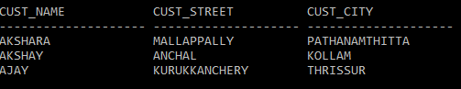

1. **DELETE THE ROWS OF THR CUSTOMER TABLE WHOSE CUST_CITY=”PATHANAMTHITTA”**

SQL> DELETE FROM CUSTOMER WHERE CUST_CITY='PATHANAMTHITTA';

1 row deleted.

SQL> SELECT * FROM CUSTOMER;

