09/02/2024

1)CREATE A TABLE CALLED CUSTOMER

SQL> CREATE TABLE EMPLOYEE(EMPNO NUMBER PRIMARY KEY,ENAME VARCHAR2(20),JOB VARCHAR2(20),MGRNO NUMBER,SAL NUMBER);

Table created.

SQL> DESC EMPLOYEE

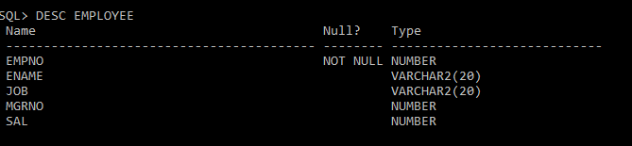

SQL> INSERT INTO EMPLOYEE VALUES(&EMPNO,'&ENAME','&JOB',&MGRNO,&SAL);

Enter value for empno: 101

Enter value for ename: AKSHARA

Enter value for job: PEON

Enter value for mgrno: 10

Enter value for sal: 1001

old 1: INSERT INTO EMPLOYEE VALUES(&EMPNO,'&ENAME','&JOB',&MGRNO,&SAL)

new 1: INSERT INTO EMPLOYEE VALUES(101,'AKSHARA','PEON',10,1001)

1 row created.

SQL> /

Enter value for empno: 102

Enter value for ename: AKSHAY

Enter value for job: OWNER

Enter value for mgrno: 00

Enter value for sal: 125000

old 1: INSERT INTO EMPLOYEE VALUES(&EMPNO,'&ENAME','&JOB',&MGRNO,&SAL)

new 1: INSERT INTO EMPLOYEE VALUES(102,'AKSHAY','OWNER',00,125000)

1 row created.

SQL> /

Enter value for empno: 103

Enter value for ename: ALEX

Enter value for job: MANAGER

Enter value for mgrno: 01

Enter value for sal: 100000

old 1: INSERT INTO EMPLOYEE VALUES(&EMPNO,'&ENAME','&JOB',&MGRNO,&SAL)

new 1: INSERT INTO EMPLOYEE VALUES(103,'ALEX','MANAGER',01,100000)

1 row created.

SQL> SELECT \* FROM EMPLOYEE;

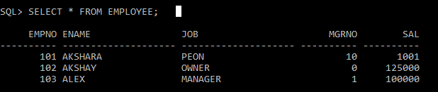

SQL> UPDATE EMPLOYEE SET JOB='CASHIER' WHERE EMPNO=101;

1 row updated.

SQL> SELECT \* FROM EMPLOYEE;

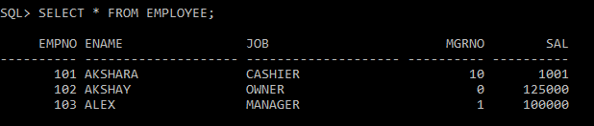

SQL> UPDATE EMPLOYEE SET SAL=60000 WHERE EMPNO=101;

1 row updated.

SQL> SELECT \* FROM EMPLOYEE;

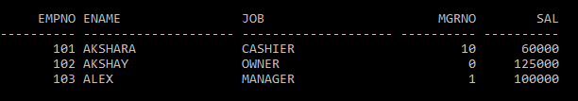SQL> ALTER TABLE EMPLOYEE RENAME COLUMN SAL TO SALARY;

Table altered.

SQL> SELECT \* FROM EMPLOYEE;

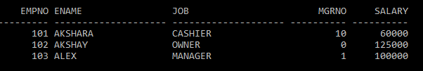

SQL> DELETE FROM EMPLOYEE WHERE EMPNO=103;

1 row deleted.

SQL> SELECT \* FROM EMPLOYEE;

