**Set9 q1**

SQL> create table stud_file(sid number,name varchar2(20),m1 number,m2 number);

Table created.

SQL> insert into stud_file values(&sid,'&name',&m1,&m2);

Enter value for sid: 1

Enter value for name: akshay

Enter value for m1: 45

Enter value for m2: 67

old 1: insert into stud_file values(&sid,'&name',&m1,&m2)

new 1: insert into stud_file values(1,'akshay',45,67)

1 row created.

SQL> /

Enter value for sid: 2

Enter value for name: amal

Enter value for m1: 67

Enter value for m2: 81

old 1: insert into stud_file values(&sid,'&name',&m1,&m2)

new 1: insert into stud_file values(2,'amal',67,81)

1 row created.

SQL> /

Enter value for sid: 3

Enter value for name: athira

Enter value for m1: 88

Enter value for m2: 91

old 1: insert into stud_file values(&sid,'&name',&m1,&m2)

new 1: insert into stud_file values(3,'athira',88,91)

1 row created.

SQL> /

Enter value for sid: 4

Enter value for name: subha

Enter value for m1: 77

Enter value for m2: 69

old 1: insert into stud_file values(&sid,'&name',&m1,&m2)

new 1: insert into stud_file values(4,'subha',77,69)

1 row created.

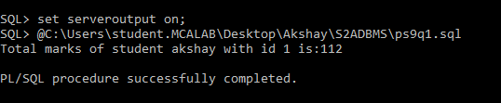

**Set9q2**

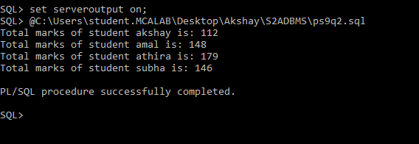

**Set9q3**

