

SecureVault Password Manager

Instructor: Sir Ali Hassan
Program: BSSE - Session 2024-2028 (Semester 4)
Subject: Database Systems (LAB)
Submitted By: Maaz Arshad Akhund & Bushra Asad

Project Overview
The SecureVault Password Manager is a locally hosted, web based application designed to help users securely store and manage their login credentials for multiple websites in one place. The system is built using Python with the Flask framework on the backend and MySQL as the database. Instead of storing passwords as plain text, SecureVault encrypts every password entry using AES-256 encryption before saving it to the database, meaning even if the database were compromised, the actual passwords would not be readable. Users access the system through a master password which is never stored directly but instead saved as a hash, adding another layer of security. Once logged in, the system creates a session token to keep the user authenticated across requests. Every action a user performs, whether adding, viewing, or deleting a password entry, is recorded in an audit log so there is always a traceable history of activity. The project was developed as a lab semester project in pairs, focusing on applying real database design principles alongside backend development to build something that reflects a realistic use case.
VC Table

Milestone | Progress | Version | Remarks | Date
Schema | Made the Schema tables on 19 April 2026 for the project having the basic layout | 1.0 | Completed | (19 April 2026)
ERD | Made the ERD Diagram having the basic layout for the project in the diagram format as the 1st milestone | 1.1 | Completed | (25 April 2026)
ERD | Made the new ERD Diagram and did changes to the schema added new tables as per sirs instruction and project scope | 1.2 | Completed | (12 May 2026)
Workflow Diagram | I made a workflow diagram and it shows the step by step working of the whole project | 1.3 | Completed | (10 May 2026)
Normalization | Applied and verified 1NF, 2NF, and 3NF rules. Checked for redundancies and validated 1:1/1:N ERD relationships. | 1.4 | Completed | (15 May 2026)
Dataflow/CSV | Made csv files that contains data using the python faker library, and made the dataflow diagram showing how the data flows using mermaid AI | 1.5 | Completed | (16th May 2026)

Database Schema MySQL
CREATE DATABASE securevault;
USE securevault;

CREATE TABLE users (
user_id INT AUTO_INCREMENT PRIMARY KEY,
username VARCHAR(100) UNIQUE NOT NULL,
master_password_hash VARCHAR(255) NOT NULL,
created_at TIMESTAMP DEFAULT CURRENT_TIMESTAMP
);

CREATE TABLE credential_types (
type_id INT AUTO_INCREMENT PRIMARY KEY,
type_name VARCHAR(50) NOT NULL,
security_level ENUM('critical', 'high', 'medium', 'low') NOT NULL,
requires_reauth BOOLEAN DEFAULT FALSE,
clipboard_timeout INT DEFAULT 30,
description VARCHAR(255)
);

CREATE TABLE vault (
vault_id INT AUTO_INCREMENT PRIMARY KEY,
user_id INT NOT NULL,
type_id INT,
site_name VARCHAR(100) NOT NULL,
username VARCHAR(100) NOT NULL,
encrypted_password TEXT NOT NULL,
notes TEXT,
last_updated TIMESTAMP DEFAULT CURRENT_TIMESTAMP ON UPDATE CURRENT_TIMESTAMP,
created_at TIMESTAMP DEFAULT CURRENT_TIMESTAMP,
FOREIGN KEY (user_id) REFERENCES users(user_id),
FOREIGN KEY (type_id) REFERENCES credential_types(type_id)
);

CREATE TABLE bank_credentials (
bank_id INT AUTO_INCREMENT PRIMARY KEY,
vault_id INT NOT NULL UNIQUE,
bank_name VARCHAR(100) NOT NULL,
account_number_encrypted TEXT,
card_last_four CHAR(4),
account_type ENUM('savings', 'current', 'credit', 'wallet') NOT NULL,
pin_encrypted TEXT,
created_at TIMESTAMP DEFAULT CURRENT_TIMESTAMP,
FOREIGN KEY (vault_id) REFERENCES vault(vault_id)
);

CREATE TABLE failed_login_attempts (
attempt_id INT AUTO_INCREMENT PRIMARY KEY,
user_id INT NOT NULL,
attempted_at TIMESTAMP DEFAULT CURRENT_TIMESTAMP,
ip_address VARCHAR(45),
FOREIGN KEY (user_id) REFERENCES users(user_id)
);

CREATE TABLE password_history (
history_id INT AUTO_INCREMENT PRIMARY KEY,
vault_id INT NOT NULL,
encrypted_password TEXT NOT NULL,
changed_at TIMESTAMP DEFAULT CURRENT_TIMESTAMP,
FOREIGN KEY (vault_id) REFERENCES vault(vault_id)
);

CREATE TABLE user_preferences (
pref_id INT AUTO_INCREMENT PRIMARY KEY,
user_id INT NOT NULL UNIQUE,
auto_logout_minutes INT DEFAULT 10,
clipboard_clear_seconds INT DEFAULT 30,
theme ENUM('light', 'dark') DEFAULT 'dark',
default_security_level ENUM('critical', 'high', 'medium', 'low') DEFAULT 'medium',
created_at TIMESTAMP DEFAULT CURRENT_TIMESTAMP,
FOREIGN KEY (user_id) REFERENCES users(user_id)
);

CREATE TABLE sessions (
session_id INT AUTO_INCREMENT PRIMARY KEY,
user_id INT NOT NULL,
session_token VARCHAR(255),
created_at TIMESTAMP DEFAULT CURRENT_TIMESTAMP,
expires_at TIMESTAMP,
FOREIGN KEY (user_id) REFERENCES users(user_id)
);

CREATE TABLE audit_log (
log_id INT AUTO_INCREMENT PRIMARY KEY,
user_id INT NOT NULL,
vault_id INT,
action VARCHAR(20) NOT NULL,
action_time TIMESTAMP DEFAULT CURRENT_TIMESTAMP,
FOREIGN KEY (user_id) REFERENCES users(user_id),
FOREIGN KEY (vault_id) REFERENCES vault(vault_id)
);

Description of Schema
The SecureVault database schema consists of nine interrelated tables designed to securely manage user credentials, configurations, and system activity. The users table acts as the central hub, storing essential account information including the username and a hashed version of the master password. The vault table is the core storage entity, holding the actual encrypted passwords and website details linked to the user. To organize these entries, the credential_types table categorizes them by security level and defines specific behaviors, such as clipboard timeouts. For specialized financial data, the bank_credentials table isolates sensitive information like encrypted account numbers and PINs, linking directly to a specific vault entry. The system also maintains a secure archive of previously used passwords in the password_history table. To manage the application experience, the user_preferences table stores individual configurations such as UI themes and auto-logout timers. Finally, system security and monitoring are handled by three tables: sessions manages active login tokens and their expiration times , failed_login_attempts logs unauthorized access attempts to detect potential breaches , and the audit_log provides a comprehensive, traceable history of every action a user performs within the system

ERD (Entity Relation Diagram)
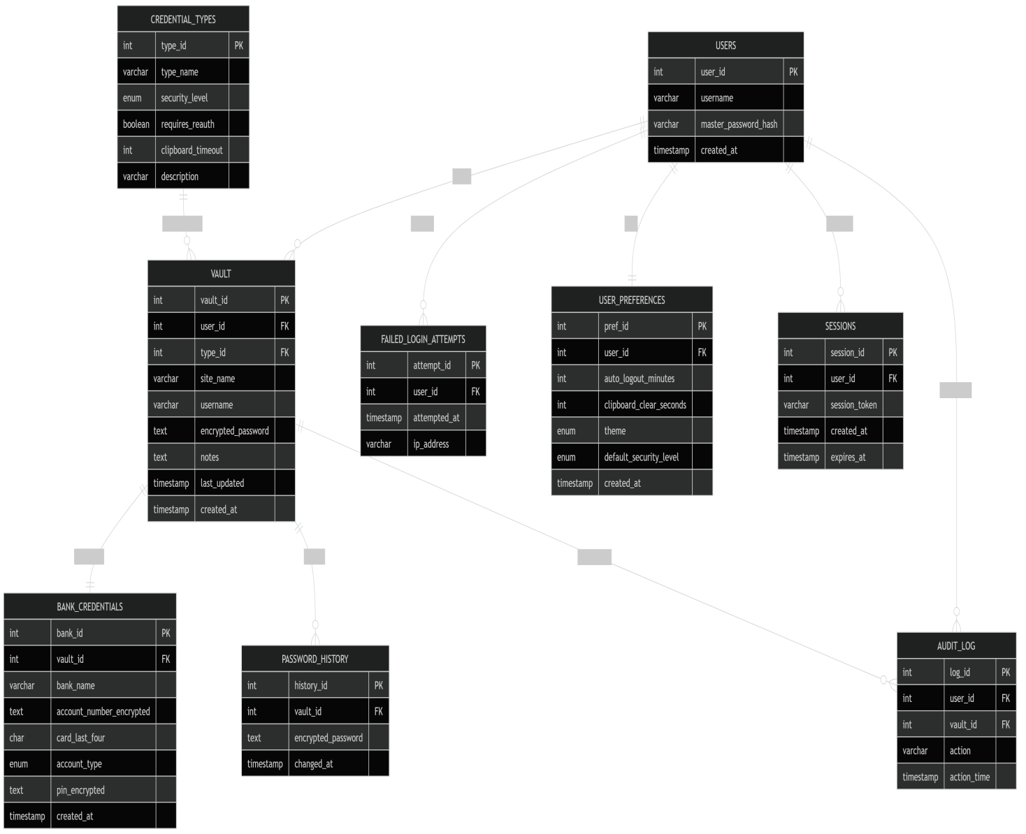
ERD Description
The ERD shows multiple entities connected through the users table as the central entity of the database. The users entity connects to vault in a one-to-many relationship, meaning one user can store multiple credential records, while each vault entry belongs to only one user. The credential_types entity also connects to vault in a one-to-many relationship because one credential type can classify many vault entries.
The vault entity connects to bank_credentials in a one-to-one relationship since a vault entry may contain one corresponding bank credential record. The vault entity also connects to password_history in a one-to-many relationship because one vault entry can store multiple previous passwords over time.
The users entity connects to failed_login_attempts in a one-to-many relationship, allowing multiple failed login records for a single user. Similarly, users connects to sessions in a one-to-many relationship because one user can maintain multiple active sessions simultaneously. The users entity also connects to audit_log in a one-to-many relationship since every action performed by a user is recorded as a separate log entry.
Additionally, vault connects to audit_log in a one-to-many relationship because a single vault entry can appear in multiple audit records whenever it is viewed, modified, or deleted. The users entity further connects to user_preferences in a one-to-one relationship because each user has a single set of application preferences.
All foreign key relationships primarily originate from the users and vault entities, making them the parent entities that the remaining schema components depend upon.

Relationships
- users to vault : one-to-many — one user can have many vault entries
- credential_types to vault : one-to-many — one credential type can classify many vault records
- vault to bank_credentials : one-to-one — one vault entry can store one bank credential record
- vault to password_history : one-to-many — one vault entry can have multiple old passwords saved
- users to failed_login_attempts : one-to-many — one user can have many failed login attempts
- users to sessions : one-to-many — one user can have multiple active sessions
- users to audit_log : one-to-many — all user actions are recorded in audit logs
- vault to audit_log : one-to-many — one vault entry can appear in multiple log records
- users to user_preferences : one-to-one — each user has one preference configuration

WorkFlow Diagram
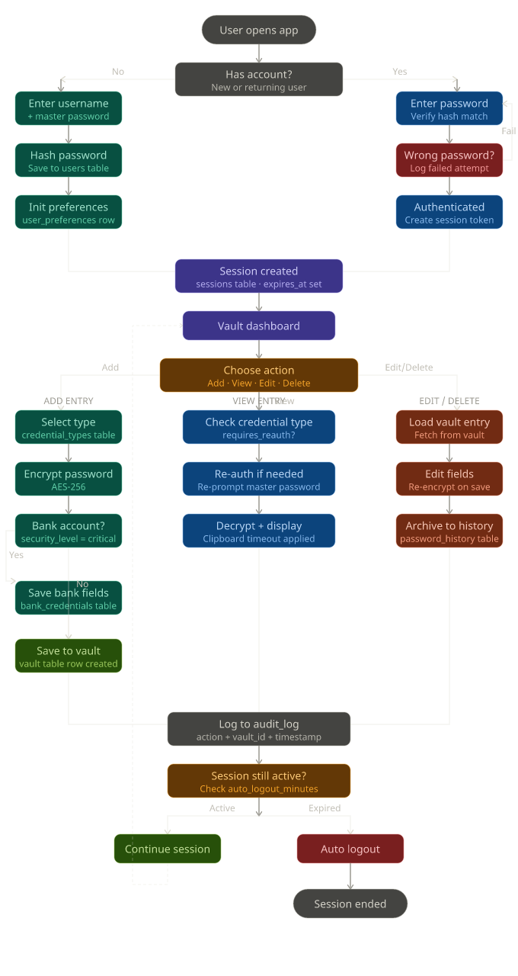
Dataflow Diagram Milestone 3
