

SecureVault Password Manager

Instructor: Sir Ali Hassan
Program: BSSE - Session 2024-2028 (Semester 4)
Subject: Database Systems (LAB)
Submitted By: Maaz Arshad Akhund & Bushra Asad

Project Overview
The SecureVault Password Manager is a locally hosted, web based application designed to help users securely store and manage their login credentials for multiple websites in one place. The system is built using Python with the Flask framework on the backend and MySQL as the database. Instead of storing passwords as plain text, SecureVault encrypts every password entry using AES-256 encryption before saving it to the database, meaning even if the database were compromised, the actual passwords would not be readable. Users access the system through a master password which is never stored directly but instead saved as a hash, adding another layer of security. Once logged in, the system creates a session token to keep the user authenticated across requests. Every action a user performs, whether adding, viewing, or deleting a password entry, is recorded in an audit log so there is always a traceable history of activity. The project was developed as a lab semester project in pairs, focusing on applying real database design principles alongside backend development to build something that reflects a realistic use case.
VC Table

Milestone | Progress | Version | Status
Schema | Made the Schema tables on 19 April 2026 for the project having the basic layout | 1.0 (19 April 2026) | Completed
ERD | Made the ERD Diagram having the basic layout for the project in the diagram format as the 1st milestone | 1.1 (25 April 2026) | Completed

Database Schema MySQL

CREATE DATABASE securevault;
USE securevault;
CREATE TABLE users (
user_id INT AUTO_INCREMENT PRIMARY KEY,
username VARCHAR(100) UNIQUE NOT NULL,
master_password_hash VARCHAR(255) NOT NULL,
created_at TIMESTAMP DEFAULT CURRENT_TIMESTAMP
);

CREATE TABLE vault (
vault_id INT AUTO_INCREMENT PRIMARY KEY,
user_id INT NOT NULL,
site_name VARCHAR(100) NOT NULL,
username VARCHAR(100) NOT NULL,
encrypted_password TEXT NOT NULL,
created_at TIMESTAMP DEFAULT CURRENT_TIMESTAMP,
FOREIGN KEY (user_id) REFERENCES users(user_id)
);

CREATE TABLE sessions (
session_id INT AUTO_INCREMENT PRIMARY KEY,
user_id INT NOT NULL,
session_token VARCHAR(255),
created_at TIMESTAMP DEFAULT CURRENT_TIMESTAMP,
expires_at TIMESTAMP,
FOREIGN KEY (user_id) REFERENCES users(user_id)
);

CREATE TABLE audit_log (
log_id INT AUTO_INCREMENT PRIMARY KEY,
user_id INT NOT NULL,
vault_id INT,
action VARCHAR(20) NOT NULL,
action_time TIMESTAMP DEFAULT CURRENT_TIMESTAMP,
FOREIGN KEY (user_id) REFERENCES users(user_id),
FOREIGN KEY (vault_id) REFERENCES vault(vault_id)
);

Description of Schema

The database has four tables. The users table stores account information for each registered user, including their username and a hashed version of their master password. The vault table holds the actual password entries, where each row stores encrypted credentials for a specific website and is linked to the user who owns it. The sessions table keeps track of active logins by storing a session token for each user along with when it was created and when it expires. The audit_log table records every action a user performs in the system, such as adding or deleting a password, so there is a complete history of activity.

ERD (Entity Relation Diagram)

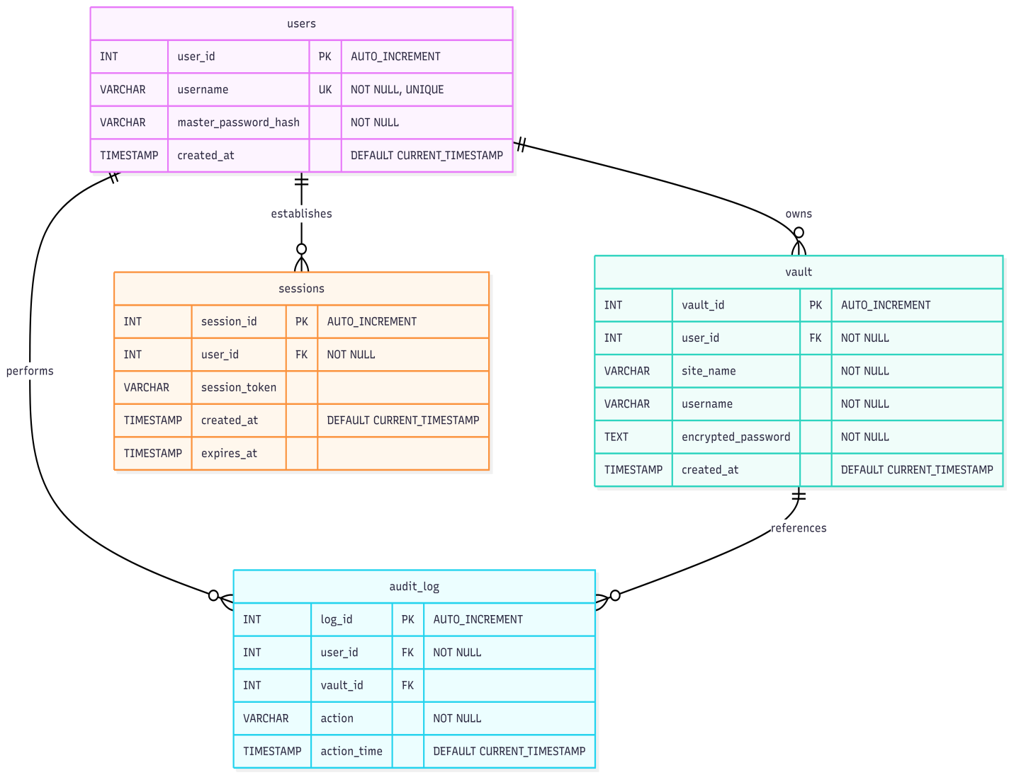

ERD Description

The ERD shows four entities connected through the users table as the central point. The users entity connects to vault in a one-to-many relationship, meaning one user can store multiple password entries but each vault entry belongs to only one user. Similarly, users connects to sessions in a one-to-many relationship since a single user can have multiple active sessions at the same time. The users entity also connects to audit_log in a one-to-many relationship because every action a user performs gets recorded as a separate log entry. Additionally, vault connects to audit_log in a one-to-many relationship since any single vault entry can appear in multiple log records whenever it is accessed, modified, or deleted. All foreign keys flow from the users table outward, making it the parent entity that the rest of the schema depends on.

Relationships
- users to vault : one to many - one user can have many vault entries
- users to sessions : one to may - one user can have multiple active sessions
- users to audit_log : one to many - all actions of a user are logged
- vault to audit_log : one to many - a vault entry can appear in multiple log records

