

INSTITUTE OF MANAGEMENT SCIENCES
HAYTABAD, PESHAWAR (2025)

Project Part II
Submitted By: Maaz Arshad Akhund
Submitted to: Sir Ijaz Ullah
Subject: Database Systems (THEORY)
Semester: IV – BSSE (A)
Session 2024 –2028 (Fall)

Front End:
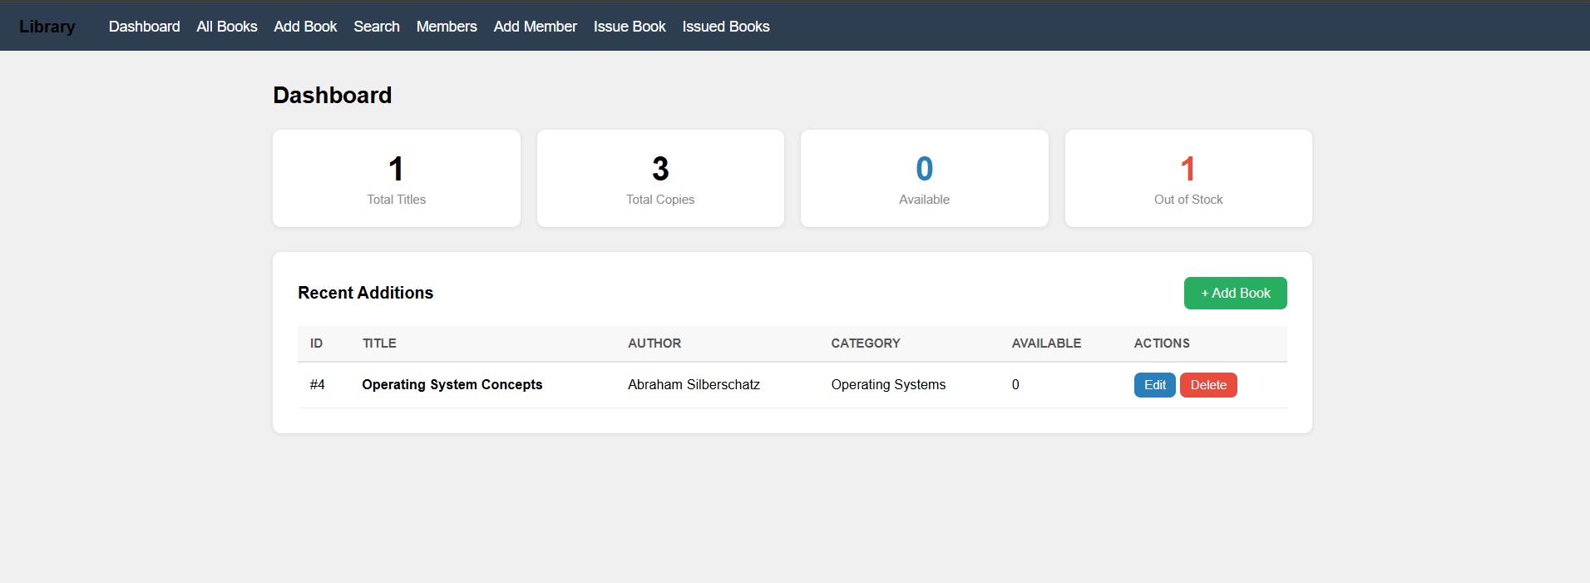
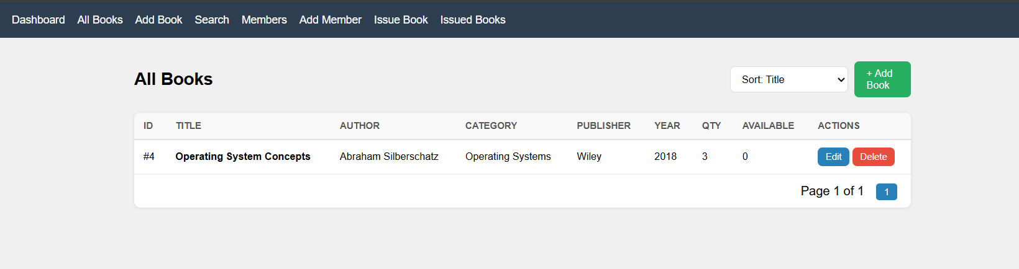
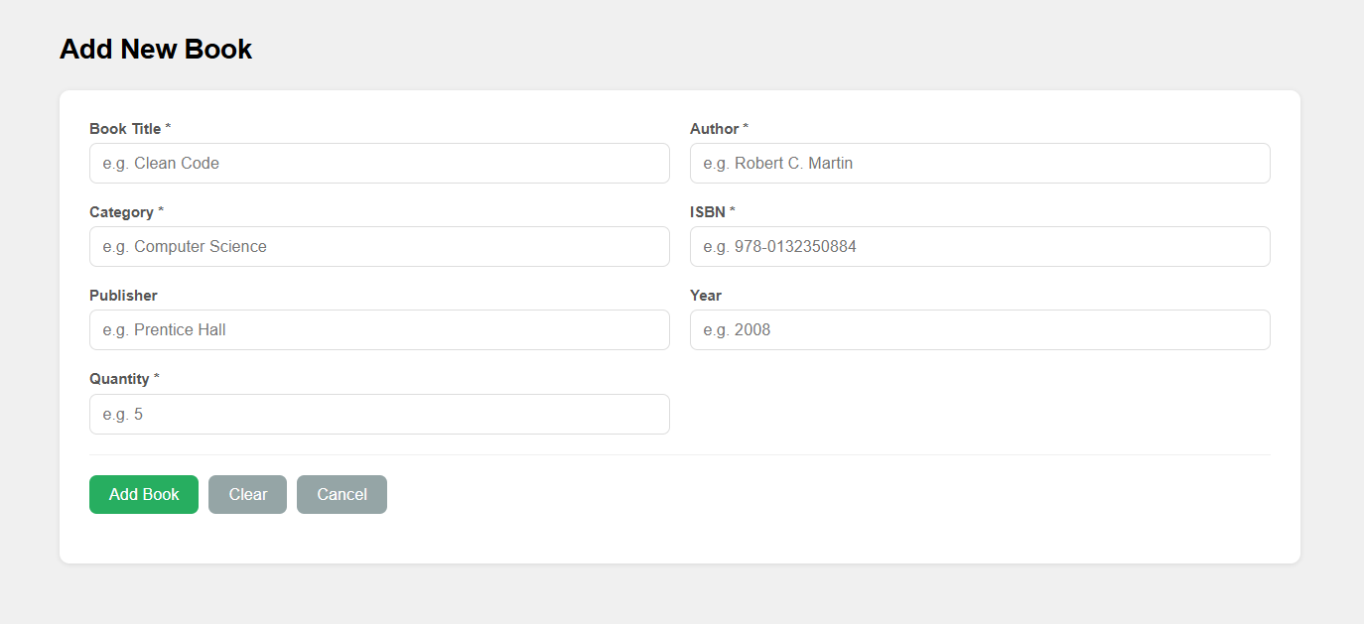
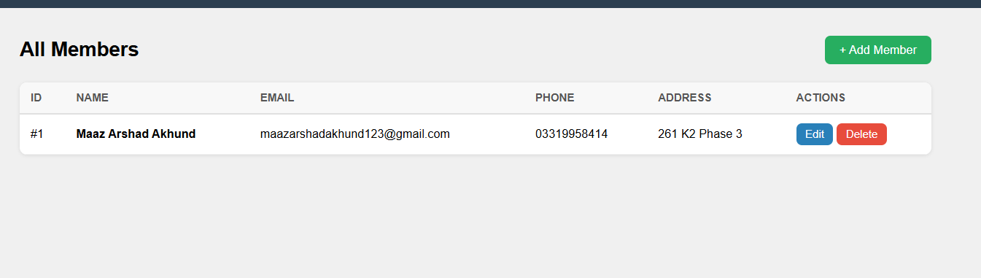
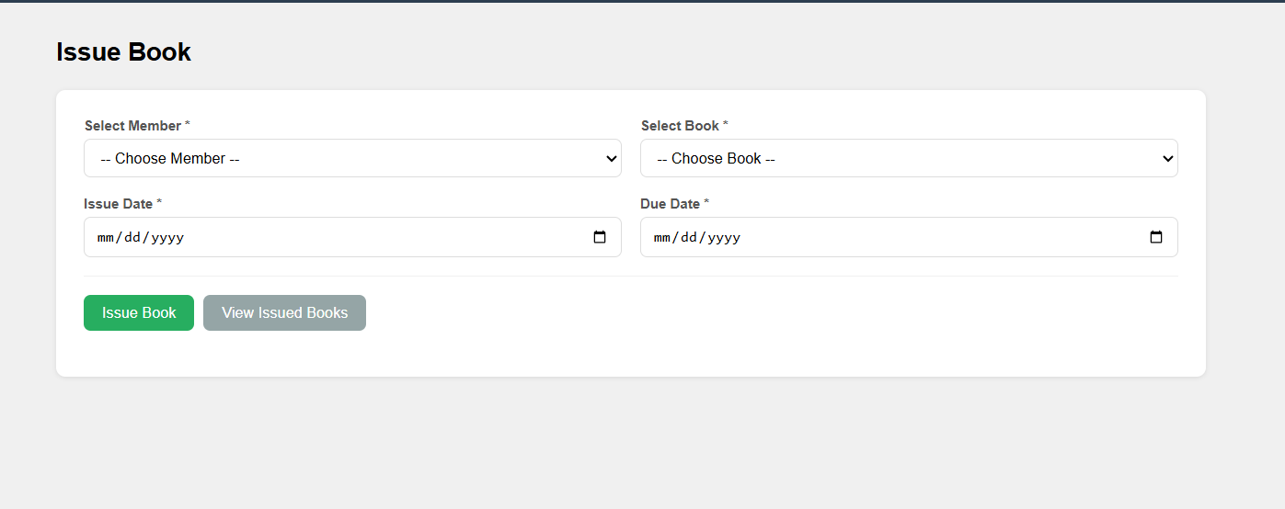
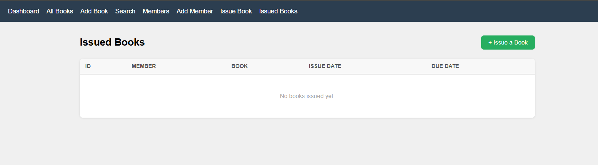

SCHEMA:
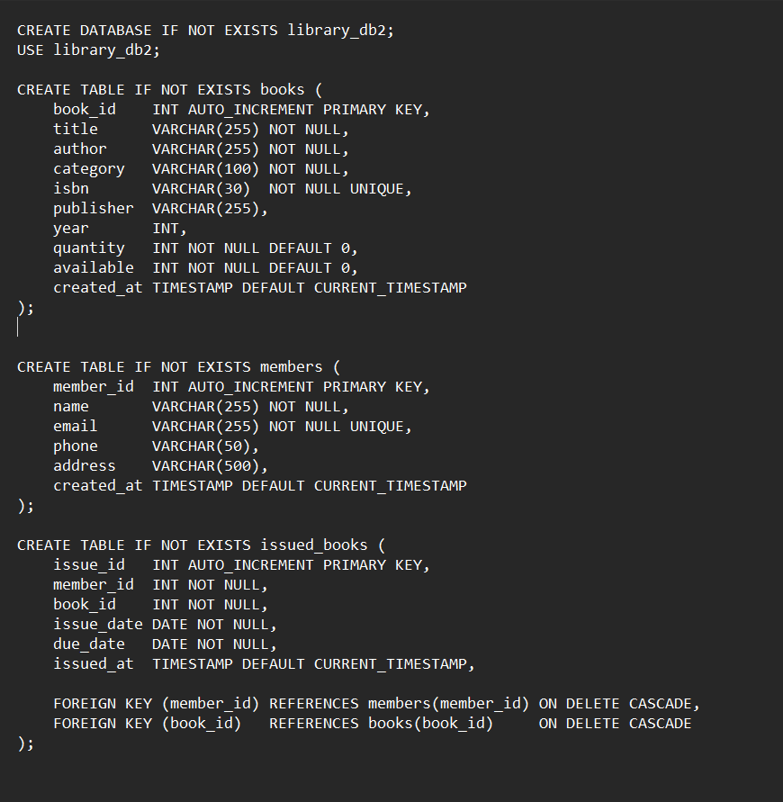

Project Update: Library System (Modules 2 & 3)

3.1 Database Changes (library.sql)
The database structure has been updated to support member management and book issuing functionality.
- Members Table:
The members table is designed to manage user records. A UNIQUE constraint is applied to the email field to prevent duplicate entries and ensure data integrity.
- Issued_Books Table:
The issued_books table establishes a relational model by linking member_id and book_id as foreign keys. This enables tracking of which member has issued which book.
- Data Integrity:
The database uses ON DELETE CASCADE constraints. This ensures that if a member or book is deleted, all related issuance records are automatically removed, maintaining consistency.

3.2 Application Logic (app.py)

Module 2: Member Management (CRUD Operations)
- Create / Update:
Member data is validated before insertion or update. Required fields are checked, and email formats are validated to ensure correctness.
- Read:
All member records are displayed in a dynamic table interface, including action buttons for updating or deleting entries.
- Delete:
Members can be removed from the system using their unique ID. Associated records are handled automatically through database constraints.

Module 3: Book Issuing System
- Dynamic User Interface:
Dropdown menus for selecting members and books are populated directly from the database, ensuring real-time data usage.
- Availability Check:
Only books with quantity > 0 are shown in the selection list, preventing invalid issuing actions.
- Transaction Logic:
The issuing process follows these steps:
  - Validates that both the selected member and book exist in the database.
  - Inserts a new record into the issued_books table.
  - Updates book availability using:
SET available = available - 1
- View Issuance History:
A SQL JOIN operation is used to generate a consolidated view displaying member names, book titles, and due dates in a single table.

