How to Run

To generate data just run Run.sh in Data_Generation folder.

Configuration

Configuration is needed for setting platform id for cpu and gpu separately as it varies for different heterogeneous systems.
1.Matrix_Mul :
Open Matrix_Mul folder.

- Setting platforms : In CPU/GPU folder set platform id according to the system.
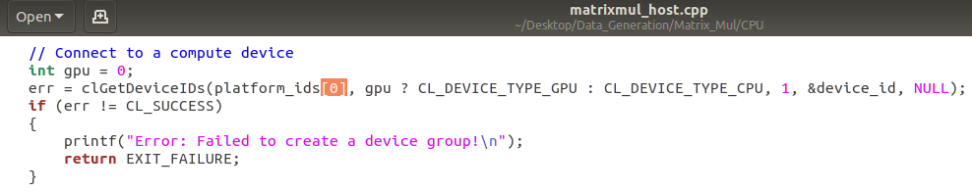
- Setting no of samples : In Run.sh set loop size according to sample size for cpu and gpu.
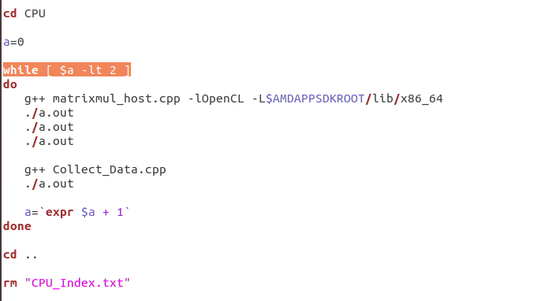
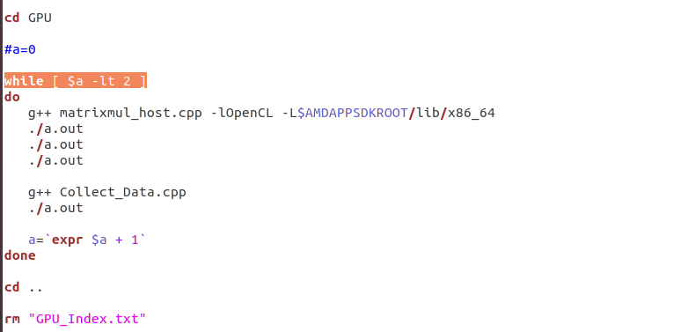
In Matrix_Sizes.cpp set loop condition with sample size ( 100 in fig below )
