Biometric Finger Vein Authentication

Biometric Finger Vein Authentication



**Session 2016-2017**

**Project Advisors**

**Mr. Muhammad Saeed**

**Name of Co-Supervisor**

**Humera Tariq**

**Submitted By**

|  |  |
| --- | --- |
| Maaz Anzar Farooqui | BS EP #1349042 |
| Mirza Muhammad Muneeb Baig | BS EP #1349046 |
| Munib Deshmukh | BS EP #1349072 |
| Muhammad Fahad | BS EP #1349024 |

Department of Computer Science

University of Karachi

Karachi

BS

A report submitted to the

Dec 20,2017

Department of Computer Science

in partial fulfillment of the requirements for the

degree

Bachelor of Science

in

Computer Science

by

Maaz Anzar Farooqui

Mirza Muhammad Muneeb Baig

Muhammad Fahad

Munib Deshmukh

University of Karachi

Mar 24, 2017

Acknowledgements

We acknowledge the cooperation and help made by Mr. Muhammad Saeed, Professor Department of Computer Science University of Karachi. He has constantly guided us throughout the course of this project. We would also like to thank Madam Humera Tariq for her help and guidance especially in understanding Image Processing and Pattern Extraction. We are also thankful to our families whose constant prayers and support led us to the completion of our project.

(Signed)

|  |  |
| --- | --- |
| Maaz Anzar Farooqui | BS Seat #1349042 |
| Mirzam Muhammad Muneeb Baig | BS Seat #1349046 |
| Munib Deshmukh | BS Seat #1349072 |
| Muhammad Fahad | BS Seat #1349024 |

Date

Mar, 24, 2017

Table of Contents

Statement Of Submission i

Acknowledgements ii

Abstract iii

Clients Approval Letter iv

List Of Figures v

List Of Tables vi

Table Of Contents vii

Chapter 1: Introduction 7

1.1 Objective 7

1.1 Motivation 7

1.2 Introduction 7

Chapter 2: Biometric System: 8

2.1 Introduction 8

2.1.1 Why use the biometic systems? 8

2.2 ) Various Biometic Methods and techniques 9

2.3 )Biometic Systems in Detail 9

2.3 )Finger Print Authentication 9

2.3.1 Advantages/ Disadvantages: 10

2.3 )Hand Geometry Recognition : 11

2.3.1 Advantages/ Disadvantages: 11

2.3 )IRIS Recognition 11

2.3.1 Advantages/ Disadvantages: 12

2.3 )Voice Recognition 13

2.3.1 Advantages/ Disadvantages: 13

2.4 ) Comparing Different Methods of Bio-Metric Systems In A Table: 14

Chapter 3: FINGER VEIN AUTHENTICATION SYSTEM 16

3.1) Introduction 16

3.2) SUMMARY 16

3.3) ADVANTAGES 16

3.4) HISTORY IN TIMELINE 16

3.4.1 Introduction 17

3.4.2 1997-2000 17

3.1.3 2000-2003 17

3.1.4 2004-2005 17

Chapter 4: Image Acquisition and Pre-processing 18

4.1 IMAGE ACCUISITION 18

4.1.1 FIR Way 19

4.1.2 NIR Way 19

4.2 Vein Scanner 20

4.3 PREPROCESSING 22

4.3.1 Cropping Image 22

4.3.2 Filtering Image 23

4.3.2.1 Low-pass 23

4.3.2.2 High pass 23

4.3.2.3 Directional 24

4.3.2.4 Median 24

4.3.2.5 Average 25

4.3.1 Intensity Adjusment 25

4.3.2 Histogram Equalization 26

4.3.3 Size adjustment 26

4.4 Image Pre Processing in Vein Pattern Recognition 26

4.4.1 Setting Webcam 26

4.4.2 Intensity Adjustment and Eliminate Extra Exposure 26

4.4.3 Removing Noise 27

Chapter 5: ROI, Featrure Extraction and Matching 28

5.1 Region of Interest 28

5.1.1 VEIN PATTERN EXTRACTION(Adaptive Threshold) 28

5.1.2 NOISE REMOVAL 29

5.1.3 PATTERN SPLIT 30

5.1.4 SKELETONIZATION 31

5.1.5 SMOOTHING AND ELIMINATING SMALL BRANCHES 31

5.2 Featrure Extraction and Matching 32

5.2.1 CombineSkel Technique 32

5.2.2 MinMax Algorithm 33

5.2.3 Introduction 34

5.2.4 Formula 34

Chapter 6: Results, Conclusion and Future Work 28

5.2 Results 36

5.2 Conclusion 36

5.2 Future Work 37

Chapter 7: References 38

6.1 References 38

**Chapter 1**

**Introduction**

**Objective:**

The target of this project is to develop an authentication system by the help of vein pattern, a system which capture images of finger veins and process them using MATLAB software. Project include designing of hardware for image acquisition, pre- processing and matching algorithm for finger vein pattern and testing on different samples. The work was divided in two parts, the study and development of finger vein identification system and its testing.

**Motivation:**

Security is important part of this technology era. To solve problem of authentication many biometrics techniques proposed and vein pattern is also a new technique, will be quickly becoming a popular method. A person vein patterns are completely unique and twin also does not have same pattern in fact left hand pattern different from right hand of same person. The pattern of vein does not change overtime. The whole process of vein recognition has three main procedures i.e. vein pattern acquisition, extracting, and pattern matching.

**Introduction:**

Here we are describing the whole mechanism of finger-vein extraction process. First of all this device constitutes of Infrared LED lights, camera and finger vein pattern extractor.

On putting the finger on this device, the infrared rays will emit from the Infrared LED lights, and they go through the finger.

Then these rays are captured by the camera. As these rays cannot pass through the veins of finger because hemoglobin absorbs the infrared rays and thus the image captured is of the vein

This captures the veins of the finger. Now the image is extracted through the vein scanner. This gives a good image of finger veins pattern in the image. Now this image will be compared through the database record of the people’s finger-vein pattern images. If the result is matched, the system will validate the finger pattern otherwise it will not.

**Overview:**

**Hardware**:

For the hardware we needed the following things

1. Near Infrared lights 2) Glass frame for LEDs 3) Camera 4) a photo negative

We gathered all the Near Infrared lights in a glass frame. Then through our own web camera we constructed the vein scanner. We disassembled the webcam and took the lens out. Then we separated the filter from the lens. Now we placed the photo negative in the place of filter. Now re-assemble the camera again. Then we placed the glass frame and the camera inside a wooden box. The camera was placed above so when we put the finger on glass frame the camera will the picture. That’s how we build up our vein scanner.

**Chapter: 2**

**BIO-Metric System:**

**Introduction:**

A **biometric system** is a system which uses a certain technology that uses information about a person to identify and validate that person. A system that qualifies to be a bio-metric system is that the characteristics, facts and figures etc. which are being used should be unique to that individual. For example, finger prints are unique to every single person in the world. They are not even identical to twins. So, for a system to be a bio-metric system it must be unique.

Some of the most famous bio-metric systems are finger print authentication, iris recognition and voice recognition. Mostly, biometric systems are developed for security applications.

**Why use the Bio-Metric systems?**

Password is a non-bio-metric system. Passwords and smart card pin numbers are two of the most common tools that are used for security and validation all over the world because they are free of cost and simpler than the bio-metric systems. However, due to bad password practices they have the reputation of being a poor protection method. They can also be stolen easily and people tend to forget them also. But bio-metric recognition systems overcome these problems because they only depend on biological and behavioral characteristics of that particular person, which are unique to each human individual. For example finger prints. Bio-metric systems provide high security. These systems have made forgery a lot harder. Although they are quite expensive but they provide what is asked of them i.e. to provide almost a full proof security mechanism which successfully authenticates an individual and provide access to that individual for which he/she got validated for.

So the saying is “Lesser the money, less powerful is the security system”.  
The best bio-metric authentication system is that which provides the complete security as well as which is reasonable or lower in prices compare to other bio-metric systems and which is hard to be accessed and duplicated by general public.

Now we will discuss and compare various bio-metric systems in terms of their technologies and the level of protection they provide through their systems.

**Various Bio-Metric Methods and techniques:**

There are various methods which are already being used as biometric systems which use the following techniques:

* **Fingerprint** – It is the most common and widely used bio-metric system. It uses the lines and patterns on the finger to identify a person as the finger prints are different and unique to every individual.
* **Palm print** – Works in the same way as the fingerprints but of course uses the larger area as it takes the patterns of the whole palm instead of just a finger.
* **Hand geometry** – Works using a number of measurements taken from the human hand, like its shape, size, length and widths of the fingers.
* **Iris Recognition** – Uses the iris of eyes to do the matching.
* **Face Characteristics** – Utilizes the features of the face of an individual for the recognition.
* **Voice** – It uses the pitch and voice of the people to identify.

**Bio-Metric System In Detail:**

* **Finger Print Authentication:**

**Fingerprint authentication** refers to the method of verifying the finger print of an individual to identify that person.

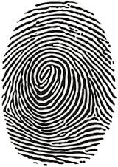

**ADVANTAGES:**

1) For years, law enforcement has used this method to identify criminals.

2) For decades, finger prints have been used to identify general public. In most of the countries around the world, finger prints are used as a source of medium to identify people and issuing of National Identity Cards.

3) The system and records stay stable over long periods of time.

4) They are very accurate.

5) They are user convenient and easy to use.

**DISADVANTAGES:**

**1)** In 2002 a Japanese cryptographer conducted an experiment and showed how fingerprint recognition devices can be fooled 4 out of 5 times by using a digital camera and some tools.

He took fingerprints of an individual from a glass, which were enhanced with a super-glue fumes and then photographed .An image tool was used to improve the contrast and then printed onto a transparency sheet. The sheet were then used to expose Ultra Violet sensitive circuit board and etched. That copper imprint was then used for a plastic mold of a finger and showed that a fake finger can be made. It showed that an un-authorized person could get access through it.

Many commercial fingerprint biometric systems took the fake finger experiment as the real threat. A well-known cryptographer Bruce Schneier said:

**"The results are enough to scrap the systems completely, and to send the various fingerprint biometric companies packing.”**

2) Finger prints slowly get vanished from the hands of many people. Thus, it gets very difficult for the people who have this issue.

* **Recognition Based on Hand Geometry :**

Hand geometry recognition systems have been there for quite a long time now. They are based on the characteristics of the human hand, including its size and shape of palm and length and widths of the fingers.

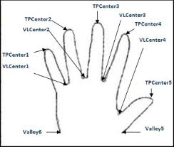

**ADVANTAGES:**

1) This technique is very simple as they only take the measurements of finger and the palm.

2) This system is in-expensive.

3) The one thing that they have advantage over fingerprint bio-metric systems are that the affected, roughed up or dry skin do not affect the performance.

**DISADVANTAGES:**

1) Hand geometry bio-metric system is not as distinctive as finger-print, iris etc. So, they are preferred not to use where security of the system/applications should be high.

2) Permanent injury like loss of a finger etc. will not get the user verified.

* **IRIS Recognition:**

**Iris recognition** uses pattern-recognition techniques on images/video of the iris of an individual's eyes. The iris patterns are unique to everybody.

First the scanner takes inner and outer boundaries of the iris in an image of an eye. It excludes eyelids, eyelashes that often hinder the parts of the iris. Then only those pixels are selected and analyzed that has the part of the iris. Then the bit pattern and information is extracted and encoded which is needed to compare the two iris images.

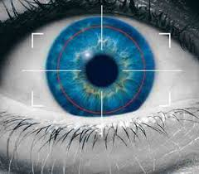

**ADVANTAGES:**

* Iris stays same across one's lifetime .i.e. it stays stable and is therefore reliable.
* Easy to use.
* Highly distinctive

**DISADVANTAGES:**

* The iris scanners can be dodged easily if the high quality image of an iris is placed in front of the scanner.
* Although the prices of scanners are gradually decreasing but yet they are quite expensive
* A diabetes patient has great difficulty in these scanners because diabetes has great effect on a human's eye.
* The rays which capture the iris of the person may damage the eye in the longer run.

**Face Recognition:**

A face recognition system identifies a person through a face of the person in images/videos. This is done by comparing the facial features from the whole databases of faces.

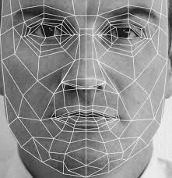

**ADVANTAGES:**

* It has high acceptance rate.
* Faces can be checked among the several faces in a crowded place.

**DIS-ADVANTAGES:**

* It cannot differentiate the faces of identical twins.
* It is not very distinctive.
* Mostly, an operator is required to select from the similar faces that the system has retrieved from the database.
* The change in appearance may dodge the system for identifying a person.

**Voice Recognition:**

Voice/Speech recognition system mainly works on identifying a person through the voice. It has no concern as to what the person might be saying. The voice pitch and speaking styles is the main thing to identify through.

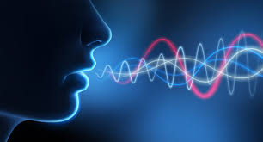

**ADVANTAGES:**

* Easy to use
* It has very high acceptance rate.

**DIS-ADVANTAGES:**

* It may be easily dodged as the mimic of voice can be done at the same pitch and speaking style of another person.
* It has low accuracy rate.

**Comparing Different Methods of Bio-Metric Systems In A Table:**

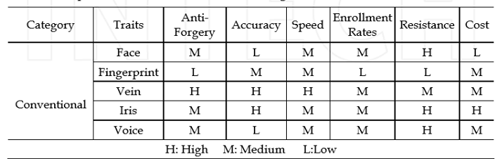

**COMPARISON IN TABULAR FORM**

|  |  |  |
| --- | --- | --- |
| SYSTEM | ADVANTAGE | DIS-ADVANTAGE |
| Finger Print Authentication | 1) Highly Distinctive  2) Easy to use  3) Highly reliable and stable  4) Have withstood the tests of time. | 1) Roughed up skin causes difficulty.  2) Ways have been developed to break through the system e.g. Fake Finger. |
| Hand Geometry | 1) Completely un-affected by roughed up skin. | 1) Low Distinctiveness.  2) Permanent injury will not get the user verified. |
| Iris Recognition | 1) Highly Distinctive  2) Highly reliable.  3) Iris patterns remain same. | 1) Expensive.  2) Could lead to eye damages.  3) Problem for diabetes patients |
| Face Characteristics | 1) Acceptance rate is high | 1) Cannot differentiate between identical twins  2) Not very distinctive. |
| Voice | 1) Acceptance rate is high | 3) Easy to dodge |

**Chapter: 3**

**FINGER VEIN AUTHENTICATION SYSTEM**

**Finger vein authentication** method recognition is one of the many different forms of biometric systems used to identify a person and verify its identity.

It uses the vein patterns of a person to identify him/her through the pattern matching technique.

This technology is being developed for many different applications and is already in use in many different fields such as for the authentication of credit cards, to keep track of employee attendance, network authentication etc…

**2. SUMMARY OF AUTHENTICATION PROCESS**

The near infrared rays are generated from several LEDs which go through the skin of the person which are absorbed by the hemoglobin in the blood. The areas in which the rays are absorbed (i.e. veins) thus appear as dark areas in the image. Then through Image processing a finger vein pattern is made from the image. This pattern is stored. When a person comes next time for identification, an input of his finger vein pattern will be taken. That input will be checked from the images earlier stored. If the input matches with any of the pattern he will get identified.

ADVANTAGES:

The features of finger vein authentication are as follows:

* The False Acceptance Rate (FAR) is very low (close to zero).
* A very high level of accuracy.
* Out of all the biometric systems, the risk of forgery or theft is the **Lowest** in vein authentication system.
* No type of trace is left by finger-vein patterns unlike finger prints.
* The process of matching the vein patterns is extremely fast. It helps the user in a speedy authentication without any wait.
* Finger veins are not influenced by external condition of weather or skin.
* Rashes or rough skin do not affect the result of authentication unlike finger print authentication system.

**HISTORY IN TIMELINE:**

Finger vein Recognition technology is brain child of Hitachi, a Japan based company. The idea was generated when Hitachi’s was doing an advanced research to measure brain-function activity in the field of medical science. In the research, near-infrared light was used to observe the changes in the flow of blood. During the research, it was found that vein patterns are unique to every individual, Hitachi thus discovered that finger vein pattern recognition is a possible biometric system that could be developed.

1. **1997-2000:**

During the first phase, Hitachi developed its original light transmission technology (i.e. near-infrared light source) for finger vein biometric authentication. Through this technology, they captured the image of vein with light which passed through the skin of person.

1. **2000-2003:**

In the second phase, a lot of work was put in to transform that idea into the product form. The first physical access control system was developed and released in 2002. In 2002 research began on the logical access systems.

1. **2004-2005:**

In this phase, Hitachi took forward their research and looked to develop the ways to deploy their technology. The first application on which this technology was used was ATM applications in 2004 by Hitachi. Hitachi commercialized their ATM applications through finger-vein technology in 2005. Finger vein authentication technology has thrived in the Japanese financial sector because of its highly secured and the un-forgery features, with major banks in Japan employing it for ATM end user verification.

**Chapter: 4**

**Image Acquisition and Pre-processing**

**Image Acquisition:**

It is the creation of photographic images, an example of it as a physical scene or the object interior.

In domain processing, compression, displaying, printing and storage of such images. Digital image acquisition can be classified as electromagnetic radiation, or waves whose variable value to affect when they pass through or reflect off through objects, contains the information that make image. In all cases of digital imaging information in converted to digital signals by image sensors that computer processed and made output in the form of visible-light image.

Gamma rays offers digital X-ray imaging (digital PET, scintigraphy and SPECT), X-rays allows digital X-ray imaging (digital CT, radiography and fluoroscopy), and Sound allows ultrasonography (medical ultrasonography and sonar), and infrared rays allows thermal imaging, Infrared thermography (IRT), and thermal video.

Digital imaging itself input to digital image analysis /digital image processing by diff kinds of software (including image editing, image manipulation, image analysis and image enhancement.

As veins are internal, their structure cannot be discerned in visible region of light. Based on the types of light of acquisition, a vein image can be classified as ultrasonic scanning, infrared scanning and X-ray scanning. X-ray and ultrasonic are used to capture vein images in medical treatment, but they are not used in identification due to the health related issues. Until now, researchers are using infrared imaging for identification of person. Infrared (IR) rays is electromagnetic radiation whose wavelength is longer than that of visible light and shorter than microwaves, and Infrared light has a range of wavelengths lies between about 1mm to 750nm, just like visible light has wavelengths that range from violet to red light. Infrared is commonly divided into 3 spectral regions: near, mid and far-infrared light, but the boundaries between them are not very distinct.

There are two types of infrared region that focuses on imaging of vein patterns in hand by infrared light, the far-infrared (FIR) imaging and the near-infrared (NIR) imaging, Capture human bodies images in a non-harmful way is through near-infrared region. Some researchers had discussed the way of the FIR and NIR imaging methods. In the FIR method, thick human veins have higher temperature than the surrounding tissues. For NIR light method, the principle could be explained by photobiology. In biology, there is a “medical spectral window”, which extends from about 740 to 1100 nm approximately. The light in this window could penetrate deeply into tissues and bones. B/c blood and surrounding tissues have different effect on the NIR light, we could use a CCD camera or modify webcam with an attached IR filter to capture vein images in which vein appears darker.

**FIR Way**

Temperature of human body is about 36.85°C, and temperature of human vein surface is higher than surrounding parts. Therefore when FIR ray is exposed to human body the vein structure is thermally mapped with the help of infrared camera at room temperature Image that is captured display a temperature gradient b/w surrounding tissues and bac-of-hand veins.

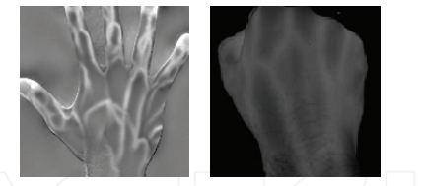

Figure 1FIR images of dosal hand vein

It is proved that FIR scan image of back of hand has good quality this means has more useful information, but FIR vein scan image of palm and wrist has poor quantity and is deeply sensitive to humidity and temp. of surrounding and also with user’s perspiration.

**NIR Way:**

The near infrared wavelength is b/w 700 nm to 1400 nm and we can use the same observation method used for visible light, except for observation by eye. The NIR light is not thermal. These rays cannot penetrate very deep inside the skin So the device will recognize the superficial veins and the deep very rarely. In NIR way, the light is almost completely absorbed by dioxides hemoglobin in veins while almost penetrated through oxidized hemoglobin in arties. Oxygenated and deoxygenated hemoglobin absorb light equally at 800nm, absorption is primarily from deoxygenated hemoglobin then vein appears darker areas in an image from CCD camera. NIR is noninvasive technique that uses the absorption properties of hemoglobin to observe the oxygen.

In this project, Image acquisition is done with the help specially modified webcam that is able to capture infrared rays. In this project infrared ray is used b/c it hemoglobin in blood absorbs infrared light and passes through all other parts so the area when vein is present due to blood seams darker for example See the figure below:

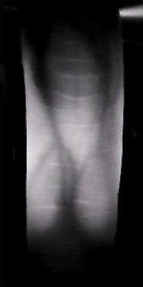

Figure 2: Image Taken from Vein scanner

**Vein Scanner:**

Vein Scanner is the basic device that is used for vein scan. This device is capable to capture finger vein pattern. With the help of infrared LEDs which emits near infrared rays which has ha properties above said. This block diagram describes the above process.

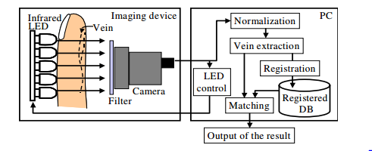

This actual diagram of vein scanner is

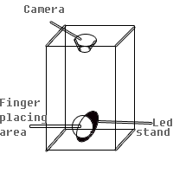

This scanner has a very simple schematic The diagram below shows the schematic.

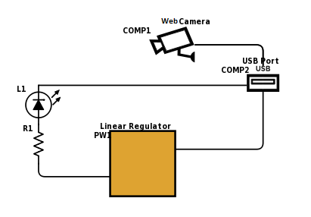

Figure 3 Schematic of vein scanner

The scanned image produce by vein scanner is shown below



***Pre-processing:***

**Image Pre-processing as the name suggest that the process that is done before processing or it can be said that the operations on images that done at lowest level of abstraction. These processes do not increase image data but they decrease if it is found that entropy is an information measure [1 2]. The goal of pre-processing is an improvement of data in an image that decreases un desired distortions and enhances few of images features that is relevant of future processing and analysis task. Image the images redundancy, neighboring pixels corresponding same object have the same brightness. If a distorted pixel can be found in an image it can be restored from the information of neighboring pixel average.** Image pre-processing methods can have classified with the size of pixel of neighborhood that is used for the calculation of restoring the pixel from the brightness values of neighborhood. Some of the types of image preprocessing are as under

* **Cropping Image**

Image cropping is the first step in image preprocessing, Image cropping is the elimination of irrelevant part of image and focuses on the region of interest in the image. MATLAB has the built-in function for that user input image and starting coordinates of the pixels and length and width and give cropped image of the same data type as of image

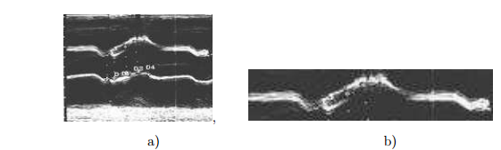

* **Filtering Image**

1. **Low-pass Filter:**

These are used to emphasize large similar areas of homogenous tone and reduce the smaller detail (i-e edges). Low frequency areas will remain same in an image as a result smoother appearance (bluer appearance) of image appear. It is also called blurring mask

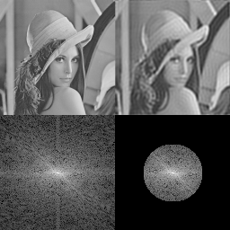

1. **High-pass Filter:**

A high-pass filter allows to pass high frequency areas as a result the edges of resultant image is much sharper than original images. It is also called derivative mask.

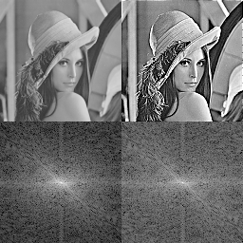

1. **Directional Filter:**

These are designed to enhance linear features in an image such as streams, faults, roads etc. These filters can be to increase features information which are oriented in specific directions, this feature of it making it useful for geological applications and for radar imagery. These filters are also known as edge directional filters.

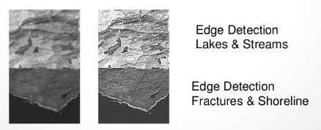

1. **Median Filter:**

A non-linear smoothing method Median filtering that reduces the blurring of edges and significantly eliminates high frequency noise [3, 4]. It suppresses image noise without reducing the image sharpness and can be applied iteratively. The brightness value of the current pixel in the image is replaced by the median brightness of either 3-by-3 or 4-by-4 neighborhood.

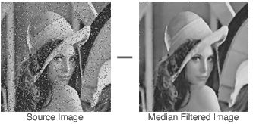

1. **Average Filter:**

Average filter (mean filter) is near neighboring processing (window filter) of linear class. The basic idea is for every pixel take the average of its neighborhood. This filter creates smoothing affect (blurring affect) just like the low level filter.

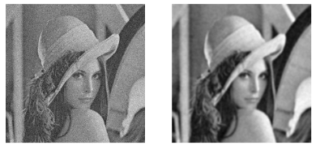

* **Intensity Adjustment**

A gray-scale transformation T of the original brightness p from scale [p0, pk] into brightness q from a new scale [q0, qk] is given by q = T(p). It does not depend on the position of the pixel in the image. Values below p0 and above pk are clipped. Values below p0 map to q0, and those above pk map to qk. Alpha argument specifies the shape of the curve describing the relationship between the values in the input image and output image. If alpha is less than 1, the mapping is weighted toward brighter output values and vice versa if the value is greater than 1. If the argument is omitted its default value is 1. Graphical controls enable an user to increase and decrease the brightness, contrast and alpha correction

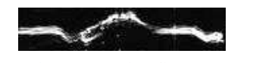

* **Histogram Equalization**

The contrast of image, by transforming the values in an intensity image so that the histogram of the output image matches a specified histogram, is histogram equalization technique. Region description is based on its statistical gray-level properties. Histogram provides the frequency of the brightness value in the image [4]. An image with n gray levels is represented with one-dimensional array with n elements. The nth element of array contains the number of pixels whose gray level is n.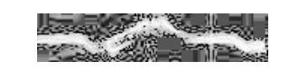

* **Size adjustment**

The size of also a preprocessing process which enable you to work on the desired image size but once the image is been resize to small when it is resize of original size it cannot be fully restored b/c in the process of resizing small image has its data.



**Image Pre Processing in Vein Pattern Recognition:**

In Vein pattern recognition the following image preprocessing steps is being done:

* **Setting Webcam:**

Adjusting the contrast, brightness, exposure and sharpness of specially modified webcam (changing filter of webcam to infrared filter)

* **Intensity Adjustment and Eliminate Extra Exposure:**

After taking picture from webcam contrast adjustment process has been applied.

Eliminate the extra exposer this is present when finger is not properly placed.

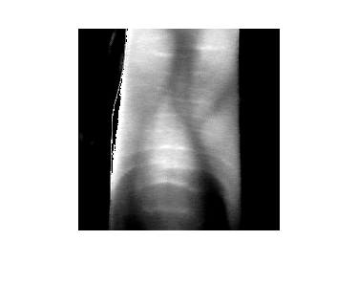

* **Removing Noise:**

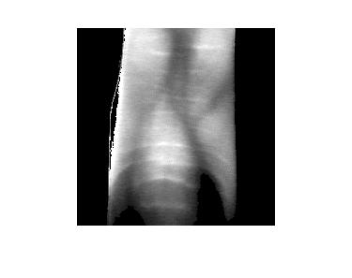Removing extra noise outside of the area of interest. This is done by finding the region of extraction and then eliminating all information outside of that region.

**Chapter: 5**

**ROI, Feature Extraction and Matching**

**ROI (Region of Interest):**

Region of interest (also abbreviated as ROI), is a selected area (subset of samples within) a data set needed for a specific purpose. Many application areas commonly used ROI concept.

For example,

* In Medical Imaging Field The concept of ROI is that, for measuring the size of tumor, the boundaries of a tumor could be defined on an image or in a volume, the endocardial border in an image,
* May be during diff cycles of cardiac, for example end-systole and end diastole, for achieving of assessing function of cardiac.
* In GIS (geographical information systems), a ROI could be 2D map of a polygonal selection.
* In computer vision and optical character recognition, the ROI is the border of an object under study.
* In many applications, symbolic (textual) are labels are added to ROI, to explain its content in a compact manner.

Within a ROI may lie individual points of interest abbreviated as POI.

In our application ROI (region of interest) is the extraction of vein pattern which is done in many steps which are described as under:

After Preprocessing steps the image that is given without any noise outside of region extracted. To Extract region of the interest i-e veins the following steps is being done.

* **Applying Adaptive threshold:**

We extracted the pattern through adaptive threshold to region [25 3].

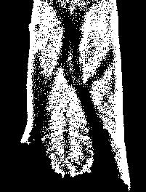

* **NOISE REMOVAL:**

1. **Cleaning and Filling**

By doing cleaning we remove noise of the black pixel in the majority of white pixels and filling we remove the noise of the white pixel in the majority of black pixels.

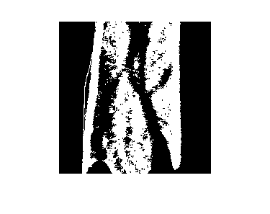

1. **Applying Average filter:**

We used average filter for noise removal i.e. to get rid of various small dots. It removes the remaining noise by removing the black areas shorter than area of certain threshold.

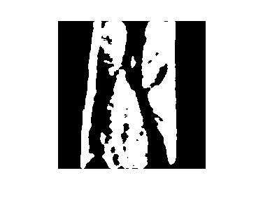

1. **Eliminate Remaining noise:**

Notice that in above image small holes are present so we eliminate these holes by open the area.

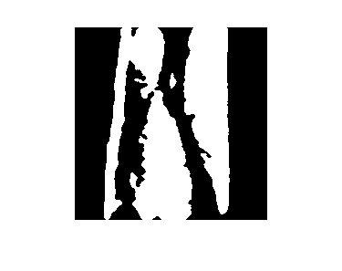

* **PATTERN SPLIT**

We split the pattern from the image using our own function in which we use region of extraction and noise removed finger-vein pattern image. During the above process, any extra noise which is generated will be removed.

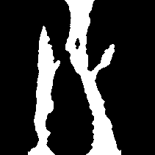

* **SKELETON**

We skeletonize the resultant image with skeleton function to reduce it to 1-pixel length.

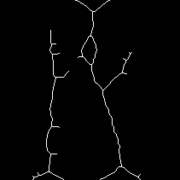

* **SMOOTHING AND ELIMINATING SMALL BRANCHES:**

Here we smooth our skeleton and then we eliminate the small braches present in the skeleton and remove small loops in the skeletonized image through our own function.

As the in the image below, it can be seen that the small branches have been eliminated and small loops has been eliminated. This helps in identification of the vein pattern since it decreases correlation b/w finger vein patterns from pattern of diff persons.

It helps in solving problems of almost undetectable patterns.

It also increases the accuracy of pattern

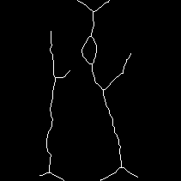

**Feature extraction:**

In image processing, pattern recognition and machine learning feature extraction beings with a measured data initial set and builds features (derived values) meant to be non-redundant and informative, facilitating the generalization and subsequent learning steps, and also in some cases directing to better interpretations. It is also related to dimensionality reduction.

When the data of input to an algorithm is too large for it to be processed and redundancy suspected. (e.g. the same measurement in both meter and feet, or the image repetitiveness a presented as pixel), then these could be transformed to reduced set of features (features vector). Deciding initial features subset is known as feature selection. The selected features are expected to have information relevant to the input, as a result of that the desired task can be performed by using this features (reduced representation) replacing initial complete data.

In this project there are two types of features are being extracted.

* **Combine Skel:**

During registration device takes 25 snap and processed these into skeleton and add them to each other making 1 single image contains all the skeleton from 25 images.

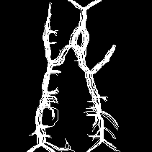

* **Minimum Maximum Distance algorithm:**

It consists into realize a cross section scanning of a pattern of vein from left to right recording the minimum and maximum distance into feature of vectors. The scanned lines no. can be lower than column number of original image to increase the speed of process with similar results, though the low speed function defined distance parameters. If there is lower than to lines, and a minimum and maximum cannot be defined so it is expressed like 0. So the vector two vector one which has one line and one which has zeros line are same this is a little weakness of this algorithm. This algorithm has the advantage is that it is not sensitive to position of finger b/c max and min distance are not affected by the position and also it is less sensitive to angle of finger.

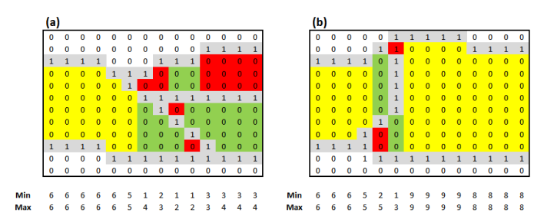

**Matching and Classification:**

* **Combine Skel:**

After extraction of Region of interest in the image during verification process. It is skeleton image & with combine skeleton image which is being made during registration process.

So the result is the image where combine image and skeleton image is white result is white. And where it is diff or zero result will be zero.

Count the number of ones in the skeleton image and resultant image

Divide count of skeleton image with resultant image count to get similarity ratio.

**Advantage:**

One of advantage of this method is that is very accurate and it gives very low values of similarity Approx. 10-30% with other person and also gives very high similarity values Approx. 75 -97 % similarity.

**Disadvantage:**

One of the disadvantage of this method is it is very sensitive to position as well as angle.

* **Minimum and Maximum Algorithm:**

We have studied this algorithm from thesis. It consists of left to right scanning of finger vein pattern. It calculates minimum and maximum distance between two vein patterns.

In this method we calculated 20 values of each minimum and maximum along horizontal axis,

If there is only one cross section than there will be zero minimum and maximum shown in figure.

When only two cross sections found it means that both values are same, more than two considering only minimum and maximum value others are ignored and when very next to cross section another one found than above one will be considered as irrelevant.

Similarity, between the two vectors is defined by a custom method as it’s shown in the figure, reflecting average similarity vector. which is calculated by dividing minimum with other sample’s minimum, then calculate its average similarity with the help of equation below, vice versa with the maxims. The Average similarity vector will have ranges between 0 and 1, where 1 means full match and 0 means mismatch.

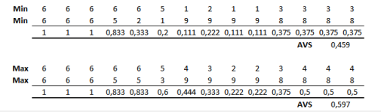

Matching Image, a with image b Features

**Formula**

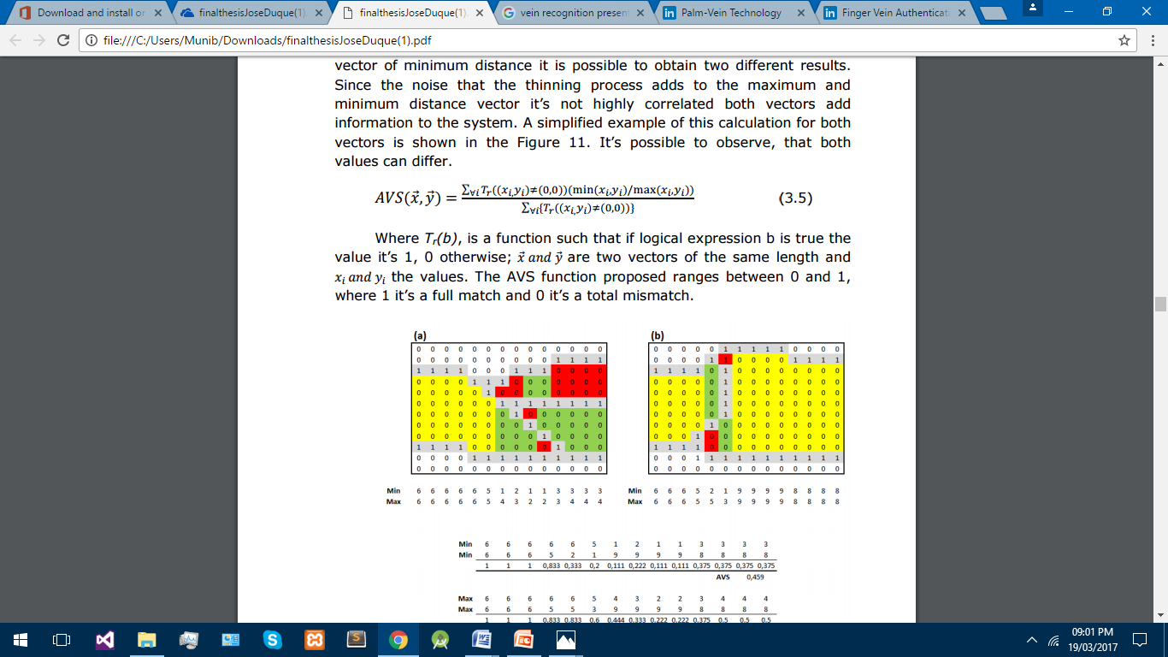

**Advantage:**

One of advantage of this method is that it is not sensitive to position of image b/c min and max distance will not be affected by distance.

It is reasonably accurate with similar images Approx. 65-90% and similarity ratio with other images is about 20-50%

**Disadvantage:**

One of the disadvantage of this method is it is not very accurate as compare to combine skeleton technique.

**Chapter 6:**

**Results, Conclusion and Future Work**

**Results:**

Our vein scanner is successfully identifying the person through the finger vein patterns and it also has high accuracy. But its accuracy rate is a little low when there is no branch vein in the sample. Since we used the min max algorithm which calculates the distance between two veins, therefore it fails to identify the person who has a single vein in the finger.

**Conclusion:**

By working on this project we can conclude that finger vein pattern can be a successful biometric system. This system has a lot of qualities. It is in-expensive, distinctive, easy to use, no external limitations like smooth skin or prominent patterns, high security implementation, no chances of forger etc. It does not require for a person to stay in contact with device so the input process is a lot easier and it is hygienically good.

**Hardware:**

For the Hardware we conclude that there is more needs to be done on hardware side b/c In our experiment wo conclude that some persons vein are so thick that and their blood circulation is not large than some other person so that these ray cannot penetrate fully through finger and other first image acquisition step failed leading entire processes to be failed and thus that person finger is not process able for this system.

Second Conclusion that is made is during winter season some person blood circulation in finger is not same during summer time so rays are penetrate too much making image too bright. But this problem is solved by making exposure adjustable. But when a condition a arrived that a person is feeling very cold its blood circulation is gone very low making it finger vein very thin. So as a result some of the vein are vanishes making its pattern diff for processing and matching.

**Software**:

For the Software we need the diff steps of image processing in diff kinds of image processing filters and image processing techniques are applied which are successful described in details are:

* + Contrast Adjustment
  + Adaptive thresholding
  + Region Growing
  + Region Extraction
  + Neighborhood Processing (Cleaning and filling)
  + Opening and Closing binary Image
  + Average Filtering (noise elimination in binary image)
  + Splitting
  + Skeletonization
  + Small branches and Small loops elimination
  + Feature Extraction

Besides these filters we also applied various kinds of filter which does not helped very much in the solving of this problem. We read these types of filters to apply in vein pattern extraction but as I said above these filters do not help for the solution of this problems these filters and steps include:

* High Pass filters.
* Fast Fourier transformation
* Inverse Fast Fourier transformation
* Butterworth filter
* Garbor filter
* Weiner filter (In Binary image of filtering)
* Median filter (In Binary image of filtering)
* Histogram equalization
* Adaptive Histogram equalization

**Future Work**:

**Hardware:**

Number of leds needs to be increased for the solution of the above said hardware side problem.

**Software:**

A lot of work needs to be done in software side of feature extraction part diff types of algorithm needs to be applied to that its accuracy increase like:

* Hausdorff Distance (HD) method
* FD Distance method (Fat Distance)
* Connected Branch point and end point matrix.

**References:**

* https://en.wikipedia.org/wiki/Feature_extraction
* <http://library.wolfram.com/infocenter/Demos/395/>
* <https://en.wikipedia.org/wiki/Region_of_interest>
* <http://www.librow.com/articles/article-5>
* <https://upcommons.upc.edu/bitstream/handle/2099.1/14178/finalthesisJoseDuque.pd>
* <https://pdfs.semanticscholar.org/fe00/5c5036ad646051cc779aafb63534bda14f06.pdf>
* **https://www.cse.unr.edu/~bebis/CS790Q/PaperPresentations/vein.pdf**
* cdn.intechopen.com/pdfs/5801.pdf
* [www.kscst.iisc.ernet.in/spp/37_series/spp37s/synopsis.../144_37S0862.pdf](http://www.kscst.iisc.ernet.in/spp/37_series/spp37s/synopsis.../144_37S0862.pdf)

**Appendix:**

|  |  |
| --- | --- |
| Readycam | function [ cam ] = ReadyCam(varargin )  list=webcamlist;  if(size(list)==1)  cam=webcam(1);  else  cam=webcam('USB2.0 Camera');  end  cam.ExposureMode='manual';  if(length(varargin)==1)  exposure= cell2mat(varargin(1));  cam.Exposure= exposure;  else  cam.Exposure=-4;  end  cam.Brightness=45;  cam.Contrast=127;  cam.Sharpness=12-6;  end |
| Taking Image | function [ imgC ] = takeimage( cam )  %takes image through webcam and crop and process that image  % Detailed explanation goes here  img=cam.snapshot();  imgG=rgb2gray(img);  imgC=imcrop(imgG,[280-18 170 200+10 240-30]);  [r,c]=size(imgC);  for i=1:r  for j=1:c    if(imgC(i,j)>250)  imgC(i,j)=0;  end    end  end  imgC=imadjust(imgC);  end |
| Adaptive Threshold | %BRADLEY local thresholding.  % BW = BRADLEY(IMAGE) performs local thresholding of a two-dimensional  % array IMAGE with Bradley method. The key idea of the algorithm is that  % every image's pixel is set to black if its brightness is T percent  % lower than the average brightness of surrounding pixels in the window  % of the specified size, otherwise it is set to white.  %  % BW = BRADLEY(IMAGE, [M N], T, PADDING) performs local  % thresholding with M-by-N neighbourhood (default is 15-by-15). The  % default value for T is 10 and can be set in range 0..100. To deal with  % border pixels the image is padded with one of PADARRAY options (default  % is 'replicate').  %  % Example  % -------  % imshow(bradley(imread('eight.tif'), [125 125], 10));  %  % See also PADARRAY, RGB2GRRAY.  % Contributed by Jan Motl (jan@motl.us)  % $Revision: 1.1 $ $Date: 2015/04/19 17:03:01 $  function output = bradley(image, varargin)  % Initialization  numvarargs = length(varargin); % only want 3 optional inputs at most  if numvarargs > 3  error('myfuns:somefun2Alt:TooManyInputs', ...  'Possible parameters are: (image, [m n], T, padding)');  end    optargs = {[15 15] 10 'replicate'}; % set defaults    optargs(1:numvarargs) = varargin; % use memorable variable names  [window, T, padding] = optargs{:};  % Convert to double  image = double(image);  % Local mean  mean = averagefilter(image, window, padding);  % Initialize the output to white color  output = true(size(image));  % Set a pixel to black if the image brightness  % is below (100-T)% of the average neighbourhood brightness  output(image <= mean*(1-T/100)) = 0; |
| Average Filter | function [image, t] = averagefilter(image, varargin)  %AVERAGEFILTER 2-D mean filtering.  % B = AVERAGEFILTER(A) performs mean filtering of two dimensional  % matrix A with integral image method. Each output pixel contains  % the mean value of the 3-by-3 neighborhood around the corresponding  % pixel in the input image.  %  % B = AVERAGEFILTER(A, [M N]) filters matrix A with M-by-N neighborhood.  % M defines vertical window size and N defines horizontal window size.  %  % B = AVERAGEFILTER(A, [M N], PADDING) filters matrix A with the  % predefined padding. By default the matrix is padded with zeros to  % be compatible with IMFILTER. But then the borders may appear distorted.  % To deal with border distortion the PADDING parameter can be either  % set to a scalar or a string:  % 'circular' Pads with circular repetition of elements.  % 'replicate' Repeats border elements of matrix A.  % 'symmetric' Pads array with mirror reflections of itself.  %  % B = AVERAGEFILTER(A, [M N], INTEGRAL) filters matrix A with  % the precalculated integral image INTEGRAL. Reuse of the INTEGRAL  % dramatically reduces the computation time. However, the filter size  % [M, N] can't be bigger than the filter size specified during  % the creation of the INTEGRAL. The padding parameter is also inherited  % with the passed INTEGRAL image.  %  % [B, INTEGRAL] = AVERAGEFILTER(A) filters matrix A and returns the  % average image B together with the integral image INTEGRAL.  %  % Comparison  % ----------  % There are different ways how to perform mean filtering in MATLAB.  % An effective way for small neighborhoods is to use IMFILTER:  %  % I = imread('eight.tif');  % meanFilter = fspecial('average', [3 3]);  % J = imfilter(I, meanFilter);  % figure, imshow(I), figure, imshow(J)  %  % However, IMFILTER slows down with the increasing size of the  % neighborhood while AVERAGEFILTER processing time remains constant.  % And once one of the neighborhood dimensions is over 7 pixels,  % AVERAGEFILTER is faster. Anyway, both IMFILTER and AVERAGEFILTER give  % the same results.  %  % Remark  % -------  % The output class type is the same as the class type of input matrix A.  %  % Example  % -------  % I = imread('eight.tif');  % J = averagefilter(I, [5 5], 'replicate');  % figure, imshow(I), figure, imshow(J)  %  % See also IMFILTER, FSPECIAL, PADARRAY.  % Contributed by Jan Motl (jan@motl.us)  % $Revision: 1.3 $ $Date: 2013/05/04 16:58:01 $  % Parameter checking.  numvarargs = length(varargin);  if numvarargs > 2  error('myfuns:somefun2Alt:TooManyInputs', ...  'requires at most 2 optional inputs');  end    optargs = {[3 3] 0}; % set defaults for optional inputs  optargs(1:numvarargs) = varargin;  [window, padding] = optargs{:}; % use memorable variable names  m = window(1);  n = window(2);  if (ndims(image)~=2) % check for color pictures  display('The input image must be a two dimensional array.')  display('Consider using rgb2gray or similar function.')  return  end  % Initialization.  [rows columns] = size(image);  % If we have to calculate the integral image, calculate it.  if ischar(padding) || isscalar(padding)  % Pad the image.  imageP = padarray(image, [floor((m+1)/2) floor((n+1)/2)], padding, 'pre');  imagePP = padarray(imageP, [ceil((m-1)/2) ceil((n-1)/2)], padding, 'post');  % Always use double because uint8 would be too small.  imageD = double(imagePP);  % Calculate the integral image - the sum of numbers above and left.  t = cumsum(cumsum(imageD),2);  else  % Cut the integral image from the potentionally bigger integral image.  intm = size(padding, 1) - rows;  intn = size(padding, 2) - columns;  deltaMPre = floor((intm+1)/2) - floor((m+1)/2) + 1;  deltaMPost = ceil((intm-1)/2) - ceil((m-1)/2);    deltaNPre = floor((intn+1)/2) - floor((n+1)/2) + 1;  deltaNPost = ceil((intn-1)/2) - ceil((n-1)/2);    t = padding(deltaMPre : end-deltaMPost, deltaNPre : end-deltaNPost);  end  % Calculate the mean values from the look up table 't'.  imageI = t(1+m:rows+m, 1+n:columns+n) + t(1:rows, 1:columns)...  - t(1+m:rows+m, 1:columns) - t(1:rows, 1+n:columns+n);  % Now each pixel contains sum of the window. But we want the average value.  imageI = imageI/(m*n);  % Return matrix in the original type class.  image = cast(imageI, class(image)); |
|  |  |
|  |  |