ENTERPRISE CRISIS INTELLIGENCE // TECHNICAL DOCUMENTATION
Sentinel Command
The enterprise crisis war room, run by agents.

A Neuro SAN–powered multi-agent platform that condenses a 72-hour, email-driven escalation into a ~15-second autonomous pipeline. An executive states the crisis; a network of specialist AI agents reasons in parallel and returns one briefing with actions attached.

10 agents · ~15 s to full assessment · parallel reasoning · live WebSocket stream
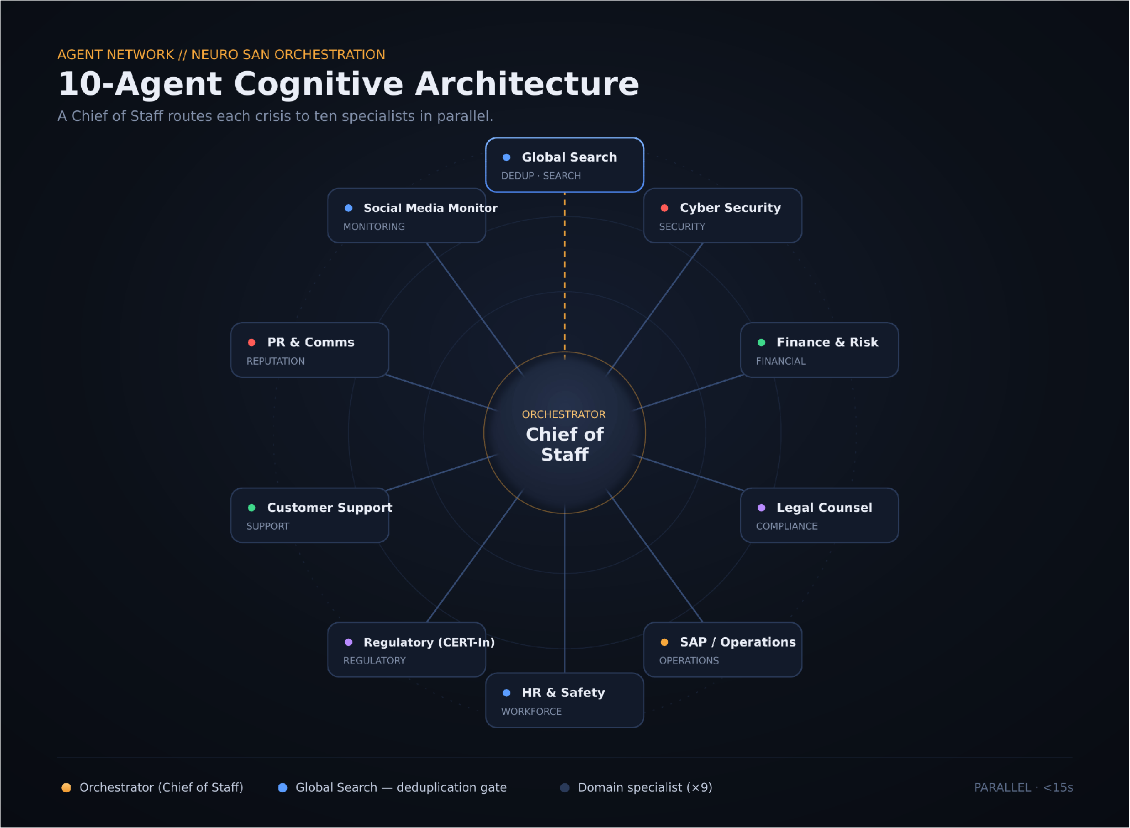
FIG 01 · Agent orchestration graph Chief of Staff → 9 specialists → synthesis
Repository: github.com/maazcognizant/SentinelCommand Built at Cognizant with Neuro SAN
01 · OVERVIEW

01 Why Sentinel exists

In large enterprises, a single crisis — a data breach, a vendor payment dispute, a compliance failure — pulls in Cybersecurity, Finance, Legal, HR and SAP Operations. The traditional escalation path is linear and human-driven: departments are reached one by one over email and ticketing systems, and it can take 48 to 72 hours just to reach a consensus for an executive decision.
Sentinel Command condenses that process into a ~15-second autonomous pipeline. It acts as a digital Chief of Staff: instead of waiting for human departments to reply, it uses AI agents scoped to corporate policy to simulate departmental analysis in parallel, then returns a single, executive-ready briefing with direct action buttons.

TRADITIONAL ESCALATION
- Departments reached one by one over email and tickets
- 48–72 hours just to reach executive consensus
- No shared memory — duplicate incidents re-worked from scratch
- Hard to see cross-department impact in one place

SENTINEL COMMAND
- A digital Chief of Staff routes the crisis to every relevant specialist at once
- 360° risk assessment returned in seconds, not days
- Global Incident Database deduplicates repeat crises before work starts
- One executive briefing with Approve / Escalate / Reject built in
02 · AGENT NETWORK

02 The agent network

Neuro SAN is Cognizant’s framework for data-driven, multi-agent networks: agents are declared in a registry and the framework handles routing, delegation, and communication. Sentinel is a real agent network, not a single-prompt chatbot.
NEURO SAN CAPABILITIES SENTINEL USES
Agent orchestration & delegation | A Chief of Staff orchestrator analyses each crisis and delegates sub-tasks to the relevant specialist agents
Parallel execution | Specialists run concurrently instead of sequentially — full assessment in ~15s instead of hours
Shared context management | The crisis prompt and injected Global Incident Database are shared across the network
Modular registries | Every agent is defined in a registry (generated/sentinel_crisis_command) — new specialists snap in without code changes
nsflow streaming | Agent reasoning and final markdown stream to the UI in real time over port 4173
MCP-ready tools | Model Context Protocol servers can add live tools (SAP OData, Microsoft Entra, UiPath RPA)

THE 10-AGENT ROSTER
Agent | Responsibility
● Chief of Staff | Orchestrator — routes the crisis, invokes specialists, and aggregates the final recommendation
● Global Search | Deduplication gate — checks the Global Incident Database before work begins
● Cyber Security | Security analysis and breach exposure
● SAP / Operations | Business continuity and SAP operations impact
● Finance & Risk | Financial impact and risk exposure
● HR & Safety | Workforce and employee-safety impact
● Legal Counsel | Compliance review and contract-law evaluation
● Regulatory (CERT-In) | Regulatory and statutory reporting (e.g. CERT-In directions)
● Customer Support | Customer and service-impact assessment
● PR & Comms | Reputation and communications risk
● Social Media Monitor | Public sentiment and social-media monitoring

The Chief of Staff invokes specialists in parallel — Legal Counsel evaluates contract law while SAP / Operations evaluates continuity and Regulatory (CERT-In) checks statutory reporting — then aggregates their outputs into one unified recommendation.
03 · SYSTEM ARCHITECTURE

03 System architecture

A decoupled client–server design: a Vite + React command center streams over WebSockets into a Python Neuro SAN backend, with a memory bridge that injects prior sessions into every request.
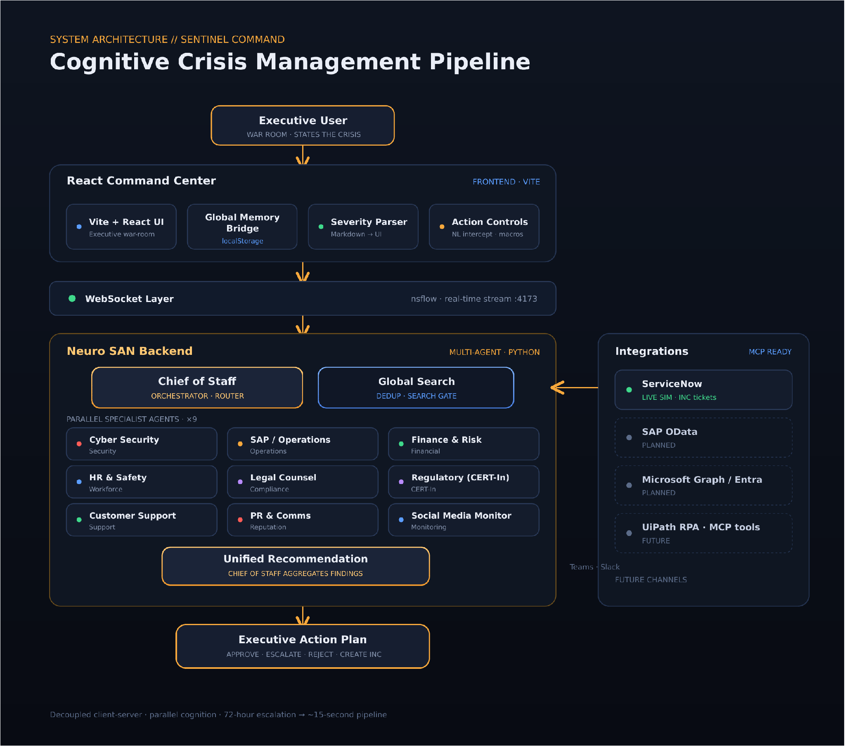
FIG 02 · Cognitive crisis management pipeline Frontend · WebSocket · Neuro SAN · Integrations
FRONTEND — REACT COMMAND CENTER
- Global Memory Bridge — reads prior sessions and ServiceNow IDs from browser storage, compiles a Global Incident Database block, and injects it into context before the request reaches the backend.
- Severity parsing engine — parses raw markdown from Neuro SAN to detect CRITICAL / MEDIUM / LOW and mount the matching UI (severity meter, impact panels, action buttons).
- Natural-language intercept — catches intents like “create a ServiceNow ticket” in the UI and runs them as deterministic macros, bypassing the LLM for speed.

BACKEND — NEURO SAN
- Parallel cognition — the Chief of Staff invokes Cyber Security, Legal Counsel, HR & Safety, Finance & Risk and SAP / Operations at once, cutting assessment from minutes to under 15 seconds.
- nsflow streaming — agent thought processes and final markdown summaries stream back to the client in real time over port 4173.
- MCP-ready extensibility — designed to snap in Model Context Protocol servers for live SAP OData, Microsoft Entra lookups and UiPath RPA triggers.
04 · PIPELINE

04 How a crisis flows

Nine steps from the moment an executive states the problem to the moment they act on it.
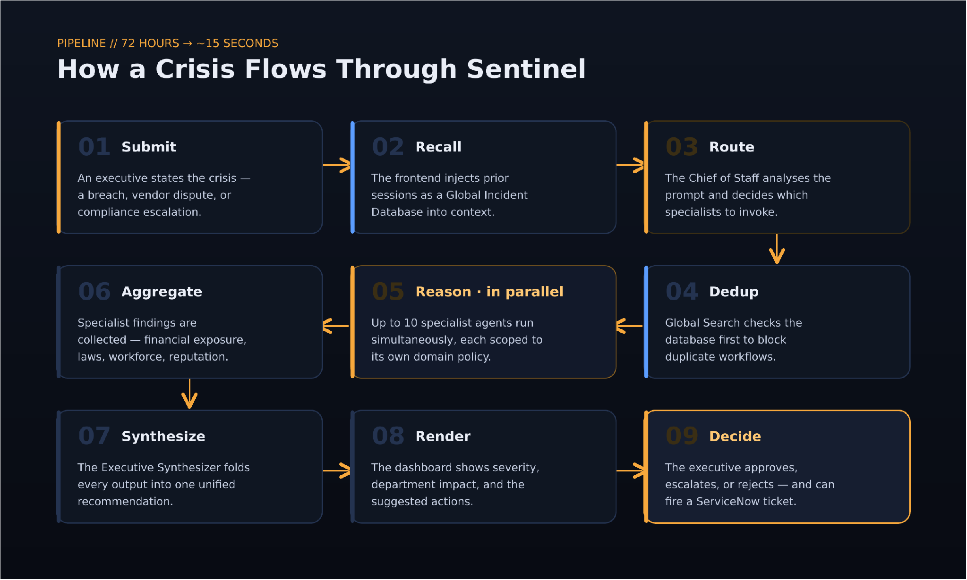
FIG 03 · End-to-end request pipeline Submit → Reason in parallel → Decide

05 · CAPABILITIES

05 What it does

Sentinel is not a chatbot — it is active decision-support infrastructure.
- Multi-agent orchestration — Specialists reason in parallel under a single Chief of Staff.
- Executive decision support — One briefing with severity, impact and recommended actions.
- Persistent incident memory — Past incidents carry forward as a Global Incident Database.
- Duplicate detection — Global Search blocks repeat crises before work starts.
- Severity classification — Automatic CRITICAL / MEDIUM / LOW tagging drives the UI.
- Intelligent routing — Only the departments a crisis actually touches get engaged.
- Real-time updates — Live WebSocket stream of agent reasoning and results.
- Agent-to-UI execution — Natural language triggers real, deterministic UI actions.
- Enterprise integration ready — ServiceNow today; SAP, Graph and MCP tools next.
06 · STACK

06 Technology stack

FRONTEND | React · TypeScript · TailwindCSS · Vite
BACKEND | Python
AI FRAMEWORK | Cognizant Neuro SAN
COMMUNICATION | WebSocket · nsflow (port 4173)
LLM PROVIDERS | Gemini · Mistral AI
FUTURE INTEGRATIONS | ServiceNow · SAP · Microsoft Graph · MCP tools

07 · QUICKSTART

07 Run it locally

Clone, install, point it at your keys, and open the command center on localhost.
● ● ● bash — sentinel-command
# 1 · clone the repository
$ git clone <repository-url>
$ cd Sentinel-Command-Center

# 2 · install dependencies
$ pip install -r requirements.txt
$ npm install

# 3 · run the Neuro SAN backend
$ nss run --registry generated/sentinel_crisis_command

# 4 · run the frontend
$ npm run dev

# 5 · open the command center
$ open http://localhost:5173

ENVIRONMENT CONFIGURATION
Create a .env file in the project root with your provider keys. The backend streams on :4173 and the UI serves on :5173.
● ● ● .env
GEMINI_API_KEY=your_gemini_api_key
MISTRAL_API_KEY=your_mistral_api_key
08 · ROADMAP

08 Prototype & roadmap

What ships in the current prototype, and what is planned next.
▲ IMPLEMENTED  [✓] Multi-agent orchestration  [✓] Executive dashboard  [✓] Persistent incident memory  [✓] Duplicate detection  [✓] Severity classification  [✓] Real-time communication & ServiceNow ticket simulation | △ PLANNED  [ ] ServiceNow & SAP integrations  [ ] Microsoft Graph & Teams support  [ ] Slack support  [ ] Voice interface  [ ] Autonomous remediation  [ ] Live MCP tools (SAP OData · Entra · UiPath)

Sentinel Command is active decision-support infrastructure — organizational memory, parallel reasoning and executive decision support unified into a single Neuro SAN workflow.

