CE221: Digital Logic Design

Design and Implementation of a
Fastest Finger Circuit using Verilog HDL



SUBMITTED BY

Syed Ali Vijdaan Naqvi (2022560)
Muhammad Maaz Hamid (2022655)
Hamza Amin (2022378)
Ali Raza (2022664)

SUBMITTED TO
Dr. Waqar Ahmad & Engineer Zaheer Ahmed

Ghulam Ishaq Khan Institute of
Engineering Sciences and Technology

Abstract:
This research aims to design, simulate, and implement a Fastest Finger Circuit using Verilog hardware description language. The Fastest Finger Circuit will involve the creation of a system that accurately measures and records the response time of multiple participants interacting with a set of buttons or inputs. The Verilog implementation will focus on achieving high-speed processing and accuracy in measuring the reaction times.

Objectives:

1. Circuit Design: Develop a Verilog-based design for the Fastest Finger Circuit, specifying the architecture, functionality, and logic involved in accurately measuring response times.
2. Button Interface: Implement an interface for multiple input buttons to simulate participant responses and trigger the LED’s/visual mechanism.
3. Display and Recording: Design a system to identify and record the response times, potentially incorporating an output interface for displaying the fastest responder.
4. Verification and Simulation: Conduct rigorous simulations to verify the functionality and accuracy of the Fastest Finger Circuit design under various conditions and participant responses.

Methodology:

1. Research and Design Phase: Review existing literature on Verilog implementations and timing circuits. Develop a comprehensive design for the Fastest Finger Circuit, including the architecture, timing logic, and interface requirements.
2. Verilog Coding and Simulation: Implement the designed circuit using Verilog HDL. Simulate the design using tools like RLS Schematics and Behavioral Simulator.
3. Documentation and Reporting: Prepare comprehensive documentation detailing the design, implementation, testing procedures, and results obtained. Present findings via PowerPoint.

IMPLEMENTATIION:
A fastest finger first circuit which can track the first person to press the trigger. Each module contains a trigger and an LED indicating whether the team corresponding to this module is the first one to press the trigger.

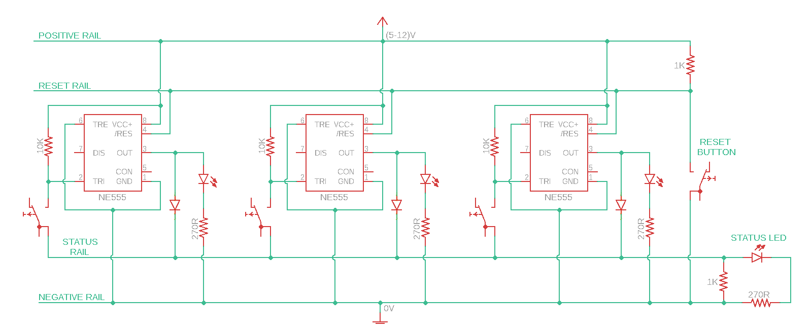
Circuit Diagram

Components Required:
* 555 Timer IC
* Momentary Push Button Switch
* PN Diode (I used 1N4148)
* LED + Series Resistor (270R)
* 10K Resistor
* 2 x 1K Resistors
* LED + Series Resistor (270R)
* Momentary Push Button (For resetting)
* Breadboard
* 9V Power Supply

How This Circuit Works?

If Pin-2 of 555 IC sees any voltage less than 1/3rds of the supply voltage, it turns the output ON
If the reset Pin of 555 IC sees 0V, it resets the output
Apart from positive and negative rails, we used two other rails:
Reset rail which is pulled up to positive voltage by default using a 1K resistor
Status / Feedback rail which is pulled down to 0V by default using a 1K resistor. This rail is connected to output of all the modules via diodes. So, this rail will be at 0V by default. But as soon as any of the modules output is ON, the voltage at this rail reaches positive voltage via the diode
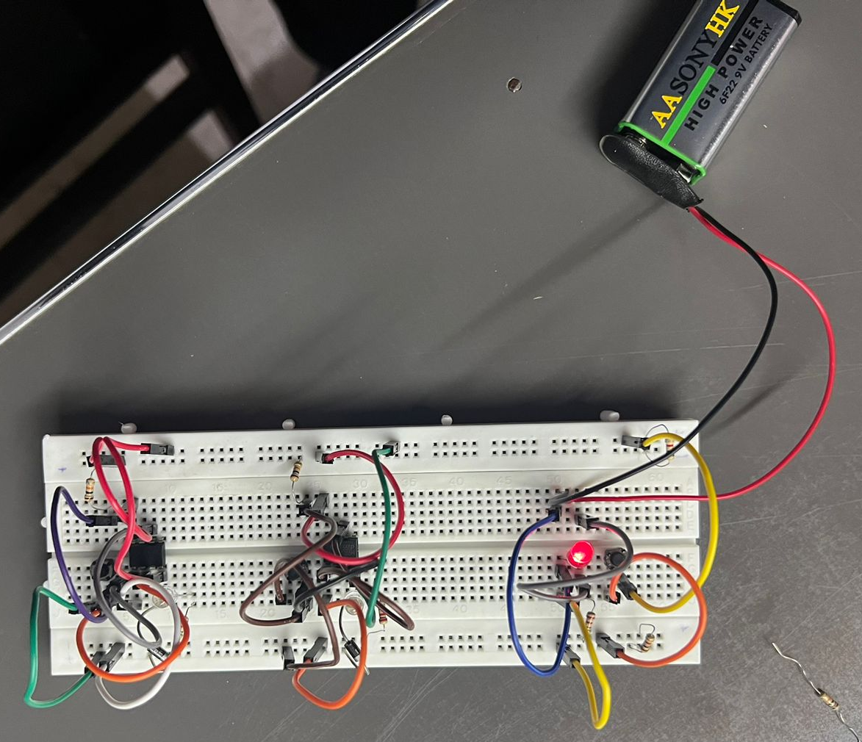

Hardware Implementation:

So, when the output of all the modules are in OFF state, the voltage at status rail will be at 0V (default). When any team presses the button, this 0V from status rail is applied at Pin-2.
Because 0V is less than 1/3rds of the supply voltage, the output of 555 IC corresponding to the team which pressed the trigger first turns ON.
Immediately after this happens, the voltage at status rail changes to positive voltage because of the feedback via PN diode. So even if other teams press the trigger now, the voltage at Pin-2 of the respective modules will be at positive voltage and the output doesn’t turn ON.
Resetting of states of all the modules is done by applying 0V at the reset pin of all the 555 ICs using reset rail and a dedicated push button.

Verilog Code with results:

Code
module fastest_finger_first (
input wire clk,
input wire rst,
input wire buzzer_user1,
input wire buzzer_user2,
output wire winner_user1,
output wire winner_user2
);

reg [1:0] state_user1, state_user2;
reg winner_hold_user1, winner_hold_user2;

always @(posedge clk or posedge rst) begin
if (rst) begin
state_user1 <= 2'b00;
state_user2 <= 2'b00;
winner_hold_user1 <= 1'b0;
winner_hold_user2 <= 1'b0;
end else begin
// State machine for User 1
case (state_user1)
2'b00: if (buzzer_user1) state_user1 <= 2'b01;
2'b01: if (!buzzer_user1 && !winner_user2) state_user1 <= 2'b10;
2'b10: begin
state_user1 <= (winner_user1) ? 2'b11 : 2'b00; // New state for disabled game
winner_hold_user1 <= (winner_user1) ? 1'b1 : (state_user2 == 2'b11) ? 1'b1 : 1'b0; // Hold the winner signal, disable if User 2 won
end
2'b11: state_user1 <= (winner_hold_user1 && !rst) ? 2'b11 : 2'b00; // Stay in the disabled state until reset

endcase

// State machine for User 2
case (state_user2)
2'b00: if (buzzer_user2) state_user2 <= 2'b01;
2'b01: if (!buzzer_user2 && !winner_user1) state_user2 <= 2'b10;
2'b10: begin
state_user2 <= (winner_user2) ? 2'b11 : 2'b00; // New state for disabled game
winner_hold_user2 <= (winner_user2) ? 1'b1 : (state_user1 == 2'b11) ? 1'b1 : 1'b0; // Hold the winner signal, disable if User 1 won
end
2'b11: state_user2 <= (winner_hold_user2 && !rst) ? 2'b11 : 2'b00; // Stay in the disabled state until reset

endcase
end
end

// Determine the winner based on the fastest buzzer press
assign winner_user1 = (state_user1 == 2'b10) ? 1'b1 : winner_hold_user1;
assign winner_user2 = (state_user2 == 2'b10) ? 1'b1 : winner_hold_user2;

endmodule

Testbench:

module tb_fastest_finger_first;

reg clk, rst, buzzer_user1, buzzer_user2;
wire winner_user1, winner_user2;

// Instantiate the module
fastest_finger_first uut (
.clk(clk),
.rst(rst),
.buzzer_user1(buzzer_user1),
.buzzer_user2(buzzer_user2),
.winner_user1(winner_user1),
.winner_user2(winner_user2)
);

// Clock generation
always #5 clk = ~clk;

// Initial values
initial begin
clk = 0;
rst = 1;
buzzer_user1 = 0;
buzzer_user2 = 0;

// Apply reset
#10 rst = 0;

// Test case 1: User 1 wins and stays winner until reset
#20 buzzer_user1 = 1;
#25 buzzer_user1 = 0;
#30 buzzer_user2 = 1;
#35 buzzer_user2 = 0;
#40 rst = 1; // Reset after User 1 wins
#45 #10 rst = 0; // Reset before the next test case
#50 buzzer_user2 = 1;
#55 buzzer_user2 = 0;

// Test case 2: User 2 wins and stays winner until reset
#60 buzzer_user1 = 1;
#65 buzzer_user1 = 0;
#80 rst = 1; // Reset after User 1 wins
#82 #10 rst = 0; // Reset before the next test case
#70 buzzer_user2 = 1;
#75 buzzer_user2 = 0;
#80 rst = 1; // Reset after User 2 wins
#85 #10 rst = 0; // Reset before the next test case
#90 buzzer_user1 = 1;
#95 buzzer_user1 = 0;

// Test case 3: No winner (both press simultaneously)
#100 buzzer_user1 = 1;
#105 buzzer_user2 = 1;
#110 buzzer_user1 = 0;
#115 buzzer_user2 = 0;
#120 rst = 1; // Reset after simultaneous press
#125 #10 rst = 0; // Reset before the next test case
#130 buzzer_user1 = 1;
#135 buzzer_user1 = 0;

// Test case 4: User 1 wins again and stays winner until reset
#140 buzzer_user1 = 1;
#145 buzzer_user1 = 0;
#150 buzzer_user2 = 1;
#155 buzzer_user2 = 0;
#160 rst = 1; // Reset after User 1 wins again
#165 #10 rst = 0; // Reset before the next test case
#170 buzzer_user2 = 1;
#175 buzzer_user2 = 0;

// Add more test cases as needed
#180 $stop; // Stop simulation
end

endmodule

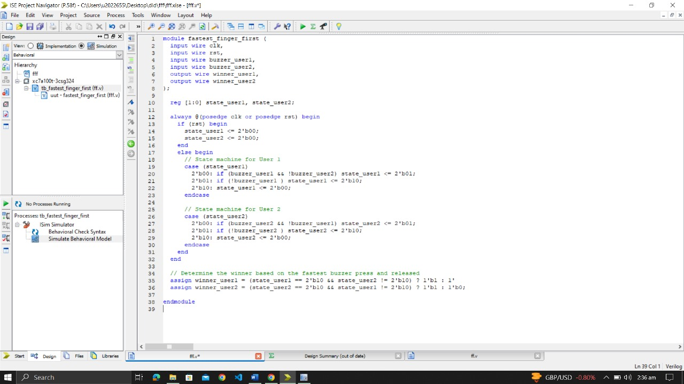

Waveform

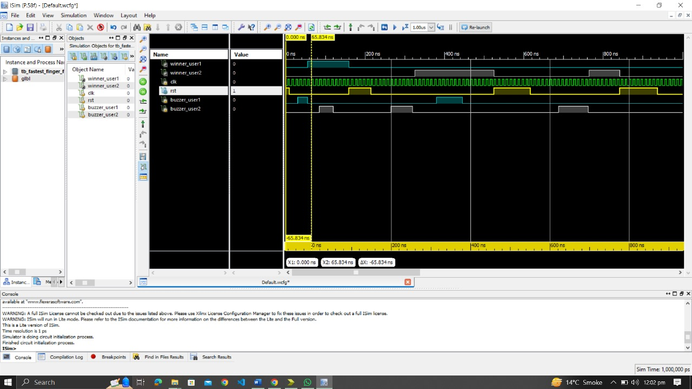

Explanation:
State Initialization (rst):

Both state_user1 and state_user2 are initialized to 2'b00.
Both winner_hold_user1 and winner_hold_user2 are set to 1'b0.
User 1 State Machine (state_user1):

State 2'b00: Initial state. User 1 is waiting for the buzzer to be pressed (buzzer_user1).
Transition to State 2'b01: When buzzer_user1 is pressed, transition to the next state.
State 2'b01: User 1 has pressed the buzzer. Wait for buzzer_user1 to be released and ensure User 2 has not won (!winner_user2).
Transition to State 2'b10: When buzzer_user1 is released and User 2 has not won, transition to the next state.
State 2'b10: Determine if User 1 is the winner (winner_user1). If yes, go to the disabled state (2'b11) and hold the winner signal. If not, go back to the initial state (2'b00).
Transition to State 2'b11: If User 1 has won, go to the disabled state and hold the winner signal until a reset occurs.
Stay in State 2'b11: Stay in the disabled state until a reset occurs.
User 2 State Machine (state_user2):

State 2'b00: Initial state. User 2 is waiting for the buzzer to be pressed (buzzer_user2).
Transition to State 2'b01: When buzzer_user2 is pressed, transition to the next state.
State 2'b01: User 2 has pressed the buzzer. Wait for buzzer_user2 to be released and ensure User 1 has not won (!winner_user1).
Transition to State 2'b10: When buzzer_user2 is released and User 1 has not won, transition to the next state.
State 2'b10: Determine if User 2 is the winner (winner_user2). If yes, go to the disabled state (2'b11) and hold the winner signal. If not, go back to the initial state (2'b00).
Transition to State 2'b11: If User 2 has won, go to the disabled state and hold the winner signal until a reset occurs.
Stay in State 2'b11: Stay in the disabled state until a reset occurs.
Winner Output Determination:
The winner_user1 and winner_user2 outputs are determined based on the state machines and the holding registers (winner_hold_user1 and winner_hold_user2).
If a user wins, the corresponding winner signal is set to 1, and it stays at 1 until a reset occurs.
This code models a game where two users can press buzzers, and the winner is determined by the first buzzer press. The winner signal stays high until a reset occurs, and the game prevents the other user from winning until the reset.

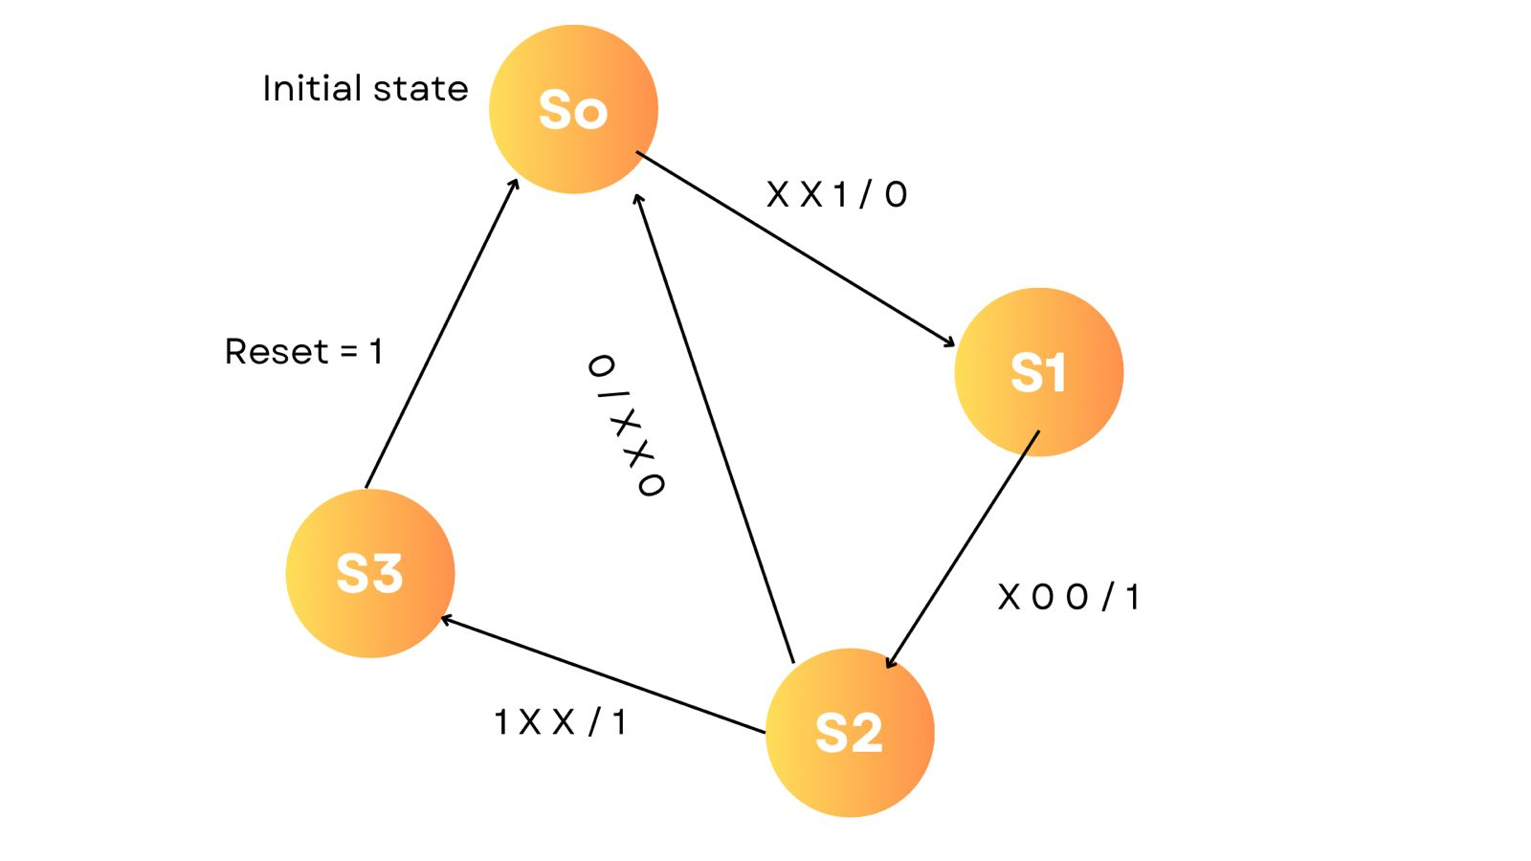

Conclusion:

The successful implementation of a Fastest Finger Circuit using Verilog holds the potential for diverse applications in testing reaction times, gaming, or competitive scenarios. This research will contribute to the development of high-speed timing circuits and advance the understanding of hardware design using Verilog HDL.

