***LAB # 03***

*TASK 1:*

**Take two input and multiply.**

**SOURCE CODE:**

IN

STO 49

IN

SUB 46

STO 48

LDA 47

ADD 49

STO 47

LDA 48

SUB 46

STO 48

BRP 05

LDA 47

OUT

HLT

*46

DAT 001

DAT 000

DAT 000

DAT 000

**OUTPUT:**

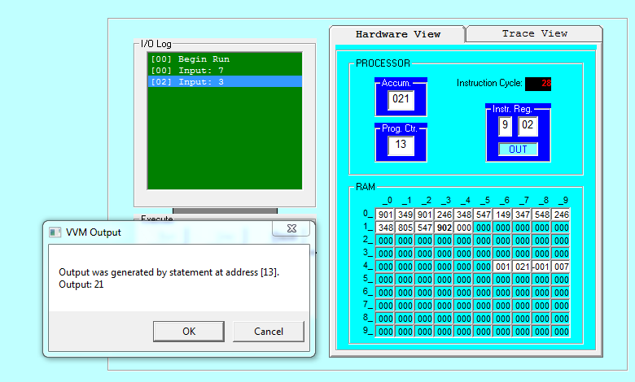

*TASK 2:*

**Take one input and generate table.**

**SOURCE CODE:**

IN

STO 49

LDA 48

ADD 49

STO 48

OUT

LDA 47

ADD 46

STO 47

SUB 45

BRZ 12

BR 02

HLT

*45

DAT 010

DAT 001

DAT 000

DAT 000

**OUTPUT:**

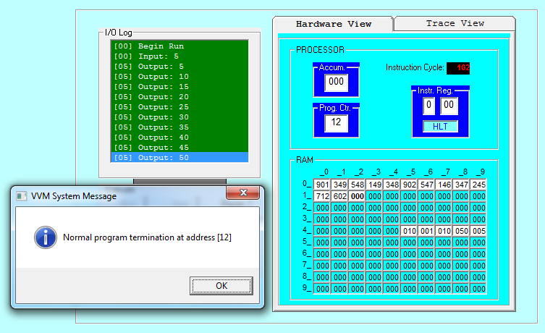

*TASK 3:*

**Take two input and divide them.**

**SOURCE CODE:**

IN

STO 35

IN

STO 41

LDA 35

BRZ 14

SUB 41

STO 35

BRP 10

BR 16

LDA 42

ADD 43

STO 42

BR 04

LDA 42

OUT

HLT

*42

DAT 000

DAT 001

**OUTPUT:**

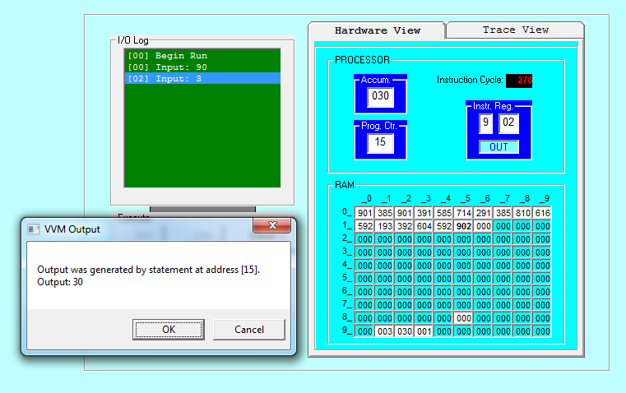

*TASK 4:*

**Take an input and print square of that number.**

**SOURCE CODE:**

IN

STO 49

LDA 48

ADD 49

STO 48

LDA 47

ADD 46

STO 47

SUB 49

BRZ 11

BR 02

LDA 48

OUT

HLT

*46

DAT 001

DAT 000

DAT 000

**OUTPUT:**

