NUCESHUB

Phase-1

Team-6 BSCS-5D

|  |  |  |
| --- | --- | --- |
| **Member Name** | **Member Roll #** | **Primary Responsibility** |
| **Hassan Javed** | **22l-6567** | **Use Case Template** |
| **Mohsin Kamal** | **22l-6745** | **Use Case Diagram** |
| **Maaz Khan** | **22l-6726** | **Use Case Diagram** |
| **Afaq Khaliq** | **22l-6939** | **UML Class Analysis Diagram** |

**Table of Contents**

1. Use Case Diagram
2. Use Case Template
3. UML Class Analysis Diagram

# Use Case Diagram

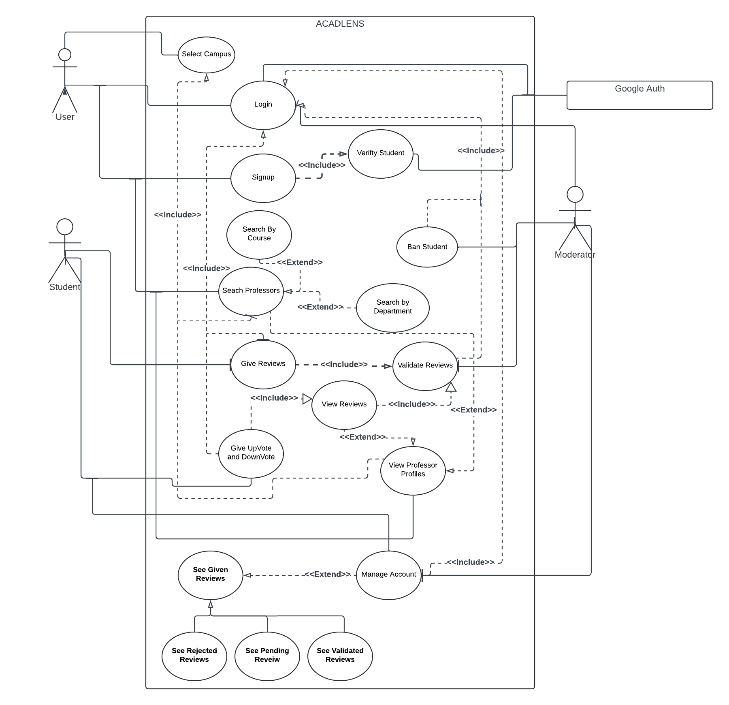

# Use Case Template

|  |  |  |  |
| --- | --- | --- | --- |
| **Identifier** | | UC-1 | |
| **Name** | | Search Professor | |
| **Summary** | | Student searches for the professors | |
| **Priority** | | high | |
| **Actors** | | student | |
| **Pre-condition(s)** | | null | |
| **Post-condition(s)** | | Search Result Displays | |
| **Typical Course of Action** | | | |
| **S#** | **Actor Action** | | **System Response** |
|  | Student enters the Professors name . | |  |
|  | student press search button | |  |
|  |  | | Systems load the requested Search results |
| **Alternate Course of Action** | | | |
| **S#** | **Actor Action** | | **System Response** |
|  | Student enters the Professors name which is not in the database. | | system generates Not Found message |

|  |  |  |  |
| --- | --- | --- | --- |
| **Identifier** | | UC-2 | |
| **Name** | | Select Campus | |
| **Summary** | | Student selects his current campus in order to show his own campus reviews Professors and latest reviews | |
| **Priority** | | high | |
| **Actors** | | student | |
| **Pre-condition(s)** | | login | |
| **Post-condition(s)** | | Respected Professors are Displayed | |
| **Typical Course of Action** | | | |
| **S#** | **Actor Action** | | **System Response** |
|  | Student select any one of the campus from the given option | |  |
|  |  | | Systems load the selected Campus Professors Data |
| **Alternate Course of Action** | | | |
| **S#** | **Actor Action** | | **System Response** |

|  |  |  |  |
| --- | --- | --- | --- |
| **Identifier** | | UC-3 | |
| **Name** | | Search Professor By course | |
| **Summary** | | Extended functionality of search in which students searches for the professors by filtering the professors based on the courses they have thought. | |
| **Priority** | | medium | |
| **Actors** | | student | |
| **Pre-condition(s)** | | null | |
| **Post-condition(s)** | | Search Result Displays filtered by course | |
| **Typical Course of Action** | | | |
| **S#** | **Actor Action** | | **System Response** |
|  | Student enters the professor name | |  |
|  | Student Select the desired course from the list | |  |
|  |  | | Systems load the requested Search results |
| **Alternate Course of Action** | | | |
| **S#** | **Actor Action** | | **System Response** |
|  | Student enters the Professors name which is not in the database. | | system generates Not Found message |

|  |  |  |  |
| --- | --- | --- | --- |
| **Identifier** | | UC-4 | |
| **Name** | | Search by Department | |
| **Summary** | | Extended functionality of search in which students searches for the professors by filtering the professors based on their parent department. | |
| **Priority** | | medium | |
| **Actors** | | student | |
| **Pre-condition(s)** | | null | |
| **Post-condition(s)** | | Search Result Displays filtered by department | |
| **Typical Course of Action** | | | |
| **S#** | **Actor Action** | | **System Response** |
|  | Student enters the professor name | |  |
|  | Student Select the desired department from the list | |  |
|  |  | | Systems load the requested Search results |
| **Alternate Course of Action** | | | |
| **S#** | **Actor Action** | | **System Response** |
|  | Student enters the Professors name which is not in the database. | | system generates Not Found message |

|  |  |  |  |
| --- | --- | --- | --- |
| **Identifier** | | UC-6 | |
| **Name** | | Sign Up | |
| **Summary** | | Students Sign up using their University Domain | |
| **Priority** | | high | |
| **Actors** | | student | |
| **Pre-condition(s)** | | null | |
| **Post-condition(s)** | | Student logs in and lands on home page | |
| **Typical Course of Action** | | | |
| **S#** | **Actor Action** | | **System Response** |
|  | Student clicks on the sign up with Google button | |  |
|  |  | | System Redirects User to Google OAuth |
|  | Student Enters his university email address and password in the respective fields | |  |
|  | Students Press Signs In button. | |  |
|  |  | | Google OAuth Send Successful Response to the System with all details of the sign up. |
|  |  | | Systems inserts the user data in to the database. |
|  |  | | System Displays registration successful Message. |
|  |  | | System Redirects user to homepage |
| **Alternate Course of Action** | | | |
| **S#** | **Actor Action** | | **System Response** |
|  | Student enters invalid email (outside university domain) | |  |
|  |  | | Google OAuth responds system with message indicating email is invalid |
|  |  | | System Displays Registration fail message |

|  |  |  |  |
| --- | --- | --- | --- |
| **Identifier** | | UC-6 | |
| **Name** | | Logs in | |
| **Summary** | | Students Logs in to the an existing acount | |
| **Priority** | | high | |
| **Actors** | | student | |
| **Pre-condition(s)** | | sign up | |
| **Post-condition(s)** | | Student logs in and lands on home page | |
| **Typical Course of Action** | | | |
| **S#** | **Actor Action** | | **System Response** |
|  | Student clicks on the login with Google button | |  |
|  |  | | System Redirects User to Google OAuth |
|  | Student Enters his university email address and password in the respective fields | |  |
|  | Students Press Signs In button. | |  |
|  |  | | Google OAuth Send Successful Response to the System. |
|  |  | | System Redirects user to homepage |
| **Alternate Course of Action** | | | |
| **S#** | **Actor Action** | | **System Response** |
|  | Student enters invalid email (outside university domain) | |  |
|  |  | | Google OAuth responds system with message indicating email is invalid |
|  |  | | System Displays Registration fail message |

|  |  |  |  |
| --- | --- | --- | --- |
| **Identifier** | | UC-7 | |
| **Name** | | Give Review | |
| **Summary** | | Student Give Feedback to the professor | |
| **Priority** | | medium | |
| **Actors** | | student | |
| **Pre-condition(s)** | | student logins and is on professors profile | |
| **Post-condition(s)** | | Request is sent to moderator to validate the review | |
| **Typical Course of Action** | | | |
| **S#** | **Actor Action** | | **System Response** |
|  | Student clicks the review button | |  |
|  | Student Enter Comments. | |  |
|  | Student Selects rating out of 5 | |  |
|  | Student Selects the course for which he is reviewing the professor | |  |
|  | Student clicks on submit review button. | |  |
|  |  | | Systems sends the review to moderator for validation. |
|  |  | | System Displays the following message “Review is waiting to be approved by the moderator and would be posted shortly” |
| **Alternate Course of Action** | | | |
| **S#** | **Actor Action** | | **System Response** |
|  | Student does not enter any one of the three fields (comment,rating,course) and presses enter | |  |
|  |  | | system displays a message prompting user to enter all details. |

|  |  |  |  |
| --- | --- | --- | --- |
| **Identifier** | | UC-8 | |
| **Name** | | Validate Review | |
| **Summary** | | Moderator Approves Reviews of Students | |
| **Priority** | | high | |
| **Actors** | | moderator | |
| **Pre-condition(s)** | | A student submits a review. Moderator is login | |
| **Post-condition(s)** | | Review is displayed on professor and user profile | |
| **Typical Course of Action** | | | |
| **S#** | **Actor Action** | | **System Response** |
|  | Moderator selects a review from the list of pending reviews. | |  |
|  | Moderator reviews the review | |  |
|  | Moderator Clicks Validate | |  |
|  |  | | System Marks the review as validated |
|  |  | | System shows the review on student and professor page |
| **Alternate Course of Action** | | | |
| **S#** | **Actor Action** | | **System Response** |
|  | Moderator rejects the review | |  |
|  |  | | System Marks the Review as rejected |
|  |  | | System notifies the student that the review is rejected;. |

|  |  |  |  |
| --- | --- | --- | --- |
| **Identifier** | | UC-9 | |
| **Name** | | Up/down Vote | |
| **Summary** | | Student upvotes or down votes any review | |
| **Priority** | | high | |
| **Actors** | | Student | |
| **Pre-condition(s)** | | Student is logged in and previewing any review | |
| **Post-condition(s)** | | Review is upvoted/ downvoted | |
| **Typical Course of Action** | | | |
| **S#** | **Actor Action** | | **System Response** |
|  | Student either clicks the up vote or down vote | |  |
|  |  | | System add up vote or down vote to the review. |
| **Alternate Course of Action** | | | |

|  |  |  |  |
| --- | --- | --- | --- |
| **Identifier** | | UC-10 | |
| **Name** | | See given Reviews | |
| **Summary** | | student can see all of his validated, rejected , pending reviews | |
| **Priority** | | high | |
| **Actors** | | Student | |
| **Pre-condition(s)** | | Student is logged in and is on manage profile page | |
| **Post-condition(s)** | | Reviews are displayed | |
| **Typical Course of Action** | | | |
| **S#** | **Actor Action** | | **System Response** |
|  | Student selects from any three option, pending, validated, rejected | |  |
|  |  | | System displays the selected reviws |
| **Alternate Course of Action** | | | |

|  |  |  |  |
| --- | --- | --- | --- |
| **Identifier** | | UC-11 | |
| **Name** | | View Reviews | |
| **Summary** | | Student see the selected professor reviews | |
| **Priority** | | high | |
| **Actors** | | Student | |
| **Pre-condition(s)** | | Student is logged in, searched or viewing professor. | |
| **Post-condition(s)** | | Reviews are displayed | |
| **Typical Course of Action** | | | |
| **S#** | **Actor Action** | | **System Response** |
|  | Student selects Professor | |  |
|  |  | | System redirects to the professor profile and show all reviews. |
| **Alternate Course of Action** | | | |

|  |  |  |  |
| --- | --- | --- | --- |
| **Identifier** | | UC-12 | |
| **Name** | | View Professor Profile | |
| **Summary** | | Student see the professors profile | |
| **Priority** | | high | |
| **Actors** | | Student | |
| **Pre-condition(s)** | | Student is logged in, searched professor, and selects the cmapus. | |
| **Post-condition(s)** | | Profressor profile is dusplayed | |
| **Typical Course of Action** | | | |
| **S#** | **Actor Action** | | **System Response** |
|  | Student Clicks on Professor | |  |
|  |  | | System loads the Professor profile |
| **Alternate Course of Action** | | | |

|  |  |  |  |
| --- | --- | --- | --- |
| **Identifier** | | UC-12 | |
| **Name** | | Ban Student | |
| **Summary** | | Moderator Bans the Student from further posts | |
| **Priority** | | high | |
| **Actors** | | Moderator | |
| **Pre-condition(s)** | | Moderator is logged in. | |
| **Post-condition(s)** | | Notification is sent to user that he can not review any more | |
| **Typical Course of Action** | | | |
| **S#** | **Actor Action** | | **System Response** |
|  | Moderator Selects the student and clicks ban. | |  |
|  | Moderator selects the time period and clicks confirm. | |  |
|  |  | | System bans the student from further posting. |
|  |  | | System Send the student a notification. |
| **Alternate Course of Action** | | | |

|  |  |  |  |
| --- | --- | --- | --- |
| **Identifier** | | UC-13 | |
| **Name** | | Verify Account | |
| **Summary** | | Google Auth Verifies student account | |
| **Priority** | | high | |
| **Actors** | | Google Oauth | |
| **Pre-condition(s)** | | null | |
| **Post-condition(s)** | | verification sent to system | |
| **Typical Course of Action** | | | |
| **S#** | **Actor Action** | | **System Response** |
|  | Google Auth Received email and password from the user | |  |
|  | Google Auth application verifies the domain and account and send Verification. | |  |
|  |  | | System Receives the confirmation and continues with the login/signup process |
| **Alternate Course of Action** | | | |
|  | Google Auth verification fails and failure message is sent to the system. | |  |
|  |  | | System acknowledges the failure and redirects to the login page. |

# UML Class Analysis Diagram