
COMSATS University Islamabad
SDS and 60% Implementation
(Document 4 — Half Report)
MalTwin: An AI-Based Framework for Malware Variant
Detection in Industrial IoT Using Digital Twins
and Visual Analysis
By
Iman Fatima CIIT/SP23-BCT-021/ISB
Maaz Malik CIIT/SP23-BCT-025/ISB
Supervisor
Ms. Najla Raza
Bachelor of Science in Cyber Security (2023-2027)
The candidate confirms that the work submitted is their own and appropriate
credit has been given where reference has been made to the work of others.

Contents
Chapter 3: Design and Architecture 6
3.1 System Architecture Overview 6
3.1.1 Purpose 6
3.2 Architecture Diagram 7
3.2.1 Technologies and Services 9
3.3 Key Design Decisions 9
3.4 Design Models 10
3.4.1 Design Models for the Object-Oriented Approach 10
3.4.2 Design Models for the Procedural Approach 12
3.5 Data Design 17
Chapter 4: Implementation 20
4.1 Project Methodology & Algorithms 20
4.1.1 Project Methodology (Step-by-Step Approach) 20
4.1.2 Algorithms 23
4.2 Training Results & Model Evaluation 24
4.3 Security Techniques 27
4.4 External APIs/SDKs 28
4.5 User Interface 28
4.6 Deployment 32
Chapter 5: Testing and Evaluation 34
5.1 Unit Testing 34
Unit Testing 1: Binary-to-Image Conversion (M2) 34
Unit Testing 2: Dataset Loading and Splitting (M3) 35
Unit Testing 3: Augmentation and Oversampling (M4) 35
Unit Testing 4: CNN Model and Inference (M5) 35
Unit Testing 5: Grad-CAM Explanation (M7) 36
Unit Testing 6: Reporting and MITRE Mapping (M8) 36
Unit Testing 7: Detection Log Database (M6/M8) 37
Unit Testing 8: Dynamic Behavioural Analysis (M9) 37
Unit Testing 9: Hybrid Fusion (M10) 38
Unit Testing 10: Extended Evaluation Metrics 38
Unit Testing 11: Module Health Checks (M6) 39
Unit Testing 12: Training Manager (M5/M6) 39
5.2 Functional Testing 40
Functional Testing 1: Binary Upload 40
Functional Testing 2: Malware Detection 41
Functional Testing 3: Dynamic Analysis 41
Functional Testing 4: Hybrid Verdict 42
Functional Testing 5: Navigation and Digital Twin Page 42
5.3 Business Rules Testing 42
Business Rule Test 1: Upload Acceptance 43
Business Rule Test 2: Confidence Colour Coding 43
Business Rule Test 3: Hybrid Fusion Decision 44
5.4 Integration Testing 44
Integration Testing 1: Training Pipeline (M3 + M4 + M5 + evaluation) 44
Integration Testing 2: Static Analysis Path with the Dashboard and Database (M2 + M5 + M6 + SQLite) 45
Integration Testing 3: Dynamic Path and Fusion (M9 + M10 + M8 mapping) 45
5.5 Performance Testing 46
5.6 Defects Found and Fixed 46
Summary of Testing Results 47
Chapter 6: Conclusion and Future Work 48
6.1 Conclusion 48
6.2 Future Work 48
6.2.1 Digital Twin Implementation (final evaluation) 48
6.2.2 Paired Static–Dynamic Evaluation (final evaluation) 48
6.2.3 A Benign Class for the Static Detector 49
6.2.4 Richer Dynamic Features 49
6.2.5 Stronger Open-Set Detection 49
6.2.6 Reporting and Deployment 49
Chapter 7: References 50
Chapter 8: Plagiarism Report 52

List of Figures
Figure 3.1 System architecture of MalTwin 6
Figure 3.2 Layered architecture 8
Figure 3.3 Class diagram of the core classes 11
Figure 3.4 Activity diagram for analysing a sample 12
Figure 3.5 Level 0 context diagram 13
Figure 3.6 Level 1 data flow diagram 14
Figure 3.7 Level 2 data flow diagram for Process 4.0 15
Figure 3.8 State transition diagram for a submitted sample 16
Figure 3.9 Entity relationship diagram 17
Figure 4.6 Binary Upload page after validating a PE file 29
Figure 4.7 Dynamic Analysis page (demonstration model trained on synthetic traffic, clearly labelled as such in the interface) 30
Figure 4.8 Hybrid Verdict what-if simulator showing the NOVEL VARIANT case 31
Figure 4.9 Digital Twin page with the planned architecture 32

List of Tables
Table 3.1 Architecture layers 8
Table 3.2 Components, technologies and security measures 9
Table 3.3 Design decisions and rationale 9
Table 3.4 Level 1 processes and data stores 13
Table 3.5 detection_events 17
Table 3.6 report_events 17
Table 3.7 Files produced by training 18
Table 3.8 Data retention policy 18
Table 3.9 How modules exchange data 19
Table 4.1 Implementation status by module 20
Table 4.2 Algorithms implemented in MalTwin 23
Table 4.3 Training configuration 25
Table 4.4 Static CNN — Malimg test set 25
Table 4.5 Unseen-family experiment (5 families held out) 26
Table 4.6 Dynamic model — IoT-23 26
Table 4.7 Measured performance against SRS targets 26
Table 4.8 External libraries and SDKs 28
Table 4.9 Dashboard pages and modules covered 28
Table 4.10 System requirements 32
Table 4.11 Configuration through environment variables 33
Table 5.1 Binary-to-Image Conversion (M2) — unit test results 34
Table 5.2 Dataset Loading and Splitting (M3) — unit test results 35
Table 5.3 Augmentation and Oversampling (M4) — unit test results 35
Table 5.4 CNN Model and Inference (M5) — unit test results 36
Table 5.5 Grad-CAM Explanation (M7) — unit test results 36
Table 5.6 Reporting and MITRE Mapping (M8) — unit test results 36
Table 5.7 Detection Log Database (M6/M8) — unit test results 37
Table 5.8 Dynamic Behavioural Analysis (M9) — unit test results 37
Table 5.9 Hybrid Fusion (M10) — unit test results 38
Table 5.10 Extended Evaluation Metrics — unit test results 38
Table 5.11 Module Health Checks (M6) — unit test results 39
Table 5.12 Training Manager (M5/M6) — unit test results 39
Table 5.13 Unit test summary by file 39
Table 5.14 Binary upload — functional test results 40
Table 5.15 Malware detection — functional test results 41
Table 5.16 Dynamic analysis — functional test results 41
Table 5.17 Hybrid verdict — functional test results 42
Table 5.18 Navigation and Digital Twin — functional test results 42
Table 5.19 Decision table — upload acceptance 43
Table 5.20 Test cases — upload acceptance 43
Table 5.21 Test cases — confidence colour boundaries 43
Table 5.22 Decision table — fusion category and escalation 44
Table 5.23 Test cases — fusion decision (automated in tests/test_fusion.py) 44
Table 5.24 Training pipeline integration results 45
Table 5.25 Static path integration results 45
Table 5.26 Dynamic path and fusion integration results 45
Table 5.27 Defects found during Evaluation 3 testing 46
Table 5.28 Overall testing summary 47

Chapter 3: Design and Architecture
This chapter describes how MalTwin is put together: which components exist, how a sample moves through them, how data is stored, and the reasoning behind the main design decisions. It reflects the system as implemented for the 60% evaluation, including the two modules added since the SRS: dynamic behavioural analysis (M9) and hybrid static–dynamic fusion (M10). Both were promised as objectives 03 and 04 of the project proposal.

3.1 System Architecture Overview
MalTwin is a research platform for detecting and explaining malware variants that target Industrial IoT environments. It looks at a suspicious sample from two complementary angles. The static view examines the structure of the binary file without running it. The dynamic view examines what the sample does on the network when it runs. A fusion layer combines the two. Everything is operated from a single web dashboard and runs locally on the analyst's machine.
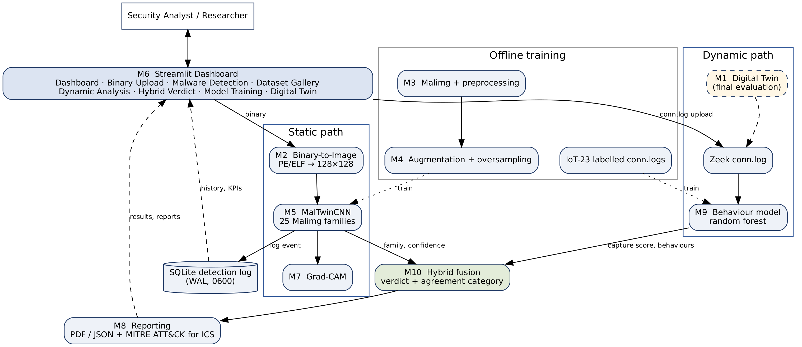
Figure 3.1 System architecture of MalTwin

3.1.1 Purpose
What this diagram shows
Figure 3.1 shows the ten modules and the data passed between them. The analyst only interacts with the dashboard (M6). The static path (M2 → M5 → M7) handles binaries. The dynamic path (M1 → Zeek → M9) handles network behaviour. Fusion (M10) and reporting (M8) produce the final outputs. Training is done offline, and its products (model files and metrics) are read by the online components.
Walking through the flow
The following sequence is what happens when an analyst submits a sample:
- Upload and validation. The analyst uploads a PE (.exe, .dll) or ELF binary on the Binary Upload page. The file is rejected if it is larger than 50 MB or if its first bytes are not the MZ (PE) or \x7fELF (ELF) signature. The extension is never trusted, because Linux IIoT binaries usually have none.
- Fingerprinting. A SHA-256 digest is computed locally with hashlib. No hash or file ever leaves the machine, so analysing a sample does not alert its authors.
- Binary-to-image conversion (M2). The raw bytes are laid out row by row as an 8-bit grayscale image. The row width follows the Nataraj et al. file-size table used to build Malimg (32 px for files under 10 KB, up to 1,024 px above 1 MB), then the image is resized to 128 × 128. Using the same layout as the training data keeps uploaded binaries in the distribution the network has learned.
- Static classification (M5). MalTwinCNN, a three-block convolutional network, returns a probability for each of the 25 Malimg families. The top-1 family and its probability (confidence) are shown with a green, amber or red bar at the 0.80 and 0.50 thresholds.
- Explanation (M7). On request, Grad-CAM computes which regions of the image, and therefore which byte ranges of the binary, contributed most to the predicted family. The result is overlaid as a heatmap.
- Dynamic analysis (M9). If a network capture of the sample is available as a Zeek conn.log (from IoT-23 today, from the Digital Twin in the final phase), each connection is converted into 61 behavioural features and classified by a random forest into Benign, PortScan, C&C, DDoS, Attack, FileDownload or Okiru behaviour. A capture-level score summarises the most suspicious flows.
- Fusion (M10). The static confidence and the dynamic score are combined into one verdict (MALICIOUS, SUSPICIOUS or BENIGN) together with an agreement category that tells the analyst why: confirmed by both views, static-only, behaviour-only (possible novel variant) or no evidence.
- Threat intelligence and reporting (M8). The predicted family and observed behaviours are mapped to MITRE ATT&CK for ICS tactics and techniques. A PDF or JSON forensic report can be downloaded, and every detection is written to an SQLite log that feeds the dashboard's history and KPI cards.
The Digital Twin (M1) appears with a dashed outline because it is designed but scheduled for the final evaluation. Its only contract with the rest of the system is to produce a Zeek conn.log for each run, which is the same format the dynamic model is already trained on. When the twin is built, it plugs into the existing pipeline without changes to M9 or M10.

3.2 Architecture Diagram
Why a layered architecture
Internally MalTwin follows a layered architecture. Each layer only depends on the one beneath it, and every module sits in exactly one layer. We chose this structure for four reasons:
- Separation of concerns. File validation knows nothing about neural networks, and the CNN knows nothing about Streamlit. This kept the code base testable: 322 unit tests run without a GPU, without the dataset and without a browser.
- Replaceable components. The CNN and the random forest can be retrained or replaced without touching the dashboard, because the layer above only consumes their outputs (a family name and a probability, or a capture score).
- Graceful degradation. If a model file is missing, the detection layer reports itself as inactive and the dashboard still works for every other task. The health panel (FR1.1) shows exactly which layer is unavailable.
- A clear path for the Digital Twin. The twin is a new data source at Layer 2. Nothing above that layer needs to change.
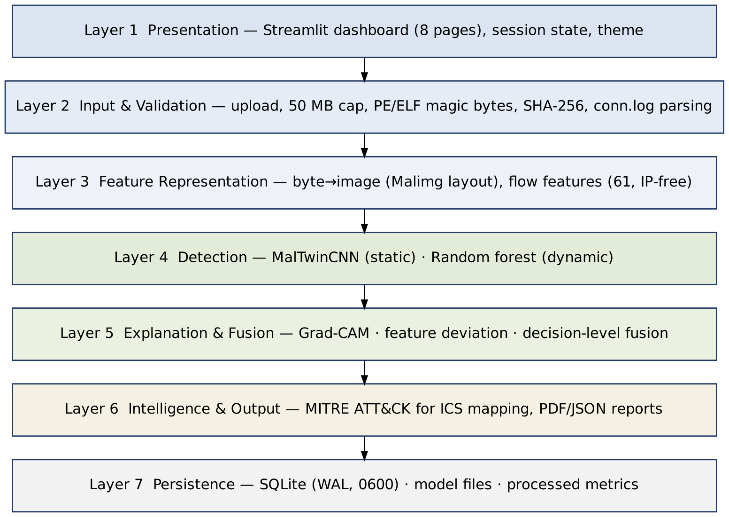
Figure 3.2 Layered architecture
Table 3.1 Architecture layers
Layer | What is inside | Its job
1. Presentation | Streamlit dashboard, 8 pages, theme | Interaction, visualisation, downloads
2. Input & validation | Upload checks, magic bytes, SHA-256, Zeek parser | Reject bad input early and fingerprint samples
3. Feature representation | Binary-to-image converter; flow feature extractor | Turn raw evidence into model-ready inputs
4. Detection | MalTwinCNN; random-forest behaviour model | Classify family and behaviour
5. Explanation & fusion | Grad-CAM; feature-deviation explanation; fusion rules | Say why, and combine the two views
6. Intelligence & output | MITRE ATT&CK for ICS mapping; PDF/JSON reports | Make results actionable and shareable
7. Persistence | SQLite (WAL), model files, processed metrics | Durable, auditable records

3.2.1 Technologies and Services
Table 3.2 lists the main components, the technology each uses and the security measure applied to it. Versions are pinned in requirements.txt.
Table 3.2 Components, technologies and security measures
Component | What it does | Technology | Security measure
Dashboard (M6) | Eight-page web UI | Streamlit 1.37, Plotly | Bound to 127.0.0.1; 50 MB upload cap; usage statistics disabled
Binary-to-image (M2) | PE/ELF bytes → 128×128 image | NumPy, OpenCV | Magic-byte validation; file is never executed or written to disk
Dataset & enhancement (M3, M4) | Stratified splits, augmentation, oversampling | PyTorch, torchvision | Integrity check flags corrupt images before training
Static detector (M5) | 25-family CNN | PyTorch 2.x | Model loaded only from the project directory; eval mode for deterministic output
Explainability (M7) | Grad-CAM heatmaps | Captum LayerGradCam | Runs locally; no data leaves the host
Reporting (M8) | PDF/JSON reports, MITRE mapping | FPDF2, JSON | Reports identify samples by SHA-256, not file path
Detection log | History and KPIs | SQLite (WAL mode) | File permission 0600; parameterised queries
Dynamic detector (M9) | Behaviour classification of flows | scikit-learn RandomForest, pandas | No IP addresses used as features; model file format and feature list verified on load
Fusion (M10) | Combined verdict | Pure Python | Input range checks; deterministic rules
Digital Twin (M1, planned) | Isolated IIoT network for running samples | Docker (internal network), Zeek | No route to host LAN; no host mounts; CPU/RAM limits; teardown per run

3.3 Key Design Decisions
Several decisions shaped the implementation. Each one is recorded here with its reason, so it can be revisited if the assumptions change.
Table 3.3 Design decisions and rationale
Decision | Alternatives considered | Reason
Lay out bytes with the Malimg width table before resizing | Square layout (width = √size) | The CNN is trained on Malimg images, which were built with this table. Using a different layout at upload time would show the network images unlike anything it was trained on.
Compact 3-block CNN (1.35 M parameters) trained from scratch | ImageNet-pretrained ResNet / VGG | Grayscale 128×128 byte images share little with natural photos. A small network trains on a laptop CPU, runs inference in milliseconds, and keeps Grad-CAM readable.
Weighted random oversampling | Class-weighted loss only; SMOTE on images | Malimg is 36:1 imbalanced (Allaple.A 2,949 vs Skintrim.N 80). Oversampling with augmentation shows the network varied minority samples instead of duplicates.
Zeek conn.log as the dynamic input format | Raw PCAP; system-call traces | IoT-23 is published in this format, so a model can be trained now. The Digital Twin can produce the same file by running Zeek on its bridge.
Random forest for flows | Deep sequence models (LSTM) | Tabular, heavy-tailed features with extreme class imbalance; built-in feature importance gives the "why" required for explainability.
No IP addresses as features | Include source/destination IP | Each IoT-23 capture has its own infected host IP. A model that learned IPs would learn identities, not behaviour, and would not transfer to the twin.
Decision-level (late) fusion | Feature-level fusion in one network | Static and dynamic evidence are not yet available for the same samples (that needs the twin). Late fusion works with either source alone and keeps each model independently testable.
Docker networking for the twin, Mininet optional | Mininet only | Mininet requires a native Linux host with root. Docker internal networks give the needed isolation and also run on Windows with WSL2.

3.4 Design Models

3.4.1 Design Models for the Object-Oriented Approach
Class diagram
Purpose: to show the main classes, what they hold and how they depend on each other. Functions that are stateless (validation, hashing, MITRE lookup, report generation) are kept as module-level functions and are omitted.
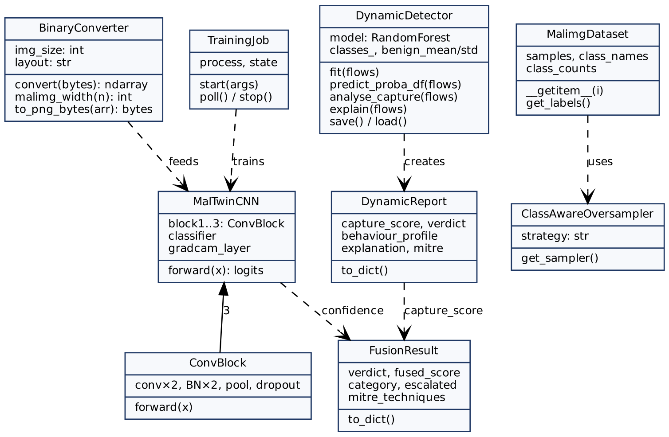
Figure 3.3 Class diagram of the core classes
MalTwinCNN is composed of three ConvBlock instances and exposes gradcam_layer, the last convolution, which Grad-CAM hooks into. DynamicDetector wraps the random forest and also stores the mean and spread of benign traffic, which it needs to explain a capture. Both detectors feed FusionResult only through plain numbers (a confidence and a capture score). This loose coupling is what allows either detector to be retrained or replaced independently.
Activity diagram
Purpose: to show the complete workflow for one sample, from upload to report. Core workflow: validation → conversion → static classification → optional explanation → optional dynamic analysis → fusion → reporting.
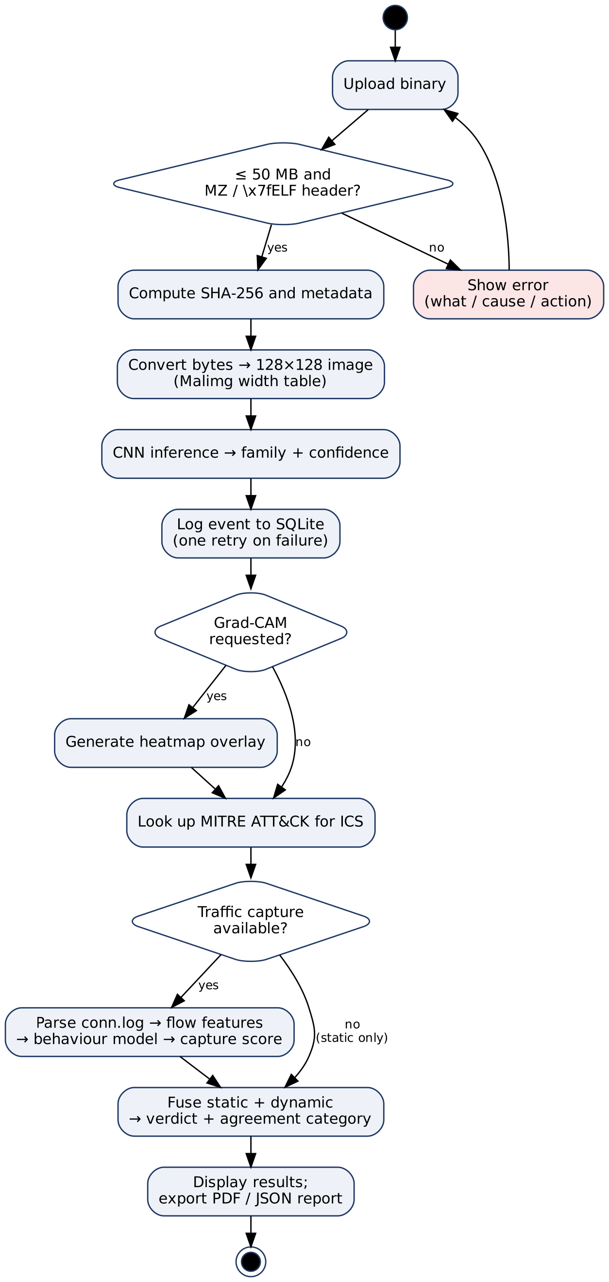
Figure 3.4 Activity diagram for analysing a sample

3.4.2 Design Models for the Procedural Approach

3.4.2.1 Data Flow Diagrams
Purpose: to show how data moves through the system, from samples and captures to verdicts, reports and stored records.
Level 0: Context diagram
At the highest level MalTwin is a single process exchanging data with four external entities: the analyst who submits samples and reads results, the public datasets used for training, the Digital Twin that supplies runtime traffic (dashed, final phase), and the MITRE ATT&CK for ICS knowledge base, which is stored locally as JSON.
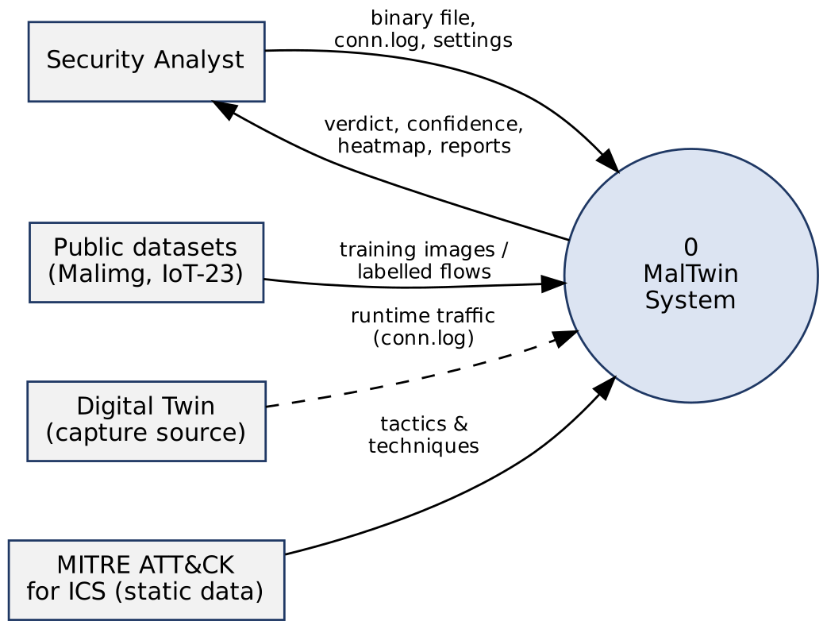
Figure 3.5 Level 0 context diagram
Level 1: Main processes
Level 1 breaks the system into six processes and four data stores.
Table 3.4 Level 1 processes and data stores
ID | Name | What it does
1.0 | Validate & Convert | Checks size and magic bytes, computes SHA-256, builds the 128×128 image
2.0 | Static Detect | Runs MalTwinCNN, returns family probabilities
3.0 | Dynamic Analyse | Parses conn.log, extracts flow features, scores behaviour
4.0 | Fuse & Explain | Combines both scores, assigns agreement category, merges MITRE techniques
5.0 | Report & Log | Writes the SQLite event, builds PDF/JSON reports, feeds the dashboard
6.0 | Train Models | Offline: trains the CNN and the behaviour model, writes metrics
D1 | Model files | best_model.pt, dynamic_model.joblib
D2 | Detection log | SQLite detection_events, report_events
D3 | MITRE mapping | mitre_ics_mapping.json (families), mitre_ics_behaviour_mapping.json (behaviours)
D4 | Processed metrics | eval_metrics.json, dynamic_metrics.json, plots
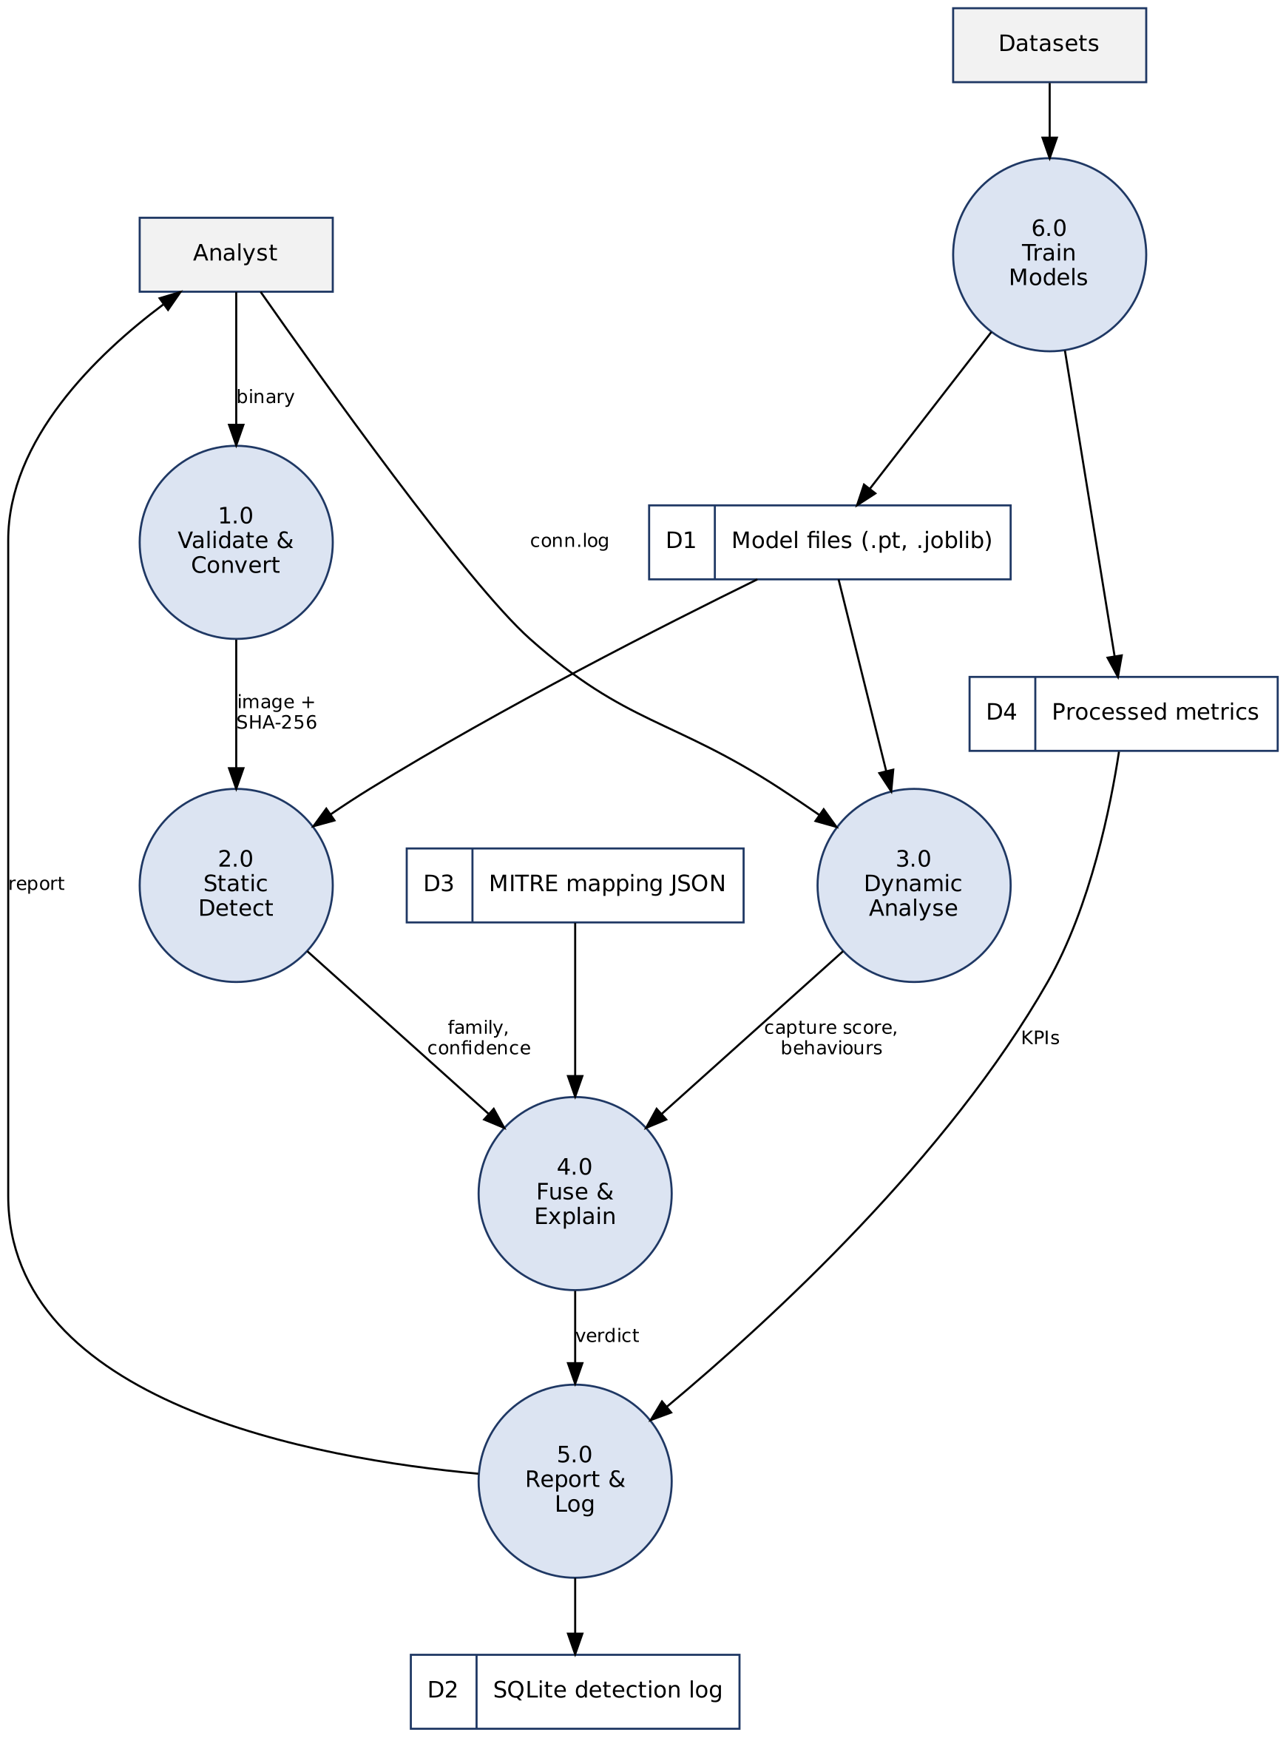
Figure 3.6 Level 1 data flow diagram
Level 2: Process 4.0 — Fuse & Explain
Process 4.0 is the part of MalTwin that is new relative to image-only malware classifiers, so it is expanded here. Sub-process 4.1 computes the weighted score. Sub-process 4.2 independently decides whether each view is "high" (static confidence ≥ 0.80, dynamic score ≥ 0.50). Sub-process 4.3 turns these into a verdict and applies the novel-variant escalation rule. Sub-process 4.4 merges MITRE techniques from both sources, listing those supported by both first.
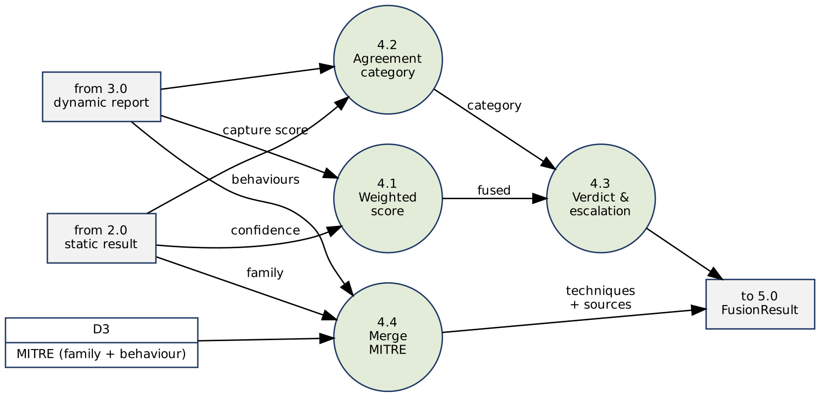
Figure 3.7 Level 2 data flow diagram for Process 4.0

3.4.2.2 State Transition Diagram
Purpose: to show the states a sample passes through during analysis. A sample becomes Rejected if it fails validation and returns to Uploaded when a new file is chosen. After Classified, logging happens automatically, while explanation, fusion and reporting are optional and can be taken in any order the analyst chooses.
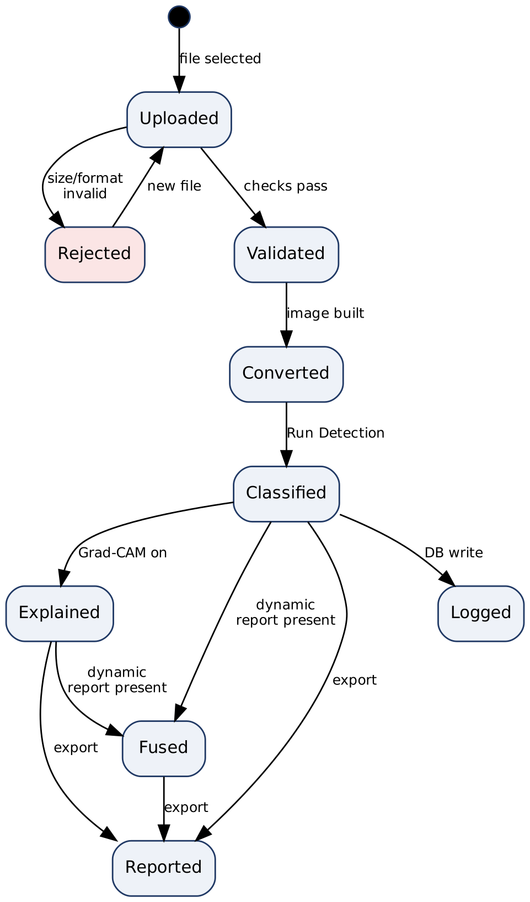
Figure 3.8 State transition diagram for a submitted sample

3.4.2.3 Entity Relationship Diagram
MalTwin deliberately keeps its persistent data small. Two entities are stored in SQLite: DetectionEvent, one row per detection run, and ReportEvent, one row per report download, which references the detection it came from. Three further entities are reference data held in version-controlled JSON files rather than the database, because they change only when the models are retrained: MalwareFamily, Behaviour and MitreTechnique. A family or a behaviour maps to many ATT&CK techniques, and a technique (for example T0846 Remote System Discovery) can be shared by several families and behaviours.
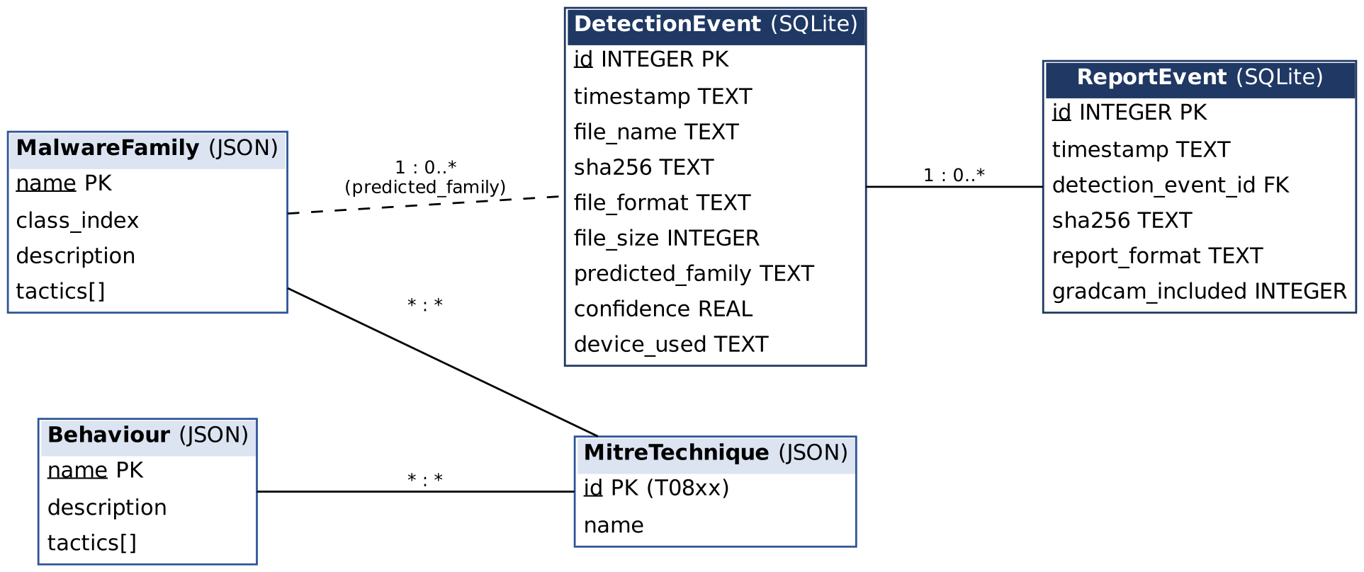
Figure 3.9 Entity relationship diagram

3.5 Data Design
This section describes how MalTwin structures and stores its data.
1. Detection events (SQLite table `detection_events`)
Every detection run is recorded. This is the audit trail behind the dashboard's history view, KPI cards and CSV export.
Table 3.5 detection_events
Field | Type | What it stores
id | INTEGER PK | Auto-increment identifier
timestamp | TEXT | UTC time in ISO 8601 format
file_name | TEXT | Original upload name (display only)
sha256 | TEXT | 64-character hex digest; the real identity of the sample
file_format | TEXT | "PE" or "ELF"
file_size | INTEGER | Size in bytes
predicted_family | TEXT | Top-1 Malimg family
confidence | REAL | Top-1 softmax probability, 0–1
device_used | TEXT | "cpu" or "cuda"
Indexes on timestamp and predicted_family support the date and family filters. With 100,000 rows, a filtered aggregate query takes about 0.1 s (Section 5.5).
2. Report events (SQLite table `report_events`)
Table 3.6 report_events
Field | Type | What it stores
id | INTEGER PK | Auto-increment identifier
timestamp | TEXT | When the report was generated
detection_event_id | INTEGER FK | The detection the report describes
sha256 | TEXT | Sample digest (indexed)
report_format | TEXT | "pdf" or "json"
gradcam_included | INTEGER | 1 if a heatmap was embedded

3. Reference data (JSON)
mitre_ics_mapping.json holds, for each of the 25 families, a short description, its ATT&CK for ICS tactics and a list of technique IDs and names. mitre_ics_behaviour_mapping.json does the same for the six malicious behaviour classes (for example PortScan → T0846 Remote System Discovery and T0840 Network Connection Enumeration; DDoS → T0814 Denial of Service and T0826 Loss of Availability). class_names.json fixes the order of the CNN's output classes.
4. Model and evaluation artefacts
Table 3.7 Files produced by training
File | Produced by | Content
models/best_model.pt | scripts/train.py | CNN weights with the best validation accuracy
data/processed/eval_metrics.json | scripts/train.py | Test-set accuracy, precision, recall, F1, ROC-AUC, FPR, MCC, per-class metrics
data/processed/*.png | training scripts | Confusion matrices, ROC curves, training curves, importance plots
data/processed/unseen_family_eval.json | scripts/evaluate_unseen.py | Known-vs-unseen family separation metrics
models/dynamic_model.joblib | scripts/train_dynamic.py | Random forest, feature list, benign baseline, metadata
data/processed/dynamic_metrics.json | scripts/train_dynamic.py | Behaviour and malicious-vs-benign metrics
data/processed/performance.json | scripts/benchmark.py | Measured timings for the SRS performance requirements

Data retention
Table 3.8 Data retention policy
Data | Retention | Reason
Uploaded binaries | Not stored | Held in memory for the session only; avoids keeping live malware on disk
Detection and report events | Until the analyst clears the log | Audit trail; small (one row per run)
Model files and metrics | Versioned per training run | Reproducibility of reported results
Traffic captures | Not stored by the dashboard | Analysed in memory; the analyst keeps the source file

Module interaction summary
Table 3.9 How modules exchange data
From | To | Data | How
Upload page | M2 converter | Raw bytes | In-process function call
M2 | M5 CNN | 128×128 uint8 array | Tensor in memory
M5 | M7 Grad-CAM | Model + target class | Captum hook on the last conv layer
M5 | SQLite | Detection event | Parameterised INSERT, one retry on failure
Dynamic page | M9 detector | Parsed conn.log rows | pandas DataFrame
M5, M9 | M10 fusion | Confidence, capture score, MITRE lists | Session state → fuse()
M10 / M5 | M8 reporting | Result dictionaries | PDF/JSON bytes to download button
Training scripts | Dashboard | Models and metrics | Files in models/ and data/processed/

Chapter 4: Implementation
This chapter documents the implementation of MalTwin at the 60% milestone. It covers the methodology followed for each module, the core algorithms written as pseudocode, the training setup and evaluation method, the security techniques applied, the external libraries used, the user interface and the deployment procedure.
Table 4.1 summarises where each module stands. Eight of the ten modules are implemented and unit-tested. The Digital Twin (M1) is designed and its interface is fixed, but it is not yet built. The fusion module (M10) is complete, but its paired evaluation, scoring the same sample's image and traffic together, depends on the twin. Both are the main work for the final evaluation.
Table 4.1 Implementation status by module
Module | Status | Evidence | Remaining for final evaluation
M1 Digital Twin | Designed | Architecture, node plan, interface contract; dashboard page with live prerequisite checks | Build Docker network (PLC, HMI, sensors, MQTT broker, sandbox, Zeek); start/stop, live log, node status
M2 Binary-to-Image | Complete | 32 unit tests; Malimg-consistent layout | —
M3 Dataset & preprocessing | Complete | 22 unit tests; stratified 70/15/15 split | Optional: add further IIoT sample sources
M4 Enhancement & balancing | Complete | 18 unit tests; 3 oversampling strategies | —
M5 Static detection (CNN) | Complete | 23 unit tests; end-to-end training run verified | Report final metrics; hyperparameter study
M6 Dashboard | Complete | 8 pages; functional tests in Section 5.2 | Twin controls; usability trial (USE-1)
M7 Grad-CAM XAI | Complete | 20 unit tests | —
M8 Reporting & MITRE | Complete | 30 unit tests; 25/25 families mapped | Include dynamic and fused results in PDF
M9 Dynamic analysis | Complete | 31 unit tests; IoT-23 format parser | Train on twin captures; capture-split results
M10 Hybrid fusion | Logic complete | 16 unit tests incl. decision table | Paired evaluation and weight tuning with twin data

4.1 Project Methodology & Algorithms

4.1.1 Project Methodology (Step-by-Step Approach)
Development followed an incremental, test-first approach. Each module was built behind a small interface, covered by unit tests that run on synthetic data (no dataset or GPU required), and only then connected to the dashboard. The steps below follow the order of the data pipeline.

Step 1: Binary-to-Image Conversion (M2)
BinaryConverter reads the uploaded bytes into a NumPy uint8 array without copying, chooses the row width from the file size using the Malimg table, reshapes the bytes into a 2-D array (discarding the incomplete last row), and resizes the result to 128 × 128 with bilinear interpolation. Before conversion, validate_binary_format() checks the magic bytes (MZ for PE, \x7fELF for ELF) and compute_sha256() fingerprints the file. A 256-bin pixel histogram is computed for display (FR3.4).
During this phase we found that the original converter used a square layout (width = √size), whereas the Malimg images used for training were built with Nataraj's width table. The converter now uses the Malimg layout by default. A unit test checks that it reproduces the reference pipeline pixel for pixel. The square layout remains available through MALTWIN_IMAGE_LAYOUT=square.

Step 2: Dataset Loading and Preprocessing (M3)
MalimgDataset scans one folder per family, encodes labels alphabetically, and performs a two-stage stratified split (70% train, 15% validation, 15% test, seed 42), so every family appears in every split in proportion. validate_dataset_integrity() counts samples per family, reports the imbalance ratio and lists unreadable files before training starts. A custom dataset class was used instead of ImageFolder (SRS SI-5) because it supports stratified splits and per-split class counts, which the oversampler needs. An include_families option was added to support the unseen-family experiment (Step 7).

Step 3: Data Enhancement and Balancing (M4)
Malimg is strongly imbalanced: the largest family (Allaple.A, 2,949 images) has about 36 times as many samples as the smallest (Skintrim.N, 80). Two techniques address this:
- Augmentation (training split only): random rotation up to ±15°, horizontal and vertical flips (p = 0.5), brightness jitter (±20%) and Gaussian noise (σ between 0.01 and 0.05), followed by normalisation to [−1, 1].
- Class-aware oversampling: ClassAwareOversampler gives every training sample a weight of 1/count (default), 1/√count or 1, and draws batches with PyTorch's WeightedRandomSampler. Minority families are therefore seen as often as majority ones, and augmentation makes the repeats differ.

Step 4: Static Detection with MalTwinCNN (M5)
The network has three convolutional blocks (32, 64 and 128 channels). Each block applies two 3×3 convolutions with batch normalisation and ReLU, then 2×2 max-pooling and spatial dropout. Adaptive average pooling reduces the output to 4×4×128, followed by a 512-unit fully connected layer with dropout 0.5 and a 25-way output. The model has 1,348,793 trainable parameters. Training uses Adam with weight decay, cross-entropy loss and a learning-rate schedule that halves the rate when validation accuracy stalls. The checkpoint with the best validation accuracy is kept. Inference applies softmax and returns the top-1 family, its confidence, the top-3 list and all 25 probabilities.
Two defects were fixed during this phase. Training crashed on current PyTorch releases because of a removed scheduler argument (verbose). An unseeded unit test failed intermittently. Both are listed in Table 5.27.

Step 5: Explainable AI with Grad-CAM (M7)
Grad-CAM is computed with Captum's LayerGradCam on the last convolution of block 3 (model.gradcam_layer). The class-specific gradients are averaged over each feature map to weight it, the weighted maps are summed and passed through ReLU, and the result is upsampled to 128×128, normalised to [0, 1] and blended over the grayscale image with a jet colour map. Because rows of the image correspond to consecutive byte ranges, a hot region points the analyst to a specific part of the file, such as the code section or an appended resource.

Step 6: Threat Intelligence and Reporting (M8)
Each of the 25 families is mapped to MITRE ATT&CK for ICS tactics and techniques in mitre_ics_mapping.json (25/25 families covered, verified by verify_mitre.py and unit tests). The PDF report (FPDF2) contains file information, the SHA-256 digest, the detection result with a confidence bar, the top-3 predictions, the MITRE table and, optionally, the Grad-CAM overlay. The JSON report contains the same information in machine-readable form. Every detection is logged to SQLite in WAL mode, so an unclean shutdown cannot corrupt the log (REL-4).

Step 7: Extended Evaluation and Unseen-Variant Experiment
The evaluator was extended beyond accuracy, precision, recall and F1 to cover the metrics listed in the proposal's evaluation plan: one-vs-rest ROC-AUC (macro and weighted), per-class false positive rate, Matthews correlation coefficient, Cohen's kappa and top-3 accuracy, plus ROC-curve and training-curve plots. False positive rate is reported explicitly because a false alarm in an industrial setting can stop a production line.
To measure behaviour on unseen variants, scripts/evaluate_unseen.py runs a leave-families-out experiment. Five families are held out entirely, a fresh model is trained on the remaining twenty, and the model's top-1 confidence is compared on known-family test images and on all images of the held-out families. A closed-set classifier must answer with a known family, so the useful question is whether it does so with low confidence, which the dashboard shows as an amber or red bar. The experiment reports the AUROC for separating known from unseen samples by confidence, the false positive rate at 95% true positive rate, and the share of unseen samples flagged at the 0.50 and 0.80 dashboard thresholds.

Step 8: Dynamic Behavioural Analysis (M9)
The dynamic module reads Zeek connection logs. IoT-23, a labelled dataset of IoT malware and benign traffic from the Stratosphere Laboratory, publishes its data in this format, so the module can be trained now. The parser handles IoT-23's known formatting quirk (the last three columns are separated by spaces rather than tabs) and samples large files with reservoir sampling so that multi-gigabyte captures fit in memory. IoT-23's fine-grained labels are mapped to seven behaviour classes, for example C&C-HeartBeat → C&C and PartOfAHorizontalPortScan → PortScan.
Each connection becomes 61 numeric features: durations, byte and packet counts (raw and log-scaled), direction ratios, indicators for IIoT-relevant destination ports (Modbus 502, MQTT 1883/8883, Telnet 23/2323, IRC 6667), protocol, application service, Zeek connection state, and counts of TCP flags from the connection history. IP addresses are deliberately excluded. A random forest (200 trees, maximum depth 25, balanced class weights) classifies each flow. For a whole capture, the score is the mean malicious probability of the top 5% most suspicious flows, which stays robust to one noisy flow while still reacting when only a minority of traffic is malicious. The explanation lists the features in which the flagged flows deviate most from benign traffic, weighted by their importance to the model.

Step 9: Hybrid Fusion (M10)
Fusion operates on the outputs of the two detectors. It computes a weighted average of the CNN's top-1 confidence and the dynamic capture score (equal weights by default, adjustable on the dashboard). It assigns an agreement category from whether each view is "high". It maps the fused score to a verdict using thresholds of 0.70 (MALICIOUS) and 0.40 (SUSPICIOUS). One safety rule applies: when behaviour is malicious but the binary matches no known family (NOVEL_VARIANT), the verdict is never lower than SUSPICIOUS, because missing a new variant is the costlier error in an IIoT setting. MITRE techniques from both sources are merged and tagged with the evidence that supports them.

Step 10: Dashboard Implementation (M6)
The Streamlit dashboard has eight pages (Table 4.6). Pages share state through a central module (state.py) that defines every session key, so pages never use ad-hoc strings. A health module checks all ten modules and shows their status on the main page and in the sidebar. Four defects in the existing dashboard were found and fixed during functional testing (Section 5.2): a crash after every upload, a navigation click that was discarded after an upload, a duplicate auto-generated page list, and an upload page that wiped the current detection result whenever it was revisited.

4.1.2 Algorithms
Table 4.2 documents the main algorithms in pseudocode.
Table 4.2 Algorithms implemented in MalTwin
Algorithm | Details
Binary-to-image (M2)  Data preparation | Input: bytes B (≥ 64)  Output: 128×128 uint8 image  1. A ← uint8 view of B; n ← |A|  2. w ← MalimgWidth(n) // 32 … 1024 by size  3. w ← min(w, ⌊n/2⌋); r ← ⌊n/w⌋  4. M ← reshape(A[0 : r·w], r × w)  5. return resize(M, 128 × 128, bilinear)
Oversampling weights (M4)  Class balancing | Input: training labels y, strategy s  Output: sampler  1. for each class c: n_c ← count(y = c)  2. w_c ← 1/n_c (minority) | 1/√n_c (sqrt) | 1 (uniform)  3. weight of sample i ← w_{y_i}  4. return WeightedRandomSampler(weights, |y|, replacement)
CNN training (M5)  Supervised learning | Input: loaders, epochs E  Output: best model  1. for e in 1..E:  2. for batch (x, t): loss ← CE(f(x), t); Adam step  3. (v_loss, v_acc) ← validate()  4. scheduler.step(v_acc) // halve LR on plateau  5. if v_acc > best: save weights; best ← v_acc
Grad-CAM (M7)  Explainability | Input: image x, class c  Output: heatmap H  1. A ← activations of last conv layer  2. α_k ← mean over pixels of ∂y_c / ∂A_k  3. H ← ReLU(Σ_k α_k · A_k)  4. H ← upsample to 128×128; normalise to [0, 1]
Unseen-family test  Evaluation | Input: families F, holdout k  Output: separation metrics  1. U ← k families chosen with fixed seed; K ← F \ U  2. train fresh CNN on K only  3. s_K ← max softmax on K test set; s_U ← max softmax on all of U  4. AUROC(known vs unseen by 1 − s); share of s_U below 0.50 / 0.80
Capture scoring (M9)  Behaviour detection | Input: flows F, trained forest  Output: score, profile, explanation  1. X ← features(F); p_i ← 1 − P(Benign | X_i)  2. k ← max(1, ⌈0.05·|F|⌉)  3. score ← mean of the k largest p_i  4. profile ← counts of predicted behaviour where p_i ≥ 0.5  5. explanation ← top features by |z-score vs benign| × importance
Fusion (M10)  Business rule | Input: static s, dynamic d, weights w_s, w_d  Output: verdict, category  1. f ← (w_s·s + w_d·d)/(w_s + w_d)  2. category ← CONFIRMED | STATIC_ONLY | NOVEL_VARIANT | NO_EVIDENCE  from (s ≥ 0.80, d ≥ 0.50)  3. verdict ← MALICIOUS if f ≥ 0.70; SUSPICIOUS if f ≥ 0.40; else BENIGN  4. if category = NOVEL_VARIANT and verdict = BENIGN → SUSPICIOUS

4.2 Training Results & Model Evaluation
This section describes the datasets, the training configuration and the evaluation method for both detectors.
PENDING — The figures in Tables 4.4, 4.5 and 4.6 and in Figures 4.1–4.5 are produced by the full training runs on the Malimg and IoT-23 datasets (scripts/train.py, scripts/evaluate_unseen.py, scripts/train_dynamic.py). They will be inserted from data/processed/ before submission. All code paths producing them have been executed end-to-end on small synthetic datasets to confirm they run and write every output file.
Datasets used
- Malimg (Nataraj et al., 2011): 9,339 grayscale images of Windows malware from 25 families, with a 36:1 imbalance between the largest and smallest family. Split 70/15/15, stratified by family.
- IoT-23 (Garcia et al., Stratosphere Laboratory, 2020): labelled Zeek connection logs from 20 malware captures and 3 benign IoT device captures, covering Mirai, Okiru, Torii, Hide-and-Seek and other IoT botnets. Up to 200,000 flows are sampled per capture. Results are reported for a stratified random split and, as a harder test, a split that holds out entire captures.
Training setup
Table 4.3 Training configuration
Parameter | Static CNN (M5) | Dynamic model (M9)
Framework | PyTorch 2.x | scikit-learn RandomForestClassifier
Input | 1 × 128 × 128 grayscale image | 61 flow features
Output | 25 families (softmax) | 7 behaviour classes
Optimiser / learner | Adam, lr 0.001, weight decay 1e-4 | 200 trees, max depth 25, min 2 samples per leaf
Schedule | ReduceLROnPlateau (factor 0.5, patience 5, min 1e-6) | —
Epochs / batch | 30 epochs, batch size 32 | —
Imbalance handling | Weighted random oversampling (1/count) + augmentation | class_weight = balanced_subsample
Regularisation | Batch norm, spatial dropout, dropout 0.5 | Depth limit, min samples per leaf
Split | 70 / 15 / 15 stratified, seed 42 | 80 / 20 stratified, or held-out captures
Model selection | Best validation accuracy | Fixed hyperparameters

Performance metrics
Table 4.4 Static CNN — Malimg test set
Metric | Value
Accuracy | PENDING (eval_metrics.json → accuracy)
Precision / Recall / F1 (macro) | PENDING (precision_macro, recall_macro, f1_macro)
F1 (weighted) | PENDING (f1_weighted)
ROC-AUC (macro, one-vs-rest) | PENDING (roc_auc_macro)
False positive rate (macro) | PENDING (fpr_macro)
MCC / top-3 accuracy | PENDING (mcc, top3_accuracy)
Worst three families by F1 | PENDING (per_class)

Table 4.5 Unseen-family experiment (5 families held out)
Metric | Value
Known-family test accuracy | PENDING (unseen_family_eval.json)
AUROC, known vs unseen by confidence | PENDING
FPR at 95% TPR | PENDING
Mean confidence: known / unseen | PENDING
Unseen samples flagged below 0.50 / 0.80 | PENDING

Table 4.6 Dynamic model — IoT-23
Metric | Random split | Held-out captures
Behaviour accuracy / macro F1 | PENDING (dynamic_metrics.json) | PENDING
Malicious detection rate | PENDING (binary.detection_rate) | PENDING
False positive rate | PENDING (binary.false_positive_rate) | PENDING
ROC-AUC (malicious vs benign) | PENDING (binary.roc_auc) | PENDING

Figures
PENDING — Figure 4.1 Training and validation curves (training_curves.png) · Figure 4.2 Confusion matrix, 25 families (confusion_matrix.png) · Figure 4.3 One-vs-rest ROC curves (roc_curves.png) · Figure 4.4 Confidence on known vs unseen families (unseen_confidence_hist.png) · Figure 4.5 Dynamic model confusion matrix and feature importance (dynamic_confusion_matrix.png, dynamic_feature_importance.png).
Measured performance
The SRS performance requirements were measured with scripts/benchmark.py on a 2-core, CPU-only machine (no GPU). The timings do not depend on trained weights because the computation graph is the same. They will be re-measured on the demonstration laptop.
Table 4.7 Measured performance against SRS targets
Requirement | Target | Measured (mean / max of runs) | Result
PER-1 Conversion, 10 MB | < 3 s | 0.1 ms / 0.2 ms | Pass
PER-1 Conversion, 50 MB | < 10 s | 0.3 ms / 0.4 ms | Pass
PER-2 CNN inference (CPU) | < 5 s | 14 ms / 26 ms | Pass
PER-4 Grad-CAM (CPU) | < 8 s | 0.26 s / 0.49 s | Pass
PER-5 PDF + JSON report | < 10 s | 9 ms / 10 ms | Pass
PER-6 Query over 100,000 rows | < 500 ms | 94 ms / 105 ms | Pass
REL-1 Repeatability over 10 runs | variation < 0.5% | 0.0 | Pass
M9 Analyse a 10,000-flow capture | — | 0.18 s / 0.19 s | —
M10 Fusion decision | — | < 0.1 ms | —
Conversion is fast because the bytes are viewed without copying and only one resize is performed. Grad-CAM is the slowest step because it needs a backward pass, but it is still well within its limit.

4.3 Security Techniques
MalTwin handles live malware, so the implementation applies the following techniques.
Input validation and safe handling of samples
Uploads are capped at 50 MB both in Streamlit's server configuration and in the upload handler, and are accepted only if the magic bytes identify a PE or ELF file. Samples are processed as bytes in memory. They are never executed and never written to disk by the dashboard. Malformed files produce an error that states what failed, why and what to do (USE-3) instead of an exception. Implementation: validate_binary_format(), .streamlit/config.toml.
Local fingerprinting
SHA-256 digests are computed locally with hashlib. No hash or file is submitted to an online service, so analysis does not reveal itself to the malware's authors (SEC-4). Implementation: compute_sha256().
Database protection
The SQLite log is created with file permission 0600 (owner read/write only, SEC-3) and uses write-ahead logging, so an unclean shutdown cannot corrupt committed records (REL-4). All queries use parameter placeholders, never string formatting, which prevents SQL injection through file names. Implementation: db.py (init_db, log_detection_event).
Network exposure
The dashboard binds to 127.0.0.1 by default and shows a warning if it is started on another interface (SEC-5). Streamlit's usage statistics are disabled. Implementation: .streamlit/config.toml, app.py.
Model integrity
Model files are loaded only from the project's own models/ directory. The dynamic model file stores a format version and its feature list, and loading is refused if either differs from the running code. This prevents silently using a model with mismatched inputs. Because the file format relies on Python object serialisation, only files produced by the project's training script should be loaded. Implementation: DynamicDetector.load().
Privacy-preserving features
The behavioural model uses no IP addresses. This avoids learning host identities and keeps captured addresses out of the trained model.
Isolation (planned with the Digital Twin)
Running samples will be confined to an internal Docker network with no route to the host or LAN, no host volume mounts, CPU and memory limits, and teardown after each run (CON-2, SEC-2). Until then, MalTwin performs no execution at all, which is why SEC-1 is marked as partially met in the compliance matrix.

4.4 External APIs/SDKs
The following libraries are used. No external web API is called at run time.
Table 4.8 External libraries and SDKs
Library | Version | Purpose | Used in
Python | 3.11 | Implementation language | All modules
PyTorch / torchvision | 2.6 / 0.21 | CNN, training loop, augmentation transforms | M3, M4, M5
Captum | 0.7 | Grad-CAM attribution | M7 gradcam.py
OpenCV (headless), Pillow | 4.10 / 12.2 | Image resizing, PNG encoding | M2, M3
NumPy, pandas, SciPy | 1.26 / 2.2 / 1.14 | Arrays, flow tables | M2, M9
scikit-learn, imbalanced-learn | 1.5 / 0.12 | Metrics, splits, random forest | M3, M5, M9
joblib | ≥ 1.3 | Model persistence for the dynamic model | M9
Streamlit, Plotly | 1.37 / 5.23 | Dashboard and charts | M6
FPDF2 | 2.7 | PDF forensic reports | M8
Matplotlib | 3.9 | Confusion matrices and curves | Evaluation scripts
psutil | ≥ 5.9 | CPU and RAM statistics | M6 health panel
pytest, pytest-cov | 8.3 / 5.0 | Unit and integration testing | tests/
Zeek (external tool) | — | Produces conn.log from network traffic | M1 (planned), IoT-23 source

4.5 User Interface
The dashboard follows a dark "security operations" theme. Hashes and numeric values use a monospace font, and the confidence and verdict colours carry meaning (green, amber, red). Every page guards against missing prerequisites with an explanatory message rather than an error.
Table 4.9 Dashboard pages and modules covered
Page | Purpose | Modules
Dashboard | KPI cards, 7-day activity, recent detections, history with filters and CSV export, system resources, status of all 10 modules | M6, M8, all (health)
Binary Upload | Upload and validate a PE/ELF file; grayscale image, metadata, SHA-256, pixel histogram | M2
Malware Detection | Family, confidence bar, top-3, 25-class probability chart, Grad-CAM, MITRE table, PDF/JSON export | M5, M7, M8
Dataset Gallery | Sample images per family with MITRE context | M3, M8
Dynamic Analysis | Analyse a Zeek conn.log: verdict, behaviour profile, explanation, MITRE, suspicious flows, JSON export | M9
Hybrid Verdict | Fuse current static and dynamic evidence; what-if simulator with agreement matrix | M10
Model Training | Configure and launch training with live log and progress | M3–M5
Digital Twin | Architecture, planned nodes, interface contract, live prerequisite checks | M1

Screenshots
Screenshots of pages that display model predictions will be taken after the final training run, so they show real results. The pages below do not depend on trained weights.
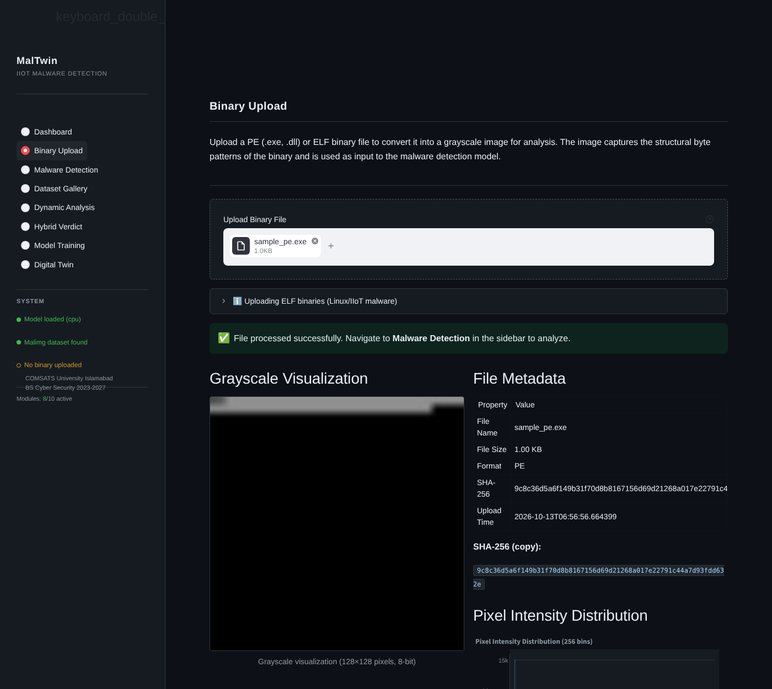
Figure 4.6 Binary Upload page after validating a PE file
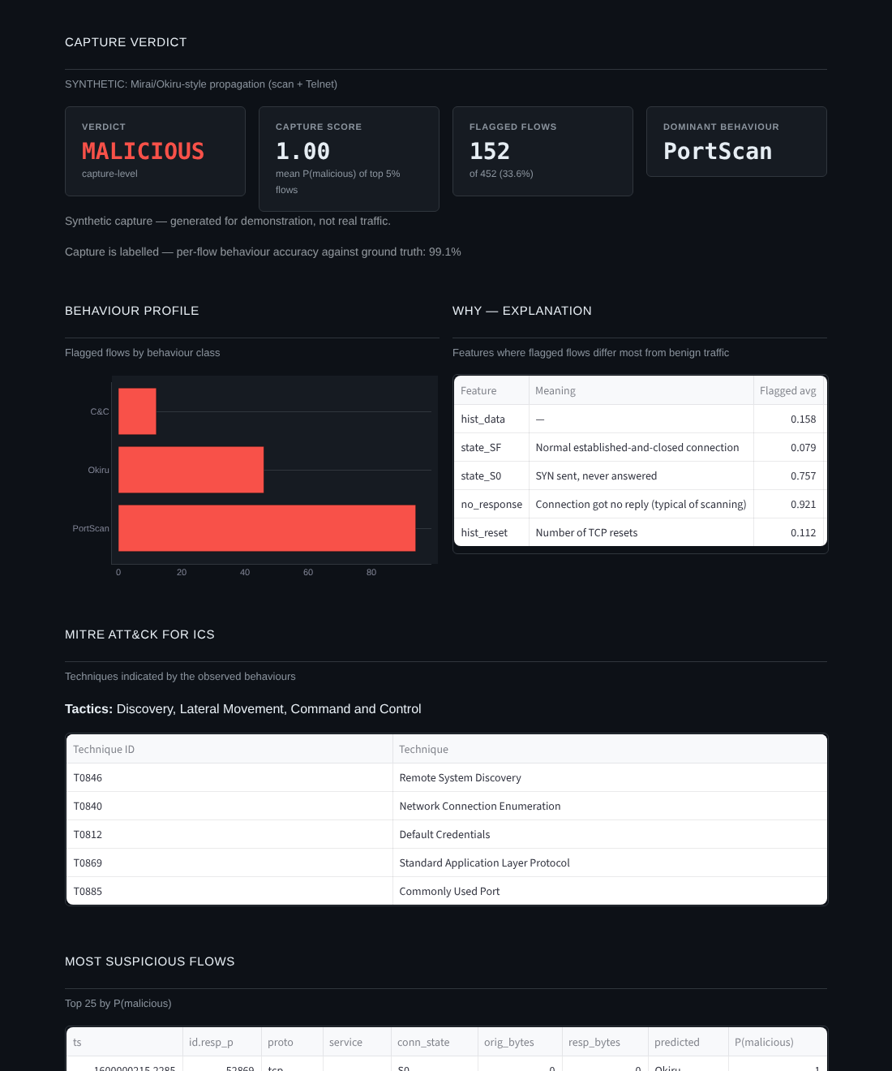
Figure 4.7 Dynamic Analysis page (demonstration model trained on synthetic traffic, clearly labelled as such in the interface)
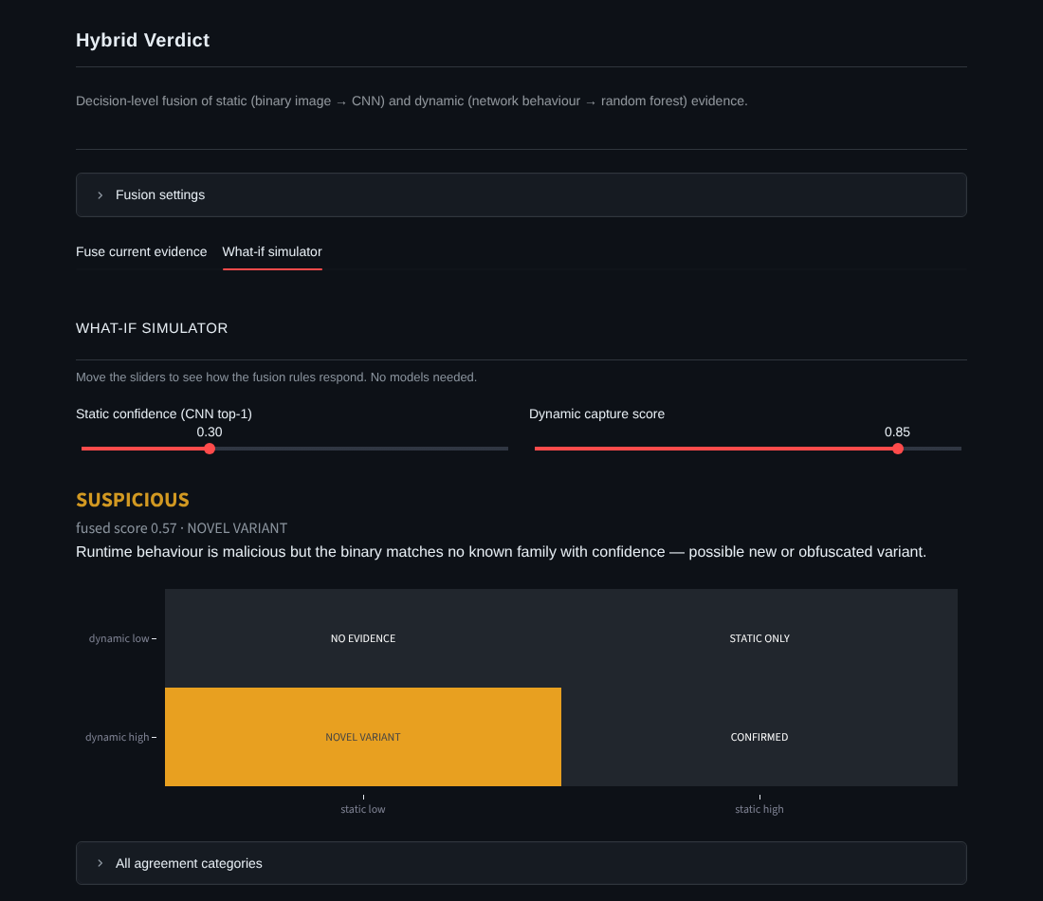
Figure 4.8 Hybrid Verdict what-if simulator showing the NOVEL VARIANT case
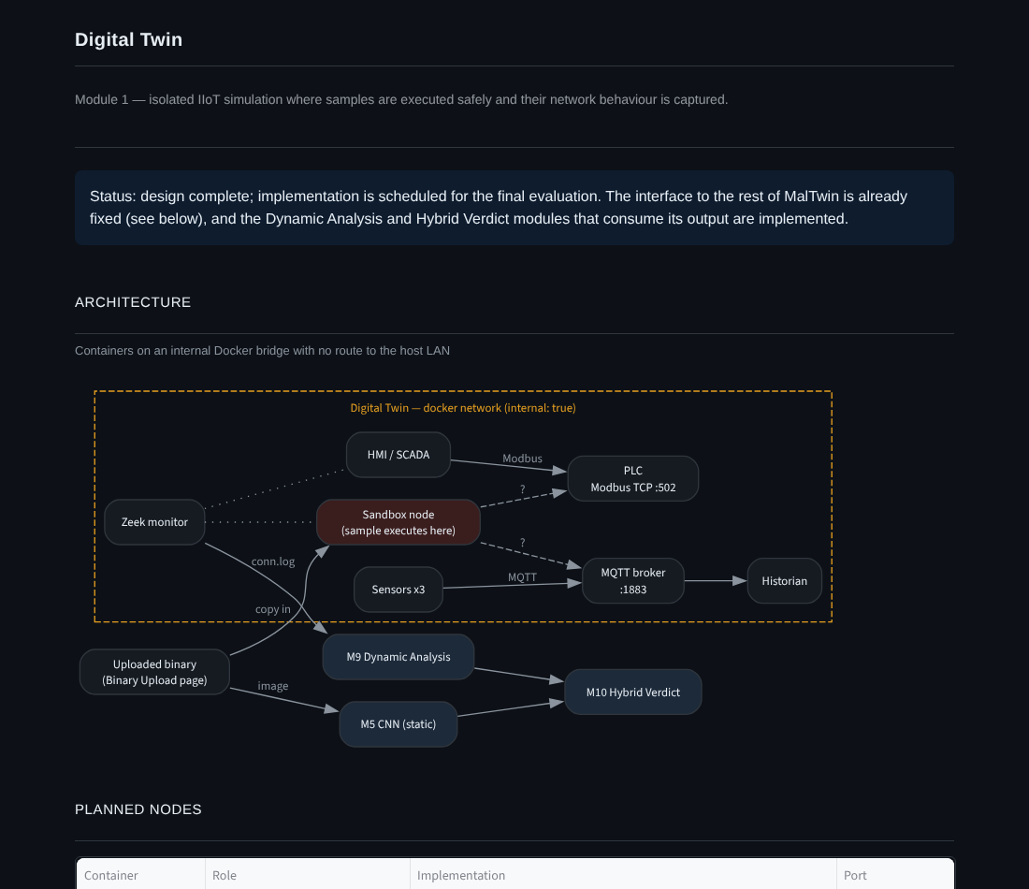
Figure 4.9 Digital Twin page with the planned architecture
PENDING — Figure 4.10 Malware Detection result with Grad-CAM · Figure 4.11 Dashboard KPIs and module status · Figure 4.12 Dynamic Analysis on a real IoT-23 capture · Figure 4.13 Hybrid verdict with both sources (screenshots after training).

4.6 Deployment
MalTwin is deployed as a local Python application. The Digital Twin will add a Docker Compose stack in the final phase.
System requirements
Table 4.10 System requirements
Resource | Minimum | Recommended
Operating system | Ubuntu 22.04 or Windows 10/11 | Ubuntu 22.04 (needed for the full Digital Twin)
Python | 3.11 | 3.11
CPU / RAM | 4 cores, 8 GB | 8 cores, 16 GB or more
GPU | None (CPU works) | NVIDIA, 6 GB VRAM, CUDA 12
Disk | 20 GB free | 100 GB free (with IoT-23)
Container runtime | — | Docker Engine with Compose (for M1)

Main environment variables
Table 4.11 Configuration through environment variables
Variable | Default | Purpose
MALTWIN_DATA_DIR | ./data/malimg | Malimg dataset root
MALTWIN_DYNAMIC_DATA_DIR | ./data/iot23 | IoT-23 conn.log root
MALTWIN_IMAGE_LAYOUT | malimg | Byte layout before resizing
MALTWIN_EPOCHS / _BATCH_SIZE / _LR | 30 / 32 / 0.001 | CNN training
MALTWIN_OVERSAMPLE_STRATEGY | oversample_minority | Balancing strategy
MALTWIN_CONFIDENCE_GREEN / _AMBER | 0.80 / 0.50 | Confidence colour thresholds
MALTWIN_FUSION_STATIC_WEIGHT / _DYNAMIC_WEIGHT | 0.5 / 0.5 | Fusion weights
MALTWIN_FUSION_MALICIOUS / _SUSPICIOUS | 0.70 / 0.40 | Fusion verdict thresholds
MALTWIN_DEVICE | auto | cpu, cuda or auto

Deployment steps
- Install Python 3.11 (Ubuntu 22.04 recommended; Windows 10/11 also works).
- Clone the repository and create a virtual environment: python3.11 -m venv venv then activate it.
- Install dependencies: pip install -r requirements.txt (for a CUDA GPU, install the CUDA build of PyTorch first).
- Copy .env.example to .env; defaults work out of the box.
- Place the Malimg dataset under data/malimg/ (25 family folders) and IoT-23 labelled conn.log files under data/iot23/.
- Train: python scripts/train.py, then python scripts/train_dynamic.py.
- Verify: pytest tests/ -m "not integration" (all tests should pass) and python scripts/benchmark.py.
- Launch: streamlit run modules/dashboard/app.py, then open http://localhost:8501.

Chapter 5: Testing and Evaluation
Testing confirms that MalTwin behaves as specified and exposes defects before evaluation. Four kinds of testing were carried out: unit testing of individual functions and classes, functional testing of the dashboard through a real browser, business-rule testing with decision tables, and integration testing of modules working together. Performance was measured separately (Table 4.7).
Unit tests run with pytest on synthetic data, so they need neither the Malimg dataset nor a GPU and can run on any machine. Eleven further integration tests require the real dataset and a trained model and are marked @pytest.mark.integration. Functional tests were executed with a headless Chromium browser (Playwright) driving the running dashboard.
$ pytest tests/ -m "not integration" -q
........................................................................ [ 22%]
........................................................................ [ 44%]
........................................................................ [ 67%]
........................................................................ [ 89%]
.................................. [100%]
322 passed, 11 deselected in 18.82s

5.1 Unit Testing
Unit testing verifies the smallest testable parts of the software (functions, methods and classes) in isolation. Table 5.13 at the end of this section summarises all 322 unit tests. The tables below show representative cases for each module.

Unit Testing 1: Binary-to-Image Conversion (M2)
Testing objective: to ensure binaries are validated, fingerprinted and converted into 128×128 images exactly as the Malimg training images were built. Test file: tests/test_converter.py.
Table 5.1 Binary-to-Image Conversion (M2) — unit test results
No. | Test case | Input | Expected result | Actual result | Status
1 | PE conversion shape | 1,024-byte PE fixture | 128×128 uint8 array | 128×128 uint8 | Pass
2 | Magic-byte validation | Bytes starting MZ, \x7fELF, ABCD | PE, ELF, rejected | PE, ELF, ValueError | Pass
3 | SHA-256 correctness | Known byte string | Matches hashlib reference digest | Matches | Pass
4 | Malimg width table | Files of 5 KB … 2 MB (8 sizes) | Widths 32, 64, 128, 256, 384, 512, 768, 1024 | All 8 widths correct | Pass
5 | Matches training pipeline | 50 KB random bytes | Pixel-identical to reference Malimg layout + resize | Identical | Pass
6 | Minimum-size file | 64-byte PE | No crash, 128×128 output | 128×128 output | Pass
7 | Pixel histogram | 128×128 image | 256 bins, counts sum to 16,384 | 256 bins, sum 16,384 | Pass

Unit Testing 2: Dataset Loading and Splitting (M3)
Testing objective: to ensure the dataset loader encodes labels consistently and splits data without overlap or loss. Test file: tests/test_dataset.py.
Table 5.2 Dataset Loading and Splitting (M3) — unit test results
No. | Test case | Input | Expected result | Actual result | Status
1 | Label encoding | Family folder names | Contiguous indices 0…N−1, sorted | Contiguous, sorted | Pass
2 | Split sizes | Synthetic dataset | train + val + test = total; train largest | Sums match; train largest | Pass
3 | Item format | dataset[0] | (1×128×128 float tensor, int label) | As expected | Pass
4 | Missing directory | Non-existent path | FileNotFoundError | FileNotFoundError | Pass
5 | Invalid split name | split='foo' | ValueError | ValueError | Pass

Unit Testing 3: Augmentation and Oversampling (M4)
Testing objective: to ensure augmentation keeps tensor shape and type and that the sampler favours minority families. Test file: tests/test_enhancement.py.
Table 5.3 Augmentation and Oversampling (M4) — unit test results
No. | Test case | Input | Expected result | Actual result | Status
1 | Train transform output | PIL grayscale image | 1×128×128 float32 tensor | As expected | Pass
2 | Augmentation varies | Same image twice | Two different tensors | Different | Pass
3 | Validation transform deterministic | Same image twice | Identical tensors | Identical | Pass
4 | Minority weighting | Imbalanced labels | Minority sample weight > majority weight | Greater | Pass
5 | Invalid strategy | strategy='foo' | ValueError | ValueError | Pass

Unit Testing 4: CNN Model and Inference (M5)
Testing objective: to ensure the network has the intended structure, can learn, and that inference returns a well-formed prediction. Test file: tests/test_model.py.
Table 5.4 CNN Model and Inference (M5) — unit test results
No. | Test case | Input | Expected result | Actual result | Status
1 | Forward pass shape | Batch of 2 images | Logits of shape (2, 25) | (2, 25) | Pass
2 | Raw logits | Model output | Rows do not sum to 1 (softmax applied only at inference) | Not normalised | Pass
3 | Can fit one batch | 4 random images, 30 Adam steps (seeded) | Final loss < initial loss | Loss decreased | Pass
4 | Gradients reach all layers | One backward pass | Every parameter has a gradient | All present | Pass
5 | predict_single output | 128×128 image | family in class list, confidence in [0, 1], 3 top-k entries | As expected | Pass
6 | Save and reload | state_dict round-trip | Identical outputs | Identical | Pass

Unit Testing 5: Grad-CAM Explanation (M7)
Testing objective: to ensure Grad-CAM produces a valid, normalised heatmap and overlay for the requested class. Test file: tests/test_gradcam.py.
Table 5.5 Grad-CAM Explanation (M7) — unit test results
No. | Test case | Input | Expected result | Actual result | Status
1 | Heatmap shape and range | Image, target class 0 | 128×128 float32 in [0, 1] | As expected | Pass
2 | Overlay is a valid PNG | Result bytes | Decodable RGB PNG | Decodable | Pass
3 | Class-specific | Target classes 0 and 1 | Different heatmaps | Different | Pass
4 | Bad target class | Class index 999 | Returns None, no crash | None | Pass
5 | Deterministic | Same input twice (eval mode) | Identical heatmaps | Identical | Pass

Unit Testing 6: Reporting and MITRE Mapping (M8)
Testing objective: to ensure every family is mapped to ATT&CK for ICS and that reports contain the required sections. Test file: tests/test_reporting.py.
Table 5.6 Reporting and MITRE Mapping (M8) — unit test results
No. | Test case | Input | Expected result | Actual result | Status
1 | MITRE coverage | mitre_ics_mapping.json | All 25 families with tactics and techniques | 25/25 | Pass
2 | Unknown family | 'NotAFamily' | found = False, empty lists | As expected | Pass
3 | JSON report sections | Detection result | Metadata, file info, detection, top-3, MITRE, explainability | All present | Pass
4 | PDF report | Detection result + heatmap | Bytes starting with %PDF | %PDF… | Pass
5 | Bad input | Empty dictionary | No exception; error JSON / None | Handled | Pass

Unit Testing 7: Detection Log Database (M6/M8)
Testing objective: to ensure detection events are stored correctly and that database failures never crash the dashboard. Test file: tests/test_db.py.
Table 5.7 Detection Log Database (M6/M8) — unit test results
No. | Test case | Input | Expected result | Actual result | Status
1 | WAL mode | init_db() | journal_mode = 'wal' | wal | Pass
2 | Insert and read back | One event | SHA-256, family, confidence stored exactly | Exact | Pass
3 | Idempotent init | init_db() twice | No error, schema unchanged | As expected | Pass
4 | Unicode file name | '恶意软件.exe' | Stored and retrieved | As expected | Pass
5 | Missing database | Query non-existent file | Empty list / zero stats, no exception | As expected | Pass

Unit Testing 8: Dynamic Behavioural Analysis (M9)
Testing objective: to ensure Zeek logs are parsed correctly, features are well-formed, and the detector classifies and explains behaviour. Test file: tests/test_dynamic.py.
Table 5.8 Dynamic Behavioural Analysis (M9) — unit test results
No. | Test case | Input | Expected result | Actual result | Status
1 | IoT-23 label mapping | 13 label / detailed-label pairs | Correct behaviour class for each | All 13 correct | Pass
2 | IoT-23 format quirk | Row with space-separated last columns | Parsed; behaviour = PortScan; port 23 | As expected | Pass
3 | Feature matrix | Synthetic flows | 61 columns, no NaN, no IP features | As expected | Pass
4 | Port indicators | Ports 502, 1883, 23, 443, 50000 | Modbus, MQTT, Telnet, ephemeral flags set correctly | Correct | Pass
5 | Benign capture | 200 benign flows | Verdict BENIGN, empty profile | BENIGN | Pass
6 | Malicious capture | 200 benign + 40 scan flows | MALICIOUS, PortScan dominant, T0846 mapped, explanation present | As expected | Pass
7 | Save / load | Trained model | Identical probabilities after reload | Identical | Pass

Unit Testing 9: Hybrid Fusion (M10)
Testing objective: to ensure the fusion rules produce the specified verdict and category, validate inputs, and merge MITRE techniques. Test file: tests/test_fusion.py.
Table 5.9 Hybrid Fusion (M10) — unit test results
No. | Test case | Input | Expected result | Actual result | Status
1 | Decision table | 6 cases (Table 5.23) | Category and verdict per rule | All 6 correct | Pass
2 | Single source | Static only (0.9) | STATIC_SOURCE_ONLY, MALICIOUS | As expected | Pass
3 | Out-of-range input | Confidence 1.1 | ValueError | ValueError | Pass
4 | Custom weights | s = 1, d = 0, weights 3 : 1 | Fused score 0.75 | 0.75 | Pass
5 | MITRE merge | Overlapping technique lists | Shared technique first, tagged static + dynamic | As expected | Pass

Unit Testing 10: Extended Evaluation Metrics
Testing objective: to ensure the new evaluation metrics are computed correctly, including edge cases. Test file: tests/test_evaluation_extended.py.
Table 5.10 Extended Evaluation Metrics — unit test results
No. | Test case | Input | Expected result | Actual result | Status
1 | Per-class FPR | Hand-built 3-class confusion matrix | FPR A = 0.25, B = 0.25, C = 0 | As expected | Pass
2 | Perfect predictions | All correct | ROC-AUC = 1, FPR = 0, MCC = 1 | As expected | Pass
3 | Class missing from test set | 3 classes, 1 absent | AUC computed over present classes, no crash | As expected | Pass
4 | Open-set: perfect separation | Known conf. high, unseen low | AUROC = 1, FPR@95 = 0 | As expected | Pass
5 | Open-set: no separation | Identical distributions | AUROC = 0.5 | 0.5 | Pass

Unit Testing 11: Module Health Checks (M6)
Testing objective: to ensure the dashboard can always report the status of every module, even when parts are missing. Test file: tests/test_health.py.
Table 5.11 Module Health Checks (M6) — unit test results
No. | Test case | Input | Expected result | Actual result | Status
1 | All modules listed | get_all_module_statuses() | 10 entries, IDs M1–M10 | 10 entries | Pass
2 | Valid status values | Each entry | 'active', 'inactive' or 'error' | As expected | Pass
3 | Never raises | No model, no dataset | Returns statuses without exception | As expected | Pass

Unit Testing 12: Training Manager (M5/M6)
Testing objective: to ensure training can be started, monitored and stopped from the dashboard as a background process. Test file: tests/test_training_manager.py.
Table 5.12 Training Manager (M5/M6) — unit test results
No. | Test case | Input | Expected result | Actual result | Status
1 | Start job | Small script | Process running, log lines captured | As expected | Pass
2 | Poll | Running job | Returns running flag, new lines, exit code | As expected | Pass
3 | Stop job | Running job | Process terminated | Terminated | Pass

Table 5.13 Unit test summary by file
Test file | Module(s) | Tests | Passed
test_converter.py | M2 | 32 | 32
test_dataset.py | M3 | 22 | 22
test_enhancement.py | M4 | 18 | 18
test_model.py | M5 | 23 | 23
test_gradcam.py | M7 | 20 | 20
test_reporting.py | M8 | 30 | 30
test_db.py | M6 / M8 | 30 | 30
test_gallery.py | M6 | 32 | 32
test_health.py | M6 | 31 | 31
test_training_manager.py | M5 / M6 | 23 | 23
test_dynamic.py | M9 | 31 | 31
test_fusion.py | M10 | 16 | 16
test_evaluation_extended.py | M5 (evaluation) | 14 | 14
Total |  | 322 | 322
Five histogram tests had been silently skipped because they referred to a function by an old name. They were corrected during this phase and now run and pass.

5.2 Functional Testing
Functional testing checks user-facing features through the interface. The dashboard was started locally and driven by a headless Chromium browser that clicked, uploaded files and captured screenshots. Where a test first failed, the defect was fixed and the test repeated. The "Actual result" column gives the final outcome, and the defects are listed in Table 5.27.

Functional Testing 1: Binary Upload
Objective: to ensure a binary can be uploaded and its image, metadata and histogram are displayed.
Table 5.14 Binary upload — functional test results
No. | Test case | Action | Expected result | Actual result | Status
1 | Upload valid PE | Select tests/fixtures/sample_pe.exe | Success message, image, metadata, SHA-256, histogram | All shown (after fix D1) | Pass
2 | Upload non-binary | Select a non-binary file renamed .exe | Error: what / cause / action | "Error: Unsupported file format. Cause: … magic bytes 41424344. Action: …" | Pass
3 | Sidebar reflects upload | Upload, then view sidebar | File shown as loaded | Shown immediately (after fix D9) | Pass
4 | Navigate after upload | Click "Malware Detection" | Detection page opens | Opens (after fix D2) | Pass

Functional Testing 2: Malware Detection
Objective: to ensure detection runs on the uploaded file and the result, charts, MITRE table and reports are shown.
Table 5.15 Malware detection — functional test results
No. | Test case | Action | Expected result | Actual result | Status
1 | Guard without file | Open page before uploading | Warning asking for an upload | Warning shown | Pass
2 | Run detection | Click "Run Detection" | Family, confidence bar, top-3, probability chart | All shown | Pass
3 | Low-confidence warning | Prediction below 0.50 | Red bar and expert-review message | Shown | Pass
4 | Event logged | Return to Dashboard | Detection appears in Recent Detections and KPIs | Appears; total = 1 | Pass
5 | Result survives revisit | Open Binary Upload, then return | Detection result still shown | Still shown (after fix D9) | Pass

Functional Testing 3: Dynamic Analysis
Objective: to ensure a traffic capture can be analysed and its verdict, explanation and MITRE mapping are displayed.
Table 5.16 Dynamic analysis — functional test results
No. | Test case | Action | Expected result | Actual result | Status
1 | Guard without model | Open page with no dynamic model | Instructions to train | Shown | Pass
2 | Model information | Open page with demo model | Data source, detection rate, FPR, F1; synthetic warning | Shown, labelled SYNTHETIC DEMO | Pass
3 | Analyse demo capture | Choose Mirai/Okiru scenario, click Generate | MALICIOUS verdict, behaviour profile, explanation, MITRE, suspicious flows | All shown; 99.1% flow accuracy against labels | Pass
4 | Benign capture | Choose benign scenario | BENIGN verdict, no techniques | BENIGN | Pass
5 | JSON export | Click download | JSON file with verdict and profile | Downloaded | Pass

Functional Testing 4: Hybrid Verdict
Objective: to ensure static and dynamic evidence can be fused and the what-if simulator follows the fusion rules.
Table 5.17 Hybrid verdict — functional test results
No. | Test case | Action | Expected result | Actual result | Status
1 | Dynamic only | Analyse capture, then Compute | Category DYNAMIC SOURCE ONLY | As expected | Pass
2 | Both sources | Detect binary + analyse capture, then Compute | Fused score, category, pairing note, JSON export | As expected | Pass
3 | What-if: novel variant | Static 0.30, dynamic 0.85 | SUSPICIOUS, NOVEL VARIANT cell highlighted | As expected (Fig. 4.8) | Pass
4 | Zero weights | Set both weights to 0 | Error message; no verdict | Error shown | Pass

Functional Testing 5: Navigation and Digital Twin Page
Objective: to ensure every page is reachable and the Digital Twin page reports its prerequisites.
Table 5.18 Navigation and Digital Twin — functional test results
No. | Test case | Action | Expected result | Actual result | Status
1 | Single navigation list | Load the app | One sidebar menu with 8 pages | One menu (after fix D3) | Pass
2 | All pages render | Visit each page | No exception on any page | No exceptions | Pass
3 | Twin architecture | Open Digital Twin | Diagram, node table, interface contract | Shown | Pass
4 | Prerequisite checks | Open Digital Twin without Docker running | Docker shown as not running; dynamic model status | As expected | Pass

5.3 Business Rules Testing
Decision-table testing was used for the rules that decide outcomes. Each rule column becomes at least one test case.

Business Rule Test 1: Upload Acceptance
Rule: a file is accepted only if it is at most 50 MB and begins with a PE (MZ) or ELF (\x7fELF) signature. The extension is not considered. TC-UP-1, 3 and 4 were executed in the browser; TC-UP-2 through validate_binary_format() because the browser file picker filters by extension.
Table 5.19 Decision table — upload acceptance
Condition / Action | Rule 1 | Rule 2 | Rule 3 | Rule 4
Size ≤ 50 MB? | Yes | Yes | No | No
Valid PE/ELF magic bytes? | Yes | No | Yes | No
Accept and convert | ✓
Reject with format error |  | ✓ |  | ✓
Reject with size error |  |  | ✓

Table 5.20 Test cases — upload acceptance
Test ID | Input | Expected | Actual | Status
TC-UP-1 | 1 KB PE fixture | Accepted | Accepted | Pass
TC-UP-2 | 1 KB ELF fixture without extension | Accepted | Accepted | Pass
TC-UP-3 | Bytes "ABCD…" with .exe extension | Format error | Format error | Pass
TC-UP-4 | 53.5 MB file with MZ header | Size error | "File must be 50.0MB or smaller" | Pass

Business Rule Test 2: Confidence Colour Coding
Rule: the confidence bar is green (HIGH) at ≥ 0.80, amber (MEDIUM) at ≥ 0.50, and red (LOW) below 0.50.
Table 5.21 Test cases — confidence colour boundaries
Test ID | Confidence | Expected | Actual | Status
TC-CONF-1 | 0.95 | HIGH (green) | HIGH | Pass
TC-CONF-2 | 0.80 (boundary) | HIGH (green) | HIGH | Pass
TC-CONF-3 | 0.79 | MEDIUM (amber) | MEDIUM | Pass
TC-CONF-4 | 0.50 (boundary) | MEDIUM (amber) | MEDIUM | Pass
TC-CONF-5 | 0.49 | LOW (red) | LOW | Pass
TC-CONF-6 | 0.00 | LOW (red) | LOW | Pass

Business Rule Test 3: Hybrid Fusion Decision
Rule: fused = (s + d) / 2 with default weights. Verdict is MALICIOUS if fused ≥ 0.70, SUSPICIOUS if fused ≥ 0.40, and otherwise BENIGN. The category follows from s ≥ 0.80 (static high) and d ≥ 0.50 (dynamic high). A NOVEL_VARIANT is never reported as BENIGN.
Table 5.22 Decision table — fusion category and escalation
Condition / Action | Rule 1 | Rule 2 | Rule 3 | Rule 4
Static confidence ≥ 0.80? | Yes | Yes | No | No
Dynamic score ≥ 0.50? | Yes | No | Yes | No
Category | CONFIRMED | STATIC_ONLY | NOVEL_VARIANT | NO_EVIDENCE
Verdict from fused score | ✓ | ✓ | ✓ | ✓
Escalate BENIGN → SUSPICIOUS |  |  | ✓

Table 5.23 Test cases — fusion decision (automated in tests/test_fusion.py)
Test ID | Static | Dynamic | Fused | Expected | Actual | Status
TC-FUS-1 | 0.95 | 0.90 | 0.925 | MALICIOUS · CONFIRMED | MALICIOUS · CONFIRMED | Pass
TC-FUS-2 | 0.92 | 0.10 | 0.51 | SUSPICIOUS · STATIC_ONLY | SUSPICIOUS · STATIC_ONLY | Pass
TC-FUS-3 | 0.30 | 0.95 | 0.625 | SUSPICIOUS · NOVEL_VARIANT | SUSPICIOUS · NOVEL_VARIANT | Pass
TC-FUS-4 | 0.10 | 0.60 | 0.35 | SUSPICIOUS (escalated) · NOVEL_VARIANT | SUSPICIOUS (escalated) | Pass
TC-FUS-5 | 0.20 | 0.05 | 0.125 | BENIGN · NO_EVIDENCE | BENIGN · NO_EVIDENCE | Pass
TC-FUS-6 | 0.85 | 0.55 | 0.70 | MALICIOUS (boundary) · CONFIRMED | MALICIOUS · CONFIRMED | Pass

5.4 Integration Testing
Integration testing verifies that modules developed separately work together through their interfaces.

Integration Testing 1: Training Pipeline (M3 + M4 + M5 + evaluation)
Objective: to ensure the full training script runs end-to-end and writes every artefact the dashboard and this report depend on. A synthetic six-family image set was used so the test is quick and repeatable. The same command is used on Malimg.
Table 5.24 Training pipeline integration results
No. | Test case | Steps | Expected | Actual | Status
1 | Full training run | 1. Validate dataset 2. Build loaders with oversampling 3. Train 8 epochs 4. Evaluate on test split | Completes; all outputs written | Completed; test accuracy 1.00 on separable synthetic data | Pass
2 | Outputs written | Inspect data/processed/ | class_names, eval_metrics, confusion matrix, ROC, training curves, history | All 6 files present | Pass
3 | Unseen-family run | Hold out 2 families, train, compare confidence | JSON + histogram written; main model untouched | As expected | Pass

Integration Testing 2: Static Analysis Path with the Dashboard and Database (M2 + M5 + M6 + SQLite)
Objective: to ensure a sample uploaded in the browser flows through conversion, detection and logging, and appears in the dashboard history.
Table 5.25 Static path integration results
No. | Test case | Steps | Expected | Actual | Status
1 | Upload to detection | 1. Upload PE 2. Open Malware Detection 3. Run Detection | Prediction displayed | Displayed | Pass
2 | Detection to database | 4. Open Dashboard | Total analysed = 1; event in Recent Detections with same file name | As expected | Pass
3 | Module status | 5. Inspect module table | M2, M5 active; M1 inactive (Docker not running) | As expected | Pass

Integration Testing 3: Dynamic Path and Fusion (M9 + M10 + M8 mapping)
Objective: to ensure a dynamic report produced on one page is consumed by the fusion page together with the static result, and that MITRE techniques from both sources are merged.
Table 5.26 Dynamic path and fusion integration results
No. | Test case | Steps | Expected | Actual | Status
1 | Dynamic → fusion | 1. Analyse capture 2. Open Hybrid Verdict | Dynamic evidence card filled from session | Filled | Pass
2 | Static + dynamic | 3. Detect binary 4. Compute verdict | Both sources used; category from both | NO_EVIDENCE for benign capture + low-confidence binary (expected) | Pass
3 | IoT-23 file format | Train dynamic model from two capture folders, one in IoT-23's space-separated format | Both parsed; all 7 classes learned | As expected | Pass

PENDING — Integration tests on the real dataset (pytest tests/ -m integration, 11 tests) run after the Malimg training run; results will be added here.

5.5 Performance Testing
All six measurable SRS performance and reliability targets were met on a 2-core CPU-only machine (Table 4.7). The slowest operation was Grad-CAM at 0.49 s worst case against an 8 s limit. A 100,000-row history query took 0.1 s against a 0.5 s limit.

5.6 Defects Found and Fixed
Testing in this phase found the following defects in previously delivered code. All are fixed and covered by tests or repeated functional checks.
Table 5.27 Defects found during Evaluation 3 testing
ID | Defect | Found by | Impact | Fix
D1 | NameError: mono in upload and detection pages | Functional test FT1 | Upload page crashed after every upload | Module-level import
D2 | Navigation labels changed after upload | Functional test FT1-4 | Click to Malware Detection was discarded | Fixed labels with a stable widget key
D3 | Streamlit auto-generated page list | Functional test FT5-1 | Second menu exposing blank pages | Disabled in .streamlit/config.toml
D4 | Removed verbose argument to LR scheduler | Integration test IT1 | Training crashed on current PyTorch | Argument removed
D5 | Square byte layout at upload | Code review against Malimg method | Uploads differed from training images | Malimg width table
D6 | Unseeded overfit unit test | Repeated unit runs | Intermittent failure | Seed fixed, dropout off for this test
D7 | Histogram tests skipped by name mismatch | Test report review | Feature untested | Tests repointed
D8 | Parameter count documented as 3.2 M | Counting parameters | Incorrect documentation | Corrected to 1.35 M
D9 | Upload re-processed on every rerun; sidebar drawn before upload handled | Functional tests FT1-3, FT1-5 | Detection result lost on revisiting Upload; stale sidebar status | Skip already-processed SHA-256; refresh once after upload

Summary of Testing Results
Table 5.28 Overall testing summary
Test type | Test cases | Passed | Failed | Pass rate
Unit testing (automated) | 322 | 322 | 0 | 100%
Functional testing (browser) | 22 | 22 | 0 | 100%
Business rules testing | 16 | 16 | 0 | 100%
Integration testing | 9 | 9 | 0 | 100%
Performance (SRS targets) | 7 | 7 | 0 | 100%
Total | 376 | 376 | 0 | 100%
The pass rates refer to the final state after the defects in Table 5.27 were fixed. Model-quality results (accuracy, F1, ROC-AUC) are not pass/fail tests. They are reported in Section 4.2.

Chapter 6: Conclusion and Future Work
This chapter summarises what has been achieved at the 60% milestone and sets out the work planned for the final evaluation and beyond.

6.1 Conclusion
MalTwin set out to detect and explain malware variants that target Industrial IoT systems without putting real industrial equipment at risk. At this milestone the static analysis pipeline is complete. Binaries are validated, fingerprinted and converted into images in the same way the Malimg training data was built. A compact convolutional network classifies them into 25 families. Grad-CAM shows which byte regions drove the decision, and each result is mapped to MITRE ATT&CK for ICS and exported as a forensic report.
Since the SRS, two modules promised in the proposal have been added. The dynamic analysis module classifies the network behaviour of a sample from Zeek connection logs, using a format shared by the public IoT-23 dataset and by the planned Digital Twin. It explains each verdict in terms of the features that deviate from normal traffic. The fusion module combines the static and dynamic views into a single verdict. It reports how the two views agree, and in particular it raises the case where a binary matches no known family but behaves maliciously, which is how a new variant is most likely to appear.
The evaluation was extended with ROC-AUC, false positive rate and an unseen-family experiment that tests whether the model's confidence drops on families it has never seen. Testing covers 322 automated unit tests, browser-driven functional tests, decision-table tests and integration tests. All pass, and all measured SRS performance targets are met. Testing also uncovered nine defects in earlier work, including a crash on every upload and a mismatch between how uploaded and training images were built. All nine have been fixed.
Two limitations remain and are stated plainly. First, the Digital Twin is designed but not yet built, so static and dynamic evidence cannot yet be collected for the same sample; fusion is therefore tested against its decision rules rather than evaluated on paired data. Second, Malimg contains no benign class, so the CNN always names a family; low confidence, rather than a "benign" label, is the signal that a file may be unknown, and the unseen-family experiment measures how reliable that signal is.

6.2 Future Work

6.2.1 Digital Twin Implementation (final evaluation)
Build the Docker-based IIoT network designed in Section 3.1: a Modbus TCP PLC, an HMI that polls it, MQTT sensors, a broker and historian, an isolated sandbox node that executes the sample, and a Zeek monitor. Add start/stop control, a live traffic log, node status and a protocol mix chart to the dashboard (FR2.1–FR2.4), with the isolation controls of CON-2 and SEC-2.

6.2.2 Paired Static–Dynamic Evaluation (final evaluation)
Run IIoT malware samples (for example from the Mirai and Gafgyt families) inside the twin, so each sample has both an image and a traffic capture. Then evaluate fusion against each detector alone, tune the fusion weights and thresholds, and measure the false positive rate on benign IIoT software.

6.2.3 A Benign Class for the Static Detector
Add a curated set of benign PE and ELF binaries so the CNN can say "benign" explicitly, and compare this with the confidence-based approach.

6.2.4 Richer Dynamic Features
Extend behavioural features beyond connection summaries to industrial protocol content: Modbus function codes and write rates, and MQTT topic patterns. Add host-level signals from the sandbox, such as process creation and file writes.

6.2.5 Stronger Open-Set Detection
Compare maximum-softmax confidence with dedicated unknown-detection methods such as temperature scaling, energy scores and distance in feature space, using the unseen-family experiment as the benchmark.

6.2.6 Reporting and Deployment
Include dynamic and fused results in the PDF report, package the whole platform as a Docker Compose stack for reproducibility, and run a timed usability trial with first-time users to validate USE-1.

Chapter 7: References
The following works were consulted during the design and implementation of MalTwin.
Books
[1] K. Wiegers and J. Beatty, Software Requirements, 3rd ed. Redmond, WA, USA: Microsoft Press, 2013.
[2] I. Sommerville, Software Engineering, 10th ed. Boston, MA, USA: Pearson, 2016.
[3] I. Goodfellow, Y. Bengio and A. Courville, Deep Learning. Cambridge, MA, USA: MIT Press, 2016.
Journal articles and conference papers
[4] L. Nataraj, S. Karthikeyan, G. Jacob and B. S. Manjunath, "Malware images: Visualization and automatic classification," in Proc. 8th Int. Symp. Visualization for Cyber Security (VizSec), 2011.
[5] R. R. Selvaraju, M. Cogswell, A. Das, R. Vedantam, D. Parikh and D. Batra, "Grad-CAM: Visual explanations from deep networks via gradient-based localization," in Proc. IEEE Int. Conf. Computer Vision (ICCV), 2017, pp. 618–626.
[6] N. Kokhlikyan et al., "Captum: A unified and generic model interpretability library for PyTorch," arXiv:2009.07896, 2020.
[7] L. Breiman, "Random forests," Machine Learning, vol. 45, no. 1, pp. 5–32, 2001.
[8] D. P. Kingma and J. Ba, "Adam: A method for stochastic optimization," in Proc. Int. Conf. Learning Representations (ICLR), 2015.
[9] S. Ioffe and C. Szegedy, "Batch normalization: Accelerating deep network training by reducing internal covariate shift," in Proc. 32nd Int. Conf. Machine Learning (ICML), 2015, pp. 448–456.
[10] N. Srivastava, G. Hinton, A. Krizhevsky, I. Sutskever and R. Salakhutdinov, "Dropout: A simple way to prevent neural networks from overfitting," J. Machine Learning Research, vol. 15, pp. 1929–1958, 2014.
[11] D. Hendrycks and K. Gimpel, "A baseline for detecting misclassified and out-of-distribution examples in neural networks," in Proc. Int. Conf. Learning Representations (ICLR), 2017.
[12] M. Antonakakis et al., "Understanding the Mirai botnet," in Proc. 26th USENIX Security Symposium, 2017, pp. 1093–1110.
[13] V. Paxson, "Bro: A system for detecting network intruders in real-time," Computer Networks, vol. 31, no. 23–24, pp. 2435–2463, 1999.
[14] A. Paszke et al., "PyTorch: An imperative style, high-performance deep learning library," in Advances in Neural Information Processing Systems 32 (NeurIPS), 2019.
[15] F. Pedregosa et al., "Scikit-learn: Machine learning in Python," J. Machine Learning Research, vol. 12, pp. 2825–2830, 2011.
Datasets
[16] Malimg dataset, Vision Research Lab, University of California, Santa Barbara, released with [4].
[17] S. Garcia, A. Parmisano and M. J. Erquiaga, "IoT-23: A labeled dataset with malicious and benign IoT network traffic," Stratosphere Laboratory, Czech Technical University in Prague, 2020. doi: 10.5281/zenodo.4743746.
Technical documentation and websites
[18] MITRE Corporation, "MITRE ATT&CK for ICS," https://attack.mitre.org/matrices/ics/.
[19] The Zeek Project, "Zeek documentation — conn.log," https://docs.zeek.org/.
[20] Streamlit Inc., "Streamlit documentation," https://docs.streamlit.io/.
[21] Docker Inc., "Docker networking — internal networks," https://docs.docker.com/network/.

Chapter 8: Plagiarism Report
PENDING — Attach the plagiarism (Turnitin) report from the FYP portal here before final submission.

