^{Objective}
The purpose of this analysis is to understand fraud patterns and identify high-risk transactions.
^{Dataset Overview}
- ^{Total Transactions: 284,807}
- ^{Fraud Transactions: 492}
- ^{Fraud Percentage: 0.17%}
^{Key Findings}
- Fraud cases are very low but important.
- Morning time has the highest fraud percentage.
- Night time has more fraud count but lower percentage.
- High amount transactions have higher fraud risk.
^{Conclusion}
- Fraud risk is higher in the morning and in high-value transactions. Proper monitoring is needed to reduce fraud.
^{Recommendation}
- Increase monitoring during morning time
- Apply checks on high amount transactions
- Use better fraud detection systems

^{Fraud Types & How It Happens} | ^{Prevention & Actions}
Common Fraud Types  - Card Not Present (Online fraud)  - Skimming (Card data stolen from machines)  - Phishing (Fake calls/emails)  - Identity Theft | Prevention Tips  - Do not share card details  - Use secure websites only  - Enable transaction alerts  - Avoid public Wi-Fi for payments
How Fraud Happens  - Weak security systems  - Fake websites or apps  - Stolen card details  - Lack of user awareness | What to Do if Fraud Happens  - Immediately block your card  - Contact bank support  - Raise a complaint  - Monitor your transactions
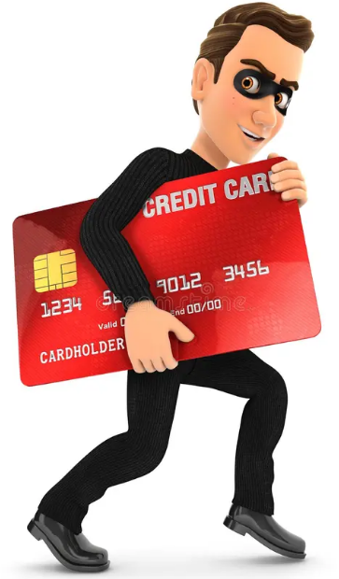
How Scammers Operate
Fraud usually happens when scammers trick users into sharing their card details through fake calls, messages, or websites.

They may pretend to be bank officials or send fake links to steal sensitive information like card number, CVV, and OTP.

Once they get access, they perform unauthorized transactions without the user’s knowledge.

