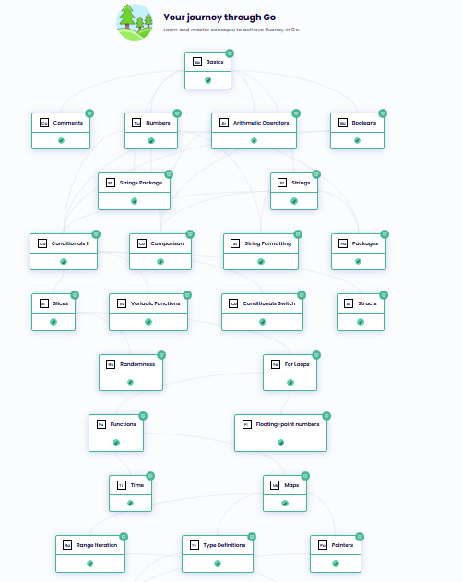
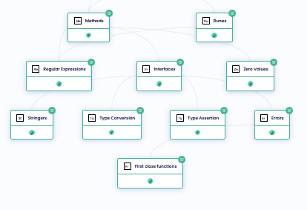

package greeting
import "fmt";
func HelloWorld() string {
fmt.Println("Hello, world!")
return "Hello, World!"
}

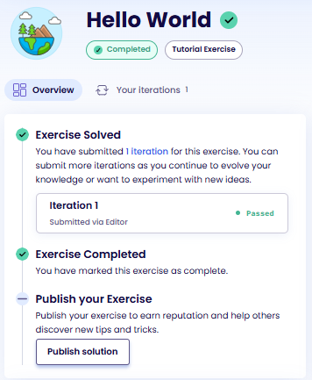
package lasagna
var OvenTime int = 40;
func RemainingOvenTime(actualMinutesInOven int) int {
// panic("RemainingOvenTime not implemented")
return OvenTime - actualMinutesInOven;
}
func PreparationTime(numberOfLayers int) int {
// panic("PreparationTime not implemented")
return numberOfLayers * 2;
}
func ElapsedTime(numberOfLayers, actualMinutesInOven int) int {
// panic("ElapsedTime not implemented")
var result int = PreparationTime(numberOfLayers) + actualMinutesInOven;
return result;
}

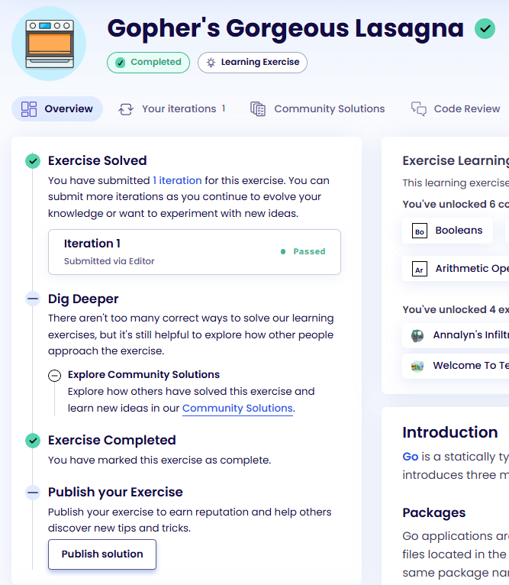

package annalyn
// CanFastAttack can be executed only when the knight is sleeping.
func CanFastAttack(knightIsAwake bool) bool {
// panic("Please implement the CanFastAttack() function")
return !knightIsAwake;
}
// CanSpy can be executed if at least one of the characters is awake.
func CanSpy(knightIsAwake, archerIsAwake, prisonerIsAwake bool) bool {
// panic("Please implement the CanSpy() function")
return knightIsAwake || archerIsAwake || prisonerIsAwake;
}
// CanSignalPrisoner can be executed if the prisoner is awake and the archer is sleeping.
func CanSignalPrisoner(archerIsAwake, prisonerIsAwake bool) bool {
// panic("Please implement the CanSignalPrisoner() function")
return prisonerIsAwake && !archerIsAwake;
}
// CanFreePrisoner can be executed if the prisoner is awake and the other 2 characters are asleep
// or if Annalyn's pet dog is with her and the archer is sleeping.
func CanFreePrisoner(knightIsAwake, archerIsAwake, prisonerIsAwake, petDogIsPresent bool) bool {
return (petDogIsPresent && !archerIsAwake) ||
(!petDogIsPresent && prisonerIsAwake && !knightIsAwake && !archerIsAwake)
}
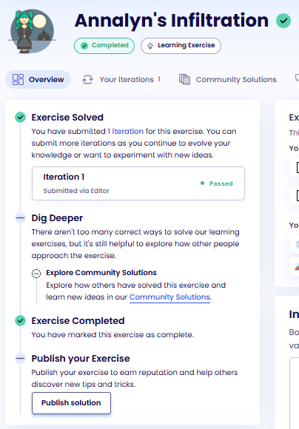

package partyrobot
import "fmt"
func Welcome(name string) string {
return fmt.Sprintf("Welcome to my party, %s!", name)
}
func HappyBirthday(name string, age int) string {
return fmt.Sprintf("Happy birthday %s! You are now %d years old!", name, age)
}
func AssignTable(name string, table int, neighbor, direction string, distance float64) string {
return fmt.Sprintf(
"Welcome to my party, %s!\nYou have been assigned to table %03d. Your table is %s, exactly %.1f meters from here.\nYou will be sitting next to %s.",
name,
table,
direction,
distance,
neighbor,
)
}

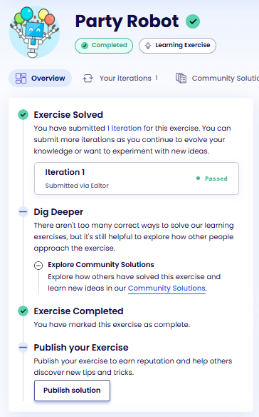

// Package weather is used to forecast weather for a given city.
package weather
var (
// CurrentCondition describes the current weather.
CurrentCondition string
// CurrentLocation describes the current location.
CurrentLocation string
)
// Forecast function provides the weather condition for the given city.
func Forecast(city, condition string) string {
CurrentLocation, CurrentCondition = city, condition
return CurrentLocation + " - current weather condition: " + CurrentCondition
}

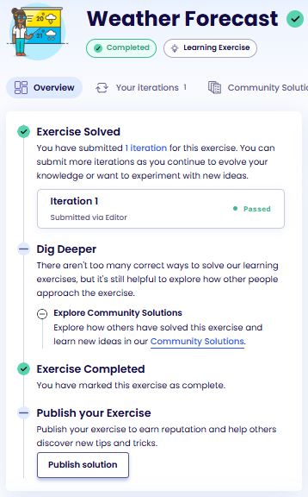

package blackjack
// ParseCard returns the integer value of a card following blackjack ruleset.
func ParseCard(card string) int {
switch card {
case "ace":
return 11
case "two":
return 2
case "three":
return 3
case "four":
return 4
case "five":
return 5
case "six":
return 6
case "seven":
return 7
case "eight":
return 8
case "nine":
return 9
case "ten", "jack", "queen", "king":
return 10
default:
return 0
}
}
func FirstTurn(c1, c2, dc string) string {
card1 := ParseCard(c1)
card2 := ParseCard(c2)
dealerCard := ParseCard(dc)
total := card1 + card2
if c1 == "ace" && c2 == "ace" {
return "P"
}
if total == 21 {
if dealerCard == 11 || dealerCard == 10 {
return "S"
}
return "W"
}
if total >= 17 && total <= 20 {
return "S"
}
if total >= 12 && total <= 16 {
if dealerCard >= 7 {
return "H"
}
return "S"
}
return "H"
}

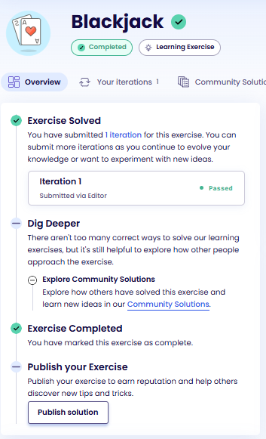
package booking
import "time"
func Schedule(date string) time.Time {
const layout = "1/2/2006 15:04:05"
t, _ := time.Parse(layout, date)
return t
}
func HasPassed(date string) bool {
const layout = "January 2, 2006 15:04:05"
t, _ := time.Parse(layout, date)
return t.Before(time.Now())
}
func IsAfternoonAppointment(date string) bool {
const layout = "Monday, January 2, 2006 15:04:05"
t, _ := time.Parse(layout, date)
hour := t.Hour()
return hour >= 12 && hour < 18
}
func Description(date string) string {
const inputLayout = "1/2/2006 15:04:05"
t, _ := time.Parse(inputLayout, date)
const outputLayout = "Monday, January 2, 2006, at 15:04."
return "You have an appointment on " + t.Format(outputLayout)
}
func AnniversaryDate() time.Time {
now := time.Now().UTC()
return time.Date(now.Year(), time.September, 15, 0, 0, 0, 0, time.UTC)
}

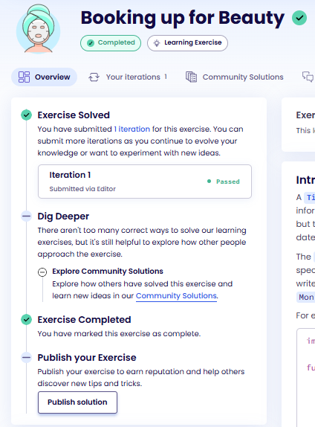
package cars
func CalculateWorkingCarsPerHour(productionRate int, successRate float64) float64 {
return float64(productionRate) * (successRate / 100.0)
}
func CalculateWorkingCarsPerMinute(productionRate int, successRate float64) int {
perHour := CalculateWorkingCarsPerHour(productionRate, successRate)
return int(perHour / 60.0)
}
func CalculateCost(carsCount int) uint {
groupsOfTen := carsCount / 10
remainder := carsCount % 10
return uint(groupsOfTen*95000 + remainder*10000)
}

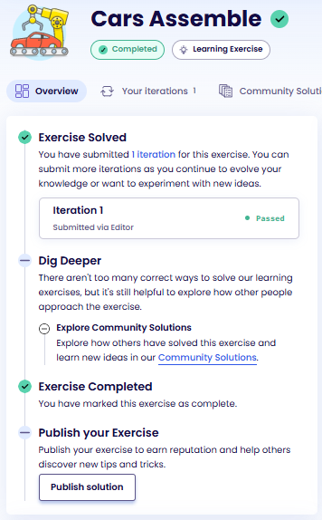
package purchase
func NeedsLicense(kind string) bool {
switch kind {
case "car", "truck":
return true
default:
return false
}
}
func ChooseVehicle(option1, option2 string) string {
var rec string
if option1 < option2 {
rec = option1
} else {
rec = option2
}
return rec + " is clearly the better choice."
}
func CalculateResellPrice(originalPrice, age float64) float64 {
if age < 3 {
return 0.8 * originalPrice
}
if age >= 10 {
return 0.5 * originalPrice
}
return 0.7 * originalPrice
}
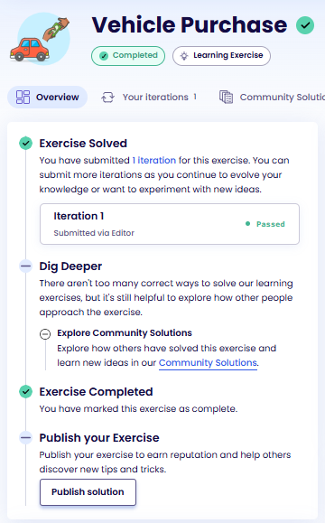
package gross
func Units() map[string]int {
return map[string]int{
"quarter_of_a_dozen": 3,
"half_of_a_dozen": 6,
"dozen": 12,
"small_gross": 120,
"gross": 144,
"great_gross": 1728,
}
}
func NewBill() map[string]int {
return make(map[string]int)
}
func AddItem(bill, units map[string]int, item, unit string) bool {
qty, ok := units[unit]
if !ok {
return false
}
bill[item] += qty
return true
}
func RemoveItem(bill, units map[string]int, item, unit string) bool {
qty, ok := units[unit]
if !ok {
return false
}
current, ok := bill[item]
if !ok {
return false
}
if current-qty < 0 {
return false
}
if current-qty == 0 {
delete(bill, item)
} else {
bill[item] = current - qty
}
return true
}
func GetItem(bill map[string]int, item string) (int, bool) {
qty, ok := bill[item]
return qty, ok
}

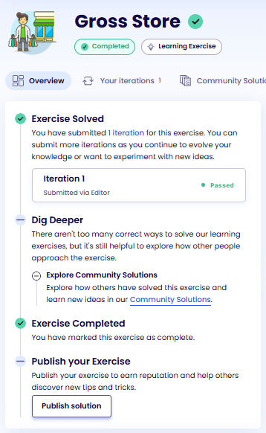

package lasagna
func PreparationTime(layers []string, avgTime int) int {
if avgTime == 0 {
avgTime = 2
}
return len(layers) * avgTime
}
func Quantities(layers []string) (int, float64) {
noodles := 0
sauce := 0.0
for _, layer := range layers {
switch layer {
case "noodles":
noodles += 50
case "sauce":
sauce += 0.2
}
}
return noodles, sauce
}
func AddSecretIngredient(friendsList, myList []string) {
if len(friendsList) == 0 || len(myList) == 0 {
return
}
secret := friendsList[len(friendsList)-1]
myList[len(myList)-1] = secret
}
func ScaleRecipe(quantities []float64, portions int) []float64 {
scaled := make([]float64, len(quantities))
factor := float64(portions) / 2.0
for i, q := range quantities {
scaled[i] = q * factor
}
return scaled
}

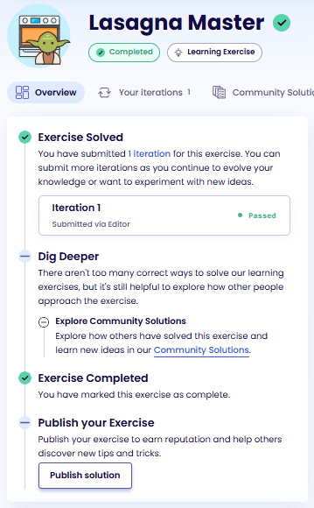
package speed
type Car struct {
battery int
batteryDrain int
speed int
distance int
}
func NewCar(speed, batteryDrain int) Car {
return Car{
speed: speed,
batteryDrain: batteryDrain,
battery: 100,
distance: 0,
}
}
type Track struct {
distance int
}
func NewTrack(distance int) Track {
return Track{
distance: distance,
}
}
func Drive(car Car) Car {
if car.battery < car.batteryDrain {
return car
}
car.distance += car.speed
car.battery -= car.batteryDrain
return car
}
func CanFinish(car Car, track Track) bool {
possibleDrives := car.battery / car.batteryDrain
maxDistance := possibleDrives * car.speed
return maxDistance >= track.distance
}

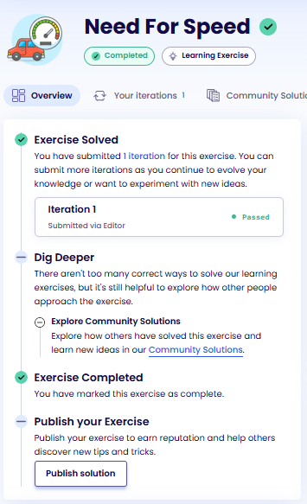

package jedlik
import "fmt"
func (c *Car) Drive() {
if c.battery < c.batteryDrain {
return
}
c.distance += c.speed
c.battery -= c.batteryDrain
}
func (c Car) DisplayDistance() string {
return fmt.Sprintf("Driven %d meters", c.distance)
}
func (c Car) DisplayBattery() string {
return fmt.Sprintf("Battery at %d%%", c.battery)
}
func (c Car) CanFinish(trackDistance int) bool {
maxDrives := c.battery / c.batteryDrain
maxDistance := maxDrives * c.speed
return maxDistance >= trackDistance
}

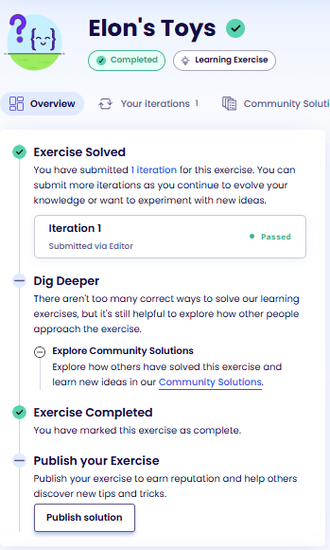
package techpalace
import "strings"
func WelcomeMessage(customer string) string {
// panic("Please implement the WelcomeMessage() function")
return "Welcome to the Tech Palace, "+strings.ToUpper(customer)
}
func AddBorder(welcomeMsg string, numStarsPerLine int) string {
// panic("Please implement the AddBorder() function")
var border string = strings.Repeat("*",numStarsPerLine)
return border+"\n"+welcomeMsg+"\n"+border;
}
func CleanupMessage(oldMsg string) string {
// panic("Please implement the CleanupMessage() function")
var tmp string = strings.ReplaceAll(oldMsg,"*","");
return strings.TrimSpace(tmp);
}

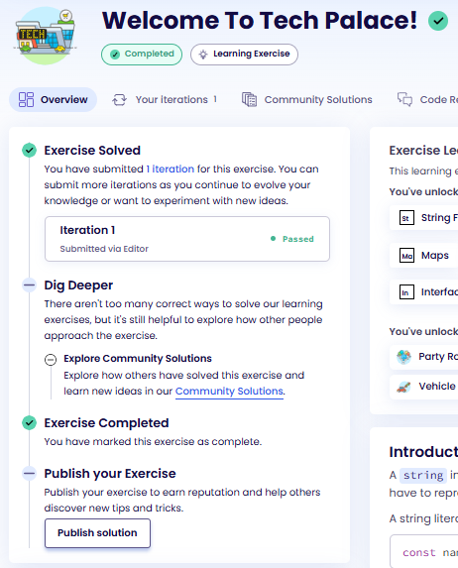
package birdwatcher
func TotalBirdCount(birdsPerDay []int) int {
total := 0
for _, count := range birdsPerDay {
total += count
}
return total
}
func BirdsInWeek(birdsPerDay []int, week int) int {
start := (week - 1) * 7
end := start + 7
total := 0
for i := start; i < end; i++ {
total += birdsPerDay[i]
}
return total
}
func FixBirdCountLog(birdsPerDay []int) []int {
for i := 0; i < len(birdsPerDay); i++ {
if i%2 == 0 {
birdsPerDay[i] = birdsPerDay[i] + 1
} else {
birdsPerDay[i] = birdsPerDay[i]
}
}
return birdsPerDay
}

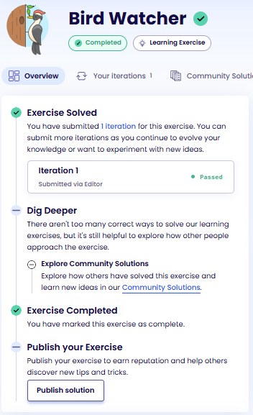
package cards
// FavoriteCards returns a slice with the cards 2, 6 and 9 in that order.
func FavoriteCards() []int {
// panic("Please implement the FavoriteCards function")
fav := make([]int, 0);
fav=append(fav,2,6,9)
return fav;
}
// GetItem retrieves an item from a slice at given position.
// If the index is out of range, we want it to return -1.
func GetItem(slice []int, index int) int {
// panic("Please implement the GetItem function")
if index < 0 || index >= len(slice) {
return -1;
}
return slice[index];
}
// SetItem writes an item to a slice at given position overwriting an existing value.
// If the index is out of range the value needs to be appended.
func SetItem(slice []int, index, value int) []int {
// panic("Please implement the SetItem function")
if index < 0 || index >= len(slice) {
slice = append(slice, value)
return slice;
}
slice[index] = value;
return slice;
}
// PrependItems adds an arbitrary number of values at the front of a slice.
func PrependItems(slice []int, values ...int) []int {
// panic("Please implement the PrependItems function")
slice = append(values, slice...);
return slice;
}
// RemoveItem removes an item from a slice by modifying the existing slice.
func RemoveItem(slice []int, index int) []int {
// panic("Please implement the RemoveItem function")
if index < 0 || index >= len(slice) {
return slice;
}
tmp := make([]int,0);
tmp = append(slice[:index], slice[index+1:]...)
return tmp;
}

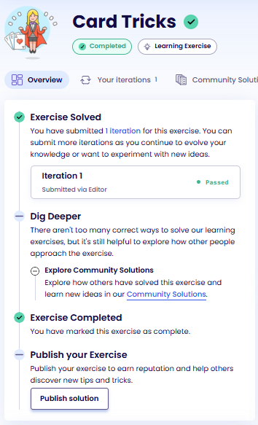

package chance
import "math/rand"
// RollADie returns a random int d with 1 <= d <= 20.
func RollADie() int {
// panic("Please implement the RollADie function")
return rand.Intn(20)+1;
}
// GenerateWandEnergy returns a random float64 f with 0.0 <= f < 12.0.
func GenerateWandEnergy() float64 {
// panic("Please implement the GenerateWandEnergy function")
return rand.Float64() * 12;
}
// ShuffleAnimals returns a slice with all eight animal strings in random order.
func ShuffleAnimals() []string {
// panic("Please implement the ShuffleAnimals function")
animals := []string{"ant","beaver","cat","dog","elephant","fox","giraffe","hedgehog"}
rand.Shuffle(len(animals), func(i,j int){
animals[i], animals[j] = animals[j],animals[i];
})
return animals;
}

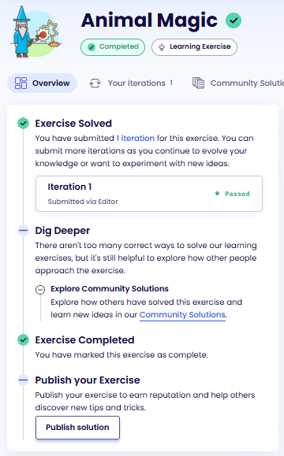
package interest
// InterestRate returns the interest rate for the provided balance.
func InterestRate(balance float64) float32 {
// panic("Please implement the InterestRate function")
if balance < 0 {
return 3.213;
}
if balance >= 0 && balance < 1000 {
return 0.5;
}
if balance >= 1000 && balance < 5000 {
return 1.621;
}
if balance >= 5000 {
return 2.475;
}
return 0;
}
// Interest calculates the interest for the provided balance.
func Interest(balance float64) float64 {
// panic("Please implement the Interest function")
return balance * float64(InterestRate(balance))/100;
}
// AnnualBalanceUpdate calculates the annual balance update, taking into account the interest rate.
func AnnualBalanceUpdate(balance float64) float64 {
// panic("Please implement the AnnualBalanceUpdate function")
return balance + Interest(balance);
}
// YearsBeforeDesiredBalance calculates the minimum number of years required to reach the desired balance.
func YearsBeforeDesiredBalance(balance, targetBalance float64) int {
// panic("Please implement the YearsBeforeDesiredBalance function")
var count int
amount := balance
for amount < targetBalance {
amount += Interest(amount)
count++
}
return count
}

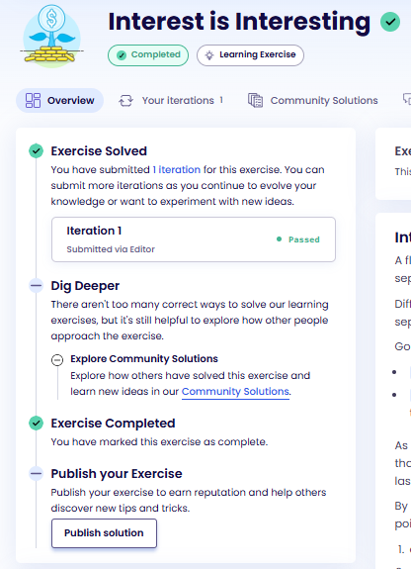

package chessboard
type File []bool
type Chessboard map[string]File
// CountInFile returns how many squares are occupied in the chessboard,
// within the given file.
func CountInFile(cb Chessboard, file string) int {
// panic("Please implement CountInFile()")
var count int = 0;
for k,v := range cb {
if k != file {
continue;
}
for _,x := range v {
if x {
count++;
}
}
}
return count;
}
// CountInRank returns how many squares are occupied in the chessboard,
// within the given rank.
func CountInRank(cb Chessboard, rank int) int {
// panic("Please implement CountInRank()")
var count int = 0;
for _,v := range cb {
// if k != file {
// continue;
// }
for i,x := range v {
if i+1 != rank {
continue;
}
if x {
count++;
}
}
}
return count;
}
// CountAll should count how many squares are present in the chessboard.
func CountAll(cb Chessboard) int {
// panic("Please implement CountAll()")
var count int = 0;
for _,v := range cb {
for range v {
count++;
}
}
return count;
}
// CountOccupied returns how many squares are occupied in the chessboard.
func CountOccupied(cb Chessboard) int {
// panic("Please implement CountOccupied()")
var count int = 0;
for _,v := range cb {
for _ ,x := range v {
if x {
count++;
}
}
}
return count;
}

package electionday
import "fmt"
// NewVoteCounter returns a new vote counter with
// a given number of initial votes.
func NewVoteCounter(initialVotes int) *int {
// panic("Please implement the NewVoteCounter() function")
var newVotes = initialVotes;
return &newVotes;
}
// VoteCount extracts the number of votes from a counter.
func VoteCount(counter *int) int {
// panic("Please implement the VoteCount() function")
if counter == nil {
return 0;
}
return *counter;
}
// IncrementVoteCount increments the value in a vote counter.
func IncrementVoteCount(counter *int, increment int) {
// panic("Please implement the IncrementVoteCount() function")
(*counter) = (*counter) + increment;
}
// NewElectionResult creates a new election result.
func NewElectionResult(candidateName string, votes int) *ElectionResult {
// panic("Please implement the NewElectionResult() function")
elres := ElectionResult {
Name:candidateName,
Votes:votes,
}
return &elres;
}
func DisplayResult(result *ElectionResult) string {
return fmt.Sprintf("%s (%d)", result.Name, result.Votes)
}
// DecrementVotesOfCandidate decrements by one the vote count of a candidate in a map.
func DecrementVotesOfCandidate(results map[string]int, candidate string) {
// panic("Please implement the DecrementVotesOfCandidate() function")
for k,_ := range results {
if k == candidate {
results[k] = results[k] - 1;
}
}
}
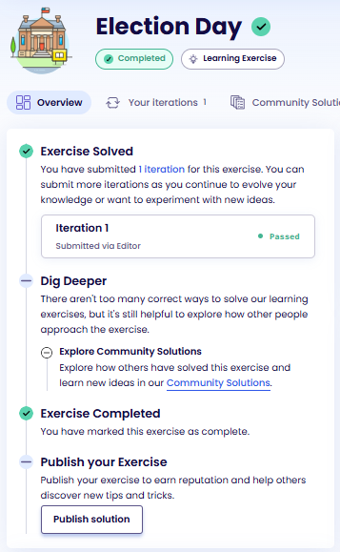

package logs
import "unicode/utf8"
// Application identifies the application emitting the given log.
func Application(log string) string {
// panic("Please implement the Application() function")
for _, char := range log {
if string(char) == string('❗'){
return "recommendation"
}
if string(char) == string('🔍'){
return "search"
}
if string(char) == string('☀'){
return "weather"
}
}
return "default"
}
// Replace replaces all occurrences of old with new, returning the modified log
// to the caller.
func Replace(log string, oldRune, newRune rune) string {
// panic("Please implement the Replace() function")
var result string = ""
for _, char := range log {
if char == oldRune {
result += string(newRune)
}else{
result += string(char)
}
}
return result;
}
// WithinLimit determines whether or not the number of characters in log is
// within the limit.
func WithinLimit(log string, limit int) bool {
// panic("Please implement the WithinLimit() function")
return utf8.RuneCountInString(log) <= limit;
}
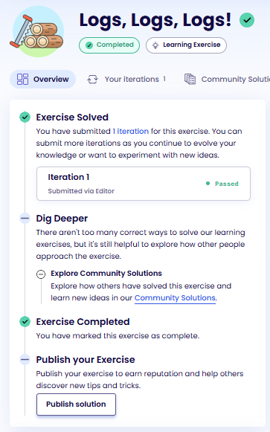

// Package census simulates a system used to collect census data.
package census
// Resident represents a resident in this city.
type Resident struct {
Name string
Age int
Address map[string]string
}
// NewResident registers a new resident in this city.
func NewResident(name string, age int, address map[string]string) *Resident {
// panic("Please implement NewResident.")
resident := Resident {
Name:name,
Age:age,
Address: address,
}
return &resident;
}
// HasRequiredInfo determines if a given resident has all of the required information.
func (r *Resident) HasRequiredInfo() bool {
// panic("Please implement HasRequiredInfo.")
derefResident := *r;
if derefResident.Name != "" && derefResident.Address["street"] != "" {
return true;
}
return false;
}
// Delete deletes a resident's information.
func (r *Resident) Delete() {
// panic("Please implement Delete.")
r.Name = "";
r.Age = 0;
r.Address = nil;
}
// Count counts all residents that have provided the required information.
func Count(residents []*Resident) int {
// panic("Please implement Count.")
var count int = 0;
for _, value := range residents {
if value.Name != "" && value.Address["street"] != ""{
count++;
}
}
return count;
}

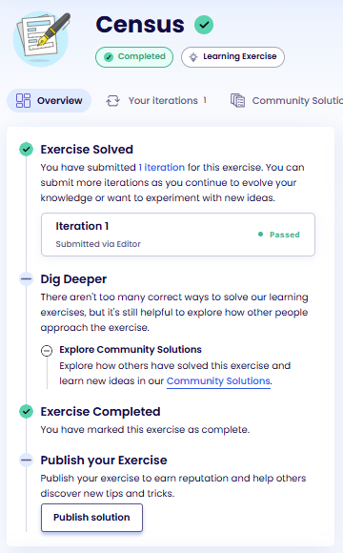
package airportrobot
// Write your code here.
// This exercise does not have tests for each individual task.
// Try to solve all the tasks first before running the tests.
import "fmt"
type Greeter interface {
LanguageName() string
Greet(name string) string
}
func SayHello (name string, g Greeter) string{
return fmt.Sprintf("I can speak %s: %s!",g.LanguageName(), g.Greet(name))
}
type Italian struct {}
func (i Italian) LanguageName () string{
return "Italian";
}
func (i Italian) Greet (name string) string{
return fmt.Sprintf("Ciao %s",name);
}
type Portuguese struct {}
func (p Portuguese) LanguageName () string{
return "Portuguese";
}
func (p Portuguese) Greet (name string) string{
return fmt.Sprintf("Olá %s",name);
}

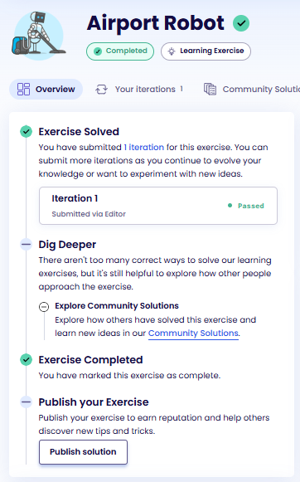

package parsinglogfiles
import (
"regexp"
"fmt"
"strings"
)
func IsValidLine(text string) bool {
// panic("Please implement the IsValidLine function")
fmt.Println(text)
pattern := `^\[[TDIWEF][RBNRT][CGFNRL]\].*$`;
reg := regexp.MustCompile(pattern);
return reg.MatchString(text);
}
func SplitLogLine(text string) []string {
// panic("Please implement the SplitLogLine function")
pattern := `<[~*=\-]*>`;
reg := regexp.MustCompile(pattern);
return reg.Split(text,-1)
}
func CountQuotedPasswords(lines []string) int {
// panic("Please implement the CountQuotedPasswords function")
var count int = 0;
pattern := `.*".*(p|P)(a|A)(s|S)(s|S)(w|W)(o|O)(r|R)(d|D).*".*`;
reg := regexp.MustCompile(pattern);
for _,v := range lines{
if reg.MatchString(v) {
fmt.Println(v)
count++;
}
}
return count;
}
func RemoveEndOfLineText(text string) string {
// panic("Please implement the RemoveEndOfLineText function")
pattern := `end-of-line[0-9]*`;
reg := regexp.MustCompile(pattern);
return reg.ReplaceAllString(text,"");
}
func TagWithUserName(lines []string) []string {
// panic("Please implement the TagWithUserName function")
pattern := `User\s+`;
reg := regexp.MustCompile(pattern);
for i,v := range lines {
if reg.MatchString(v) {
second := strings.Trim(reg.Split(v, -1)[1]," ")
userreg := regexp.MustCompile(`\s+`)
parts := userreg.Split(second,-1);
fmt.Println(parts)
lines[i] = fmt.Sprintf("[USR] %s %s",parts[0], v);
}
}
return lines;
}

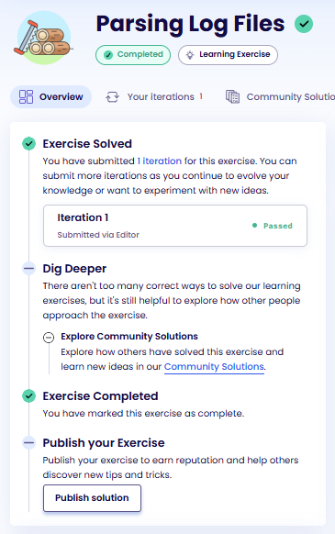

package meteorology
import (
"fmt"
)
type TemperatureUnit int
func (t TemperatureUnit) String() string{
if t == 0 {
return "°C"
}else {
return "°F"
}
}
const (
Celsius TemperatureUnit = 0
Fahrenheit TemperatureUnit = 1
)
// Add a String method to the TemperatureUnit type
type Temperature struct {
degree int
unit TemperatureUnit
}
func (t Temperature) String() string{
return fmt.Sprintf("%d %v",t.degree, t.unit)
}
// Add a String method to the Temperature type
type SpeedUnit int
const (
KmPerHour SpeedUnit = 0
MilesPerHour SpeedUnit = 1
)
// Add a String method to SpeedUnit
func (s SpeedUnit) String () string{
if s == 0 {
return "km/h"
} else {
return "mph"
}
}
type Speed struct {
magnitude int
unit SpeedUnit
}
// Add a String method to Speed
func (s Speed) String() string{
return fmt.Sprintf("%d %v",s.magnitude, s.unit);
}
type MeteorologyData struct {
location string
temperature Temperature
windDirection string
windSpeed Speed
humidity int
}
func (m MeteorologyData) String() string {
return fmt.Sprintf("%s: %v, Wind %s at %v, %d%% Humidity",m.location, m.temperature, m.windDirection,m.windSpeed, m.humidity)
}
// Add a String method to MeteorologyData

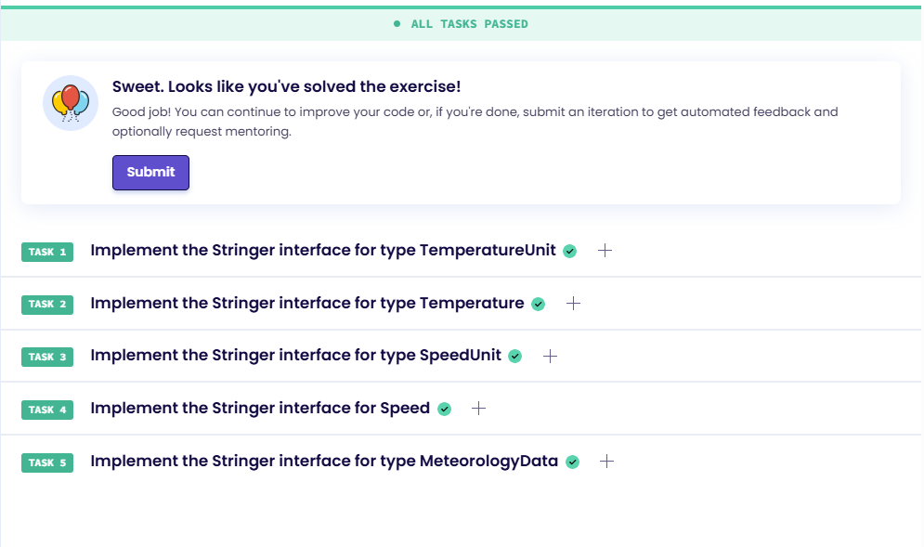
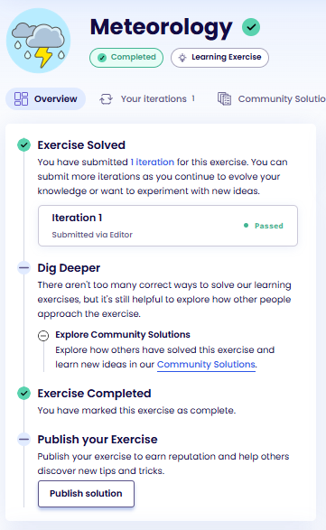

package sorting
import (
"fmt"
"strconv"
)
// DescribeNumber should return a string describing the number.
func DescribeNumber(f float64) string {
return fmt.Sprintf("This is the number %.1f", f)
}
type NumberBox interface {
Number() int
}
// DescribeNumberBox should return a string describing the NumberBox.
func DescribeNumberBox(nb NumberBox) string {
return fmt.Sprintf("This is a box containing the number %.1f", float64(nb.Number()))
}
type FancyNumber struct {
n string
}
func (i FancyNumber) Value() string {
return i.n
}
type FancyNumberBox interface {
Value() string
}
// ExtractFancyNumber should return the integer value for a FancyNumber
// and 0 if any other FancyNumberBox is supplied.
func ExtractFancyNumber(fnb FancyNumberBox) int {
fn, ok := fnb.(FancyNumber)
if !ok {
return 0
}
n, err := strconv.Atoi(fn.Value())
if err != nil {
return 0
}
return n
}
// DescribeFancyNumberBox should return a string describing the FancyNumberBox.
func DescribeFancyNumberBox(fnb FancyNumberBox) string {
n := ExtractFancyNumber(fnb)
return fmt.Sprintf("This is a fancy box containing the number %.1f", float64(n))
}
// DescribeAnything should return a string describing whatever it contains.
func DescribeAnything(i any) string {
switch v := i.(type) {
case int:
return DescribeNumber(float64(v))
case float64:
return DescribeNumber(v)
case NumberBox:
return DescribeNumberBox(v)
case FancyNumberBox:
return DescribeFancyNumberBox(v)
default:
return "Return to sender"
}
}

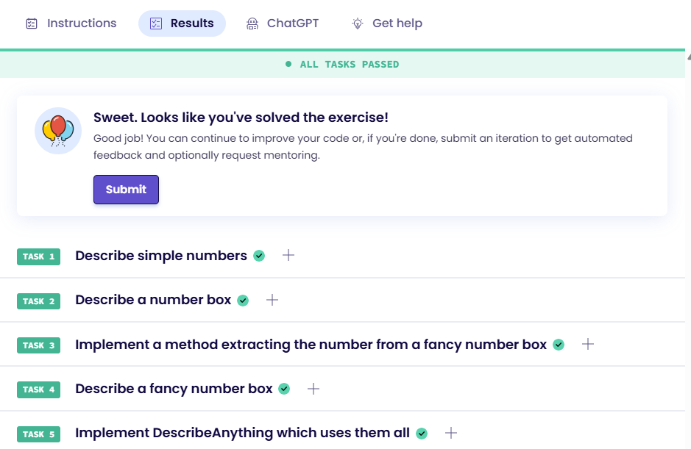

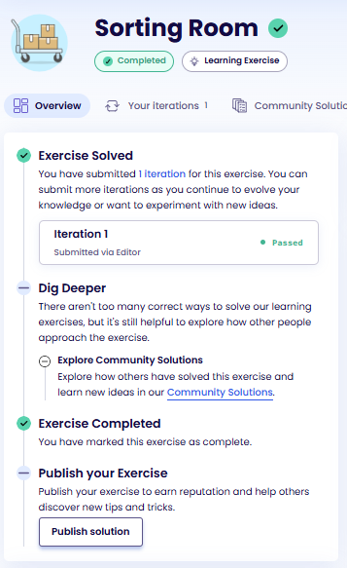

package thefarm
import (
"errors"
"fmt"
)
// TODO: define the 'DivideFood' function
func DivideFood(fc FodderCalculator, n int) (float64, error){
amount, err := fc.FodderAmount(n);
if err != nil {
return 0, err
}
factor, err := fc.FatteningFactor();
if err != nil {
return 0, err
}
amount = amount * factor
var percow float64 = float64(amount)/float64(n);
return percow, nil
}
// TODO: define the 'ValidateInputAndDivideFood' function
func ValidateInputAndDivideFood(fc FodderCalculator, n int)(float64, error){
if n > 0 {
return DivideFood(fc, n);
}else{
return 0,errors.New("invalid number of cows")
}
}
type InvalidCowsError struct {
Count int
Message string
}
func (i InvalidCowsError) Error() string{
return fmt.Sprintf("%d cows are invalid: %s",i.Count, i.Message);
}
// TODO: define the 'ValidateNumberOfCows' function
func ValidateNumberOfCows(n int) error{
if n < 0 {
err := InvalidCowsError {
Count:n,
Message:"there are no negative cows",
}
return &err;
}
if n == 0{
err := InvalidCowsError {
Count:n,
Message:"no cows don't need food",
}
return &err
}
return nil;
}
// Your first steps could be to read through the tasks, and create
// these functions with their correct parameter lists and return types.
// The function body only needs to contain `panic("")`.
//
// This will make the tests compile, but they will fail.
// You can then implement the function logic one by one and see
// an increasing number of tests passing as you implement more
// functionality.
// 0 1 2 3 4 5 6 7
// "A" => [true, false false false false, true, false, true]
// "B" => [true, false false false false, true, false, true]
// "C" => [true, false false false false, true, false, true]

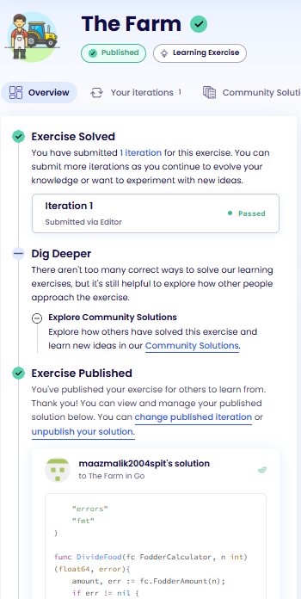

package expenses
import "fmt"
type Record struct {
Day int
Amount float64
Category string
}
type DaysPeriod struct {
From int
To int
}
func Filter(in []Record, predicate func(Record) bool) []Record {
result := make([]Record, 0)
for _, r := range in {
if predicate(r) {
result = append(result, r)
}
}
return result
}
func ByDaysPeriod(p DaysPeriod) func(Record) bool {
return func(r Record) bool {
return r.Day >= p.From && r.Day <= p.To
}
}
func ByCategory(c string) func(Record) bool {
return func(r Record) bool {
return r.Category == c
}
}
func TotalByPeriod(in []Record, p DaysPeriod) float64 {
recordsInPeriod := Filter(in, ByDaysPeriod(p))
var total float64
for _, r := range recordsInPeriod {
total += r.Amount
}
return total
}
func CategoryExpenses(in []Record, p DaysPeriod, c string) (float64, error) {
categoryRecords := Filter(in, ByCategory(c))
if len(categoryRecords) == 0 {
return 0, fmt.Errorf("unknown category %s", c)
}
recordsInPeriod := Filter(categoryRecords, ByDaysPeriod(p))
var total float64
for _, r := range recordsInPeriod {
total += r.Amount
}
return total, nil
}

