Familiarization with Git Version Control (Yash Shah)

- Created Git Repo
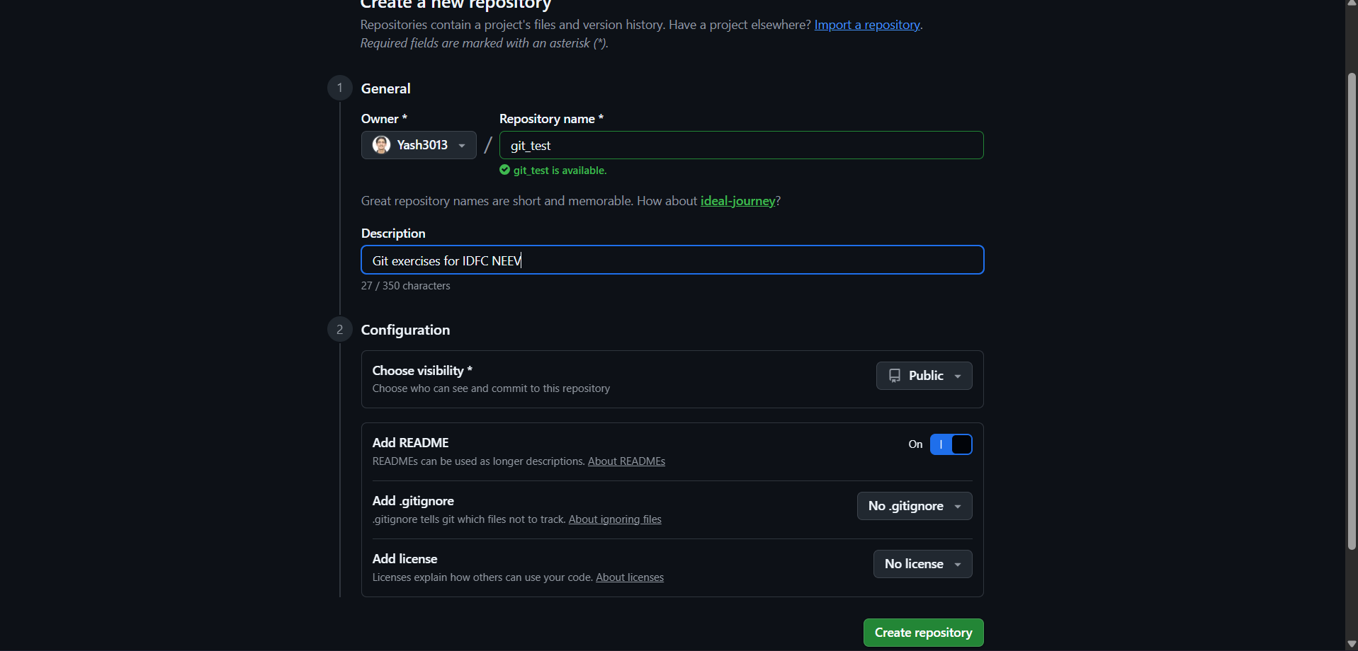
- Creating a new directory
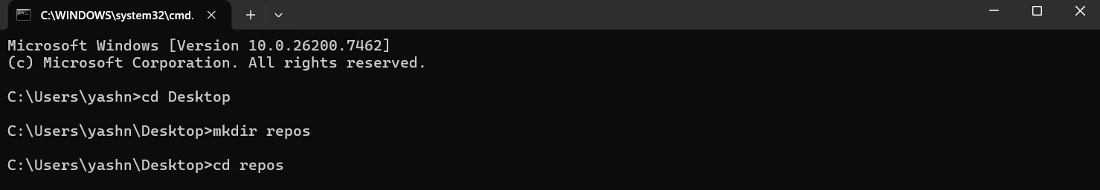
- Setting up SSH key
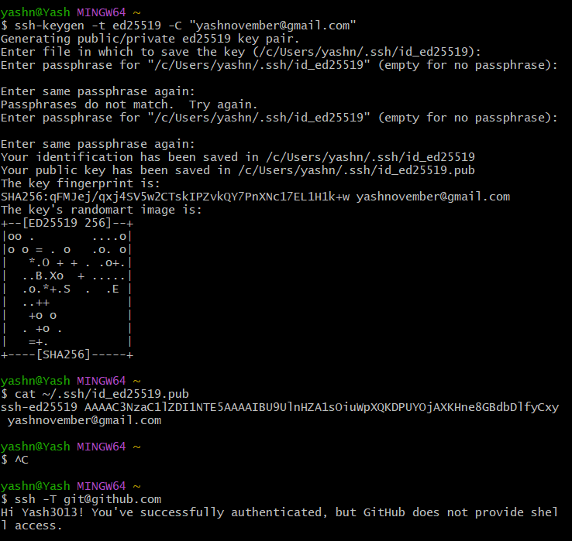
- Git clone using SSH into my machine
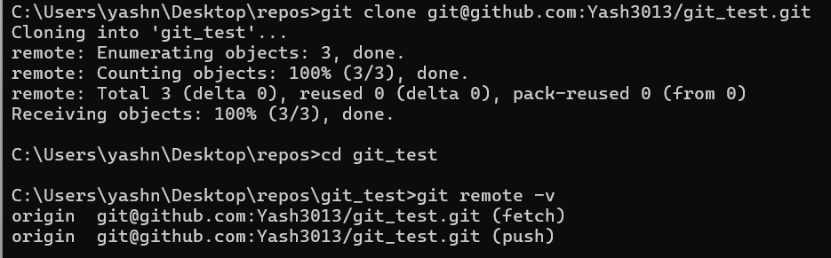
- Creating a new file
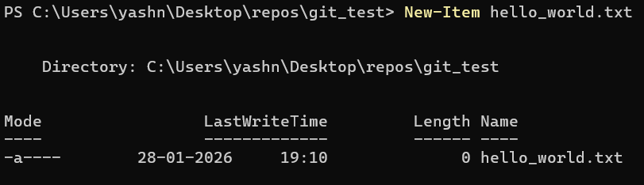
- Untracked status
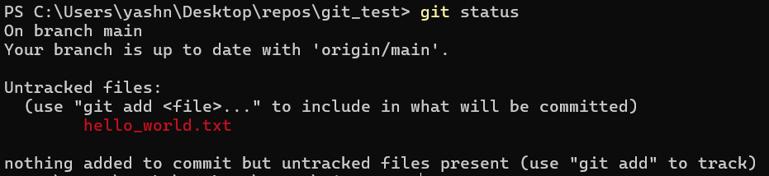
- Adding to staged area
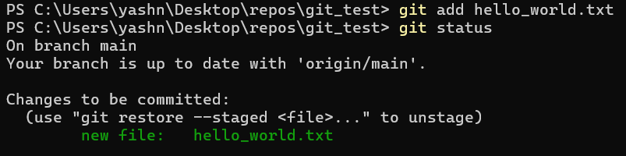
- Making a commit message
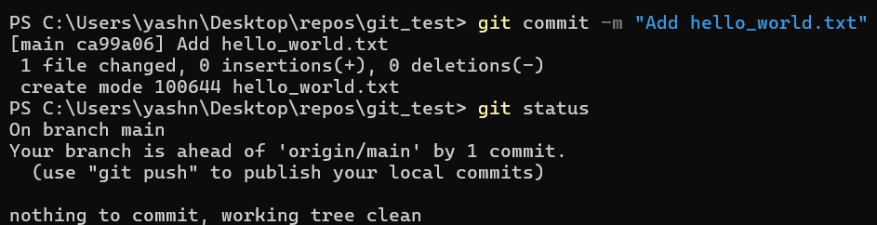
- Verifying via git log
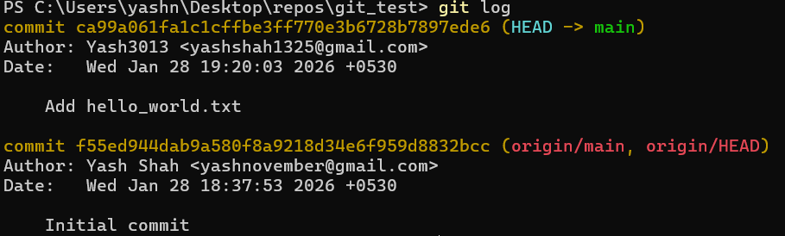
- Modifying README.md
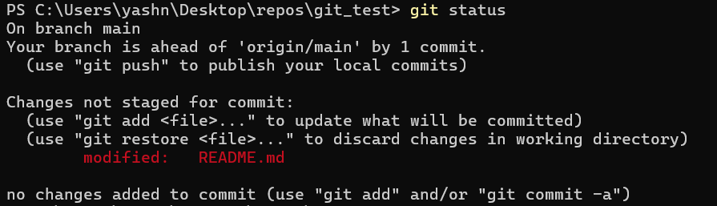
- Adding the changed file to staging area
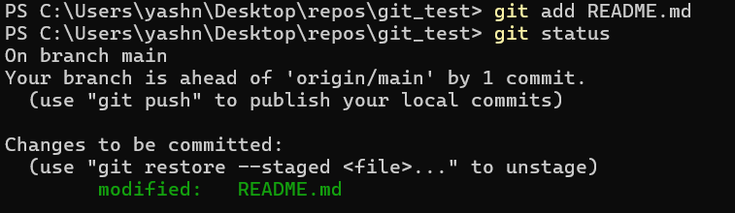
- Modifying hello_world.txt
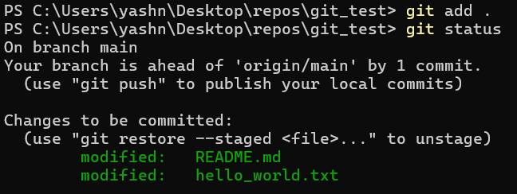

- Committing the modified version
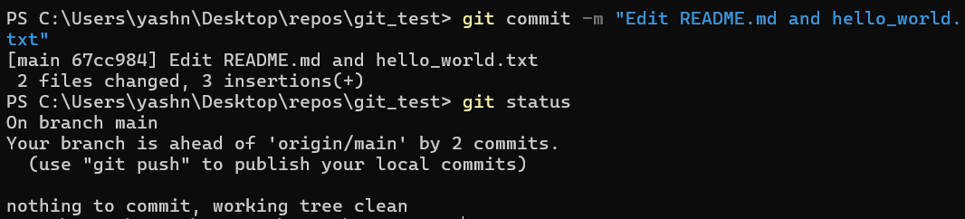
- Verifying via git log and checking status
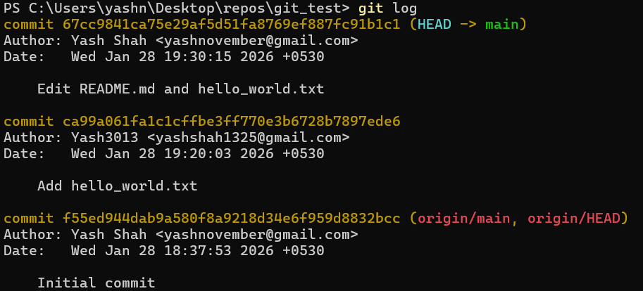
- Pushing it on github
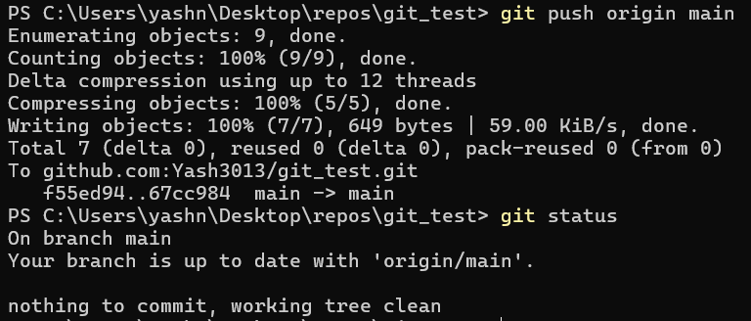

- Made the final git repository
