Maaz Malik . tic tac toe

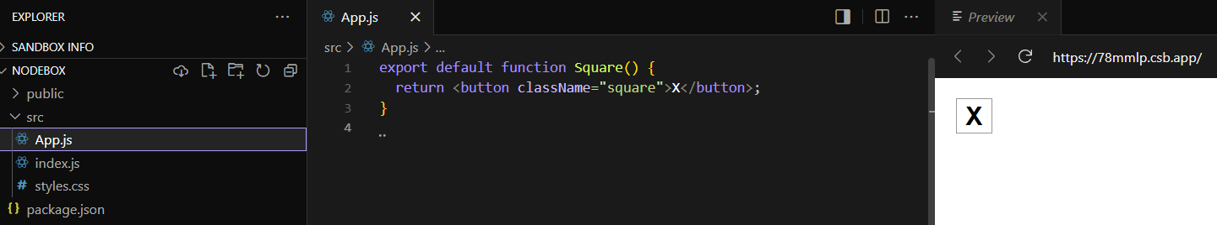
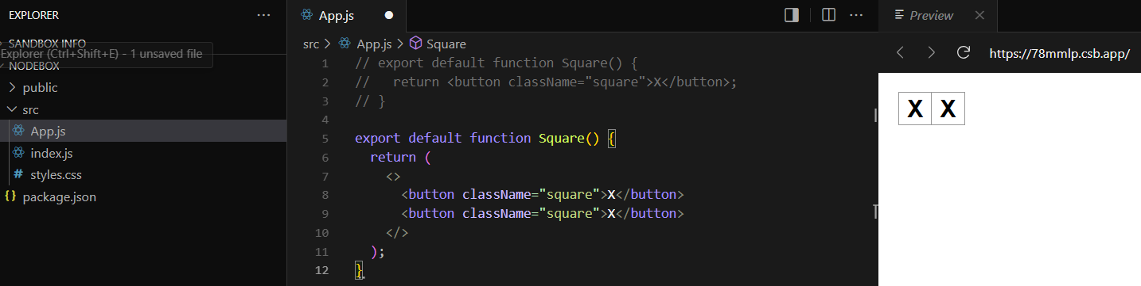
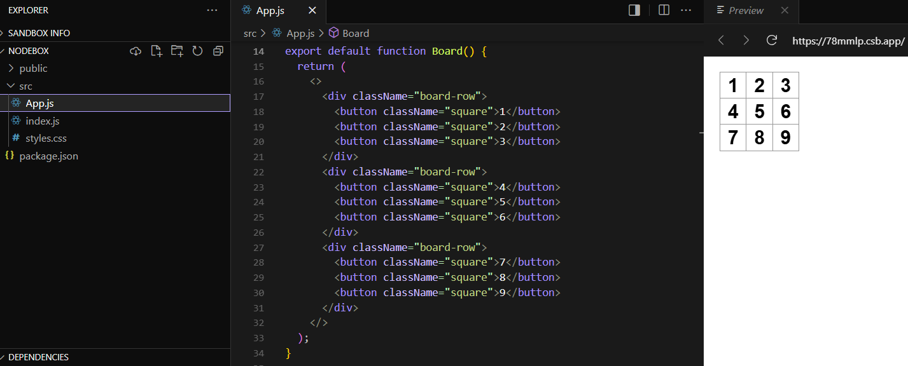
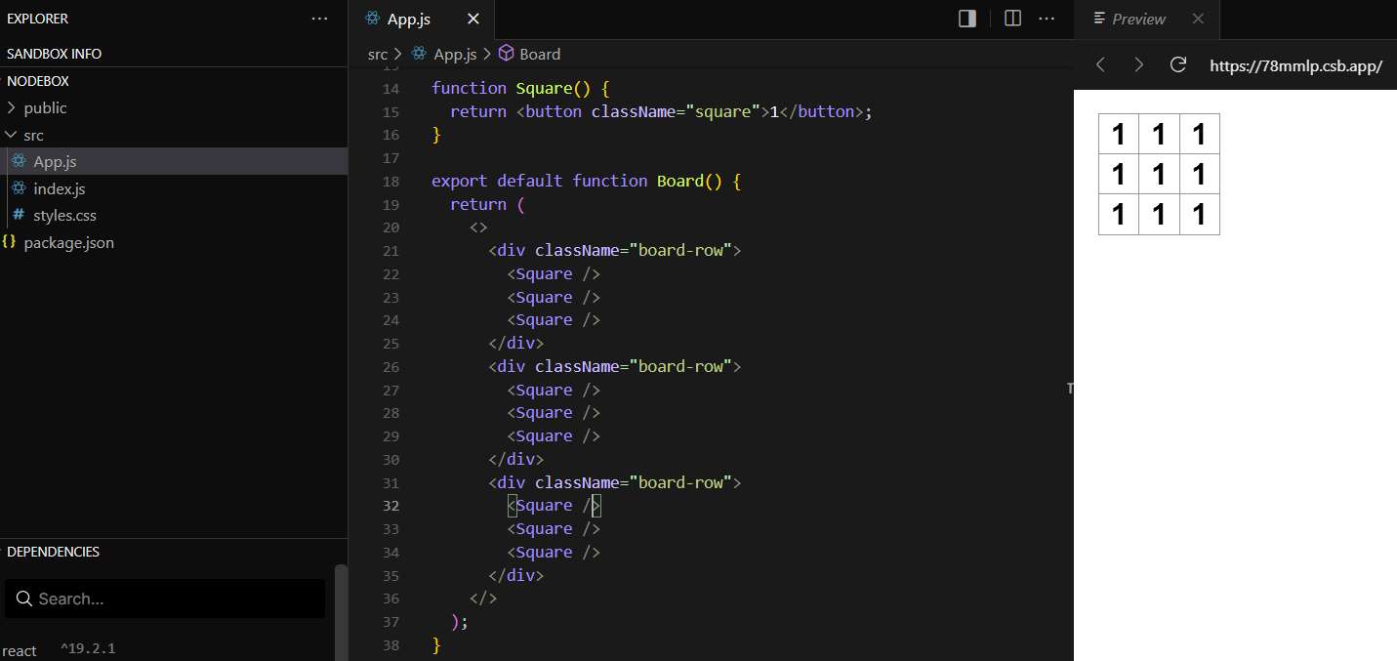
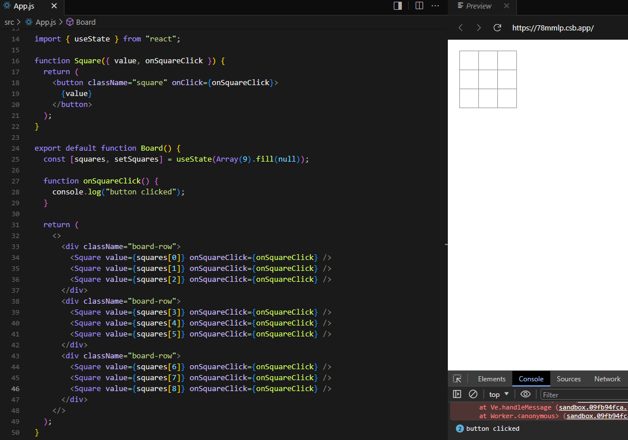

import { useState } from "react";

function Square({ value, onSquareClick }) {
return (
<button className="square" onClick={onSquareClick}>
{value}
</button>
);
}

function Board({ xIsNext, squares, onPlay }) {
function handleClick(i) {
if (calculateWinner(squares) || squares[i]) {
return;
}
const nextSquares = squares.slice();
if (xIsNext) {
nextSquares[i] = "X";
} else {
nextSquares[i] = "O";
}
onPlay(nextSquares);
}

const winner = calculateWinner(squares);
let status;
if (winner) {
status = "Winner: " + winner;
} else {
status = "Next player: " + (xIsNext ? "X" : "O");
}

return (
<>
<div className="status">{status}</div>
<div className="board-row">
<Square value={squares[0]} onSquareClick={() => handleClick(0)} />
<Square value={squares[1]} onSquareClick={() => handleClick(1)} />
<Square value={squares[2]} onSquareClick={() => handleClick(2)} />
</div>
<div className="board-row">
<Square value={squares[3]} onSquareClick={() => handleClick(3)} />
<Square value={squares[4]} onSquareClick={() => handleClick(4)} />
<Square value={squares[5]} onSquareClick={() => handleClick(5)} />
</div>
<div className="board-row">
<Square value={squares[6]} onSquareClick={() => handleClick(6)} />
<Square value={squares[7]} onSquareClick={() => handleClick(7)} />
<Square value={squares[8]} onSquareClick={() => handleClick(8)} />
</div>
</>
);
}

export default function Game() {
const [history, setHistory] = useState([Array(9).fill(null)]);
const [currentMove, setCurrentMove] = useState(0);
const xIsNext = currentMove % 2 === 0;
const currentSquares = history[currentMove];

function handlePlay(nextSquares) {
const nextHistory = [...history.slice(0, currentMove + 1), nextSquares];
setHistory(nextHistory);
setCurrentMove(nextHistory.length - 1);
}

function jumpTo(nextMove) {
setCurrentMove(nextMove);
}

const moves = history.map((squares, move) => {
let description;
if (move > 0) {
description = "Go to move #" + move;
} else {
description = "Go to game start";
}
return (
<li key={move}>
<button onClick={() => jumpTo(move)}>{description}</button>
</li>
);
});

return (
<div className="game">
<div className="game-board">
<Board xIsNext={xIsNext} squares={currentSquares} onPlay={handlePlay} />
</div>
<div className="game-info">
<ol>{moves}</ol>
</div>
</div>
);
}

function calculateWinner(squares) {
const lines = [
[0, 1, 2],
[3, 4, 5],
[6, 7, 8],
[0, 3, 6],
[1, 4, 7],
[2, 5, 8],
[0, 4, 8],
[2, 4, 6],
];
for (let i = 0; i < lines.length; i++) {
const [a, b, c] = lines[i];
if (squares[a] && squares[a] === squares[b] && squares[a] === squares[c]) {
return squares[a];
}
}
return null;
}

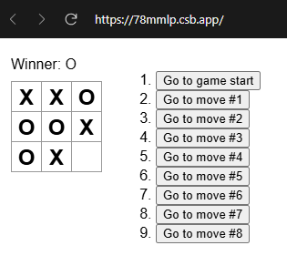
https://codesandbox.io/p/sandbox/react-dev-forked-78mmlp?file=%2Fsrc%2FApp.js%3A23%2C4

.square {
color: white;
background-color: turquoise;
margin: 0.5rem;
border-radius: 0.5rem;
border-color: #00ced1;
border-width: 0.5rem;
align-items: center;
justify-content: center;
align-items: center;
justify-items: center;
height: 5rem;
width: 5rem;
}

