# SCREENSHOTS

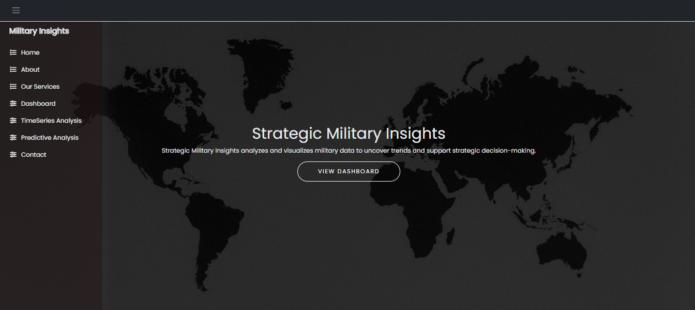

Fig 6.1 Homepage

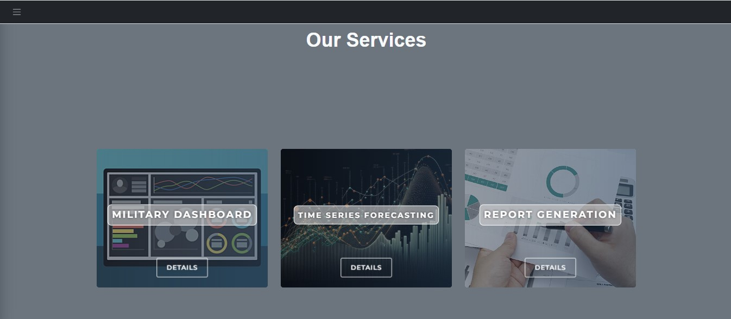

Fig 6.2 Project Feature showcase cards

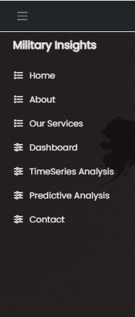

Fig 6.3. Navigation bar

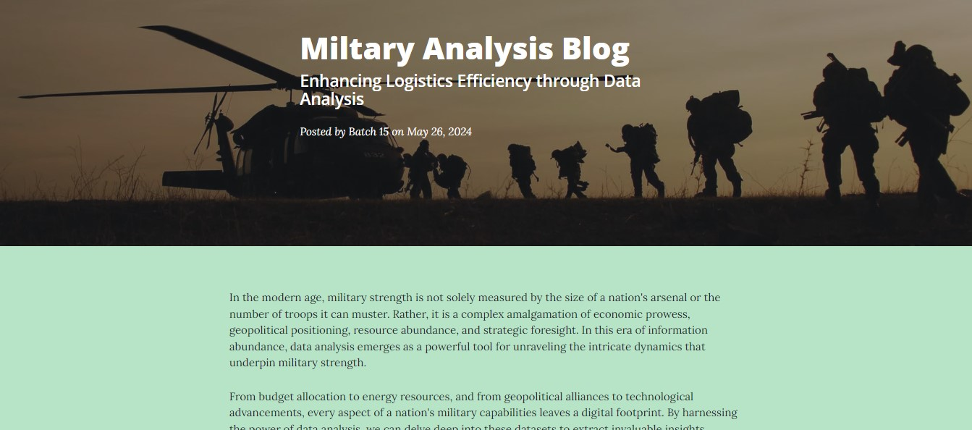

Fig 6.4. Blog Page

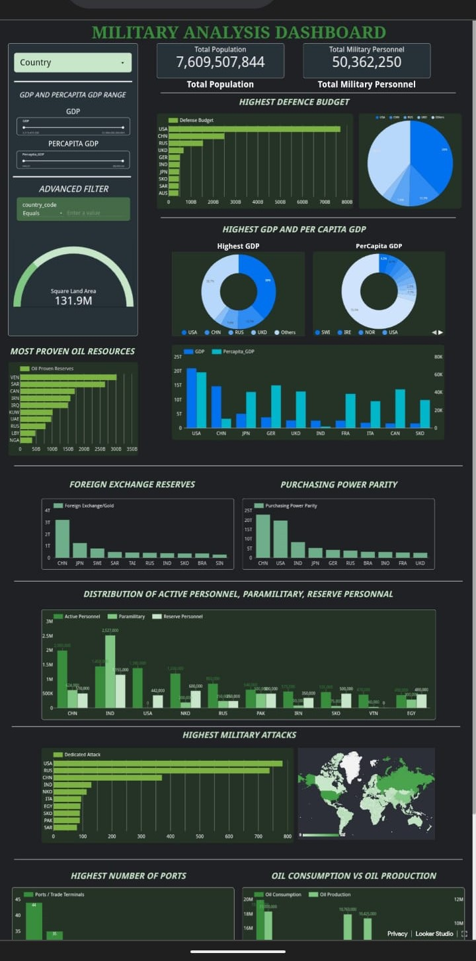

Fig 6.5. Interactive Military Dashboard

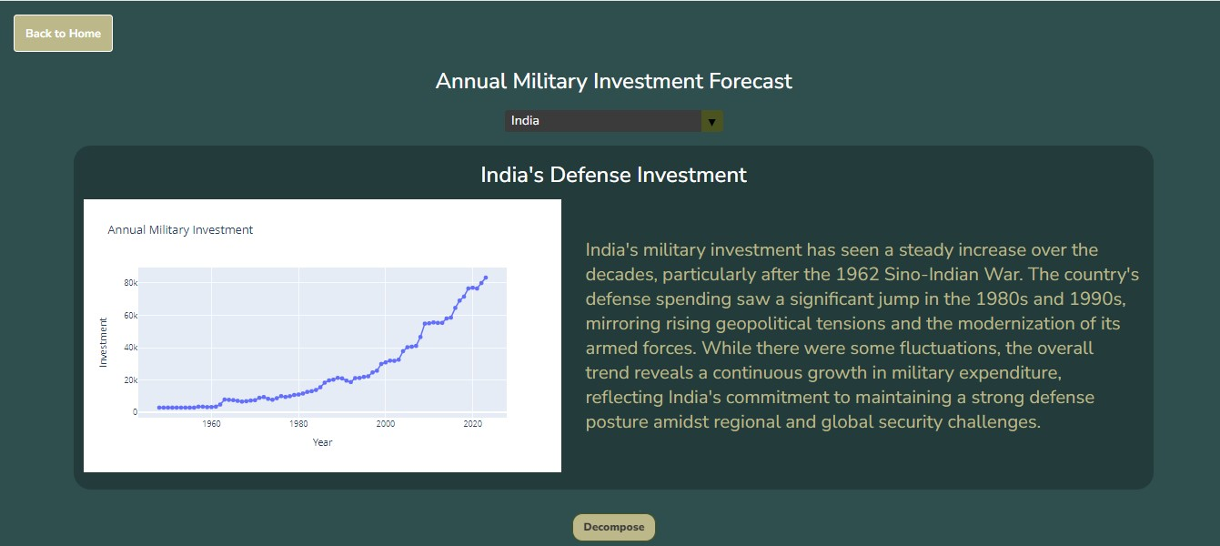

Fig 6.6. Original Time Series with AI report

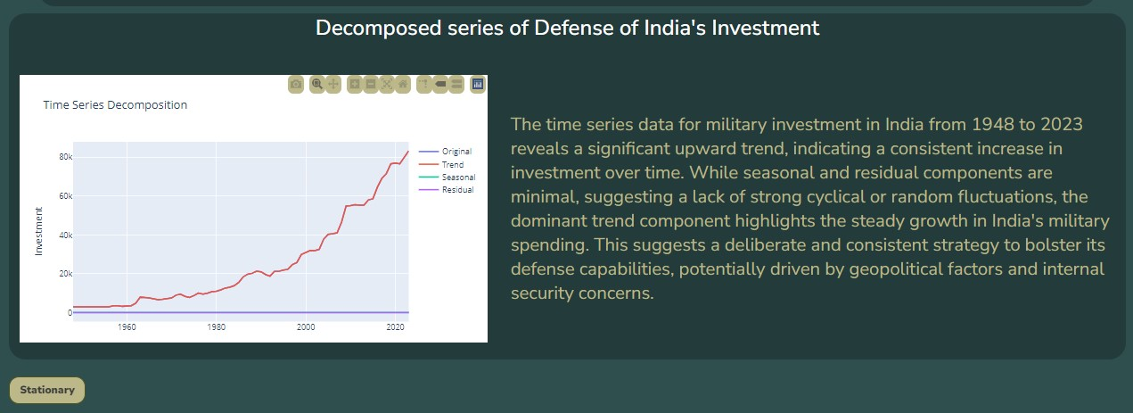

Fig 6.7. Decomposed Time Series with AI report

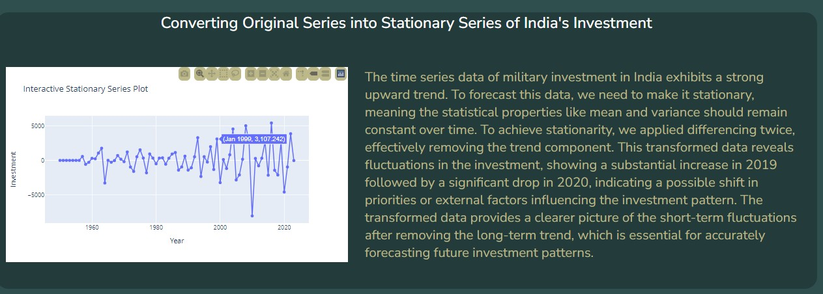

Fig 6.8. Stationary Time Series with AI report

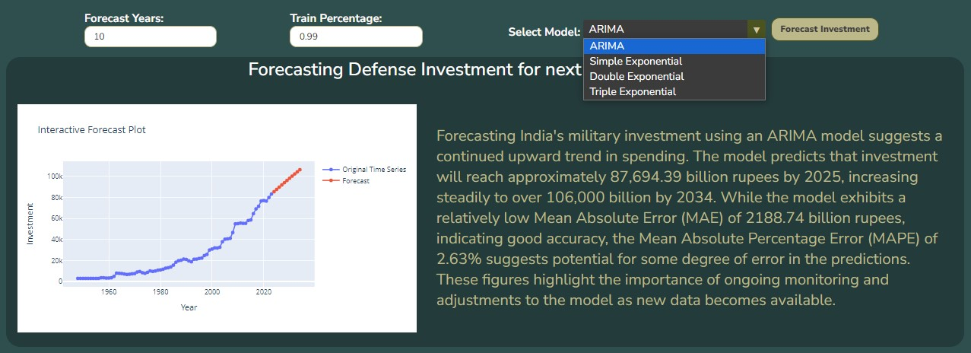

Fig 6.9. Time Series Forecasting