A triangle inside circle

#include<graphics.h>

#include<conio.h>

main()

{int gd = DETECT, gm;

initgraph(&gd, &gm, "C:\\TC\\BGI");

circle(200, 200,150);

line(200, 200, 300, 300);

line(200, 200, 150, 250);

line(300, 300, 150, 250);

line(200, 350, 200, 200);

getch();

closegraph();

return 0;}

**Out Put:-**

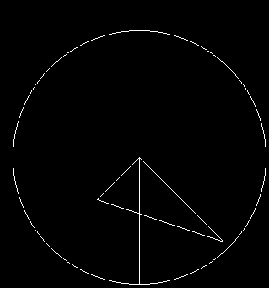

A circle

#include<graphics.h>

#include<conio.h>

main()

{int gd = DETECT, gm;

initgraph(&gd, &gm, "C:\\TC\\BGI");

circle(200, 200,150);

getch();

closegraph();}

**Output :**

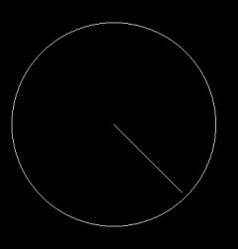

**Circles in increasing order by loop**

**#include<graphics.h>**

**#include<conio.h>**

**main()**

**{int gd = DETECT, gm;**

**initgraph(&gd, &gm, "C:\\TC\\BGI");**

**circle(200, 200,150);**

**int i;**

**for (i=10; i<=140; i=i+10)**

**{circle(200, 200,i);}**

**line(200, 200, 300, 300);**

**line(200, 200, 150, 250);**

**line(300, 300, 150, 250);**

**line(200, 350, 200, 200);**

**getch();**

**closegraph();**

**return 0;**

**}**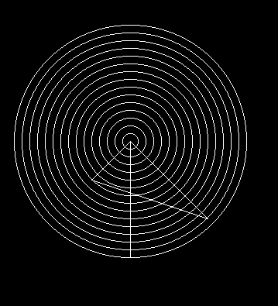

A line

#include<graphics.h>

#include<conio.h>

#include<dos.h>

int main(void) {

int gdriver = DETECT, gmode;

int x1 = 200, y1 = 200;

int x2 = 300, y2 = 300;

initgraph(&gdriver, &gmode, "c:\\tc\\bgi");

line(x1, y1, x2, y2);

getch();

closegraph();

return 0;}

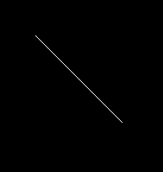

Circle patterns by loop

#include<graphics.h>

#include<conio.h>

main()

{int gd = DETECT, gm;

initgraph(&gd, &gm, "C:\\TC\\BGI");

circle(200, 200,150);

circle(350,200,150);

circle(275,50,150);

circle(275,350,150);

circle(275,200,300);

int i;

for (i=10; i<=140; i=i+10)

{setcolor(GREEN);

circle(200, 200,i);

circle(350,200,i);

circle(275,50,i);

circle(275,350,i);

//circle(275,

}

for (i=10; i<=300; i=i+10)

{circle(275,200,i);}

getch();

closegraph();

return 0;

