**Types of Computer Graphics**

**Offline Passive Computer Graphics Online active Computer Graphics**

. User have no control over the object **.** User have total control over object

Being displayed.Being displayed.

**.** Printer, plotter,vedio-records,display **.** Storage table,displays devices.

Terminal.

**NOTE:**A plotter is a printer that interprets commands from computer to make line drawing on

Paper wih one or more automated pens.

**Advantages of computer graphics:**

1. **A picture is world thousands words.**
2. **With computer graphics we can produce picture abstract object……**
3. **It allows us to achieve much higher bandwidth of non- machine communication.**

**How Computer Graphics work:**?

There are three components-

1. **FRAME BUFFER(F.B):** In F>B, image is stored as matrix of 0’s & 1’s.
2. **T.V Monitor:** Without turning and receiving circuits.
3. **Display Controller:** It is the simple interface between FB & monitor.

**F.B**

**MONITOR**

**D.C**

**Cathode ray tube(CRT)**:

Its operation based on two phenomenon:

1. Effect of electric field on motion of electron.
2. Phosphorescent behaviour of certain material.

**CRT element:**

Deflection system

Acceleration system

+

Filament - Screen

Cathode Control grid

Phosphorescent

Deflection system (phosphor coating

Glass tube ‘+’ charged)

**FILAMENT:** It is used for heating.

**CATHODE:** It is used to control the electron heating.

**CONTROL GRID:** It controls the flow of electrons.

There are a small opening through which electrons are passes,when they leave the control grid all electron carries from a point source,that opening of the grid. It control the intensity.

By applying a positive voltage to accelerating system electron are accelerated towards the phosphorescent screen.

The time elapse phosphor coated on the screen gets faded and hence continuous image to be displayed. The monitor is refreshed.

**FOCUSING SYSTEM:** Focusing system is to focus electron beam to converge into a small spot as it strikes the phosphor.

There are two types of focusing system:

1. Electrostatic focusing system.
2. Electromagnetic focusing system.

**Ques:1 Distinguishes between Electrostatic and electrostatics focusing system.**

**PERSISTENCE:** The time taken by the phosphor coating on the screen to fit to 1/10thof its l

Original intensity hen CRT is to be refreshed.

**Ques:2 What is phosphor? Writes its properties?**

**Ans:2**PHOSPHOR: It is a material which is made of calcium,cadmium and Zinc.

PROPERTIES OF PHOSPHOR(P4& P7):

**→**Phosphorus is small gain size.

**→** High contrast.

**→**High resistence to burn.

|  |  |  |
| --- | --- | --- |
| **PHOSPHOR TYPE** | **PERSISTENT** | **EFFICIENCY** |
| P1 | 24.3µs | 52% |
| P4 | 0.06µs | 43% |
| P7 | 4.00 $μ$ s | 43% |

If persistent is high then it required less refresh rate.

**DIRECT VIEW STORAGE TUBE(DVST) DISPLAY DIVICE:**

Storage grid

Float cathode gun 10kv

Screen

Writing cathode Thin at coating

Beam gun

(Accelerating & Processing system) Collector

**.** In DVST an image is stored in picture tube of CRT in the form of charged pattern.

**.** It doesn’t required refreshing.

**.** An image is stored as a pattern of change on the storage grid.

**FLAT PANEL DISPLAY DEVICE:**

1. Emisive display devices: Electrical energy is converted into light energy.
2. Non-emisivedevices: It use optical effects to convert sunlight or light from some other source into graphics pattern.

**PLASMA PANEL DISPLAY DEVICE:**

Parallel electrodes of gold

Neon gas bulb=64 cells/inch.

A plasma panel display deice is a type of flat panel display common to large T.V displays 30 inches(76 cm) or larger. Yjey are called plasma”displays because they use small cells containing electrically charged ionized gases,which are plasma.

**HALF TOMING PROCESS:**

Low intensity→High resolution

Halftoming process by which with the help of low intensity,higher resolution in screen to be produced.

**RESOLUTION:** The maximum no. of pixels(pil) which can be show on the screen(monitor,CRT) without overlap is known as the resolution of the monitor.

A monitor is characterized with its width and with its height.

Width(w)

Height(h)

h2pw2

Monitor=width x height

Monitor=2411 x 1711

Resolution of screen=1024 x 800

No. of pixels along the height.

No.of pixels

along width.

**THIN FILM ELECTROLUMINESCENT DISPLAY DEVICE:**

→ Here region between glass plates filled with a phosphor(zinc,sulphide doped with manganese).

→ When a sufficient voltage is applied,phosphor becomes conductor in the area of intersection of two electrodes.

→ The electrical energy absorbed by magnese atom which release the energy as a spot of light.

→It required more power than plasma panel.

**COMPRESSION RATIO:** If we want to display a picture of dimension mxn and if resolution of screen is mrx nr  then the pcture is compressed and the compression amt. or ratio is given by-

Compression Ratio= mxn

mr x nr

**Ques**:3 If memory spacefor storage a picture can consist of 16384 bits and we have to display a picture of 256x256,what will be the compression ratio?

**Soln-** Compression ratio= mxn

mr x nr

= 214

216

=1:2

**Compression ratio=1:2**

**ASPECT RATIO**:The ratio of no. of points(pixles) on horizontal line(width) and no. of points on

Vertical line(height) of same length is known as aspect ratio of CRT.

Aspect ratio=hi/vi= horizontal line/vertical line=width/height

*Ques:3*

If given 24”x16” monitor with resolution 1024x800 then what is its aspect ratio?

**Ans:**  Aspect ratio= horizontal line

Vertical line

= 24/16

1024/800

= 24x800/16x1024=300/256

=150/128=75/64

Aspect ratio=75:64

**Ques:4**Given 1024x768.Find aspect ratio?

**Ans:** Width=1024

Height=768

Aspect ratio =4/3

**Ques:5**If aspect ratio of a monitor is 3:2 and resolution is 1024x900.Width of the monitor 16” then find

the height of monitor?

**Ans:** Aspect ratio=horizontal line/vertical lines

Monitor resolution= 16”xh”

Resolution= 1024x900

Aspect ratio:3/2=16/h

1024/900

3/2= 16x900/hx1024

=75/8

h= 9.3”

***Ques 6: In a 512x512 raster on a monochrome display with an average access rate of 200 ns per pixel.***

What is the refresh rate?

**Ans:**  Access rate per pixel=200x10-9

Size of raster=**512x512**

Time required to access the raster=512x512x200x10-9

Refresh rate= No. of frames/sec

= 1

512x512x200x10-9

= 19.07 frame/sec.

**Time= Aspect ratio/speed**

**Ques:7**How many bits are required for a 512x512 raster with each pixel being represented by

3 bits?

**Ans:** Total no. of pixel=512x512=29x29=218

3 bits used by eachpixel,

Therfore,total required bits=218x3 bits.

**INPUT DEVICES:** Keyboard,mouse,traceball,dataglove,joysticks,digiter,imagescanner,touch

Screen,light pen.

**Ques:8** -What is traceball/spceball,dataglove,digiter,lightpen,joysticks& touch screen?

**ALIASING:**

* Aliasing means staircase effect.
* Picture is not continuous but it shown as continuous.
* Decrease in sample size.

**ANTI-ALIASING:**

* Opposite of aliasing.
* In which we increase the sample size i.e picture is continuous but it shown as not continuos.
* Area of the sample is shown(covered) instead of pixel covering.

**Ques:9** Distinguish between Aliasing & Anti-aliasing random scan system?

**RANDOM SCAN SYSTEM:**

Picture is made of certain no. of line segments than Random scan is done.

Random scan system categorized into two types:

1. Interlacing
2. Non-interlacing
3. **Interlacing:** In interlacing,odd numbered lines are scan first & then even numbered lines are scanned

Used half of memory spaces.

1. **Non-interlacing:** In non-interlacing,the lines are scanned one by one.

Used twice memory of interlacing.

**RASTER SCAN SYSTEM:**

In raster scan,the picture information is obtained by finding the pixels(points) of the picture information will be display on the screen.

In raster scan system=30 frames/sec. R G B

3 bytes.

Without color-1024x648 bit

With one color-1024x648x1 bytes.

With three color-1024x648x3 bytes.

Interactive raster graphics system typically employ several processing units i.eC.P.U,a special

Purpose proceesor,display controller is used to control the operation of the display device.

**Ques:8**Distingush between Random Scan System and Raster Scan system?

**R.G.B(Red ,Green,Blue)-**

R 1 C Cyon

G = 1 - M Magneta

B 1 Y Yellow

green

yellow

cyan

blue

magnetta

red



**SHADOW MASK:**

**R**

**G**

**B**

0-255=256 Color combination produce.

=(256)3 =256x256x256=16,777,216

**Advantage**: (1) White range of color

(2)Quality is better

**Disadvantages:** (1) This is more expensive.

(2)Performance is relatively poor.

**Ques:8**Distinguish between:

1. Beam penetration & Shadow mask.
2. Random screen system & Shadow mask.
3. Raster scan system & Shadow mask.

**PROGRAM**

-Write graphics program to draw the circle in C/C++.

# include<conio.h>

# include<graphics.h>

void main()

{

Int a=DETECT,b; //Auto-Detect Graphics Device

intigraph(&a,&b, “C://TC//BGI”); // initialize graphics.

circle(200,200,150);//circle(100,100,50);

getch();

closegraph();

return 0;

}

BOILING POINT TECHNIQUES :-

* Cartesian co-ordinate system is used.

Eg:- A={a,b}, B={c,d,e}

A×B ={(a,c),(a,d),(a,e),(b,c),(b,d),(b,e)}

* Information of pixel is stored in binary form.
* Digital to Analog (D/A) convertor is used.

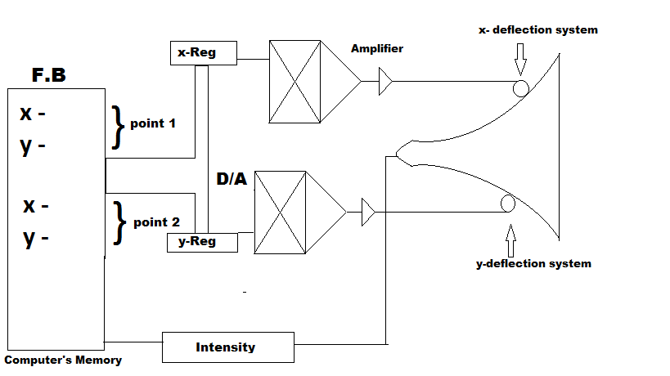

LINE DRAWING ALGORITHM:-

Criteria for Good Line :-

1. Line should appear straight.

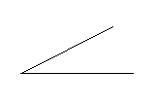

1. Line should terminate correctly. 
2. Line intensity should be constant.
3. Line density should be independent of line length.
4. It takes minimum computation time.

3 LINE DRAWING ALGORITHM :-

1. Simple DDA (Digital Differential Analyzer)
2. Symmetric DDA
3. Breshnan’s Line drawing Algorithm

(ii) SYMMETRIC DDA:-

Computer has to be taken of Pixels & Computations

Slope intercept line equation

Y=mx+c

Where, m=slope, c= y-intercept

DDA generates line by using differential equation

**🡪m= $\frac{dy}{dx}$**

**m= $\frac{Y2 – y1}{x2 – x1}$ = $\frac{y1 – y2}{x1-x2}$**

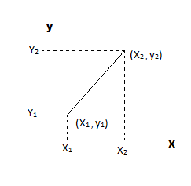 **$m=\frac{dy}{dx}=\frac{∆y}{∆x}=tanθ$**

Change in x $∝∆x$

Change in y $∝∆$ y

|  |
| --- |
| **x= x +∑∆x**  **y=y+∑∆y** |

∑ is line length estimation

|  |
| --- |
| ∑= n |
| 2n-1 ≤ max(│x│,│ $∆y$ │) ‹ 2n |

NOTE (1) :- DDA-Incremental clan conversion.

NOTE (2) :- It is Faster than direct use of line equation.

QUESTION :- (20,10) & (25,14) By using symmetric DDA?

SOLUTION:-

2-x1=25-20 = 5

2 –y1 =14-10 = 4

Max($│∆$ x│,│ $∆y│$) = max(5,4) = 5

2n-1 ≤ max($│∆$ x│,│) ≤ 2n

2n-1 ≤ 5 ≤ 2n

n=3, 22 ≤ 5 ≤ 23 ‹

∑ = n =3 = = 0.125

X=x+∑ $∆x$- - - - - - - (i)

Y=y+∑ $∆y$- - - - - - -(ii)

∑ $∆x$ = 0.125 x 5 = 0.625

∑ $∆y$ = 0.125 x 4 =0.5

Now,

X = x+∑ $∆x$

= 20 + 0.625 = 20.625

Y = y+∑ $∆y$

= 10+0.5 = 10.50

QUESTION :- (17,15) & (25,21) By using symmetric DDA?

/* DDA_LINE_PROGRAM */

#include‹conio.h›

#include‹stdio.h›

#include‹graphics.h›

#include‹device.h›

#define ROUND(a) ((int) (a+0.5))

#define lineDDA (int x1, int y1, int x2, int y2)

{

Int dx=x2 –x1, dy=y2 – y1, steps,k ;

Float xIncrement, yIncrement, x=x1, y=y1 ;

If (abs(dx) › abs (dy))

Steps=abs(dx);

else

steps=abs(dy) ;

xIncrement =dx/(float)steps ;

yIncrement =dy/(float)steps ;

setPixel(ROUNS(x),ROUND(y));

for (k=0; k‹steps; k++)

{

X=x + xIncrement;

Y=y + yIncrement;

setPixel (ROUND (x), ROUND (y));

BRESNAN’s LINE DRAWING ALGORITHM

- 1965-1BM System Journal.

- It is integer Attractive.

- Slope of line lie between 0 & 1

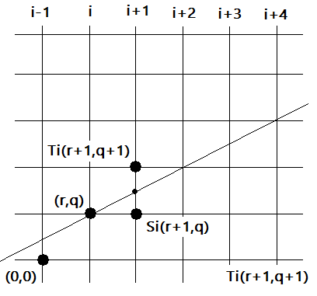

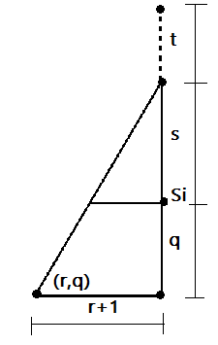

**Line is to be drawn from A(x1 ,y1) to B(x2 ,y2) and A is near to origin.**

**Translate origin to point A(x1 ,y1)**

**Line drawn from (0,0) to (x2 –x1** ,y2 –y1)

Slope=m = $\frac{dy}{dx}$ = $tanθ$

**Tan $θ$** = m = $\frac{dy}{dx}$ = $\frac{s+q}{r+1}$

$\frac{dy}{dx}$ = $\frac{s+q}{r+1}$

S+q =(r+1) $\frac{dy}{dx}$

S= (r+1) $\frac{dy}{dx}$–q - - - - - - - - - - (i)

t+s+q=q+1

* **t= 1-s**

|  |
| --- |
| **t=1-(r+1) $\frac{dy}{dx}$** +q |

**- - - - - - - - - (ii)**

**Now subtract equation (ii) from (i),**

**s-t =(r+1) $\frac{dy}{dx}$** – q-1+(r+1) $\frac{dy}{dx}$– q

**s**-t =2(r+1) $\frac{dy}{dx}$-2q-1

**(s**-t)dx = 2(r+1)dy-2q dx-dx

* **we assure that dx** › 0
* **dx(s-t) can be used for choosing Si** & Ti ,

**let di** ›dx(s-t)

**if di** ›0, then s-t ›0

**if s-t** ›0, then s›t

**di=2(r dy-q dx) + 2 dy-dx**

**r=xi-1 , q=yi-1**

**di = 2(xi-1** dy-d**yi-1 dx)+ 2dy-dx**

**di+1** =2(xidy –yidx) +**2dy-dx**

**di+1 – di =2 [ (xi - xi-1) dy (yi-yi-1)dx ]**

**di+1 – di =2 (xi -xi-1) dy -2 (yi-yi-1)dx**

|  |
| --- |
| * **di+1 – di = 2dy - 2 (yi-yi-1)dx** |

**If di > 0. Then tiis selected.**

* **yi**- **yi-1 =1**

|  |
| --- |
| **di** = **di +2dy – 2dx** |

If **di** ‹ 0, then si is selected,

**yi- yi-1 =0**

|  |
| --- |
| **di +1 = di +2dy** |

Ques:- If we have Y= $\frac{2}{3}$ x has a straight line drawn by taking one step of length 10 unit in X and Y boyh directions then the next three pixels will be

X = 10, y = $\frac{20}{3}$ =6.63(it is near to 10)

Next pixel (10,10)

X=20, y= $\frac{40}{3}$ =13.33 (it is near to 10)

Hence, next pixel (20,10)

X=30, y= $\frac{60}{3}$ = 20 🡪hence next pixel (30,20)

