**Project Report**

**On**

**“Online Discussion & File Sharing Forum”**



Department of Computer Science ,Glocal University

State highway-57,Mirzapur Pole ,Saharanpur ,UP

**Submitted by Submitted to**

1. Mohd Maaz Mr Sachin Michu
2. Mohd Shahrukh Assistant Professor
3. Mohd Israr C .S Department

Glocal university

**ACKNOWLEDGEMENT**

The satisfaction that accompanies that the successful completion of any task would be incomplete without the mention of people whose ceaseless cooperation made it possible, whose constant guidance and encouragement crown all efforts with success.

We are grateful to Mr. Sachin Michu ,Mr Shuaeb Multani &Mr Ahmad Jamal for the guidance, inspiration and constructive suggestions that help us in the preparation of this project.

We also thank our colleagues who have helped in successful completion of the project.

**Mohd Maaz**

**Mohd Israr**

**Mohd Shahrukh**

**Table of Contents**

Synopsis

**Online Discussion & File Sharing Forum**

**Introduction:-**

Online Discussion & File Sharing Forum is a **Web** **Application** developed for online file, notes sharing & discussion

For each subject there is a separate forum where a user can post his query, or anything to share so it could be solved, discussed and helpful for others also.

**Purpose:-**

The purpose of developing this Application is to change the traditional way of discussion and notes sharing in Glocal, though already there are various forum those are working efficiently, but many of them don’t have a user friendly interface and can’t be used with in a LAN, this Application can be easily installed in glocal’s server and would be accessible through LAN

**Technology Used:-**

**Language: -** HTML (bootstrap framework), PHP, JavaScript.

**Backend: -** MySql.

Feasibility Study

**Economically Feasibility:**

The Application developed is economic with respect to users and university.

The Application is also time effective a particular file or information could be share very quickly. Because of the well structured backend & GUI of the Application which is user friendly and very simple.

**Technical feasibility:**

The technical requirement for the Application is economic and it does not use any other additional Hardware and software. It is running on browser so portability and platform independency is also there.

**Behavioural Feasibility:**

The functioning of Application is quite easy to use and learn due to its simple but attractive interface. User requires no special training for using the Application.

Data Tables

**User Accountes table:-**

Storing the registration details of the user

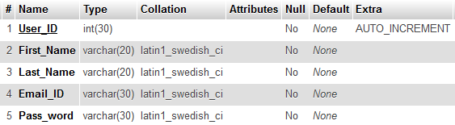

**User Profile table:-**

Storing the personal information of the user

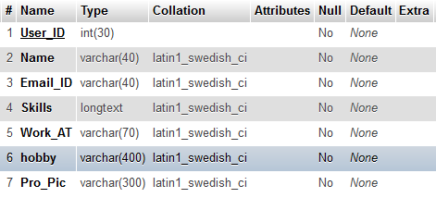

**User Queries table :-**

Storing the queries and files post by user

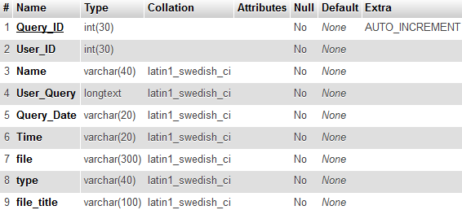

**User Replies table:-**

Storing the replies of query

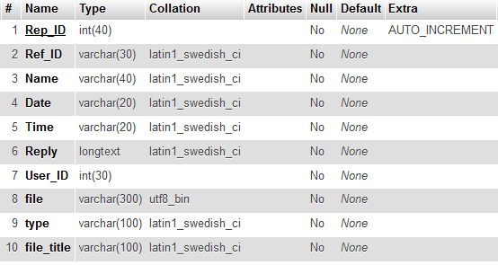

Data Flow Diagram

