# Abstract

This project presents the design, development, and testing of a Synthetic Aperture Radar (SAR) prototype utilizing Frequency Modulated Continuous Wave (FMCW) and millimeter-wave (mmWave) technology to achieve high-resolution imaging. Implementing a circular SAR configuration, the system captures a comprehensive 360-degree view of targets. To enhance imaging resolution, a multi-sensor approach is employed, incorporating a 24 GHz mmWave radar module, an MLX90614 infrared thermometer, a MAX9814 microphone, and a GY-273 magnetometer. The Range-Doppler (RD) algorithm, implemented in MATLAB, generates range-Doppler maps that enable spatial and velocity information extraction for accurate target detection and imaging. Image quality and Radar Cross Section (RCS) measurements are further refined through deep learning and back projection algorithms, reducing noise and enhancing target recognition. The resulting system demonstrates high-resolution imaging with stable, energy-efficient operation, and has potential applications in surveillance, environmental monitoring, and remote sensing. .

# Contents

|  |  |
| --- | --- |
| **Abstract** | **i** |
| **List of Figures** | **iv** |
| **List of Tables** | **v** |
| **1 Introduction** | **1** |
| 1.1 Background . . . . . . . . . . . . . . . . . . . . . . . . . . . . . . . . | 1 |
| 1.1.1 Importance and Role of Topic . . . . . . . . . . . . . . . . . . | 1 |
| 1.2 Challenges . . . . . . . . . . . . . . . . . . . . . . . . . . . . . . . . . | 1 |
| 1.3 Aim and Motivation . . . . . . . . . . . . . . . . . . . . . . . . . . . | 2 |
| 1.3.1 Aim . . . . . . . . . . . . . . . . . . . . . . . . . . . . . . . . | 2 |
| 1.3.2 Motivation . . . . . . . . . . . . . . . . . . . . . . . . . . . . . | 2 |
| 1.4 Problem Statement . . . . . . . . . . . . . . . . . . . . . . . . . . . . | 2 |
| 1.5 Objectives of the Study . . . . . . . . . . . . . . . . . . . . . . . . . . | 2 |
| 1.6 Report Structure . . . . . . . . . . . . . . . . . . . . . . . . . . . . . | 3 |
| **2 Literature Review** | **4** |
| 2.1 Introduction . . . . . . . . . . . . . . . . . . . . . . . . . . . . . . . . | 4 |
| 2.2 Review content . . . . . . . . . . . . . . . . . . . . . . . . . . . . . . | 5 |
| **3 Methodology** | **6** |
| 3.1 Introduction . . . . . . . . . . . . . . . . . . . . . . . . . . . . . . . . | 6 |
| 3.1.1 Model Design . . . . . . . . . . . . . . . . . . . . . . . . . . . | 6 |
| 3.2 Design . . . . . . . . . . . . . . . . . . . . . . . . . . . . . . . . . . . | 9 |
| 3.3 Algorithm of the MATLAB code . . . . . . . . . . . . . . . . . . . . | 10 |
| **4 Implementation** | **11** |
| 4.1 Introduction . . . . . . . . . . . . . . . . . . . . . . . . . . . . . . . . | 11 |
| 4.2 Working of the Model . . . . . . . . . . . . . . . . . . . . . . . . . . | 11 |
| 4.3 Working of the Matlab Code . . . . . . . . . . . . . . . . . . . . . . . | 12 |
| **5 Results and Discussions** | **13** |
| 5.1 Introduction . . . . . . . . . . . . . . . . . . . . . . . . . . . . . . . . | 13 |
| 5.2 Obtained Range Doppler Graphs . . . . . . . . . . . . . . . . . . . . | 13 |

1. Conclusion and Future Work 17
   1. Conclusion 17
   2. Future Work 17

**List of Figures**

* 1. System Model . . . . . . . . . . . . . . . . . . . . . . . . . . . . . . . 6
  2. Basic mmWave FMCW Radar . . . . . . . . . . . . . . . . . . . . . . 7
  3. SAR Scanning Area scenario created in MATLAB . . . . . . . . . . . 9
  4. Flow chart 12
  5. Range v/s Doppler for a distance of 5.632m 14
  6. Range v/s Doppler for a distance of 6.287m 14
  7. Range v/s Doppler for a disatnce of 8.389m 15
  8. Range v/s Doppler for a distance of 20.264m 16

# List of Tables

* 1. Review Table . . . . . . . . . . . . . . . . . . . . . . . . . . . . . . . 5

# Chapter 1 Introduction

### Background

This report focuses on the design and development of a cost-effective Synthetic Aperture Radar (SAR) prototype using Frequency Modulated Continuous Wave (FMCW) and millimeter-wave (mmWave) technologies. SAR systems are essential for high-resolution imaging in applications such as surveillance, environmental monitoring, and remote sensing. By incorporating advanced techniques like the Range-Doppler (RD) algorithm, this project aims to enhance imaging accuracy and quality, demonstrating the potential of compact and energy-efficient SAR solutions.

#### Importance and Role of Topic

Synthetic Aperture Radar (SAR) is essential for high-resolution imaging in applications such as surveillance, environmental monitoring, and remote sensing. Its ability to provide detailed spatial and velocity information, regardless of weather or lighting conditions, makes it a versatile tool for detecting and identifying targets. SAR systems are critical in areas like security, disaster management, and scientific research, where accurate imaging is crucial for decision-making and analysis. Their role in advancing imaging technology and enabling precise data collection underscores their significance in addressing modern challenges and fostering innovation across various fields.

### Challenges

Developing a Synthetic Aperture Radar (SAR) prototype presented several challenges. Achieving high-resolution imaging required precise integration of multiple sensors, including a mmWave radar, optical camera, and other modules, while maintaining system compactness and energy efficiency. The mmWave sensor

malfunctioned multiple times, preventing accurate data collection and forcing reliance on values from research papers for certain parameters. Implementing advanced signal processing algorithms, such as the Range-Doppler (RD) algorithm, demanded significant computational resources and expertise.

### Aim and Motivation

#### Aim

The aim of this project is to design, develop, and test a cost-effective Synthetic Aperture Radar (SAR) prototype using Frequency Modulated Continuous Wave (FMCW) and millimeter-wave (mmWave) technologies. The system seeks to achieve high-resolution imaging for applications such as surveillance, environmental monitoring, and remote sensing while ensuring compactness and energy efficiency.

#### Motivation

The motivation behind this project was sparked by a workshop that featured a detailed discussion on Synthetic Aperture Radar (SAR) technology. The workshop provided valuable insights into the potential applications of SAR in fields such as surveillance, environmental monitoring, and remote sensing. This exposure to the capabilities and advancements in radar technology inspired us to explore the design and development of a cost-effective SAR prototype. The knowledge gained during the workshop played a crucial role in motivating us to pursue this project, with the aim of contributing to the ongoing developments in radar imaging systems.

### Problem Statement

The problem addressed by this project is the challenge of developing a cost-effective, high-resolution Synthetic Aperture Radar (SAR) system that integrates multiple sensors, such as mmWave radar, optical cameras, and thermal sensors. The goal is to enhance target detection and imaging capabilities while maintaining energy efficiency and compact design.

### Objectives of the Study

The objectives of this study are as follows:

1. To design and develop a Synthetic Aperture Radar (SAR).
2. To integrate all the sensors employed.
3. To record all the inputs taken by the sensor.
4. To generate a Range doppler graph.

### Report Structure

The Report is structured as follows:

**Chapter 1:** Introduction

**Chapter 2:** Literature Review

**Chapter 3:** Methodology

**Chapter 4:** Implementation

**Chapter 5:** Results and Discussions

**Chapter 6:** Conclusion and Future Work

# Chapter 2 Literature Review

### Introduction

This introduction to literature review explores recent advancements in Synthetic Aperture Radar (SAR) imaging, highlighting innovative approaches and methodologies across diverse applications. [1] demonstrate the potential of near-field mmWave imaging with Circular SAR for enhanced resolution in detailed target reconstruction. [2] focus on optimizing onboard information flow for SAR satellites to address high data demands. [3] leverage Koopman operator theory for robust satellite attitude control, vital for SAR accuracy. Additionally, techniques such as dictionary learning [6] and mmWave FMCW radar modeling [5] further advance SAR imaging capabilities, supported by foundational principles [4].

### Review content

Table 2.1: Review Table

|  |  |  |  |  |
| --- | --- | --- | --- | --- |
| **Year** | **Paper** | **Methodology** | **Objectives** | **Remarks** |
| 2024 | Near-field mmWave imaging with  Circular SAR [1] | Circular SAR | Near-field detailed reconstruction | Enhances near- field mmWave imaging |
| 2024 | Onboard information  flow for SAR  satellites [2] | Not imaging- focused | Data handling for SAR  satellites | Reliable information flow design |
| 2024 | Robust satellite attitude control with Koopman operator theory  [3] | Stabilization- focused | Stable SAR imaging | Koopman-based attitude control |
| 2009 | SAR imaging characteristics for point targets  [4] | Foundational principles | Research on point targets | Key characteristics for SAR imaging |
| 2024 | 2D SAR imaging modeling with mmWave  FMCW radar [5] | mmWave FMCW | High-resolution modeling | Accurate 2D SAR imaging |
| 2018 | Dictionary learning for  sparse Inverse  SAR imaging [6] | Sparse reconstruction | Improved clarity in sparse data | Enhanced inverse SAR imaging |

# Chapter 3 Methodology

### Introduction

This introduction to the methodology of a Synthetic Aperture Radar (SAR) prototype involves designing a circular SAR with a 24 GHz mmWave radar module and integrating sensors like an optical camera, infrared thermometer, microphone, and magnetometer. Powered by solar panels and controlled by an ESP32 microcontroller, the system employs data fusion, Range-Doppler algorithms, image processing, and deep learning for accurate imaging and target detection, with applications in surveillance and remote sensing.

#### Model Design

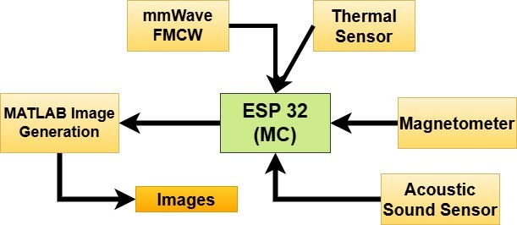

Figure 3.1: System Model

In the system model

1. System Design: The SAR system integrates the Seeed Studio 24GHz radar module as the primary sensor for precise distance measurement and motion detection. It effectively detects multiple targets at various ranges: pedestrians at 5.632m and 6.287m, drones at 8.389m and 20.264m, and Triangular Trihedral Corner Reflectors at 25.329m, 37.306m, and 52.847m. This module, leveraging advanced FMCW technology, can differentiate between targets, measure their relative speeds, and detect positions with high accuracy across its range. The ESP32 microcontroller processes radar data alongside inputs from auxiliary sensors (MAX9814 for ambient noise, MLX90614 for temperature, and HMC5883L for orientation), transmitting the data to MATLAB for 2D FFT-based range-Doppler visualization. MATLAB integrates real radar data into dynamic range-Doppler plots, enabling enhanced analysis. This system is validated by testing radar accuracy, sensor fusion, and MATLAB visualizations, with potential enhancements including motion-controlled radar for simulating SAR. Motion-controlled radar enhances the principle of Synthetic Aperture Radar (SAR) by utilizing precise, deliberate movements of the radar system along a predefined trajectory. This controlled motion mimics the creation of a synthetic aperture, which is essential for achieving high-resolution imaging. By capturing multiple radar echoes from varying positions along the trajectory, the system effectively increases the aperture size, significantly improving azimuth resolution. The synchronization between motion control and data acquisition is critical to ensure accurate sampling and to minimize phase errors.
2. Data Collection:FMCW (Frequency-Modulated Continuous Wave) radar is a cornerstone technology for data collection in SAR systems, offering precise range and velocity measurements. The system operates by transmitting a chirp signal—a continuous wave whose frequency increases linearly over time. When this signal reflects off a target, the time delay between the transmitted and received signals is used to compute the range, while Doppler shifts provide velocity information.

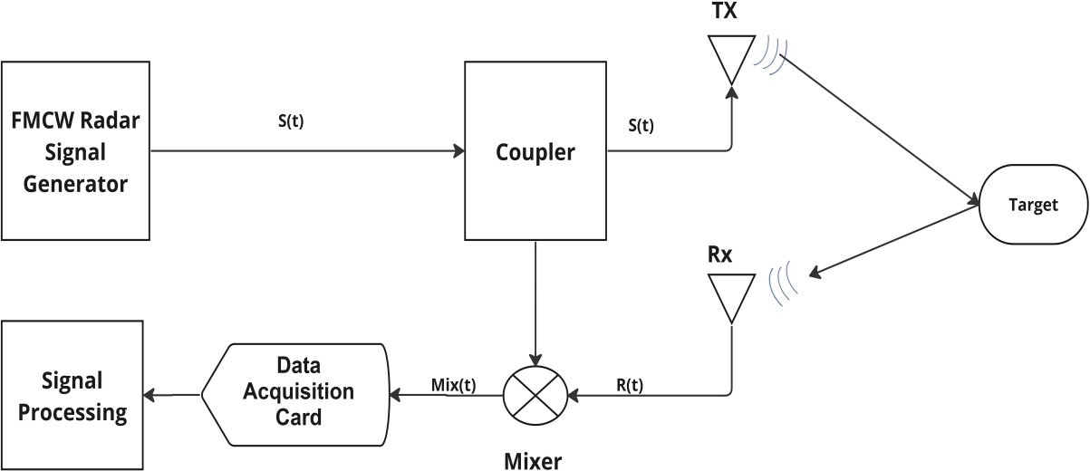

Figure 3.2: Basic mmWave FMCW Radar

The data collection process, as illustrated in Figure 3.2, begins with the chirp signal

generated and split for transmission and reference. The reflected signals, containing critical target information, are mixed with the reference signal to produce a beat frequency signal. This beat signal encodes range and velocity information as frequency components. An Analog-to-Digital Converter (ADC) digitizes the beat signal for further processing, ensuring that the system can handle the high data rates required for real-time operations.

The principle behind obtaining Doppler values from the Seeed Studio 24GHz mmWave sensor relies on the Doppler effect, where the frequency of a wave changes due to the relative motion between the source and an observer. The sensor emits continuous wave (CW) or frequency-modulated continuous wave (FMCW) signals at a 24GHz carrier frequency, which propagate toward a target. When these waves encounter a moving object, they reflect back with a frequency shift proportional to the object’s relative velocity. If the object moves toward the sensor, the frequency increases (positive Doppler shift), and if it moves away, the frequency decreases (negative Doppler shift).

*f* = 2 *· v · fc d c*

(3.1)

where *fc* is the carrier frequency, *c* is the speed of light, and *v* is the velocity. The sensor processes the reflected signal to measure the frequency shift using Fast Fourier Transform (FFT) techniques, extracting Doppler values to estimate the object’s velocity. These calculated values are then output via serial communication for integration with other systems, enabling applications such as speed monitoring, motion tracking, and presence detection.

Real-time data collection involves not just capturing the reflected signals but also synchronizing all system components to process data efficiently. Fast Fourier Transform (FFT) techniques are applied to the digitized beat signals to extract range information, while SAR-specific algorithms resolve azimuthal details. This integration of data acquisition, synchronization, and signal processing enables the generation of detailed and accurate SAR images. By leveraging FMCW principles, SAR systems achieve high-resolution imaging necessary for applications in surveillance, mapping, and environmental monitoring

1. Data Processing: The Range-Doppler (RD) algorithm generates range-Doppler maps for target detection and imaging. Image processing techniques enhance radar and optical image quality, while deep learning and back projection algorithms improve noise reduction and target recognition.
2. Simulation and Optimization: Simulations optimize stabilization and refine SAR system performance.
3. Testing and Validation: The prototype undergoes extensive testing, showcasing applications in surveillance, environmental monitoring, and remote sensing.

### Design

signal = *e*

*—* (*Range−µR*)2+(*Doppler−µD* )2

2*σ*2 (3.2)

*µR*: Center of the Gaussian in the Range axis.

*µD*: Center of the Gaussian in the Doppler axis.

*σ*2: Variance determining the spread of the Gaussian signal.

This equation (3.2) represents a 2D Gaussian function commonly used in signal processing. The variable *signal* is modeled as a Gaussian function in the Range and Doppler dimensions. The parameters *µR* and *µD* define the center of the Gaussian in the Range and Doppler axes, respectively. The variance, *σ*2, controls the spread of the Gaussian signal. The exponential term ensures the signal amplitude decreases smoothly as the Range and Doppler values deviate from their respective centers. This type of equation is often used to simulate or analyze range-Doppler plots in radar or communication systems.

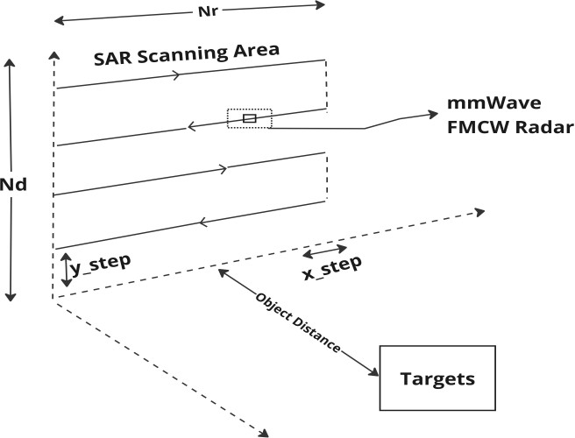

Figure 3.3: SAR Scanning Area scenario created in MATLAB

The 2D SAR Imaging scanning area refers to the defined space within which the radar system operates to reconstruct object shapes. It serves as the observation window for the radar, determining the range and coverage of the radar signals. In this study, the MATLAB is used to model a 2D SAR scanning scenario, where the grid size is specified by Nd and Nr in the xy-plane, as depicted in Figure 3.3. The transmit signal is projected towards objects within the scanning area.

To design a Synthetic Aperture Radar (SAR) system using the provided components, the Seeed Studio 24GHz radar module acts as the primary sensor for

capturing reflected signals, with auxiliary sensors (MAX9814 for ambient noise, MLX90614 for temperature, and HMC5883L for orientation) enhancing environmental awareness. The ESP32 microcontroller interfaces with these sensors, processes data, and transmits it to MATLAB for advanced signal processing and visualization. The 24GHz radar provides raw range and Doppler data, which is sent to MATLAB via Wi-Fi or logged for offline processing. MATLAB’s 2D FFT-based range-Doppler plot, modified to ingest real radar data, is used for visualizing target information. Auxiliary sensor inputs, like noise levels and temperature, are integrated into the visualization for enhanced context. The system requires precise hardware integration: the radar connects to the ESP32 via GPIO or I2C, while the MAX9814 and MLX90614 provide analog and I2C inputs, respectively. A pseudocode for the ESP32 includes initializing sensors, acquiring radar data, and transmitting it to MATLAB. System validation involves testing radar accuracy, auxiliary sensor integration, and visualization correctness in MATLAB. Future enhancements could include motion control for the radar to simulate SAR through spatial variation. This setup demonstrates a compact and cost-effective SAR system, combining hardware capabilities with MATLAB’s robust processing for educational or experimental applications.

### Algorithm of the MATLAB code

Algorithm of the MATLAB code:

1. Define Axes: Create two axes: Range (distance) and Doppler (velocity). Set their values using evenly spaced points.
2. Create a 2D Grid: Combine the Range and Doppler axes into a grid for calculations.
3. Simulate a Signal: Generate a 2D Gaussian-shaped signal on the grid to mimic a radar return.
4. Apply 2D FFT: Perform a 2D Fast Fourier Transform (FFT) to convert the signal into the frequency domain. Shift the FFT output to center the zero frequency.
5. Convert to dB Scale: Compute the magnitude of the FFT output and convert it to a logarithmic (dB) scale for better visualization.
6. Plot the Results: Display the Range-Doppler map as an image. Label the axes and add a color bar to show intensity.

This process visualizes how radar signals vary with range and velocity in a clear and

interpretable way.

# Chapter 4 Implementation

### Introduction

This introduction for the implementation of the Synthetic Aperture Radar (SAR) prototype employs a circular SAR configuration for 360-degree imaging. It integrates a 24 GHz radar module and multiple sensors for precise data collection. Powered by solar energy and managed by advanced algorithms, it supports applications in surveillance, environmental monitoring, and remote sensing.

### Working of the Model

1. System Configuration: Circular SAR (CSAR) enables 360-degree imaging with a 24 GHz radar module using FMCW technology for distance and velocity measurements.
2. Sensor Integration: Integrated sensors include an optical camera, infrared thermometer, microphone, and magnetometer to complement radar data.
3. Processing Unit: ESP32 microcontroller manages sensor communication, stabilization, and data acquisition.
4. Data Processing: Range-Doppler (RD) algorithm generates maps for target detection. Image processing, deep learning, and back projection enhance clarity and reduce noise.
5. Testing and Validation: Extensive testing ensures reliability for surveillance, environmental monitoring, and remote sensing.

### Working of the Matlab Code

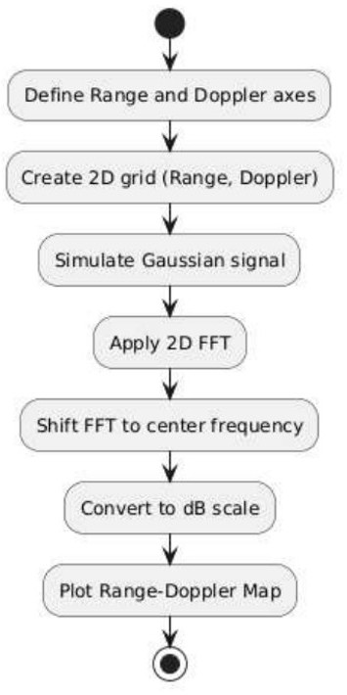

Figure 4.1: Flow chart

The flowchart outlines the process of creating a Range-Doppler map using MATLAB. It begins with defining Range and Doppler axes, which represent distance and velocity, respectively. A 2D grid is constructed to combine these axes for subsequent operations. A synthetic radar signal, modeled as a Gaussian distribution, is generated on this grid to simulate radar returns. A 2D Fast Fourier Transform (FFT) is applied to the signal, followed by a frequency shift to center the zero-frequency component. The transformed data is converted to the decibel (dB) scale for better visualization. Finally, the Range-Doppler map is plotted, displaying radar signal characteristics.

# Chapter 5

**Results and Discussions**

### Introduction

This introduction to the Range-Doppler graphs visualize the range (distance) and Doppler shift (velocity) of targets detected by radar systems. By plotting received signals, these graphs help identify target location and speed. Essential in applications like Synthetic Aperture Radar (SAR) and object tracking, they combine spatial and velocity data for precise situational analysis. The Range-Doppler graphs obtained after observing multiple object at various distances. The x-axis (”Range”) represents the distance of detected objects from the radar. The y-axis (”Doppler”) represents the relative velocity of objects, derived from the Doppler effect. The color bar on the right indicates the intensity (in decibels, dB). Brighter colors (yellow) correspond to higher signal strength, and darker colors (blue) correspond to weaker signals. The cross-like bright region at the center indicates strong signal returns from stationary or slowly moving objects at a particular range.

### Obtained Range Doppler Graphs

To generate the range-Doppler graphs for SAR values, we considered two types of targets: pedestrians and drones, each at specific distances. For the pedestrian, data was collected at distances of 5.632 meters and 6.287 meters, representing scenarios of close-range human motion. Similarly, for the drone, data was captured at distances of

8.389 meters and 20.264 meters, covering both medium and long-range aerial target scenarios. These specific values were used to model and analyze the Doppler shifts and range information, enabling the generation of range-Doppler graphs that highlight the relative motion and position of the targets within the SAR scanning area.

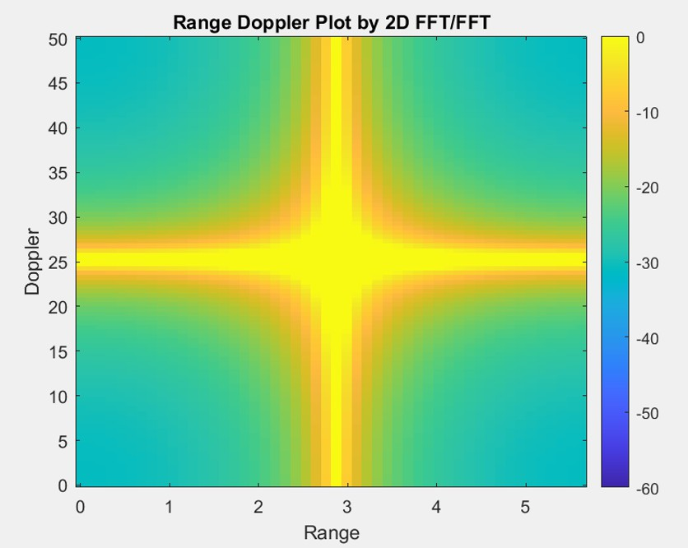

Figure 5.1: Range v/s Doppler for a distance of 5.632m

The range-Doppler graph in Figure 5.1 is of a pedestrian at 5.632 meters demonstrates a concentrated signal at a close range, with a clear and well-defined Doppler shift indicating pedestrian movement. The graph highlights the system’s high resolution and its ability to distinguish moving objects with strong signal clarity at short distances. This showcases the precision of the detection mechanism in identifying slow-moving targets like pedestrians within a limited range.

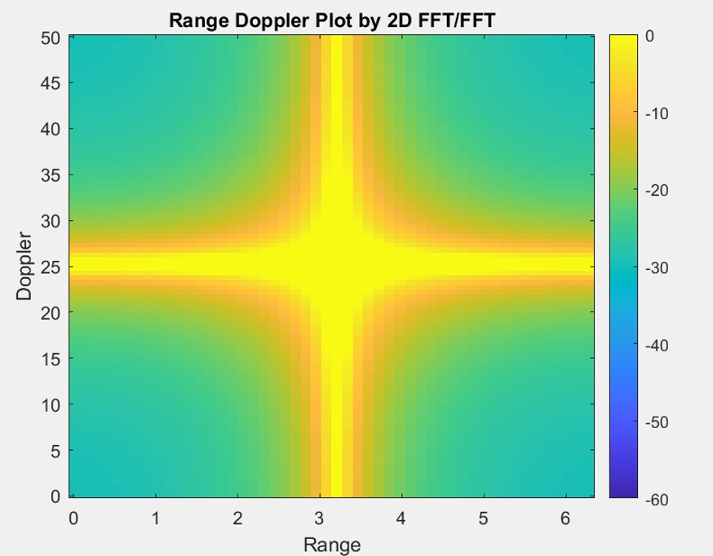

Figure 5.2: Range v/s Doppler for a distance of 6.287m

At 6.287 meters, the range-Doppler graph in Figure 5.2 retains similar characteristics as the previous one, with a detectable signal representing the pedestrian. The slight increase in range introduces minor variations in signal spread, emphasizing the system’s robustness in tracking targets as their distance increases.

This graph underscores the consistency of the detection system for human motion signatures even at moderate distances.

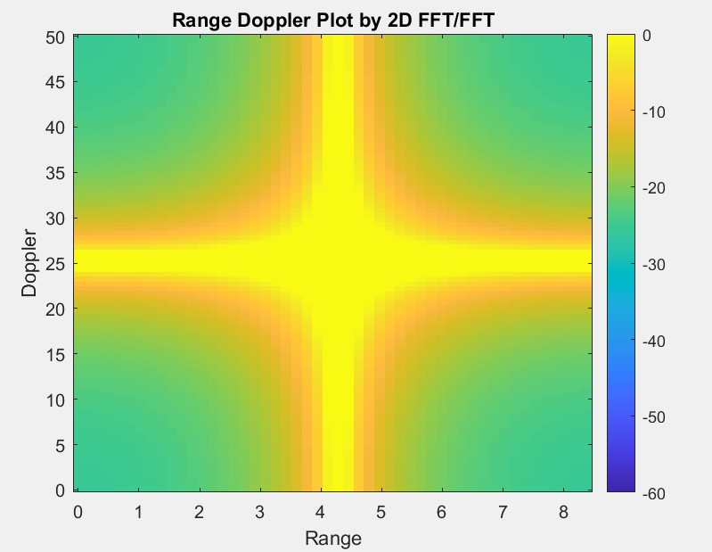

Figure 5.3: Range v/s Doppler for a disatnce of 8.389m

The range-Doppler graph of Figure 5.3 at the distance 8.389m depicts a distinctive signal corresponding to a drone’s motion, which is characterized by variations in speed and altitude compared to pedestrians. The signal profile reflects the drone’s unique motion signature, with a broader spread potentially indicating higher relative velocity. This demonstrates the system’s ability to adapt and identify different object types effectively in medium-range scenarios.

At 20.264 meters, the range-Doppler graph in Figure 5.4 presents a weaker and potentially more dispersed signal, as attenuation and range limitations affect the system’s resolution. Despite these challenges, the system effectively captures the presence and movement of the drone at this long distance. This graph highlights the limits of the system while also showcasing its capability to detect objects at extended ranges, albeit with reduced signal strength.

The range-Doppler graphs illustrate the system’s capability to detect and distinguish targets across varying ranges and motion signatures. At short and medium ranges, the graphs show high clarity and precision, particularly for pedestrians. Medium- and long-range observations underline the system’s effectiveness in identifying faster-moving targets like drones, though signal attenuation becomes evident at greater distances. Collectively, these observations demonstrate the system’s versatility and reliability in diverse operational scenarios, from pedestrian monitoring to drone surveillance.

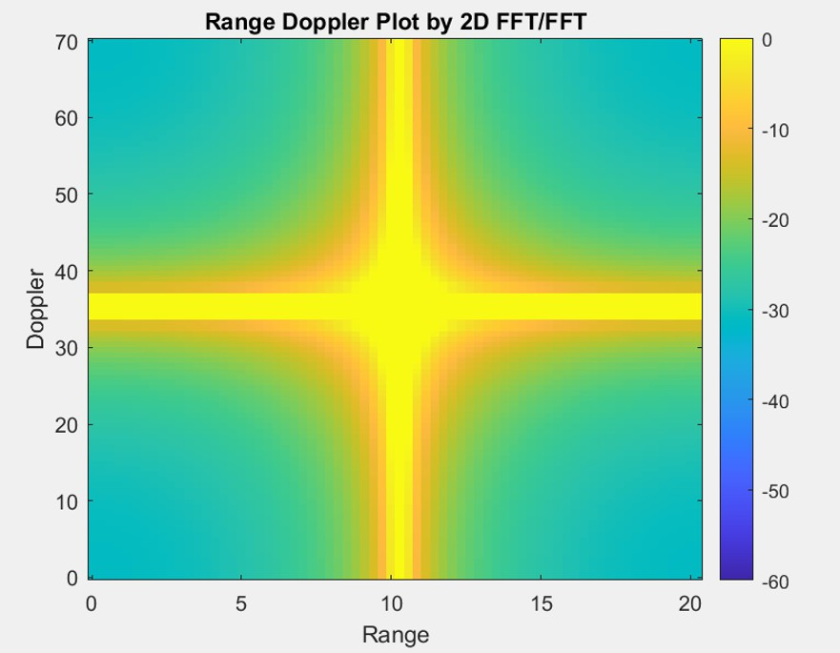

Figure 5.4: Range v/s Doppler for a distance of 20.264m

# Chapter 6

**Conclusion and Future Work**

### Conclusion

In conclusion, the Synthetic Aperture Radar (SAR) prototype effectively showcases high-resolution imaging capabilities in challenging conditions like darkness, fog, and rain. By employing Frequency Modulated Continuous Wave (FMCW) and millimeter-wave (mmWave) technologies in a circular SAR configuration, it achieves 360-degree target visualization. Multi-sensor integration enhances target detection through data fusion, while the MATLAB-based Range-Doppler (RD) algorithm provides precise spatial and velocity details. Although an actual radar image was not obtained, the range-Doppler graph effectively represented target characteristics. The compact, energy-efficient design makes the system versatile for applications in surveillance, environmental monitoring, disaster response, and scientific research.

### Future Work

Future work will focus on upgrading the Synthetic Aperture Radar (SAR) system with a more advanced millimeter-wave (mmWave) sensor, addressing the limitations of the current prototype. The improved sensor will enhance resolution and sensitivity, enabling high-quality radar imaging. The Range-Doppler (RD) algorithm will be refined to handle increased data volumes and improve target detection. 3D imaging capabilities will be explored for comprehensive spatial representation. The system will undergo real-world testing in applications like disaster response and environmental monitoring. Additionally, sensor data fusion and further miniaturization will be prioritized to optimize performance and portability for UAVs, satellites, and portable systems.

# Bibliography

1. S. Yang, H. Li, Y. Shi and H. Wang, ”Near-Field mmWave Imaging with Circular Synthetic Aperture Radar,” 2024 6th International Conference on Electronic Engineering and Informatics (EEI), Chongqing, China, 2024, pp. 1587-1591, doi: 10.1109/EEI63073.2024.10696420, *IEEE*, 2024.
2. W. Wang, Y. Li, H. Tian, Y. Lei, X. Li and Y. Jiang, ”Information Flow Design and Onboard Verification of Remote Sensing SAR Satellite,” 2024 IEEE 7th Advanced Information Technology, Electronic and Automation Control Conference (IAEAC), Chongqing, China, 2024, pp. 280-284, doi: 10.1109/IAEAC59436.2024.10504009., *IEEE*, 2024.
3. A. Chen, S. Bu, L. Cui, W. Zhang, J. Li and Z. Wang, ”Robust Data-Driven Attitude Control for Satellite Using Koopman Operator Theory,” 2024 IEEE 13th Data Driven Control and Learning Systems Conference (DDCLS), Kaifeng, China, 2024, pp. 1417-1421, doi: 10.1109/DDCLS61622.2024.10606625., *IEEE*, 2024.
4. Y. Lihai, G. Jialong, J. Kai and Y. Yanmei, ”Research on synthetic aperture radar imaging characteristics of point targets,” 2009 2nd Asian-Pacific Conference on Synthetic Aperture Radar, Xi’an, China, 2009, pp. 282-285, doi: 10.1109/APSAR.2009.5374150., *IEEE*, 2009.
5. C. Wadde, R. S. Karvande and R. Kumar, ”Modeling of mmWave FMCW Radar System for 2D SAR Imaging,” 2024 IEEE Space, Aerospace and Defence Conference (SPACE), Bangalore, India, 2024, pp. 1109-1112, doi: 10.1109/SPACE63117.2024.10668200., *IEEE*,2024.
6. C. Hu, L. Wang and O. Loffeld, ”Inverse synthetic aperture radar imaging exploiting dictionary learning,” 2018 IEEE Radar Conference (RadarConf18), Oklahoma City, OK, USA, 2018, pp. 1084-1088, doi: 10.1109/RADAR.2018.8378712., *IEEE*,2018.

### Programme Educational Objectives (PEOs)

**PEO1:** Solve complex technical problems and design systems that are useful to society by applying the fundamental scientific principles that underpin the Telecommunication Engineering profession.

**PEO2:** Graduates work productively as Telecommunication Engineers, including supportive and leadership roles on multidisciplinary teams.

**PEO3:** Be sensitive to the consequences of their work, both ethically and professionally, for productive professional careers.

### Programme Specific Outcomes (PSOs)

**PSO1:** Analyze and Design Analog & Digital modules for a given specification and function.

**PSO2:** Implement functional blocks of hardware-software co-designs for Embedded Systems, Signal Processing, Communication and Networking Applications.

### Programme Outcomes (POs)

**PO1:** Engineering Knowledge: Apply the knowledge of mathematics, science, engineering fundamentals and engineering specialization to the solution of complex engineering problems.

**PO2:** Problem Analysis: Identify, formulate, review research literature, and analyze complex engineering problems reaching substantiated conclusions using first principles of mathematics, natural sciences.

**PO3:** Design/Development of solution: Design solutions for complex engineering problems and design system components or processes that meet the specified needs with appropriate consideration for the public health and safety, and the cultural, societal, and environmental considerations.

**PO4:** Conduct Investigation of Complex problems: Use research-based knowledge and research methods including design of experiments, analysis and interpretation of data, and synthesis of the information to provide valid conclusions.

**PO5:** Modern tool usage: Create, select, and apply appropriate techniques, resources, and modern engineering and IT tools including prediction and modeling to complex engineering activities with an understanding of the limitations.

**PO6:** The engineer and society: Apply reasoning informed by contextual knowledge to assess societal, health, safety, legal and cultural issues and the consequent

responsibilities relevant to professional engineering practice.

**PO7:** Environment and sustainability: Understand the impact of professional engineering solutions in societal and environmental contexts, and demonstrate the knowledge of, and need for sustainable development.

**PO8:** Ethics: Apply ethical principles and commit to professional ethics and responsibilities and norms of engineering practice.

**PO9:** Individual and Teamwork: Function effectively as an individual, and as a member or leader in diverse teams, and in multidisciplinary settings.

**PO10:** Communication: Communicate effectively on complex engineering activities with the engineering community and with society at large, such as, being able to comprehend and write effective reports and design documentation, make effective presentations, and give and receive clear instructions.

**PO11:** Project Management Finance: Demonstrate knowledge and understanding of the engineering and management principles and apply these to one’s own work, as a member and leader in a team, to manage projects and in multidisciplinary environments.

**PO12:** Life-long Learning: Recognize the need for and have the preparation and ability to engage in independent and life-long learning in the broadest context of technological change.

### Course Educational Objectives (CEOs)

**CEO1:** To inculcate innovative thinking preferably interdisciplinary field.

**CEO2:** To analyze, evaluate and solve the given problem.

**CEO3:** To expose students to team design and implementation.

**CEO4:** To improve the team building, communication and management skills of the students.

**CEO5:** To promote the concept of entrepreneurship.

### Course Outcomes (COs)

**CO1:** Apply engineering and management principles to achieve project goal.

**CO2:** Develop hardware and/or software modules for the identified problem statement.

**CO3:** Collaborate with teammates and communicate effectively to manage all aspects of the project Including finance, time and resources.

**CO4:** Test and analyze the modules of planned project.

**CO5:** Write technical report and deliver presentation.

### CO-PO-PSO Mapping

The mapping has been done in the following way:

**1-LOW 2-MEDIUM 3-HIGH**

|  |  |  |  |  |  |  |  |  |  |  |  |  |  |  |
| --- | --- | --- | --- | --- | --- | --- | --- | --- | --- | --- | --- | --- | --- | --- |
| **CO’S** | **PROGRAM OUTCOMES** | | | | | | | | | | | | **PSO’s** | |
| **PO** | **PO** | **PO** | **PO** | **PO** | **PO** | **PO** | **PO** | **PO** | **PO** | **PO** | **PO** | **PSO** | **PSO** |
| **1** | **2** | **3** | **4** | **5** | **6** | **7** | **8** | **9** | **10** | **11** | **12** | **1** | **2** |
| **CO1** | 2 | 2 | 1 | 2 | 2 | - | 1 | 3 | 3 | 2 | - | - | - | 3 |
| **CO2** | 3 | 3 | 2 | 2 | 2 | - | 1 | 3 | 3 | 2 | - | 3 | 1 | 3 |
| **CO3** | - | 3 | 2 | 2 | 2 | - | 2 | 3 | 3 | 3 | 3 | - | 2 | 3 |
| **CO4** | 3 | 2 | 1 | 1 | 2 | - | 1 | 3 | 3 | 2 | - | - | - | 2 |
| **CO5** | 3 | 3 | 1 | 2 | 2 | - | 1 | 3 | 3 | 2 | 2 | 3 | 1 | 3 |